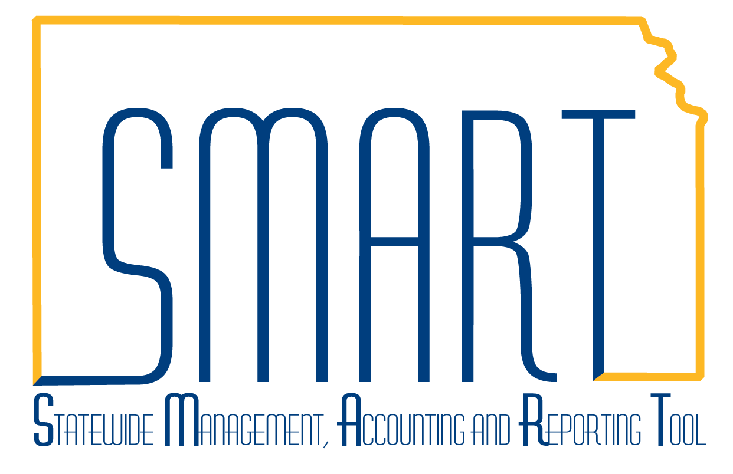
State of Kansas

Travel Authorizations – Create/Modify, View, Withdraw, Delete, Cancel, Modify Approved, Populate to an Expense Report

Statewide Management, Accounting and Reporting Tool

Date Created: | 01/29/2013
Last Updated Date: | 04/27/2021
Version: | 2.0
Overview: | A Travel Authorization/TA is used to both authorize an employee for business travel and to encumber the anticipated travel expenses. Best practice is to include all anticipated expenses including expenses that will not be reimbursed to the employee (those paid via direct bill, imprest advance, PCard, or State agency credit card). A TA does not create any payment to the employee.  Table of Contents  Create/Modify…………………………………………………………………….… Page 4  View……………………………………………………………………………….… Page 9  Withdraw……………………………………………………………………….…… Page 10  Delete…………………………………………………………………………….…..Page 11  Cancel……………………………………………………………...…………….…. Page 12  Modify Approved……………………………………………………….……….…. Page 13  Populate to an Expense Report...………….………………………………….… Page 14  When are TAs Required?  PM 10,300 Statewide Encumbrance Policy requires TAs for:  - All out-of-state travel events  - All international travel events  - any travel or expense obligation that will not be reimbursed to the employee prior to the fiscal year-end SMART cutoff date  While not required, best practice is to also create TAs for in-state travel.  Travel information for State employees including the Employee Travel Expense Reimbursement Handbook is available directly in SMART. Navigation: Expenses > Ex Utilities > Useful Links > Travel Reimbursement Handbook.  A Smart TA must be created, fully approved, and in valid budget status on or before the start date of travel. Once the TA Date From has passed, a TA cannot be further processed.
Overview:  (cont’d) | TAs and Encumbrances  - When a TA is submitted for approval and passes budget check, it creates encumbrances for the non-prepaid expenses. If a TA is returned to Pending status, the encumbrances are liquidated/unencumbered.  - When a TA is associated to an expense report/ER, the amount encumbered by the TA is completely liquidated regardless of the actual amount of the TA associated to the ER. The encumbrance liquidation is from the same fund-budget unit used for the TA.  - A TA does not create any accounting entries in the General Ledger. Instead, a TA creates encumbrance entries in Commitment Control.  If a TA was partially, but not fully approved, before the Date From has passed:  - Encumbrances were created but the TA cannot be associated to an ER.  - In the related ER, add explanatory notes and attach a copy of the TA to show encumbrances were created in case the ER is selected for audit.  - To liquidate the related TA encumbrances, enter a ManageEngine Service Desk ticket requesting assistance.  Approval Outside SMART  Approval outside SMART is discussed in the Employee Travel Expense Reimbursement Handbook. The handbook can be accessed directly from SMART. Navigation: Expenses > Ex Utilities > Useful Links > Travel Reimbursement Handbook. Section 2101(A)/Approval Methods/2 discusses approval outside SMART.  Because approval outside SMART does not create any encumbrances, such approval may result in an audit finding if the related ER is selected for audit. Also, approval must be provided prior to the travel as untimely approval may result in an audit finding if the related ER is selected for audit.  TAs require three levels of approval: first-level/HR Supervisor, second-level/Department Expense Manager, and third-level/Agency Fiscal Office approval.  A TA can be associated to only one expense report/ER.  If travel requires both a cash advance/CA and a TA, either can be created first. However, if the TA is created first, the CA can be created from the TA Actions menu which auto-populates some of the CA fields.  This job aid replaces the following job aid which has been removed from SMART Web:  - Canceling Travel Authorizations  - Creating Travel Authorizations

Security: | Users with the Agency Expense Processor (KAP_Agy_Expense_Processor) role:  - Can create/modify, view, withdraw, delete, or modify an approved TA for themselves.  Users with the Agency Expense Proxy (KAP_Agy_Expense_Proxy) role:  - Can create/modify, view, withdraw, delete, or modify an approved TA for themselves.  - Can create/modify, view, withdraw, delete, or modify an approved TA for another employee if they are an authorized expense user/proxy to that employee.  Users with the Agency T&E Maintainer (KAP_Agy_T_E_Maintainer) role:  - Can cancel or modify an approved TA for themselves.  - Can cancel or modify an approved TA for another employee if they are an authorized expense user/proxy to that employee.  See job aid titled Employee Info & Security – Update Profile, Authorize Expense Users  on SMART Web for discussion of an authorized expense user/proxy.  Users can only create/modify, view, withdraw, delete, cancel, modify approved, or populate  a TA to an ER for employees of their agency business unit.

Create/Modify a TA

A TA must be created, fully approved, and in valid budget status on or before the start date of travel.

A TA can be modified only when the CA is in Pending status.

A TA is in Pending status when it is being created, or when it has been created but not yet submitted
for approval, or when it has been withdrawn or sent back for revision.

1 | To create a TA, click Add a New Value.  To modify a TA, click Find an Existing Value. | Navigation: Expenses > Travel Authorizations > Create/Modify  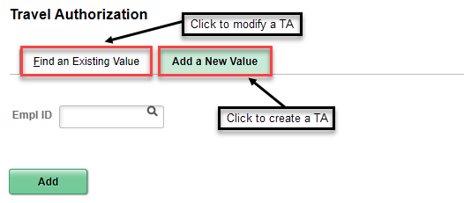
2 | To create a TA, enter the Empl ID, click Add.  To modify a TA, search by any of the listed options, enter the criteria, click Search. | 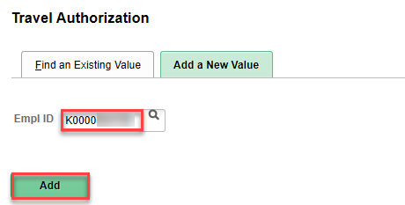  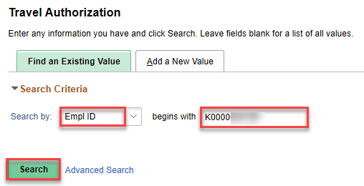  Note: The screenshot above shows a search by Empl ID.
3 | Note: The remaining steps are the same whether creating or modifying a TA.  Enter or edit the highlighted fields. | 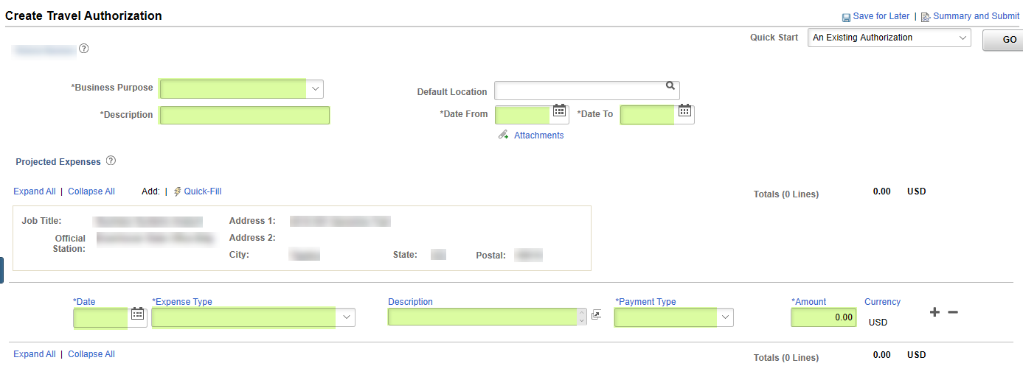  Click the + at the end of a transaction line to insert a transaction line. Click the – at the end of a transaction line to delete the transaction line.  Expense Types and Payment Types  When adding a TA, each transaction line requires selection of an Expense Type and a Payment Type.  The correct Account is populated based on the Expense Type selected. Changing the Account will cause an Expense Type-Payment Type mismatch that will result in a balance in account 140300-prepaid expenses that must be corrected to a $0.00 balance.  For each line on a TA, the Expense Type and Payment Type should match:  - A line with a prepaid Expense Type (which literally starts with the word “prepaid”) should be matched with a prepaid Payment Type (which is a payment type other than cash).  - A line with a regular Expense Type should be matched with a regular Payment Type (cash is the only regular payment type and should be used if the employee should be reimbursed for the expense).  See job aid titled Expense Types and Payment Types & Account 140300 Balances on SMART Web for additional detail.  Populating New TA Values from an Existing TA  To populate the new TA with values from an existing TA, click Quick Start….Populate From, then click An Existing Authorization, then click GO. Click Select for the existing TA to be copied. The copied fields can be edited as needed.  Only TAs for the employee the TA is being created for show in the existing travel authorization results. A TA can be copied multiple times.  Default Chartfield Values  Default ChartField Values can be set in the employee’s EX Employee Profile-Organizational Data tab. The default values auto-populate the Accounting Details-Chartfields in the TA transaction lines but can be edited as needed.
3 | (cont’d) | Originating Location, Location, Start Time, End Time  Originating Location is the employee’s official station and typically does not change. Whether keyed directly into the field or selected from the field lookup, capitalization and spacing must be exact for the field value. For example, KS,[space]TOPEKA.  Originating Location is not used for CONUS calculations.  A default Originating Location can be set in the employee’s EX Employee Profile-User Defaults tab. The default value auto-populates the Originating Location in the TA transaction lines but can be edited as needed.  Location is where the official business occurred. For non-travel expenses like postage, Location is where the expense was incurred. Whether keyed directly into the field or selected from the field lookup, capitalization and spacing must be exact for the field value. For example, KS,[space]WICHITA.  Location is used for CONUS calculations—be sure it is accurate.  A default Expense Location can be set in the employee’s EX Employee Profile-User Defaults tab. The default value auto-populates the Default Location in the TA header and the Location in the TA transaction lines but can be edited as needed.  The Default Location in the TA header is not a required field. If populated, it auto-populates the Location in the TA transaction lines but can be edited as needed.  For Location, if using the lookup for values, first look for the city the employee traveled to. If the city does not show, look for the county. If neither the city or the county shows, use KS [or other state],[space]STANDARD CONUS RATE. Only used the standard rate when both the city and county values do not show in the lookup.  When MEALS AND INCIDENTAL EXPENSES/M&IE is selected for the expense type and the Location is entered, Start Time and End Time fields show.  SMART uses the Date, Location, Start Time, and End Time to calculate and auto-populate the transaction line Amount. The Amount can be edited as needed.
3 | (cont’d) | CONUS – M&IE and Lodging Reimbursement Rates  The State’s reimbursement rates for M&IE and lodging are based on the Federal Government’s Contiguous United States/CONUS per diem rates. The State rates are updated annually on October 1 and April 1 to follow the Federal rates in effect on those dates and are the rates that should be used for expense transactions.  Use the query named KS_EX_CONUS_RATES (navigation: Expenses > Ex Utilities > Query Viewer) to view reimbursement rates and per diem deduction amounts for CONUS locations.  The Location and Date on a transaction line determine the CONUS daily reimbursement rate.  For M&IE, the Start Time and End Time are used to calculate the number of reimbursable quarters. Reimburseable quarters include the quarter of departure and the quarter of return. If there are multiple transaction lines due to multi-city travel on a single date, times should be adjusted such that an employee is not reimbursed more than once for a quarter.  Quarterly periods are:  12:00 AM (midnight) – 5:59 AM 6:00 AM – 11:59 AM  12:00 PM (noon) – 5:59 PM 6:00 PM – 11:59 PM  The number of reimbursable quarters is used to calculate the percentage of the CONUS daily reimbursement rate that is reimburseable. That calculated rate is then reduced by any Per Diem Deductions resulting in the transaction line Amount. The Amount is auto-populated but can be edited as needed.  Click Per Diem Deductions on an M&IE transaction line and select the checkbox for any meals provided at no cost to the employee. The deductions are a percentage not a dollar amount. If there are multiple transaction lines due to multi-city travel on a single date, any deductions must be selected for each transaction line for accurate calculations. Never use the expense type …PER DIEM DEDUCTION as they are used only for background CONUS calculations.  For Lodging, the Number of Nights auto-populates to 1 but can be edited as needed. The Date and Location are used to auto-populate the CONUS Nightly Rate but can be edited as needed. The Amount auto-populates based on the Number of Nights multiplied by the Nightly Rate. If either or both the number or rate are changed, click Save for Later to force the Amount to recalculate.  A callout with an exclamation point icon shows if the Nightly Rate exceeds the CONUS rate and an explanatory comment is required.  See the Travel Reimbursement Handbook (navigation: Expenses > Ex Utilities > Useful Links) for additional detail, including reimbursement rates for non-CONUS locations, same day meal reimbursement, and related informational circulars.
3 | (cont’d)  Click Save for Later  When ready to submit for approval, click the checkbox, then click Submit Travel Authorization.  Click OK.  Click Refresh Approval Status. | Mileage Reimbursement  Use expense type MILEAGE…PER MILE to reimburse at the maximum authorized mileage rate. The Amount auto-populates based on the Miles entered multiplied by the mileage rate. Use expense type MILEAGE…FLAT RATE to reimburse at a reduced rate, the Amount must be manually calculated and entered.  Billing Type  Billing Type defaults to Billable and has no effect unless your agency uses the Projects and Grants module and Customer Contracts. In that case, Billable allows a transaction to process to a billing worksheet, Non Billable excludes the transaction from processing to a billing worksheet.  Saving for later populates the Authorization ID and sets the status to Pending. It also recalculates M&IE and Lodging amounts and checks for errors on the TA. TA header errors are red backfilled . TA transaction line errors are indicated with a red flag icon. If the icon is clicked, a Authorization Line Errors message shows which provides further detail. A TA with errors can be saved but cannot be submitted for approval.  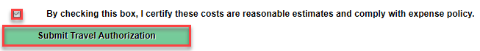  Note: If the screenshot above does not show, click Summary and Submit.  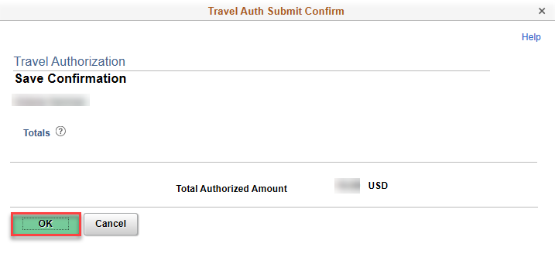  The TA report status changes to Submission in Process and a Your travel authorization 0000###### has been submitted for approval. message shows.  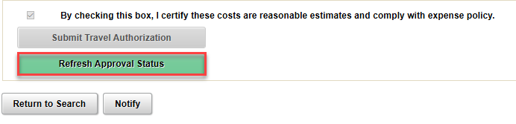  The TA status changes to Submitted for Approval, a Submitted line and icon are added to the Approval History.
View a TA

A TA can be viewed when the TA is in any status.

1 | To view a TA, search by any of the listed options, enter the criteria, click Search. | Navigation: Expenses > Travel Authorizations > View  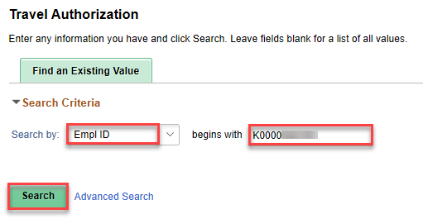  Note: The screenshot above shows a search by Empl ID.

Withdraw a TA

The Withdraw Cash Advance button is active only if the TA is in Submitted for Approval status and the TA has not yet been approved by any approver.

To withdraw a TA for another employee, a user must be an authorized expense user/proxy to that employee. See job aid titled Employee Info & Security – Update Profile, Authorize Expense Users for additional detail.

Withdraw a TA to return it to Pending status so the TA can be modified, deleted, resubmitted
for updated approval workflow, or to add or delete notes and attachments. The TA must
be resubmitted for approval to return the TA to approval workflow.

1 | To withdraw a TA, search by any of the listed options, enter the criteria, click Search. | Navigation: Expenses > Travel Authorizations > View  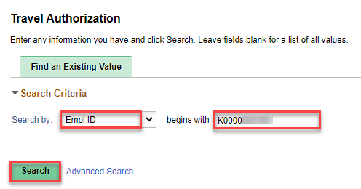  Note: The screenshot above shows a search by Empl ID.
2 | Click Withdraw Travel Authorization.  Click Refresh Approval Status. | 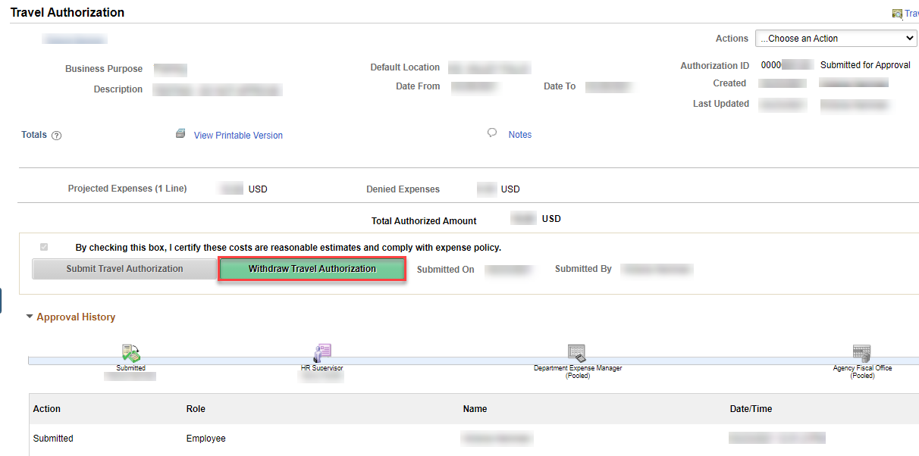  A Your travel authorization 0000###### has been withdrawn from the approvers’ queue. message shows.  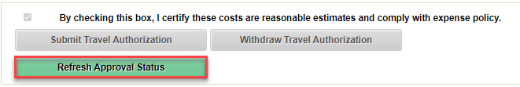  The TA status changes to Pending, a Withdrawn line is added to the Approval History, and the approval icons no longer show.
Delete a TA

A TA can be deleted only when the TA is in Pending status.

The ability to delete a TA in Denied status was removed in 2018 because it was causing
transactions to get stuck in processing.

A deleted TA does not leave an audit trail and cannot be viewed or processed.

1 | To delete a TA, enter the employee ID or the employee name, click Search. | Navigation: Expenses > Cash Advances > Delete  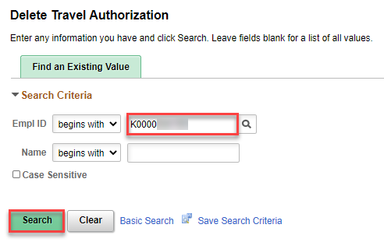
2 | Select the checkbox for the TA to delete, click Delete Selected Authorization(s).  To delete multiple TAs, multiple checkboxes can be selected.  Click OK. | 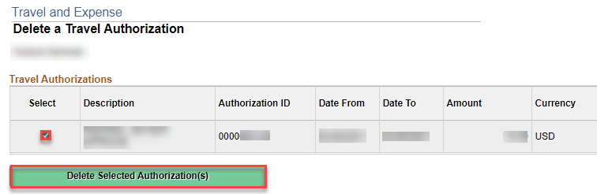

Cancel a TA

A CA can be canceled only when the CA is in Approved status.

To cancel a CA for another employee, a user must be an authorized expense user/proxy to that employee. See job aid titled Employee Info & Security – Update Profile, Authorize Expense Users for additional detail.

A canceled TA can be viewed but cannot be processed.

Cancel a TA to unauthorize an employee for business travel and to liquidate the related encumbrances.

If a large volume of TAs require canceling, rather than cancel each TA individually, create a ManageEngine Service Desk ticket requesting the TAs be mass/batch-canceled.

1 | To cancel a TA, enter the employee ID or the employee name, click Search. | Navigation: Expenses > Travel Authorizations > Cancel  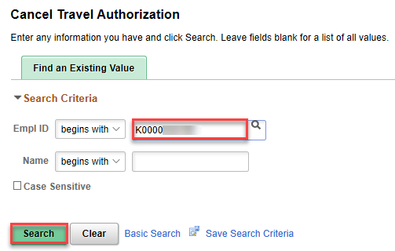
2 | Select the checkbox for the TA to cancel, click Cancel Selected Travel Authorization(s).  To cancel multiple TAs, multiple checkboxes can be selected. | 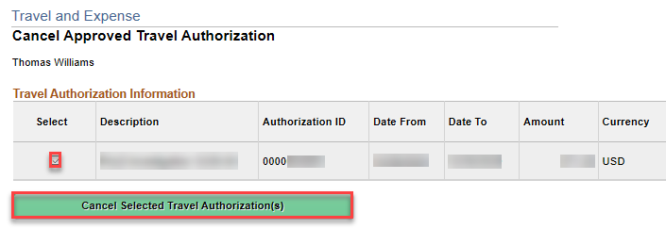  The TA status changes to Closed and the related encumbrances are liquidated.

Modify an Approved TA

An approved TA can be modified only when the TA is in Approved for Payment status.

Modify an approved TA to correct the chartfield values.

A user cannot modify an approved TA that they submitted for approval.

1 | To modify an approved TA, click the Travel Authorizations tab, then click the link to open the TA requiring correction.  Make the necessary corrections, click Save. | Navigation: Expenses > Travel Authorizations > Modify Approved Travel Auth  Note: It may take several seconds for the following screenshot to show.  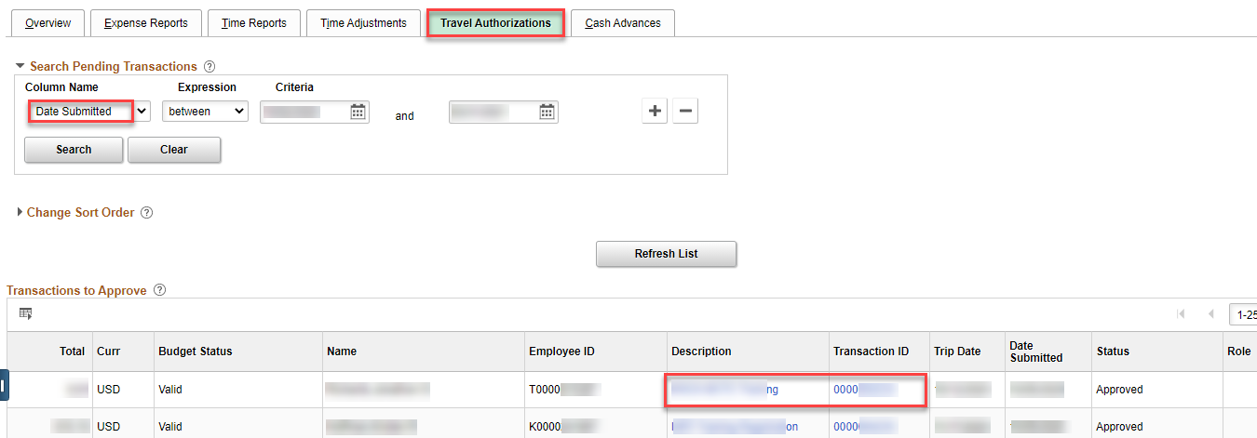  Note: The screenshot above shows a search by Date Submitted.

Populate a TA to an ER

A TA can be populated to an ER only when the ER is in Pending status and the TA is in
Approved status.

1 | To create an ER, click Add a New Value, enter the Empl ID, click Add. | Navigation: Expenses > Expense Reports > Create/Modify  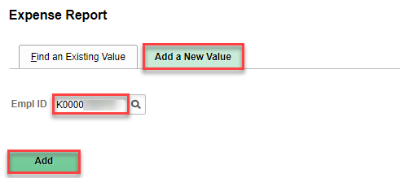
2 | Select A Travel Authorization from the Quick Start…  Populate From menu, click GO. | 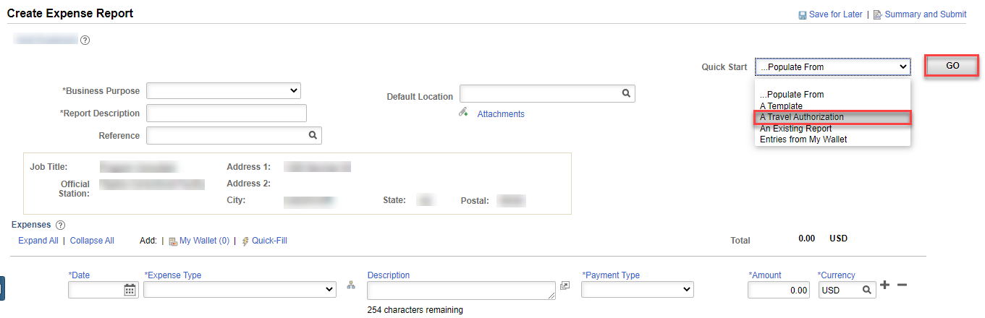
3 | Click Select for the TA to populate toward the ER. | 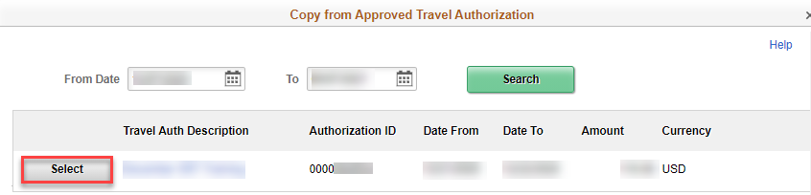

4 | Enter or edit the ER fields as needed. Add or delete transaction lines as needed.  Click Save for Later  When ready to submit for approval, click the checkbox, then click Submit Expense Report. | 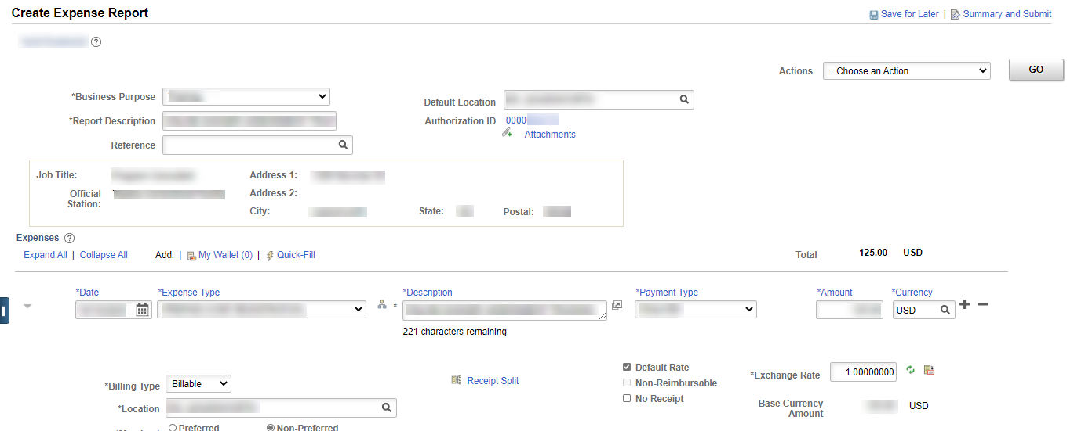  Note: The above is a partial screenshot only, additional fields must be populated.  The TA auto-populates the fields on the ER. The Authorization ID field shows with the TA ID.  Click the + at the end of a transaction line to insert a line. Click the – at the end of a transaction line to delete the line.  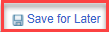  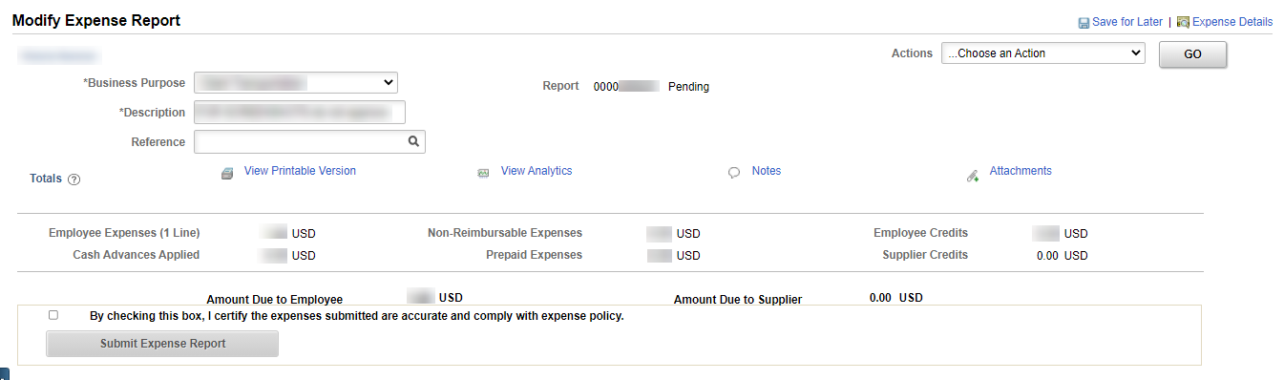  Saving for later populates the Report ID and sets the status to Pending. It also recalculates M&IE and Lodging amounts and checks for errors on the ER. ER header errors are red-backfilled . ER transaction line errors are indicated with a red flag icon. If the icon is clicked, an Expense Report Line Errors message shows which provides further detail. Am ER with errors can be saved but cannot be submitted for approval.  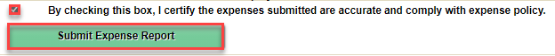  Note: If the screenshot above does not show, click Summary and Submit.
4 | (cont’d)  Click OK.  Click Refresh Approval Status. | 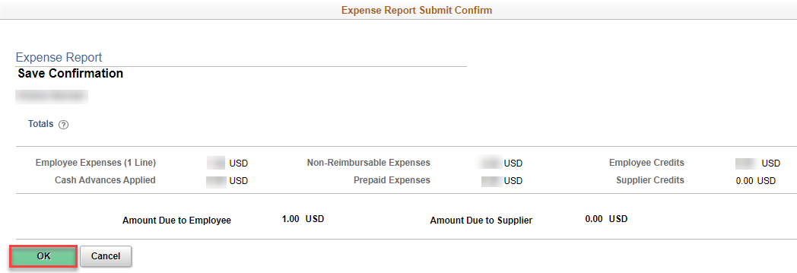  The ER report status changes to Submission in Process and a Your expense report 0000###### has been submitted for approval. message shows.  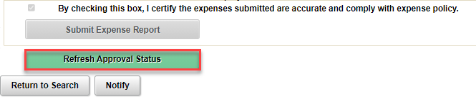  The ER status changes to Submitted for Approval, a Submitted line and icon are added to the Approval History.

