State of Kansas

Attachments – Add, View, Delete

Statewide Management, Accounting and Reporting Tool

Date |  | 02/24/2023 – The last update of this job aid was 12/28/2020.
Purpose |  | This job aid discusses:  - What documents are required to be attached in SMART.  - System requirements for attachments in SMART.  - How to add, view, and delete attachments.
Overview |  | Supporting documents, can be attached to an expense report/ER, a travel authorization/TA, or a cash advance/CA.  SMART Documentation and System Requirements  Per Informational Circular 20-A-020 titled “Attachments in SMART”:  System requirements for attachments:  - The recommended size limit for a file being attached is 1 MB—recommend black & white scans only, as color significantly increases the document size.  - Agencies should not attach CAD (Computer Aided Design) files or picture files (examples: .jpg, .tif, .png, or .gif).  - Excel, Work, PDF, or similar files are appropriate.  - Multiple attachments are allowed (larger files may be broken down into multiple attachments if necessary).  - Avoid attaching documents that do not add value to the transaction.  - System retention for attachment files is expected to be 3 years. This period may be reduced if storage space becomes an issue.  - Agencies should not rely on SMART as the method for meeting record retention policies.  Required documents supporting travel and expense reimbursements (that exceed the agency’s delegated audit authority) to be attached in SMART to the T&E report [the ER]:  - Prior authorization for travel not captured by a SMART Travel Authorization.  - Required receipts which support T&E reimbursements.  - Conference rate verification, i.e., conference materials.  - Information that is not available in SMART.
Add an Attachment

An attachment can be added when the ER, TA, or CA to which it will be attached is in Pending status.

An ER, TA, or CA is in Pending status when it is in the process of or has been created but not yet
submitted for approval or when the ER, TA, or CA has been submitted for approval but has been
withdrawn or sent back for revision.

The process to add an attachment is similar for ERs,TAs, and CAs.

Screenshots below are for an ER, screenshots for TAs and CAs would be similar.

1 | Add an attachment to an ER, TA, or CA being created by clicking Attachments.  Add an attachment to an existing ER, TA, or CA by clicking Attachments. |  | Navigation for ERs: Expenses > Expense Reports > Create/Modify  Navigation for TAs: Expenses > Travel Authorizations > Create/Modify  Navigation for CAs: Expenses > Cash Advances > Create/Modify Cash Advance  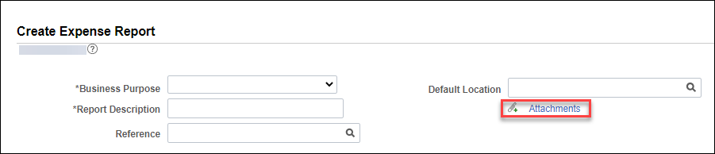  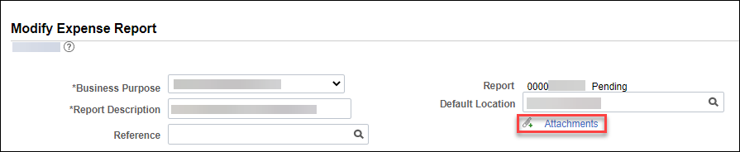  The screenshots above are from the ER details page, the same attachments link shows on the ER summary page, either link can be used, they link to the same page.
2 | Click Add Attachment. |  | 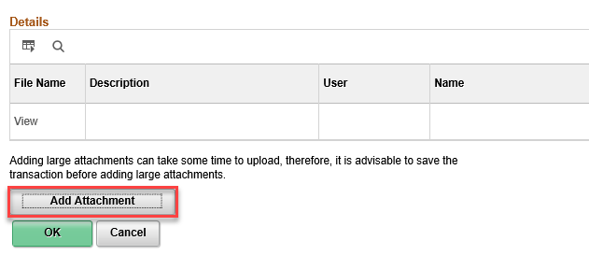
3 | Click Choose File, select the file to be attached, and click Upload. |  | 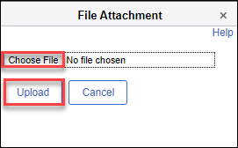
4 | Enter a Description of the attachment, click OK. |  | 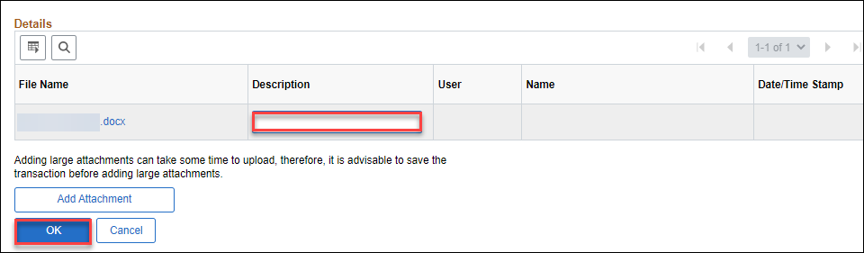
View an Attachment

An attachment can be viewed when the ER, TA, or CA to which it is attached is in any status.

The process to view an attachment is similar for ERs, TAs, and CAs.

Screenshots below are for an ER, screenshots for TAs and CAs would be similar though the Search by options are in a dropdown list format.

1 | View an attachment by entering Search Criteria, click Search. |  | Navigation for ERs: Expenses > Expense Reports > View  Navigation for TAs: Expenses > Travel Authorizations > View  Navigation for CAs: Expenses > Cash Advances > View  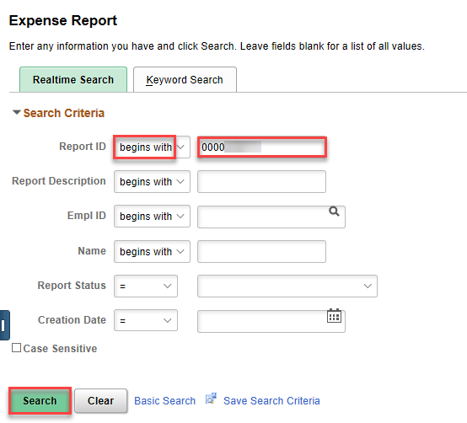  The screenshot above shows search criteria using the Report ID.
2 | Click Attachments (#).  The number following Attachments indicates the number of attachments. |  | 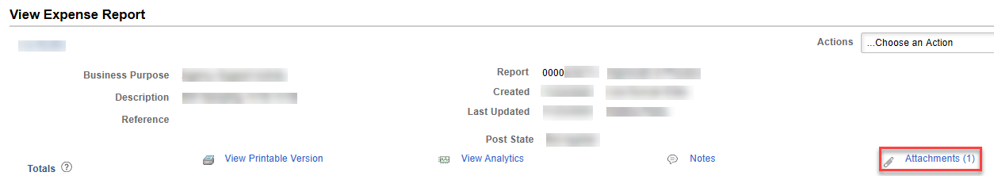  The screenshots above are from the ER details page, the same Attachments link shows on the ER summary page, either link can be used.
3 | Click the File Name link to view the attachment. |  | 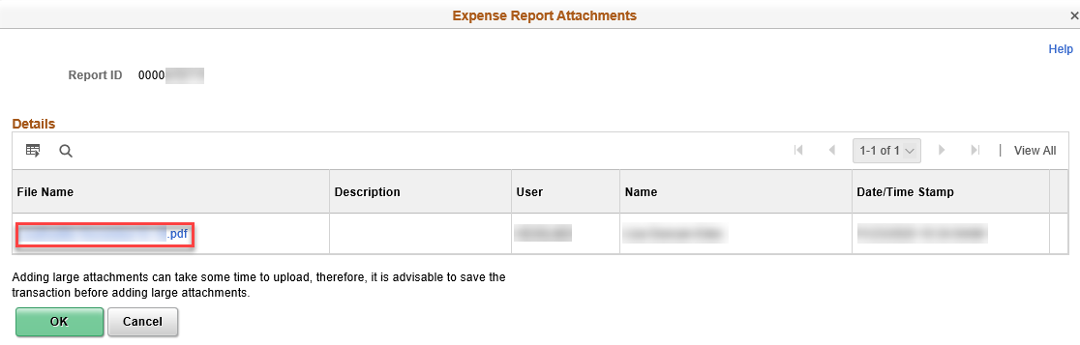
Delete an Attachment

An attachment can be deleted when the ER, TA, or CA to which it is attached is in Pending status.

An ER, TA, or CA is in Pending status when it is in the process of or has been created but not yet
submitted for approval or when the ER, TA, or CA has been submitted for approval but has been
withdrawn or sent back for revision.

The process to delete an attachment is similar for ERs, TAs, and CAs.

Screenshots below are for an ER, screenshots for TAs and CAs would be similar.

1 | Delete an attachment by clicking Attachments (#)  The number following Attachments indicates the number of attachments. |  | Navigation for ERs: Expenses > Expense Reports > Create/Modify  Navigation for TAs: Expenses > Travel Authorizations > Create/Modify  Navigation for CAs: Expenses > Cash Advances > Create/Modify Cash Advance  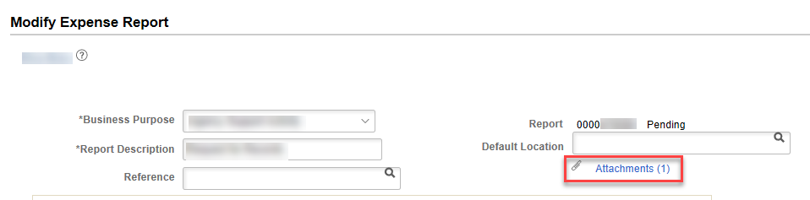  The screenshots above are from the ER details page, the same attachments link shows on the ER summary page, either link can be used, they link to the same page.
2 | Click – (minus sign). |  | 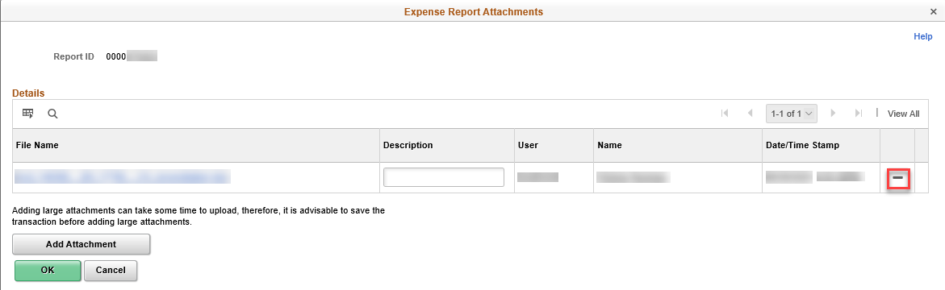
3 | Click OK. |  | 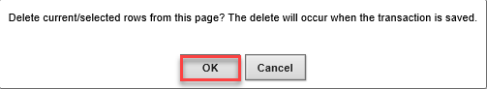
4 | Click OK. |  | 