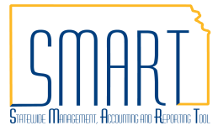
State of Kansas
Budget Date Change Request
Statewide Management, Accounting and Reporting Tool
Date Created: | 4-16-2018
Date Revised: | 6-12-2018
Version: | V.1.1
Purpose: | Agencies must complete the required information on the Budget Date Change Request Form (GL-F026) and attach to a ManageEngine Service Desk ticket using the associated ManageEngine Service Desk ticket template.  ManageEngine Service Desk ticket templates Budget Date Change Document Types  Budget Date Change - Req Requisition - GL Encumbrance  Budget Date Change - T&E Travel and Expense - GL Encumbrance  Budget Date Change - PO Requisition - PO  Budget Date Change - PO Future Requisition - PO Future  Budget Date Change - Other Other  ManageEngine Service Desk ticket templates are found in the dropdown when selecting New Request.  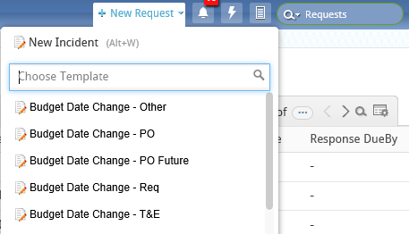  The Budget Date Change Request Form (GL-F026) can be found in the Document Center on the Department of Administration website at the following link: Budget Date Change Request Form (GL-F026)  As noted on the Budget Date Change Request Form, by submitting this request, the agency approver is certifying the budget date change constitutes an appropriate use of funds, following all federal and state laws, regulations and policies.  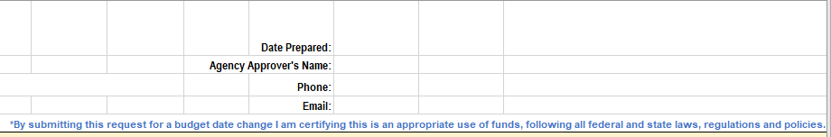  Budget Date Change Document Types – refer to the appropriate section below for specific instruction regarding each budget date change document type.  - Requisition – GL Encumbrance – This budget date change is being requested because all or a portion of a GL Encumbrance has been released to allow a prior fiscal year requisition to be created and processed.  - Travel and Expense – GL Encumbrance – This budget date change is being requested because an expense report has been created in the current fiscal year for expenses occurring in the prior fiscal year and no travel authorization was available. A GL Encumbrance is being utilized.  - Requisition – PO – This budget date change is being requested because a prior fiscal year PO can no longer be used to fulfill the obligation without match exceptions (ie. supplier has changed). In this case, the PO must be closed and a new requisition issued to continue processing.  - Requisition – PO Future – This budget date change is being requested because a new fiscal year requisition has been created pending opening of the new fiscal year. New fiscal year requisitions shall be created on or after June 1.  - Other – This budget date change is being requested because of the reason as explained and does not fall into any of the other defined categories.  Required fields for each Budget Date Change Document Type are identified in the gray lines (lines 13-17) of Form GL-F026. Entries shall be made on Form GL-F026 beginning with line 18. Multiple lines may be included on the same Form GL-F026 when the Budget Date Change Document Type is the same for all lines.  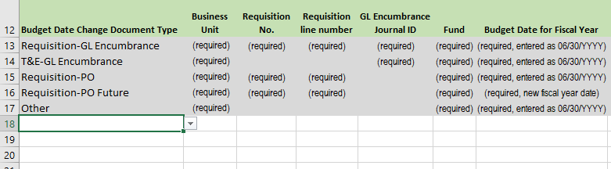

Request a Budget Date Change: Requisition – GL Encumbrance
1. | Complete the Budget Date Change Request Form (GL-F026) – select the Budget Date Change Document Type from the dropdown list.  Required information to be entered on the form for Requisition – GL Encumbrance:  - Date Prepared  - Agency Approver’s Name  - Agency Approver’s Phone number  - Agency Approver’s Email  - Business Unit  - Requisition Number  - Requisition Line Number(s) – all lines must contain the same Budget Date  - GL Encumbrance Journal ID  - Fund(s)  - Budget Date for Fiscal Year (entered as 06/30/20YY)  - Begin Date/End Date – enter dates of service or purchase date  - Description of the obligation and how it is associated with the GL Encumbrance
2. | Attach the completed Budget Date Change Request Form (GL-F026) to a ManageEngine Service Desk ticket.  In ManageEngine, click on “+ New Request” and choose the Budget Date Change – Req template. By using this template, the budget date change request will be assigned to the correct Technician. Fill in the Requester Details, attach the form and click on “Add Request”.
3. | A review of the Budget Date Change Request will be performed, within 10 business days, to determine whether the purpose of the encumbrance matches the purpose for the requisition resulting in one of the following:  - Budget Date will be changed as requested.  - Additional information will be requested, see required information in 1. above.  - The Budget Date Change Request will be denied. The denial will be communicated through the ManageEngine Service Desk ticket.
4. | After the budget date has been changed on the Requisition, the ManageEngine Service Desk ticket will be closed. The ‘Save and submit’ button on the requisition should then be clicked to submit the requisition into the workflow process for approval. Once approved, the requisition will be sourced to a Purchase Order with the correct budget date.

Request a Budget Date Change: Travel and Expense – GL Encumbrance
1. | Complete the Budget Date Change Request Form (GL-F026) – select the Budget Date Change Document Type from the dropdown list.  Required information to be entered on the form for T&E – GL Encumbrance:  - Date Prepared  - Agency Approver’s Name  - Agency Approver’s Phone number  - Agency Approver’s Email  - Business Unit  - GL Encumbrance Journal ID  - Fund  - Budget Date for Fiscal Year (entered as 06/30/20YY)  - GL Journal ID  - GL Journal ID Line Number(s)  - Expense Report ID  - Begin Date/End Date – enter dates of travel  - Description of the travel and expense obligation and how it is associated with the GL Encumbrance
2. | Attach the completed Budget Date Change Request Form (GL-F026) to a ManageEngine Service Desk ticket.  In ManageEngine, click on “+ New Request” and choose the Budget Date Change – T&E template. By using this template, the budget date change request will be assigned to the correct Technician. Fill in the Requester Details, attach the form and click on “Add Request”.
3. | A review of the Budget Date Change Request will be performed, within 10 business days, to determine whether the purpose of the encumbrance matches the purpose for the expense report resulting in one of the following:  - Budget Date will be changed as requested.  - Additional information will be requested, see required information in 1. above.  - The Budget Date Change Request will be denied. The denial will be communicated through the ManageEngine Service Desk ticket.
4. | After the budget date has been changed on the GL Journal entry, the ManageEngine Service Desk ticket will be closed. Remove the hold from the GL Journal entry by un-checking the ‘Save Journal Incomplete Status’ box on the journal header page and click ‘Save’. The GL Journal entry will be recorded in Commitment Control and posted in GL once hourly and nightly batch processes edit and budget check the GL Journal entry.

Request a Budget Date Change: Requisition – PO
1. | Complete the Budget Date Change Request Form (GL-F026) – select the Budget Date Change Document Type from the dropdown list.  Required information to be entered on the form for Requisition – PO:  - Date Prepared  - Agency Approver’s Name  - Agency Approver’s Phone number  - Agency Approver’s Email  - Business Unit  - Requisition Number  - Requisition Line Number(s) – all lines must contain the same Budget Date  - Fund  - Budget Date for Fiscal Year (entered as 06/30/20YY)  - Original PO ID  - Begin Date/End Date – enter dates of service or purchase date  - Detailed description that includes a thorough explanation of why the expenditure should be processed using the funds encumbered on the original PO
2. | Attach the completed Budget Date Change Request Form (GL-F026) to a ManageEngine Service Desk ticket.  In ManageEngine, click on “+ New Request” and choose the Budget Date Change – PO template. By using this template, the budget date change request will be assigned to the correct Technician. Fill in the Requester Details, attach the form and click on “Add Request”.
3. | A review of the Budget Date Change Request will be performed, within 10 business days, to determine whether the purpose of the existing purchase order (PO) matches the purpose for the new requisition resulting in one of the following:  - Budget Date will be changed as requested.  - Additional information will be requested, see required information in 1. above.  - The Budget Date Change Request will be denied. The denial will be communicated through the ManageEngine Service Desk ticket.
4. | After the budget date has been changed on the Requisition, the ManageEngine Service Desk ticket will be closed. The ‘Save and submit’ button on the requisition should then be clicked to submit the requisition into the workflow process for approval. Once approved, the requisition will be sourced to a Purchase Order with the correct budget date.

Request a Budget Date Change: Requisition – PO Future
1. | Complete the Budget Date Change Request Form (GL-F026) – select the Budget Date Change Document Type from the dropdown list.  Required information to be entered on the form for Requisition – PO Future:  - Date Prepared  - Agency Approver’s Name  - Agency Approver’s Phone number  - Agency Approver’s Email  - Business Unit  - Requisition Number  - Requisition Line Number(s) – all lines must contain the same Budget Date  - Fund  - Budget Date for Fiscal Year (new fiscal year date)  - Begin Date/End Date – enter dates of service or purchase date  - Detailed description that includes a thorough explanation of why the requisition should be created prior to July 1
2. | Attach the completed Budget Date Change Request Form (GL-F026) to a ManageEngine Service Desk ticket.  In ManageEngine, click on “+ New Request” and choose the Budget Date Change – PO Future template. By using this template, the budget date change request will be assigned to the correct Technician. Fill in the Requester Details, attach the form and click on “Add Request”.
3. | A review of the Budget Date Change Request will be performed resulting in one of the following:  - Budget Date will be changed as requested.  - Additional information will be requested, see required information in 1. above.
4. | After the budget date has been changed on the Requisition, the ManageEngine Service Desk ticket will be closed. The ‘Save and submit’ button on the requisition should then be clicked to submit the requisition into the workflow process for approval. Once approved, the requisition will be sourced to a Purchase Order with the correct budget date.

Request a Budget Date Change: Other
1. | Complete the Budget Date Change Request Form (GL-F026) – select the Budget Date Change Document Type from the dropdown list.  Required information to be entered on the form for Other:  - Date Prepared  - Agency Approver’s Name  - Agency Approver’s Phone number  - Agency Approver’s Email  - Business Unit  - Fund  - Budget Date for Fiscal Year (entered as 06/30/20YY)  - Begin Date/End Date – enter dates of service or purchase date  - Detailed description that includes a thorough explanation of the reason the budget date change is requested
2. | Attach the completed Budget Date Change Request Form (GL-F026) to a ManageEngine Service Desk ticket.  In ManageEngine, click on “+ New Request” and choose the Budget Date Change – Other template. By using this template, the budget date change request will be assigned to the correct Technician. Fill in the Requester Details, attach the form and click on “Add Request”.

3. | A review of the Budget Date Change Request will be performed, within 10 business days, to determine whether purpose of the budget date change request is clear resulting in one of the following:  - Budget Date will be changed as requested.  - Additional information will be requested, see required information in 1. above.  - The Budget Date Change Request will be denied. The denial will be communicated through the ManageEngine Service Desk ticket.
4. | After the budget date has been changed, the ManageEngine Service Desk ticket will be closed.

