State of Kansas
Expenses – Add a Journal Expense Report

Statewide Management, Accounting and Reporting Tool

Date Created: | 06/03/2014
Last Updated Date: | 07/24/2020
Version: | 2.0
Overview: | A journal expense report/J-ER should be added in the Expenses/EX module to correct chartfields on an expense report/ER in Paid status.  A J-ER cannot be used to correct the amount paid on an ER. However, the total amount can be redistributed between distribution lines. The total of all distribution lines must equal $0.00.  A J-ER creates EXACCRUAL accounting entries only. The accounting entries are recorded in the EX module when the J-ER is submitted for posting. The accounting entries will post to the General Ledger module/GL during nightly batch.  Once a J-ER is submitted for posting, the status is Paid even though no payment is actually created. No approvals are required for the J-ER to post.  Add a J-ER only to correct an original ER.  Do not add a J-ER to correct an incorrect J-ER.  To correct an incorrect J-ER:  - If the J-ER did not affect any accounting (e.g. the J-ER accounting entries show each line with the same debit and credit chartfields):  Note: This often happens because the J-ER was submitted for posting before any corrections were made on the J-ER.  Add a journal in GL. The journal should make the correction that should have been made on the J-ER. Add cash lines to the journal only if correcting the fund and/or budget unit.  - If the J-ER did affect accounting (e.g. the J-ER accounting entries show at least one line with different debit and credit chartfields):  Mark the J-ER for close to reverse the incorrect J-ER EXACCRUAL accounting entries; EXCLOSE accounting entries will post to GL during nightly batch. If you need assistance closing the incorrect J-ER, submit a ManageEngine/Service Desk ticket.  Add a journal in GL. The journal should make the correction that should have been made on the J-ER. Only add cash lines to the journal if the fund and/or budget unit are corrected.  See General Ledger job aids titled Online Journal Entries Training Guide and General Ledger & Journals Overview Training Guide on SMART Web for additional detail.
Overview:  (cont’d) | This job aid replaces the following job aids which have been removed from SMART Web:  - Creating a Journal Expense Report  - Creating Journal Expense Reports – Training Guide
Security: | Role: Only individuals with the following role can add a J-ER:  - Agency T&E Maintainer (KAP_Agy_T_E_Maintainer)  BU: Agencies can only add J-ERs for employees of their agency business unit.  If the employee transfers to another State agency, the prior agency is unable to add a J-ER for the employee. If the employee does not transfer to another State agency, the agency is able to add a J-ER for the employee.
Navigation: | There are two navigation paths, either path can be used:  - Expenses > EX Accounting > Create Journal Expense Report  - Expenses > Expense Reports > Create Journal Expense Report

1 | To add a J-ER, enter the employee ID associated to the ER requiring correction, click Add. | Add a J-ER only to correct an original ER—do not add a J-ER to correct an incorrect J-ER. See the text box in the Overview section above for additional detail to correct an incorrect J-ER.  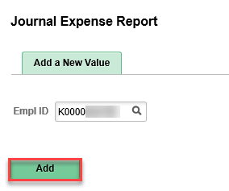
2 | Click the look-up icon and select the ER requiring correction. | 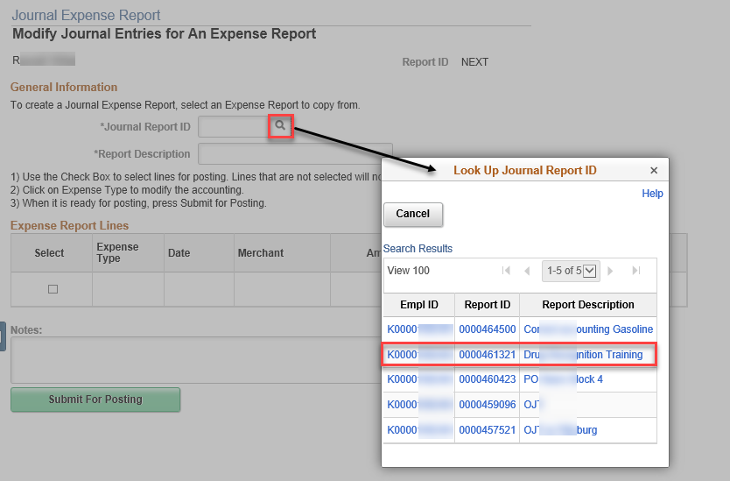  Only ERs in Paid status show in the search results.  J-ERs in Paid status will also show in the search results but you should not add a J-ER to correct an incorrect J-ER.  ERs that have already had a J-ER added will not show in the search results.
3 | Enter a description. The description should include the Journal Report ID (this is the same ER just selected) and wording such as Changing… or Correcting…. | 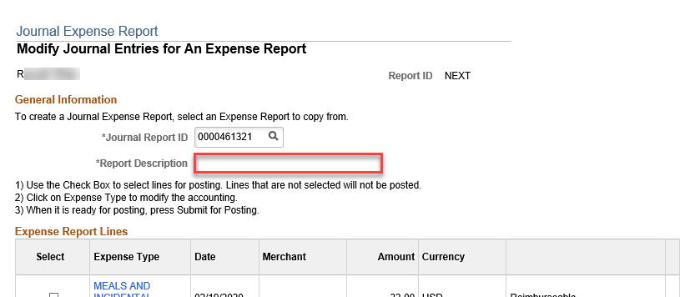
4 | Select the check box for the ER line requiring correction. Click the Expense Type link for the line selected.  For multiple ER lines requiring correction, multiple check boxes may be selected. | 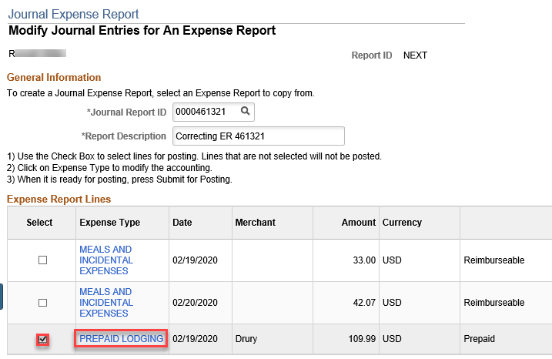
5 | On the editable line, which shows as a debit/positive amount, correct the chartfield values as needed and click OK.  For multiple ER lines requiring correction, click the next Expense Type link requiring correction and repeat step 5. | A reversing entry which shows as a credit/negative amount is automatically created for the expense line selected from the ER being corrected. This line cannot be corrected—it is non-editable.  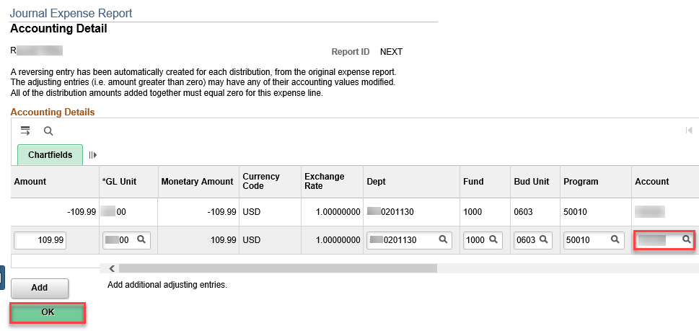  Additional funding lines may be added. However, cash lines should not be added to a J-ER. Adding cash lines to a J-ER may create incorrect accounting entries in GL. All J-ERs are reviewed by the Office of Accounts and Reports/OAR to ensure the accounting entries are correct in GL.
6 | Enter any notes (optional) and click Submit For Posting. | Once a J-ER is submitted for posting, no additional corrections can be made.  Click “Submit For Posting” only once, otherwise multiple J-ERs may be added. Sometimes it may take a few minutes for the J-ER to process. To determine if a J-ER has processed, see step 7.  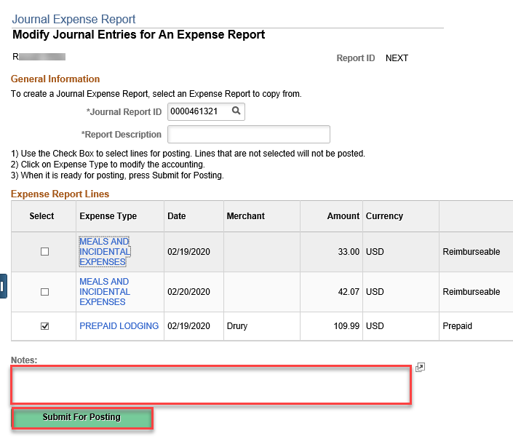  Submitting the J-ER for posting will generate a Report ID for the J-ER. The Report ID will be like that of a regular ER.
7 | Confirm the J-ER processed and is correct. | Navigate to Expenses > Expense Reports > View.  Search for the J-ER as you would a regular ER. The J-ER can be searched for using any of the search criteria options, including the J-ER Report ID:  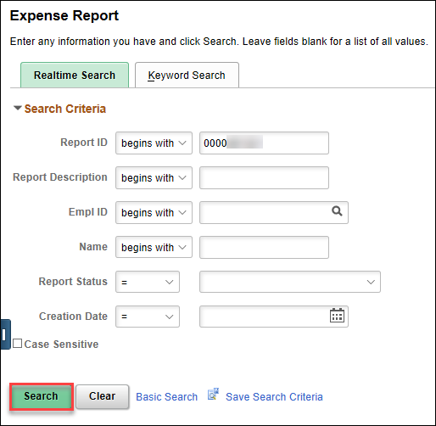  When viewing a J-ER, it appears similar to a regular ER, but a J-ER is in Paid status and does not show any Approval History.  If the J-ER is incorrect, add a journal in GL to make the correction that should have been made on the J-ER. Only add cash lines to the journal if the fund and/or budget unit are corrected.  See General Ledger job aids titled Online Journal Entries Training Guide and General Ledger & Journals Overview Training Guide on SMART Web for additional detail.

