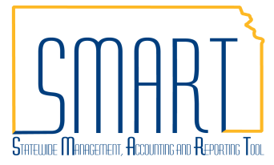
State of Kansas
Working Errors on the Sourcing Workbench
Statewide Management, Accounting and Reporting Tool

Date Created: | 12/17/2012
Version: | 2.0
Last Updated Date: | 11/5/2020
Purpose: | The Sourcing Workbench in SMART provides the results of the PO Auto Sourcing process, which creates Purchase Orders (POs) from approved and Budget Checked Requisitions.  Any requisitions rejected during the sourcing process will also display with a detailed error message on what needs to be corrected.  During the day, the Sourcing Workbench will display information concerning each line, including information about any lines that are in error. During nightly batch, the completed lines are purged with only the lines in error remaining.
SMART Security Role | Kansas Buyer
Fluid Navigation: Requisitions & PCards > Manage Requisitions > Manage Requisitions > Sourcing Workbench or POs & Receiving > Purchase Orders > Manage Purchase Orders > Sourcing Workbench
Classic Navigation: NavBar > Navigator > Purchasing > Purchase Orders > Stage/Source Requests > Sourcing Workbench
Supplier Errors
When preparing a Requisition, a Supplier should be identified on each line. If a line does not have a Supplier identified, that line will error out on the Sourcing Workbench when the Requisition tries source to a PO.
When that happens the Buyer will can assign a Supplier on the Sourcing Workbench so that the PO may be created.
NOTE: The only exception for not having a Supplier is if the line must be bid by the Office of Procurement and Contracts.
From the Sourcing Workbench page, enter search criteria, select the Search button, and select the Sourcing Details icon. | 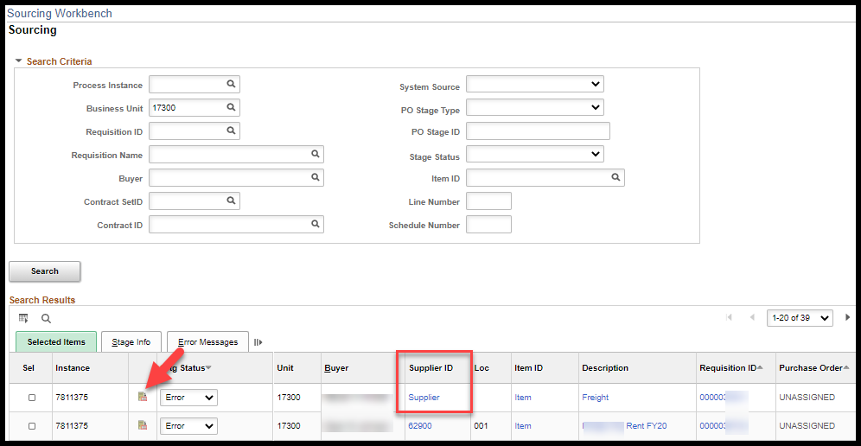
On the Sourcing Details page the Message section provide information on the error that occurred.  In this case, no supplier was found. | 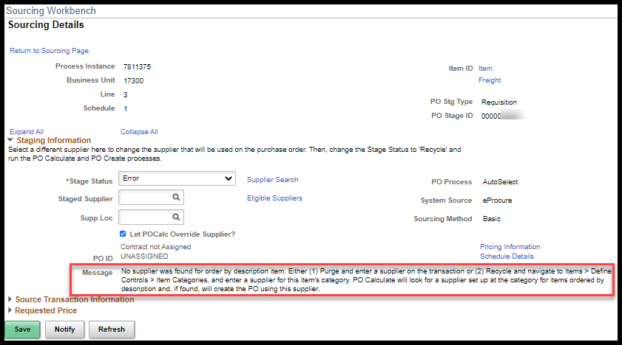
Change the Stage Status from Error Recycle and select a Staged Supplier ID.  Uncheck the Let POCalc Override Supplier? check box and select Save. | 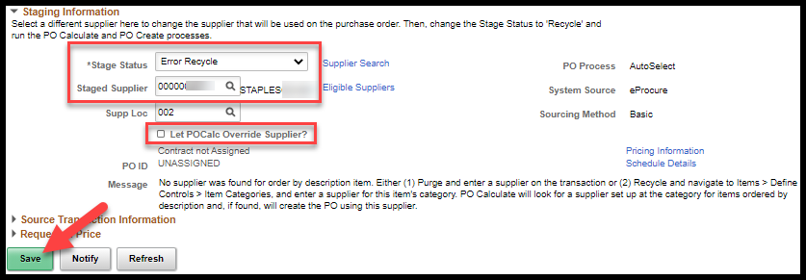
Requisition lines that have a Stg Status of Error Recycle will be picked up during the next batch process and sourced to a new PO. | 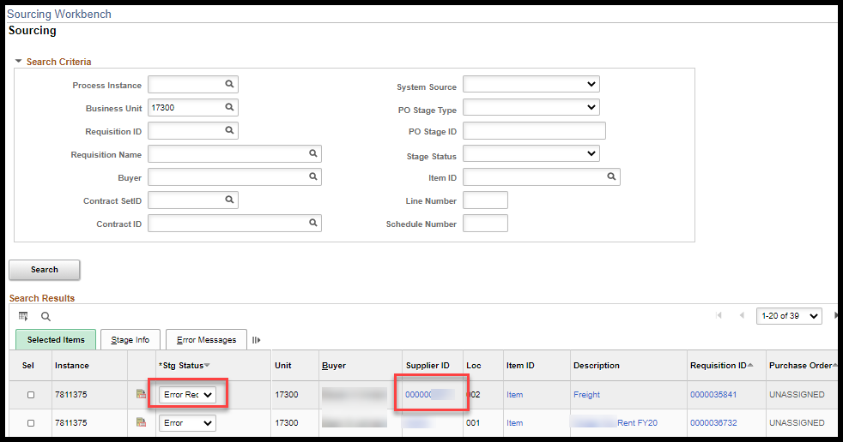
NOTE: If there were other Requisition lines on the same Requisition that had already sourced to a PO, the Requisition lines that are recycled will not be added to the original PO.
Contract Errors
NOTE: An agency will need to contact the Office of Procurement and Contracts to make updates or corrections to any EXISTING contract in SMART. Including, those that are agency specific.
The Buyer will need to identify which contract is involved on the Sourcing Details page above the PO ID. | 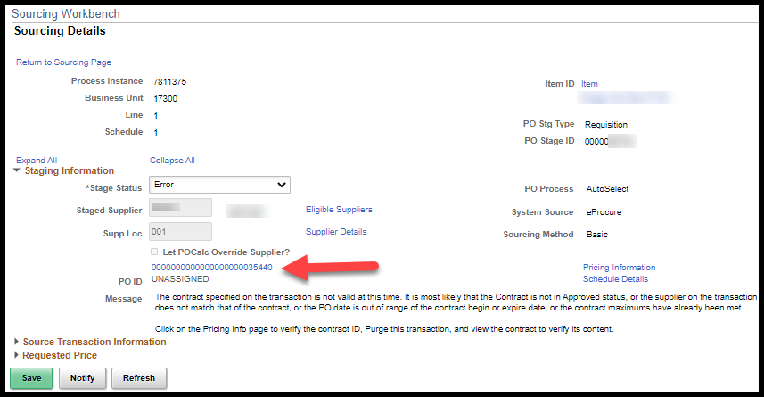
Once the contract involved has been identified, change the Stage Status to Reset Req and Purge and select Save. | 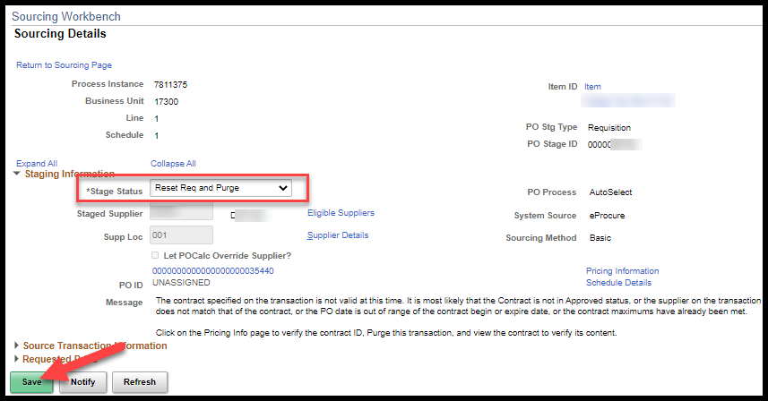
NOTE: The contract involved cannot be accessed until the requisition associated to it that is in error on the Sourcing Workbench has been purged. Until that happens the PO is lockdown.
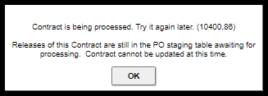

SMART Security Role | Agency Contract Processor
Fluid Navigation: Contracts & Strategic Sourcing > Supplier Contracts > Supplier Contracts > Contract Entry > Find an Existing Value
Classic Navigation: NavBar > Navigator > Supplier Contracts > Create Contracts and Documents > Contract Entry > Find an Existing Value
The Contract Entry page can allow the Buyer to see the specifics of the contract that require updating. In this case the Expire Date has passed. | 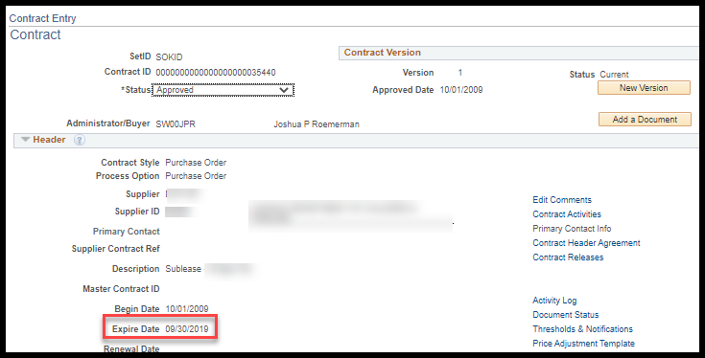
Reasons way a Requisition could end up on the Sourcing Workbench with a contract error include:
- Contract maximums have already been met
- Contract is NOT in Approved status
- PO Date (date Requisition sourced to PO) is out of range of the contract begin or expire date
- Requisition Date (date requisition entered in SMART) is out of range of the contract begin or expire date
- Supplier on the Requisition does not match the supplier on the contract

Contract maximums have already been met |  | There are times when it is appropriate to increase the maximum amount on the Contract. To increase the contract maximum amount, email a Procurement Officer within Procurement and Contracts. Include in the email a justification for increasing the maximum amount and the new maximum amount to be entered.
Contract is NOT in Approved status |  | Check with the contract administrator for a status update.
PO Date (date Requisition sourced to PO) is out of range of the contract begin or expire date |  | Check the Procurement and Contracts web site, Contract Search, to verify that the correct contract ID has been entered. If not, update the purchase requisition with the correct contract ID. If the correct contract ID has been used, validate that the date the Requisition was entered is within the Begin Date and Expire Date as noted on the contract in SMART.
Supplier on the Requisition does not match the supplier on the contract |  | Determine which supplier is correct. If supplier on the Requisition is correct, either locate the correct contract ID for the supplier or remove the contract ID from the Requisition line. If the supplier on the Requisition is correct and the supplier on the applicable contract is incorrect, contact the contract administrator or the Procurement Officer within Procurement and Contracts to rectify the incorrect supplier on the contract. If supplier on the contract is correct, update the purchase requisition with the correct supplier id.
NOTE: The PO Auto Sourcing process runs every hour daily from 9 AM to 4 PM and once during the nightly batch cycle. If a contract issue has not been resolved prior to the next PO Auto Sourcing process running, the “Stage Status” will need to be re-set to “Reset/Purg” so that the Purchase Requisition and/or the contract can be accessed.

