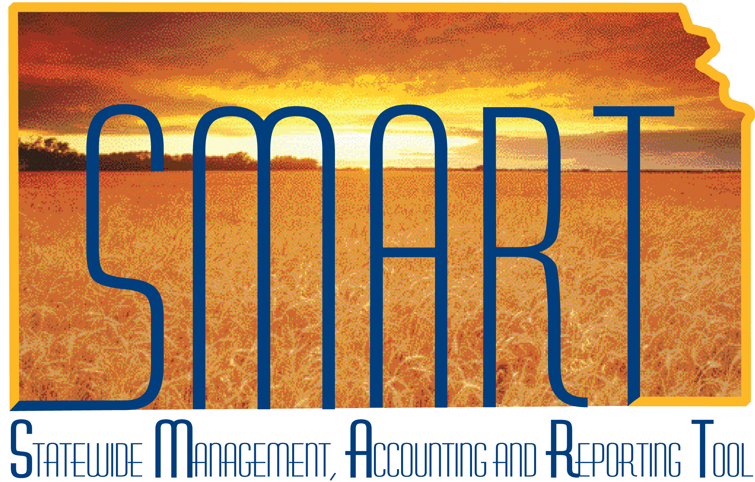
Training Guide – Purchasing
Purchase Orders: Reviewing & Approving
State of Kansas

Applicable Role(s):
KPO_KS_Buyer

Table of Contents
Table of Contents 2
Keys Terms 4
Key Concepts 4
Structure 4
Pre-Encumbrance Versus Encumbrance 5
PO Auto Sourcing 5
Sourcing Workbench 5
Key Agency Roles and Tasks 5
Generating Purchase Orders 6
PO Auto Sourcing 6
Sourcing Workbench 6
Reviewing a Purchase Order 7
Identifying PO’s Ready for Review 8
PO Information to Review 9
Supplier Details 9
Use Procurement Card (PCard) 11
Dispatch Method 12
Email 13
Supplier Email Address 13
Ad Hoc Email Address 17
Re-Dispatching PO’s 19
Dispatch History 21
Email Attachments 22
Lines 23
Lines – Details Tab 23
PO Qty 23
Category 24
Amount – Prior Authorizations 24
Lines – Attributes Tab 25
Amount Only 25
Example: 25
Example: 25
Lines – Contract Tab 26
Lines – Receiving Tab 27
Schedules 28
Schedules – Details Tab 28
Due Date 29
Ship To 30
Distributions 33
Distributions – Distribute By 33
Distributions - SpeedChart 35
Distributions Lines 36
Distributions – Chartfields Tab 36
Distributions – Asset Information Tab 38
Distributions – Req Detail Tab 39
Distributions – Budget Information Tab 40
Comments 41
Header Comments 41
Example 1: 41
Line Comments 42
Example 2: 42
Ship To Comments 43
Example 3: 43
Send to Supplier 45
Show at Receipt 46
Show at Voucher 46
Attachments 47
Managing Purchase Orders 49
Approving Purchase Orders 49
Budget Checking 49
Review Budget Error Information 50
Dispatching 52
Change Orders 53
Appendix A: Key Navigations 54
Appendix B: PO Review Checklist 58

Keys Terms
Purchase order (PO) | Legally binding contract document between your agency and a Supplier to purchase goods or services from that supplier on a specific date. The purchase information, such as item, quantity, freight terms, shipping terms, payments terms, and shipping instructions, are listed on the document and are part of the contractual nature of the purchase order.
Encumbrance | Amount of legal obligation to spend in the future, e.g., issuing a purchase order (PO) to a supplier. In SMART, the encumbrance is formed (ie: budget monies are put on hold) the moment the PO is successfully budget checked for all agencies not pre-encumbering.
Batch Process | This is a scheduled process that is performed automatically within SMART. The “Batch” process will pick up requisitions and/or purchase orders (POs) once they meet a pre-defined set of criteria. For example: Once a PO has been “Approved” by the Buyer, SMART’s hourly batch process will select the “Approved” PO to be Budget Checked. The Budget Checking batch process will check the agency’s budget to verify there is enough available budget to cover the requested purchase.

Key Concepts

Structure
The component parts of the purchase order (PO) are the header, lines, schedules, and distributions:
- Each PO has a single header containing general information about it
- Each header may have one or more related lines, which represent the goods and/or services being purchased
- Each line can have one or more schedules, which determine when and where you want the goods and/or services delivered or performed
- Each schedule (or shipment) can be distributed to one or more departments, accounts, funds, etc. (ChartField distributions)

Pre-Encumbrance Versus Encumbrance
Upon SMART implementation each agency chose whether their budget was pre-encumbering or encumbering.

For pre-encumbering agencies, the budgetary encumbrance is established when the requisition budget checks. The pre-encumbrance is released on the requisition and established as an encumbrance on the purchase order (PO) when a requisition is sourced to a PO. There are a limited number of agencies using pre-encumbrances in SMART.

For encumbering agencies, the budgetary encumbrance is established when the PO budget checks. The requisition for encumbering agencies must still have a ‘Valid’ budget status to source to a PO, however, an agency’s budget is not actually checked and no pre-encumbrance is created.

The PO encumbrance is released to related vouchers after they budget check.

PO Auto Sourcing
The PO Auto Sourcing process is a collection of application engine processes in SMART that move data from the Requisition to PO Staging tables and finally generates a purchase order (PO). Typically, POs for the State of Kansas are generated through the PO Auto Sourcing process.

Sourcing Workbench
The Sourcing Workbench lets you review the contents of the staging tables before and after each step in the sourcing process.

Key Agency Roles and Tasks

Role | Description
Kansas Buyer | Reviews, Edits/Updates, Approves, and Cancels purchase orders (POs).
Agency Contract Processor | Adds contract entries into SMART so that contracts can be associated to POs.
Agency Buying Administrator | Maintains agency POs and manually closes POs which will release any remaining encumbrances.
Kansas RFx Processor (KDOT) | Initiates sourcing events (bid events), performs RFx maintenance and awards events to either a contract or a PO.
Kansas Super Buyer (KDOT) | Creates POs, including POs from sourcing events.

Generating Purchase Orders
The State of Kansas uses the PO Auto Sourcing process to generate purchase orders (POs). This document does not provide instruction on how to directly create POs since it is the State of Kansas’ approach to use the PO Auto Sourcing process for this purpose.

PO Auto Sourcing
The PO Auto Sourcing process is a batch process that runs hourly from 9 – 3 PM Monday through Friday and once each evening Monday through Friday (excludes State Holidays). SMART looks to find any requisitions that are “Approved” (by ALL Approvers in the requisition approval workflow) and that have a “Valid” budget status. SMART will take the requisition information and place it into temporary tables; this information is then used to create purchase orders (POs).
The PO Auto sourcing process includes four (4) steps:
- Build Staging Rows – Creates temporary rows in SMART used to store PO information and calculations used to create the PO
- Select Requisitions – Selects approved requisitions to move into staging tables
- Run PO Calculations – Performs all the calculations necessary to create the PO and stores the results in the staging tables. Calculations include supplier, due date, price, and requisition consolidation.
- Create PO – Builds the PO using rows on the staging table that have been processed by the PO Calculations process

Sourcing Workbench
The Sourcing Workbench will display information that is captured in the PO Staging tables at each step in the PO Auto Sourcing process; however, the primary use is to identify and correct requisitions that were rejected during the PO Auto Sourcing process. Agencies will need to regularly check the Sourcing Workbench for transactions that have an ‘Error’ status and then take some action to correct the requisition so that it can source to a PO. SMART does NOT provide notification when a requisition ends up on the Sourcing Workbench with an ‘Error’ status.
Please refer to the ‘Working Errors on the Sourcing Workbench’ job aid for navigation to the Sourcing Workbench page and guidance for correcting requisitions with an ‘Error’ status.
Job Aid located at: https://www.smartweb.ks.gov/docs/default-source/po-job-aids/working-errors-on-the-sourcing-workbench.docx?sfvrsn=20cf273b_4

Reviewing a Purchase Order
Fluid Navigation: POs & Receiving Homepage > Purchase Orders > Purchase Orders > Add/Update POs
Classic Navigation: NavBar > Navigator > Purchasing > Purchase Orders > Add/Update POs
To have update access to a purchase order (PO), the user must have the KPO_KS_Buyer role and be listed as the Buyer on the PO being accessed. Each agency has a Buying Administrator, the agency Buying Administrator has update access for Buyers within their agency for which they have been authorized.
NOTE: If the user is not the Buyer on the PO OR if the user is not an Agency Buying Administrator with access to update for the Buyer, and the user tries to access the Add/Update Purchase Order page, SMART will automatically send the user to the Purchase Order Inquiry page for that PO. No changes or edits can be made on the Purchase Order Inquiry page.
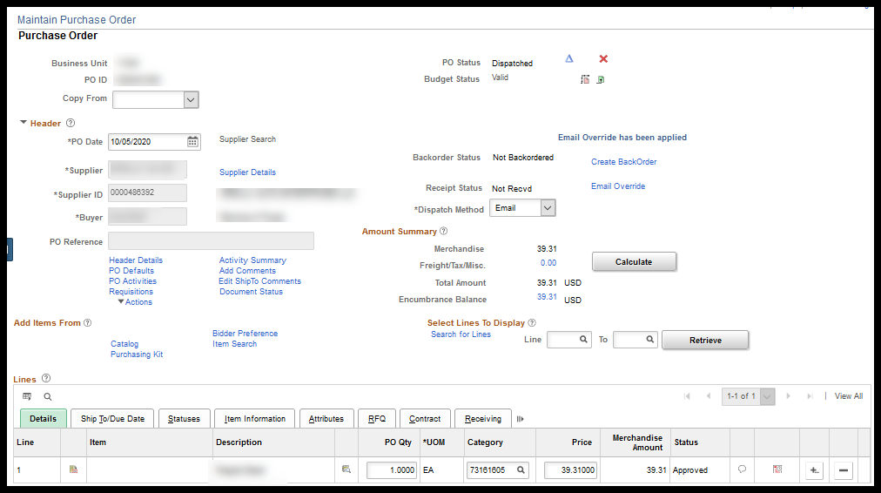

Identifying PO’s Ready for Review
Fluid Navigation: POs & Receiving Homepage > Purchase Orders > Purchase Orders > Add/Update POs
Classic Navigation: NavBar > Navigator > Purchasing > Purchase Orders > Add/Update POs
Unlike Requisitions, POs do NOT go through workflow and therefore will NOT show up on the Buyers ‘Worklist’. To identify which POs are ready for review; navigate to the Purchase Order – Find an Existing Value page. The Buyer can then search for POs with a PO Status of Open and their Buyer ID.
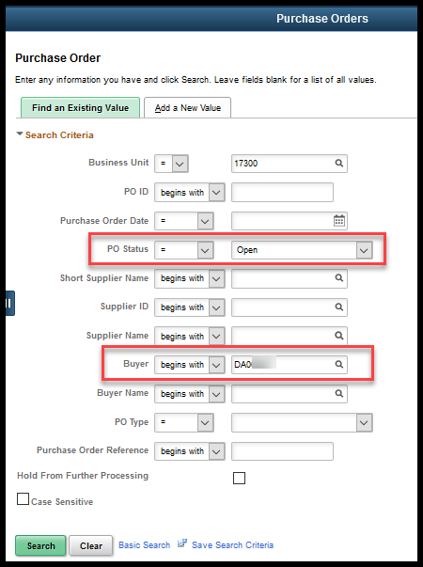

PO Information to Review
Once the POs to be reviewed have been identified, there are many things on each PO that the Buyer needs to review, which include:

- Supplier Details
- Use Procurement Card
- Dispatch Method
- Email Override Information (if necessary)
- Line – Details
- Line – Attributes (Amount Only)
- Line – Contract
- Line – Receiving
- Schedule (Shipping)
- Distribution Lines (Funding)
- Comments – Header / Line / Delivery
- Attachments

Supplier Details
Supplier ID: The Buyer can change the Supplier ID at the PO level prior to the PO being ‘Dispatched’. If the requisition reflected the wrong Supplier ID the Buyer could correct that information during the review process. Once a PO has reached the ‘Dispatched’ status, the Supplier ID can NOT be changed.
Supplier Address: The Buyer will need to select the Supplier Details link to validate that the correct supplier address is being used.
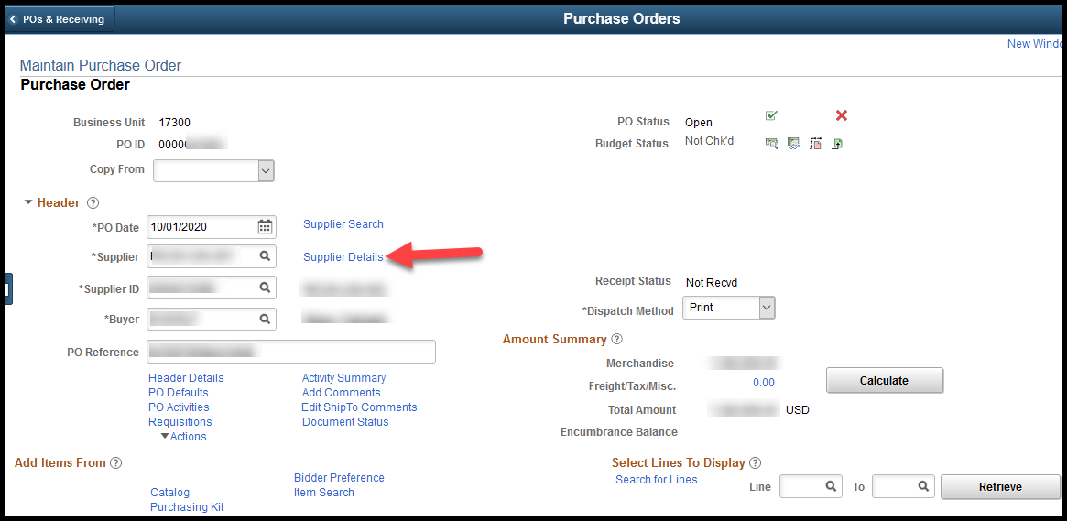
If an incorrect supplier Address is displayed, select the Look Up icon to the right of the Address field, select the correct Address ID and then select the ‘Show Address Details’ button to view the address information.
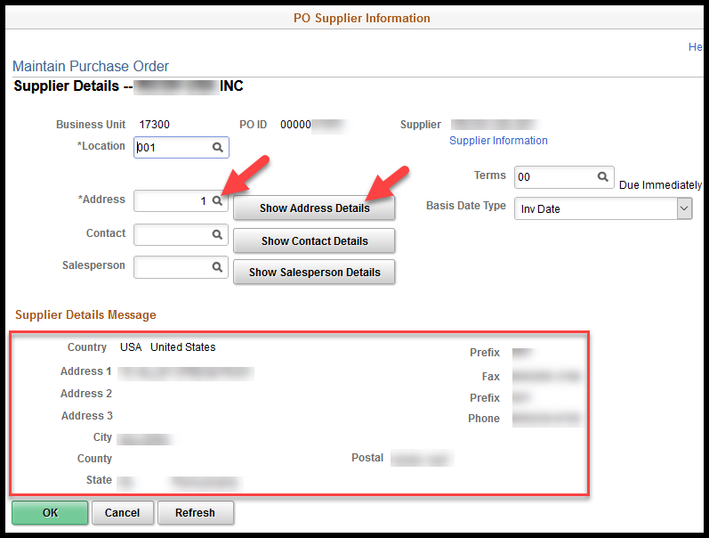
Note – The user (Requisitioner) entering the requisition does NOT have the ability to select an address; SMART selects the Address for them. Therefore, it is important that the Buyer review this information to ensure that the correct address is being used.
Note –The Supplier Information link will take you to the Supplier file by opening the supplier page in a new window.

Use Procurement Card (PCard)
The Use Procurement Card’ link will be visible when:
- The PCard must have a current expiration date;
- The Buyer must have ‘proxy’ rights to the PCard;
- The Supplier Location effective date must be on or before the PO Date.

Note – All suppliers are now setup to accept PCards.
Note – The PCard will be available for selection on the requisition if the requestor has proxy to the PCard; however, the PCard information will only flow to the PO if the above statements are true.
If the purchase is being made with a Procurement Card (PCard), the Buyer will need to select the Use Procurement Card link in the Header section of the PO.
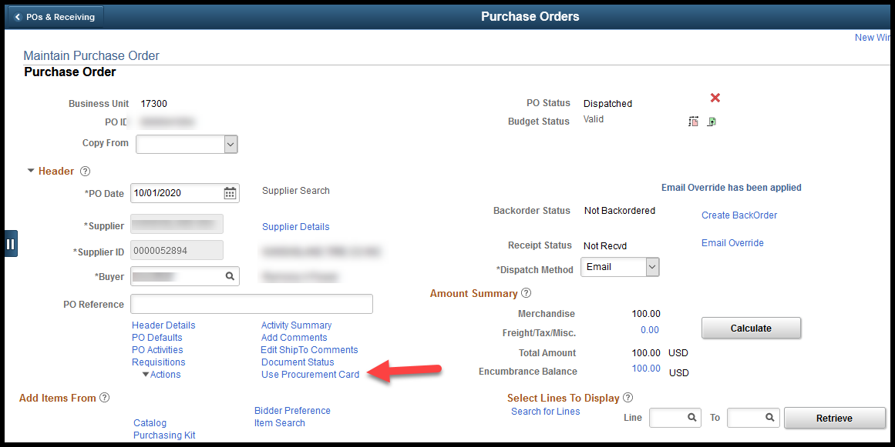
Confirm the correct PCard was applied by the requisitioner, or if needed, select a PCard Number using the drop-down list and then select the OK button.
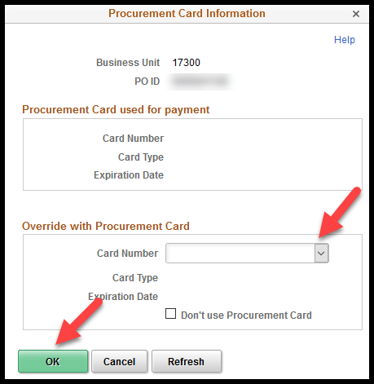
Important: The PO must be ‘saved’ before this information is retained.

Dispatch Method
The Dispatch Method indicates how the purchase order (PO) will be delivered to the supplier. There are three (3) Dispatch Method options available in SMART:
- EDX: This dispatch method is solely used for ‘Direct Connect’ suppliers. The State of Kansas currently only has one (1) ‘Direct Connect’ supplier, Staples for office supplies. POs to Direct Connect Suppliers MUST use the EDX dispatch method.
- Email: This method can dispatch with delivered functionality using supplier record email addresses or with a custom process available from the Email Override link that sends to ad hoc email addresses supplied by the Buyer. Either option will allow Buyers to send attachments with the PO using the ‘Email’ dispatch method. The next section will provide information about both features.
- Print: If this option is selected, the PO will NOT be sent to the supplier from SMART nor will the PO be sent to a printer. The State of Kansas is not set up to dispatch POs to a printer. The PO Status will change to ‘Dispatched’; however, the PO will not go anywhere.
If an agency wants to send a printed copy of the PO to a supplier, they will need to select the ‘Email’ dispatch method and enter their own email address. When they receive the PO by email, they can then print the PO and send a hard copy to the supplier.

Email
When the Dispatch Method is Email the Buyer has a choice of either allowing the purchase order (PO) and any attachments to dispatch via the supplier email address, if there is one, or an ad hoc email address provided by the Buyer.

Supplier Email Address
When the Dispatch Method of Email is selected the PO will dispatch to the email on the supplier address, if there is one.
To check the email address the PO will dispatch to, select the Header Details link on the Maintain Purchase Order page.
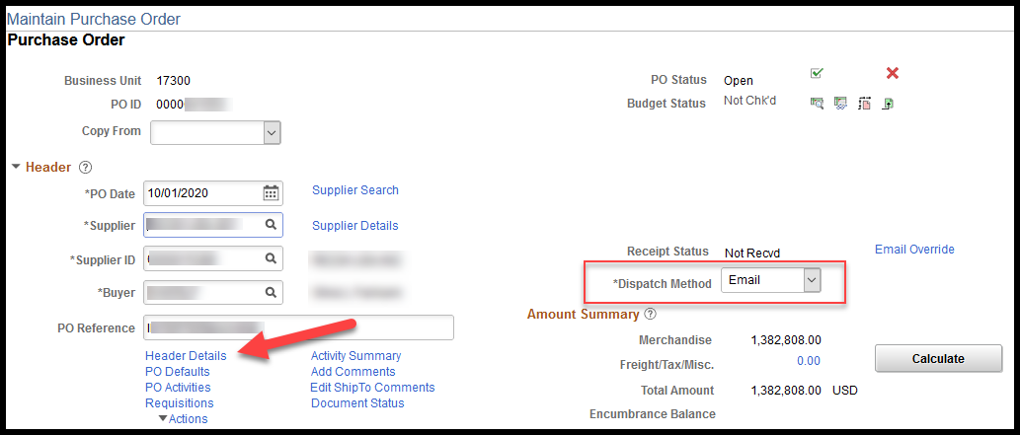
From the PO Header Details page that opens the email address where the PO will dispatch if no changes are made can be viewed in the Supplier/Contact Fax/Email section.
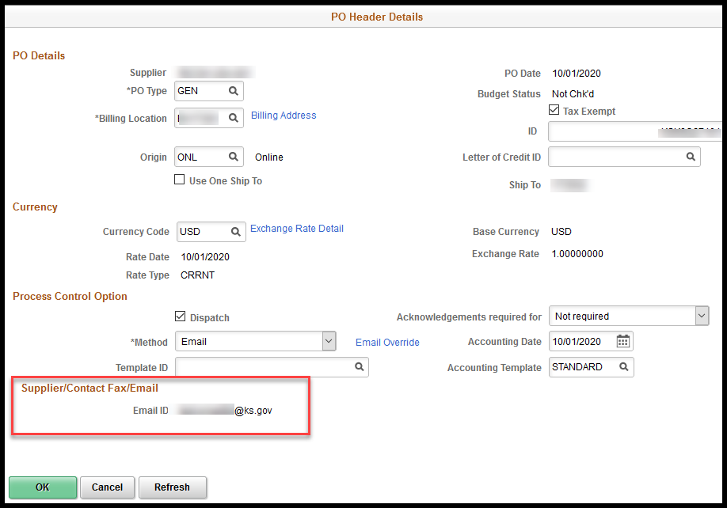
Note - The Email ID field on the PO Header Default’ page cannot be edited and does not indicate dispatch history. Its only purpose is to display email address the PO is currently set to dispatch to.
If the email address is blank, or a different email on the supplier record is needed, the default information can be changed by selecting the Supplier Details link on the Maintain Purchase Order page.
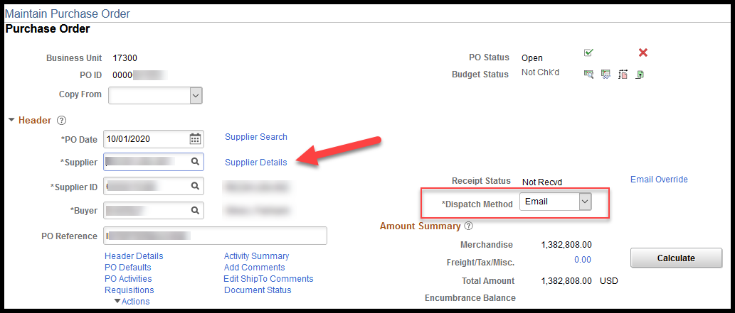
The PO Supplier Information page displays the first active Address ID that defaults in for the supplier. The email address on that Address ID, if there is one, is where the PO will dispatch to and what was seen in the Supplier/Contact Fax/Email section of the PO Defaults page.
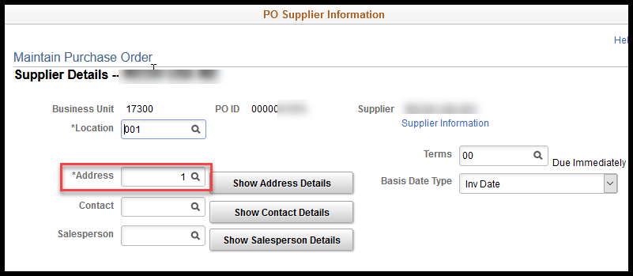
Use Look up Address icon to select another Address ID, if desired. This will update the Email ID the PO will use for dispatch to the email address of the new selection.
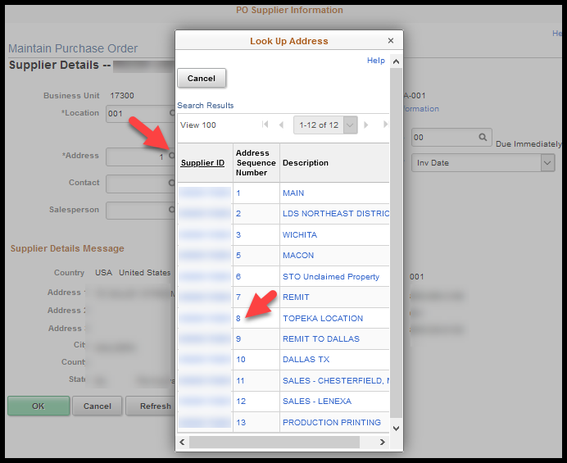
The Buyer can also choose a Contact from the supplier to add to the PO by selecting the Look up Contact icon. If a Contact is added, the PO will dispatch to the email address associated to the contact.
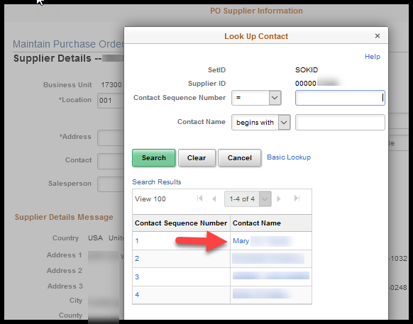
Note - The email value does not display on this page; however, the updated Email ID can be seen on the PO Header Details.

Ad Hoc Email Address
If a Buyer wants the purchase order (PO) to dispatch via email to an email address not listed on the supplier record, if there is not email associated to the supplier record, or if they would like the PO to go out to multiple email addresses upon dispatch, email addresses can be provided in an ad hoc basis using Email Override.
Select the Email Override link on the Maintain Purchase Order page.
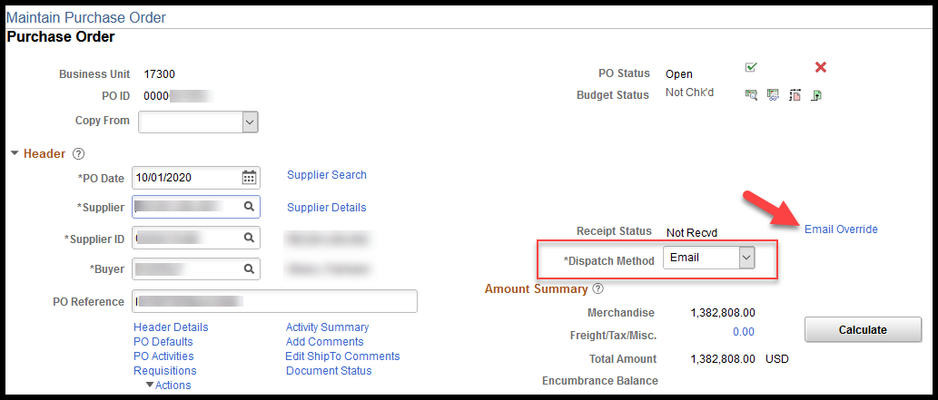
Note – If the Dispatch Method is changed to anything other than Email, the Email Override link will not be visible.
The Email Override link is also available on the PO Header Details page.
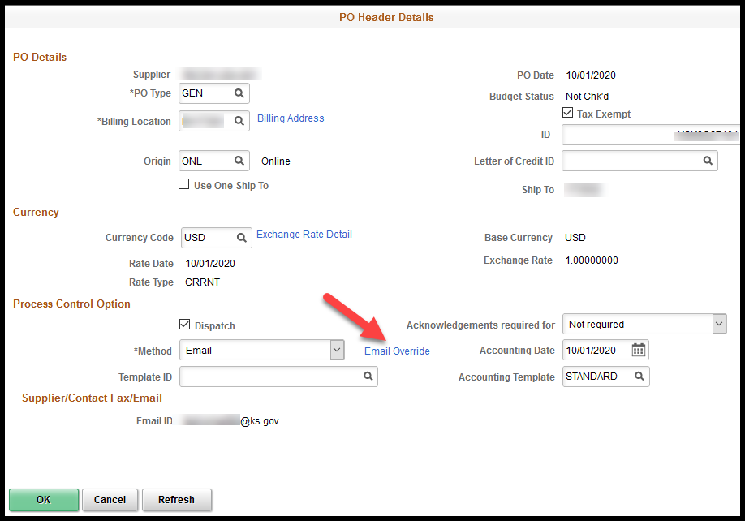
The Email Override link opens the State of Kansas Email Override Setup Page where a single To Email destination line can accept and dispatch to as many emails as fit in the number of characters available. Another line can be added by selecting the plus (+) button, if needed.
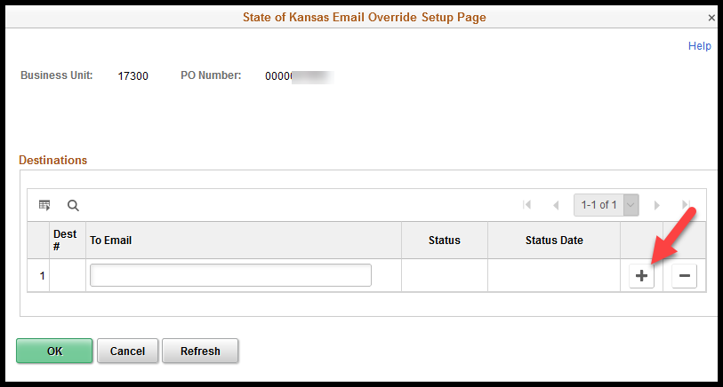
Note – When POs are dispatched to a supplier via email, the email content advises the supplier to please not reply to this email address, and to instead contact the buyer noted on the PO directly.

Re-Dispatching PO’s
To maintain dispatch history, email destination lines on the State of Kansas Email Override Setup Page can only be used once. After the purchase order (PO) or PO Change Order has been ‘Dispatched’, the destination’s email information in the To Email field is locked down and can NOT be used again.
Buyers occasionally need to re-dispatch a PO because of a change on the PO or because the email destination was incorrect. If a Change Order is created on a PO that previously dispatch using the Email Override feature, and the Dispatch Method for the Change Order is Email, the Buyer must add a new email to the Destinations section.
Note – Once the ‘Email Override’ feature is used to dispatch a PO, that PO will no longer dispatch to an email address from the supplier record.
In this case, the Buyer would need to navigate to the PO and select the Email Override link. The original destination information will be ‘grayed out’ (unable to be used), the status will typically be ‘SUCCESS’.
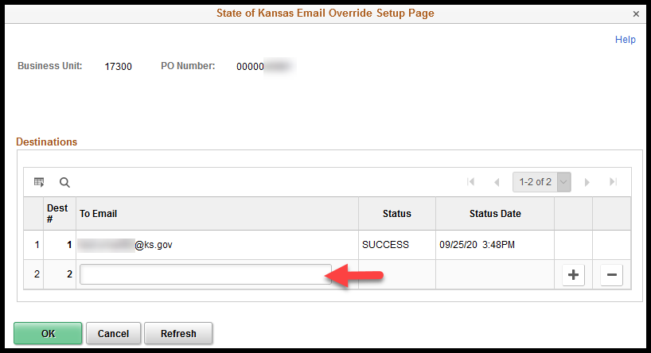
Note - A new destination line MUST be added, even if the email location is the same as a previous dispatch, AND the PO must be SAVED every time the PO needs to be dispatched.
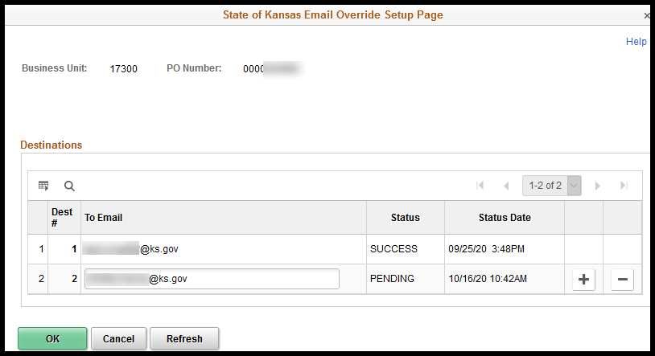
Note - When an ‘Email’ dispatched PO is changed to any other Dispatch Method the Email Override link will disappear. The Email Override link will reappear if the PO is changed back to a Dispatch Method of Email and, in the event the Email Override was used, the email dispatch history will again be visible from the link.

Dispatch History
There are two places in SMART where the Dispatch History may be viewed. The first is on the State of Kansas Email Override Setup Page accessed by the Email Override link on the PO where the ‘Status’ and ‘Status Date’ are provided for each Dest # line.
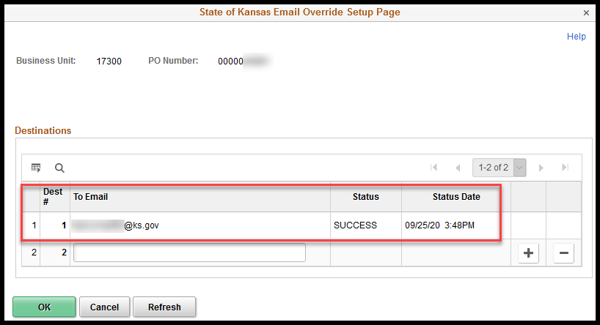
The second place to view the Dispatch History is from the Go To drop down box at the bottom right corner of the Maintain Purchase Order page – 02 PO Dispatched History option.
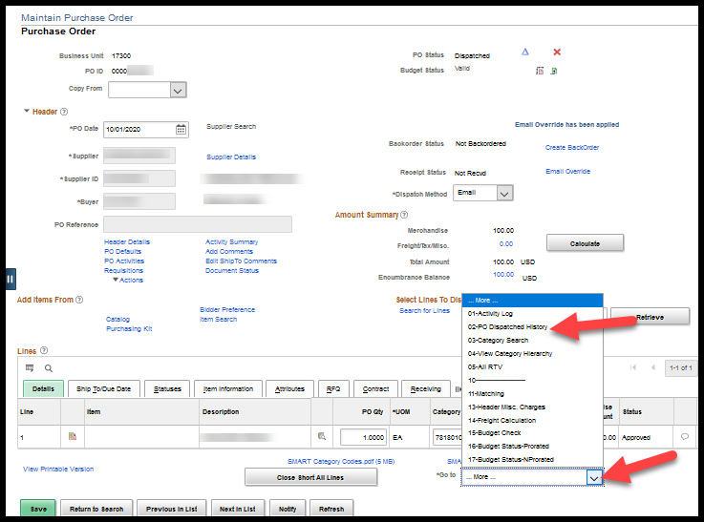
Selecting the 02 – PO Dispatched History link opens the PO Dispatched History page.
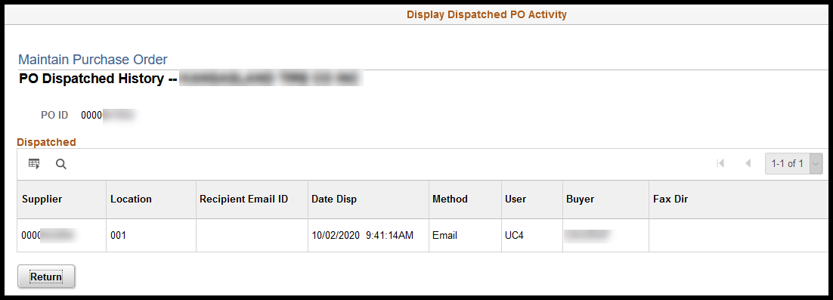

Email Attachments
Although, SMART is not a document repository and Buyers and should not attach documents such as invoices to purchase orders (POs), in some cases additional documentation is needed by the supplier to respond to the PO.
Attachments will be sent via email in addition to the PO if on the PO Header Comments or PO Line Comments pages the Buyer has:
- included an attachment, and
- has checked the Email check box beside that attachment.
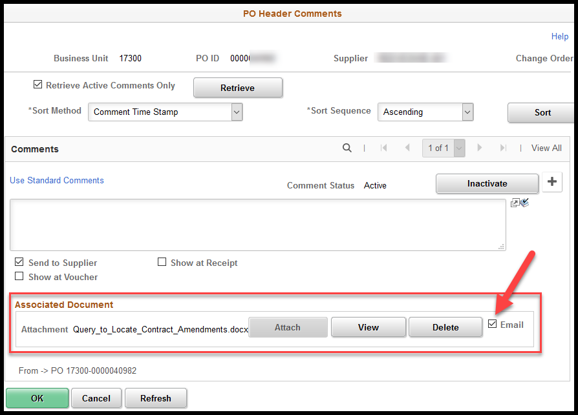

Lines
The Buyer will need to review the purchase order line detail information and update if the values pulled from the requisition are incorrect.
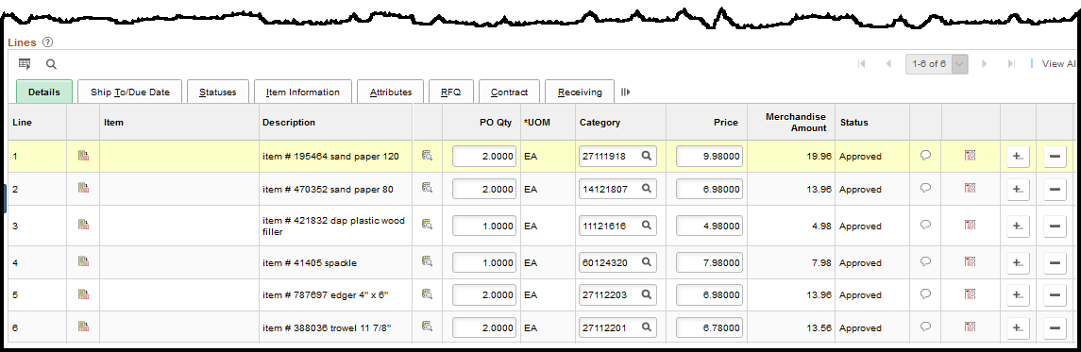

Lines – Details Tab
Much of the specific purchase order (PO) information is found on the Lines section of the PO. However, the State of Kansas is not maintaining a ‘Master Item List’, therefore, most POs have nothing listed in the Item field.

PO Qty
The PO Qty field contains the number (quantity) of items/service being ordered. The PO Qty field will be grayed out if the Amount Only check box has been selected on the Attributes tab of the PO line. The PO Qty will always be one (1) and cannot be changed when the Amount Only check box is selected.
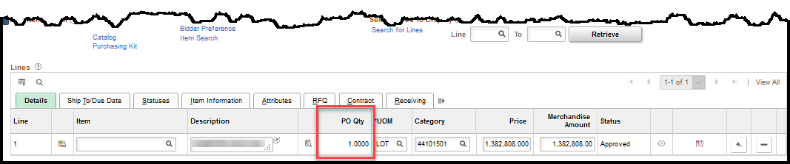

Category
The State of Kansas (State) has purchased the United Nations Standard Products and Services Code (UNSPSC) listing to be used as the ‘Category’ codes within SMART. The UNSPSC is an industry standard classification that is used to classify all products and services. By using a standardized classification for products and services we can utilize the Category field for detailed product/service reporting, used primarily by the Office of Procurement & Contracts for contract negotiations. The UNSPSC does not have categories for all the products/services that the State uses. In those cases, the Buyer will need to select a code that most closely represents the product/service being purchased.
The Buyer will need to review this field for accuracy. To assist in reviewing this information a complete listing of the Category Codes has been provided in both a .pdf and an Excel format.
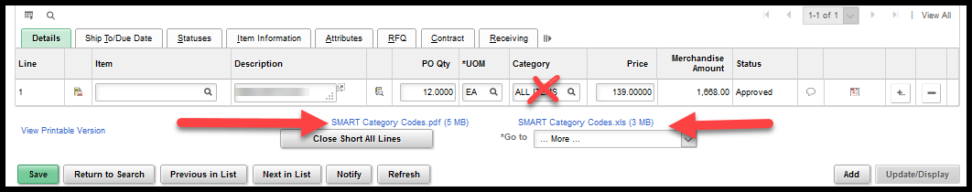
Note –Buyers should NOT use the Category Code ‘All Items’. This is a heading for the ‘Category Code’ listing. This selection provides NO value when trying to report on the types of items being purchased.

Amount – Prior Authorizations
If the Amount needs to be increased for a purchase order generated from a Prior Authorization (PA) Requisition the Buyer MUST submit a revised PA form via email to the applicable Office of Procurement and Contracts Procurement Officer. For additional information please refer to ‘Procurement Informational Circular 11-03: Procedures for Processing Prior Authorization Requisitions’.

Lines – Attributes Tab
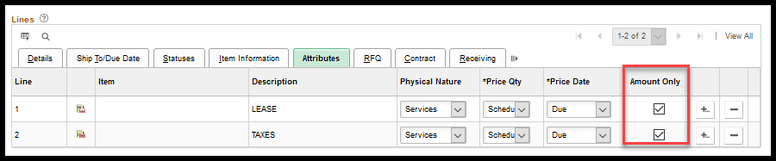

Amount Only
The Buyer will need to determine if this purchase order (PO) line item will be vouchered / paid by increments driven by the amount or by the quantity.
- If the PO will be vouchered / paid by AMOUNT then the Amount Only check box must be checked.

Example:
An agency is purchasing monthly pesticide services. In this case, the monthly invoiced amount will probably vary, which does not work well with a PO made for a quantity of 12 with a set amount for each unit. To reduce the PO line down by Amount instead of Quantity, the Amount Only check box MUST be selected.
- If the PO will be vouchered / paid by QUANTITY then the Amount Only check box must be unchecked.

Example:
An agency is purchasing 10 Widgets at $2.00 a widget. In this case, the agency will be invoiced by the supplier for the number of widgets delivered and the price of each widget remains the same. To reduce the PO line down by Quantity instead of Amount, the Amount Only check box MUST NOT be selected, e.g. 5 widgets received at $2.00 each for a voucher / payment of $10.00.
Note –When the Amount Only check box is selected SMART will generate a message notifying the Buyer that the quantity will be set to 1.
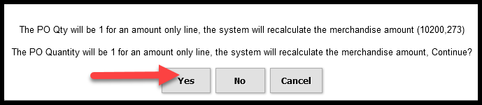

Lines – Contract Tab
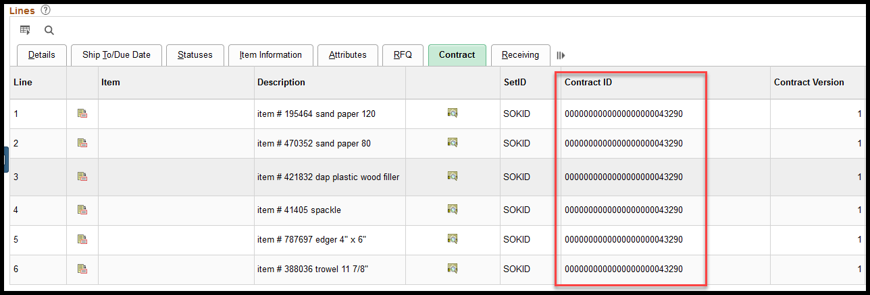
The Buyer must navigate to the Contract tab at the PO line level on every PO and validate that the Contract ID information is correct and applied to EACH LINE. The user entering the requisition may not know if the item being purchased is covered by a contract or which Contract ID should be used. Consequently, the Contract ID may be blank when it should not be or an have incorrect Contract ID.

Lines – Receiving Tab
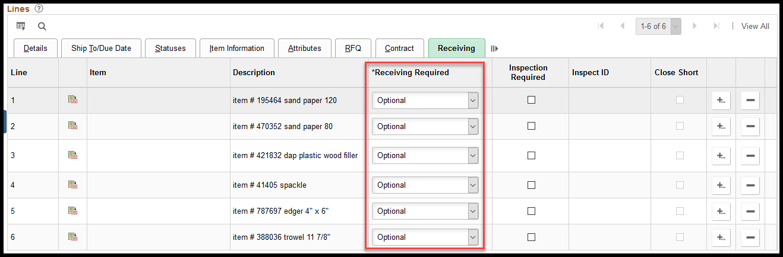
On the Receiving tab the Receiving Required field will default to Optional. The receiver is only included in the voucher matching process if this receiving field is set to Required.
If an agency is using receiving in SMART, the Buyer can choose to change the receiving lines to Required.
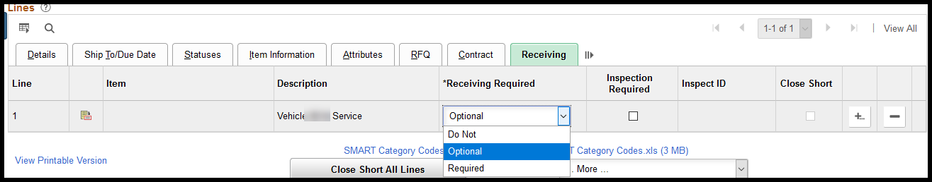

Schedules
The Buyer will need to select the Schedule icon from the purchase order Lines - Details tab.
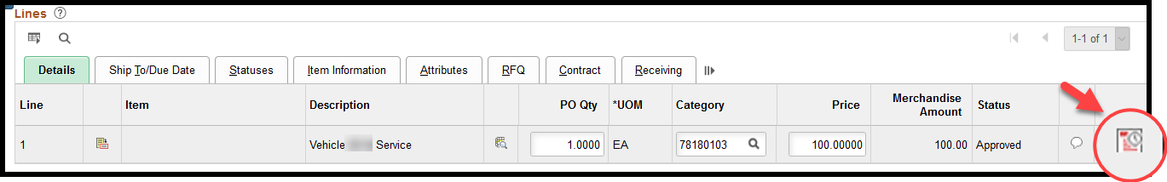

Schedules – Details Tab
The Schedules give the Buyer the ability to order a total quantity and have a portion of that quantity shipped to different locations.
Example: PO line 5 is for a quantity of 2, and each one is shipping to a different location.
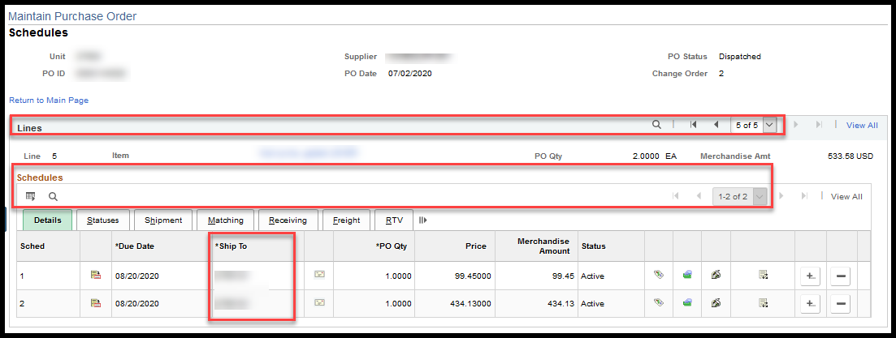

Due Date
A batch process to close Purchase Orders (POs) is ran on the Saturday following the first workday in each new month. SMART uses many factors to determine if the PO should be closed and one of the key factors is the Due Date. The PO will be picked up for closure if: Receiving is set to Optional or Do Not Receive on the Receiving tab, or it has been fully received, it has been 90 days since the last update was made to the PO, all lines on the PO are matched if matching is required, and the Due Date is equal to or less than the current date. Please refer to the ‘Parameters for Closing POs’ job aid for additional information concerning the monthly PO Close process.
The Buyer will want to make sure the Due Date is accurate or slightly future dated to ensure that the PO is not closed prematurely.
Note –The PO is updated when an action is taken that requires the PO to be Saved; simply vouchering against a PO will NOT ‘update’ the PO. To see the date that the PO was last updated, select the Activity Log from the Go To drop down box on the Maintain Purchase Order page.
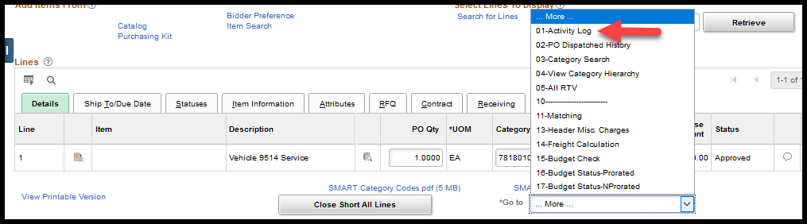

The date last updated and the user ID that updated the PO is provided in the ‘Modified’ section:
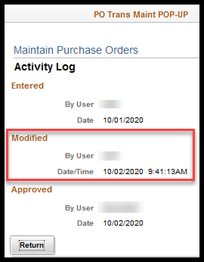

Ship To
The Ship To ID is used to tell the supplier where the product should be delivered to. The Ship To ID is a six (6) digit code that typically starts with the first three (3) digits of the Business Unit (e.g. 173301).
To validate the correct Ship To ID has been applied, select the Ship To Address (envelope) icon.
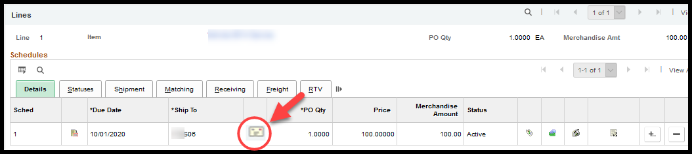

Expand the PO ShipTo Address section to verify the address and select the OK button to return to the Schedules page.
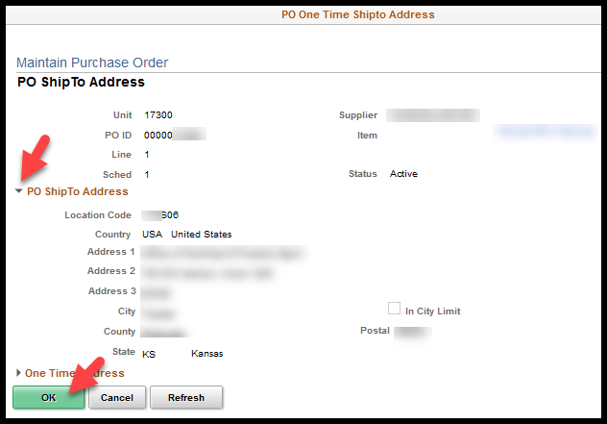
To add a new schedule line on the Schedules page, select the + (plus) button at the far-right hand side of the schedule line.
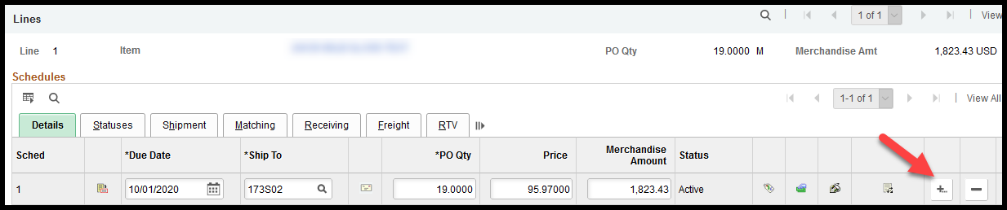

Enter the number of schedule lines needed to be entered in the pop-up box and select the OK button.
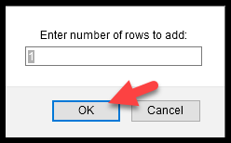
Select a Ship To ID and enter the quantity in the new Sched line and reduce down the existing lines to keep the total line quantity the same, e.g. 19 + 0 = 19, 17 + 2 = 19.
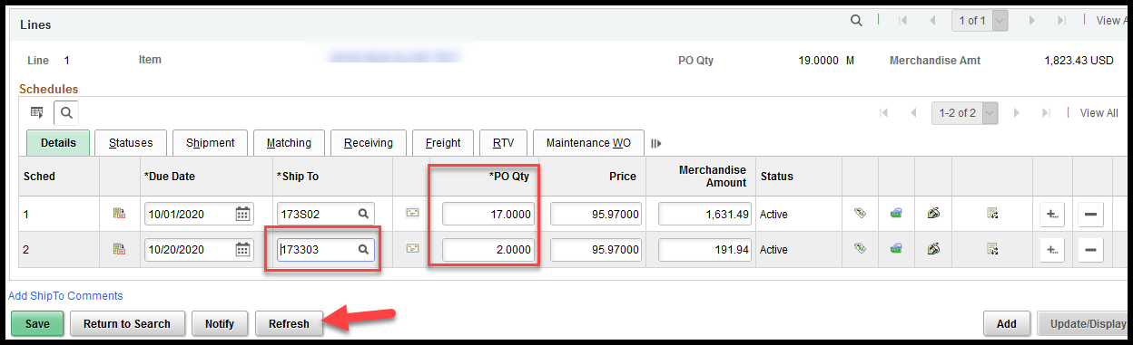
Selecting the Refresh button will calculate the Merchandise Amount for the schedule lines.
Note – Additional schedule lines can only be added to PO lines that are set up for quantity liquidation.

Distributions
The Buyer will need to select the Distributions/Chartfields icon from the Schedules – Details tab:
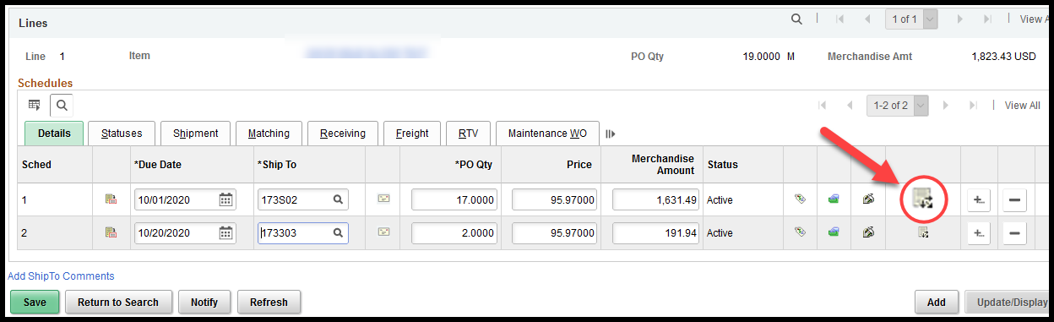
The Distributions page provides the funding information to be used for the purchase on this particular PO Line/Schedule. Each PO Line/Schedule has its own Distribution line(s).

Distributions – Distribute By
SMART is designed for the purchase order (PO) distribution lines to be set up the way the agency intends to make the payments. Vouchers inherit from the PO the Distribute by value (Amount OR Quantity), the number of distribution lines, and the percentages used to calculate the Amount or Quantity for each of the distribution lines.
SMART allows for the distribution line percentages to be applied to either the ‘Amount’ OR ‘Quantity’. The Buyer may need to consult with the agency’s budget/accounting staff to determine which Distribute by option is appropriate for the purchase being made.

However, as a guide for the Buyer they need to determine if there will be more than one (1) funding stream used to pay for this purchase?
- If no, then leave the Distribute by default value of Amount.
  - With this selection the dollar amounts associated to each distribution line is a calculated value [$ amount to be paid ($455.07) X PO percentage (85%)].
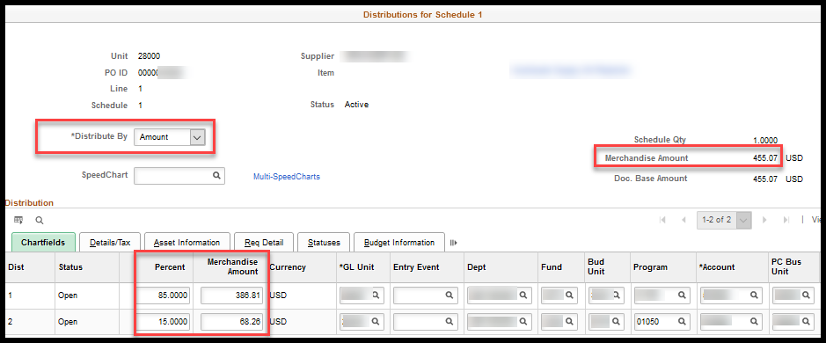
- If yes, then the Buyer will need to determine how the funding is to be applied to this purchase.
  - Will the funding be applied by Amount?
    - Example: The PO is for three (3) widgets for a total amount of $30.00, $10.50 will be paid out a Fund and Budget Unit, and $19.50 will be paid out of a DIFFERENT Fund and Budget Unit.
  - Will the funding be applied by ‘Quantity’?
    - Example: The PO is for eight (8) widgets, four (4) widget will be paid out of a Fund and Budget Unit, and one (1) widget will be paid out of a DIFFERENT Fund and Budget Unit, and three (3) widgets will be paid out of yet ANOTHER Fund and Budget Unit.
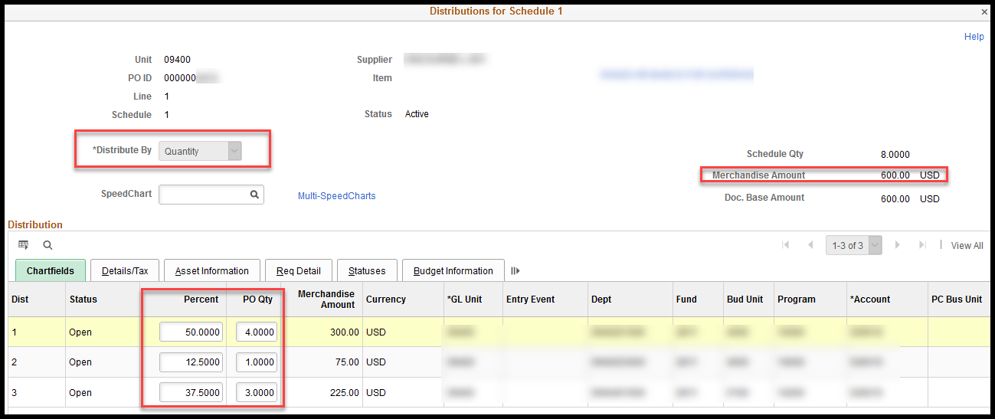
Note – For information about using a PO on a voucher please see ‘Copy a Purchase Order or Receipt into a Voucher’ on the SMART Web > Account Payable > Training.

Distributions - SpeedChart
‘SpeedChart’ is a pre-defined combination of funding streams. However, a SpeedChart cannot be applied to a PO that was created from a requisition. An attempt to add or change the SpeedChart on a PO will result in and error message.
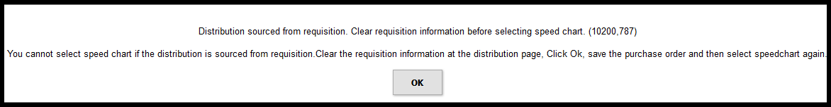

Distributions Lines
The Buyer will need to review/update the funding information associated to this PO line/schedule.

Distributions – Chartfields Tab
Chartfield Values & Chartfield Value Combinations: The Chartfield values (e.g. Project ID) and Chartfield value combinations (e.g Fund / Budget Unit) must be valid before the purchase order (PO) can be saved. The Buyer will need to consult with the agencies accounting / budget staff if staff if they are unsure of how the funding / ChartFields should be set up or SMART indicates that the values / value combinations are invalid.
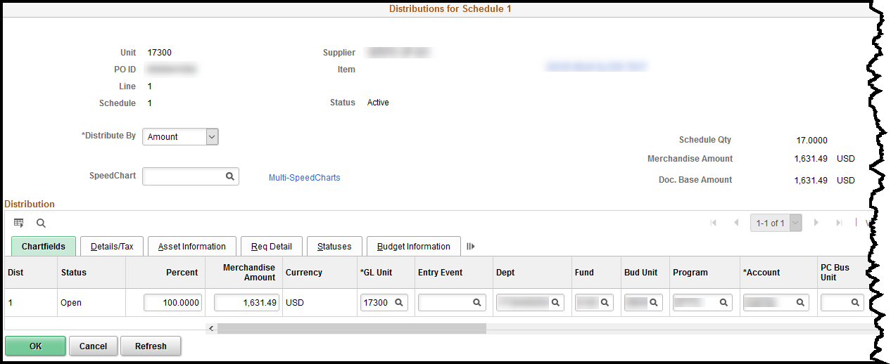
Account: The Account field is a required field.
Projects: If a Project and Activity are included on the PO distribution line, a copy of the transaction will be sent to the Project Costing Transaction list for encumbrance tracking after the PO has been budget checked and dispatched. The transaction row(s) will use an analysis type COM in Project Costing, which represents a Committed cost.

Adding Distribution Lines: If additional distribution lines are needed, select the + (plus) sign button at the end of the row (far right). A pop-up box will display, to enter the number of distribution lines to be added, and then select the OK button.
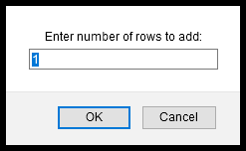
New distribution lines are added.
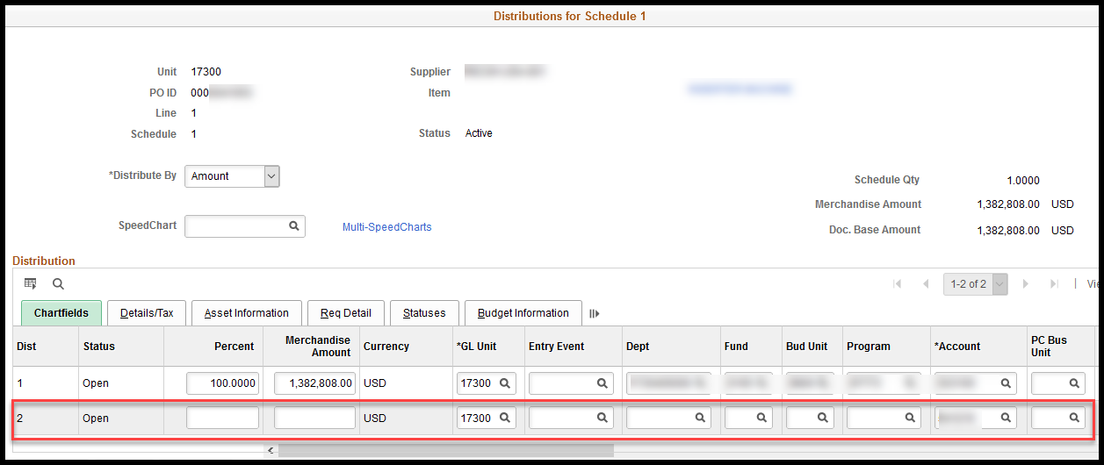
Note - It is important that the funding information is as accurate as possible before the PO is ‘Approved’. The down-stream processes, such as the creation of the voucher and the Budget and Expenditure ledgers are greatly impacted by the way the PO Distribution page is set up.

Distributions – Asset Information Tab
Before populating this tab, verify that your agency integrates Purchasing data with Asset Management.
The required asset information on a purchase order (PO) is found on the Distribution. Every distribution line associated with an asset purchase must be marked with the AM Unit and Profile ID. Those are the fields that trigger the integration.
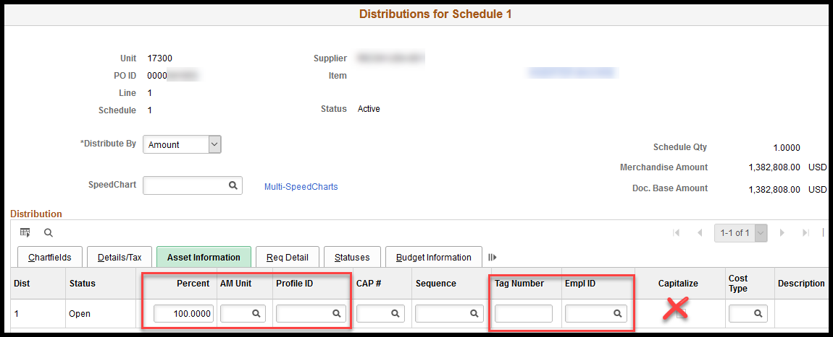
Fields | Description
Percent | Indicates the percentage breakdown of funding
AM Unit | Asset business unit
Profile ID | Select the correct Profile ID. It is imperative the correct value is selected here to reduce errors in the AM module. Be sure to consider the unit cost of each asset versus the capitalization threshold to determine whether the asset is capital or noncapital. See the Asset Management: The Basics training guide for additional information on Profile ID’s and capitalization thresholds.
Tag Number | If the Tag Number is known at the time of the request, enter that information.
EmplID | Define the Custodian if known.
Capitalize checkbox | DO NOT check this box. The amount on the voucher will be used as the capitalized cost.
For more information regarding integration with Asset Management, see AM Tool 3 – Asset Purchase Orders.

Distributions – Req Detail Tab
The Buyer will not need to review, or make adjustments on, the ‘Req Detail’ tab; however, this tab will provide the Buyer with a quick reference to the requisition that initiated the purchase order and the Requester name.
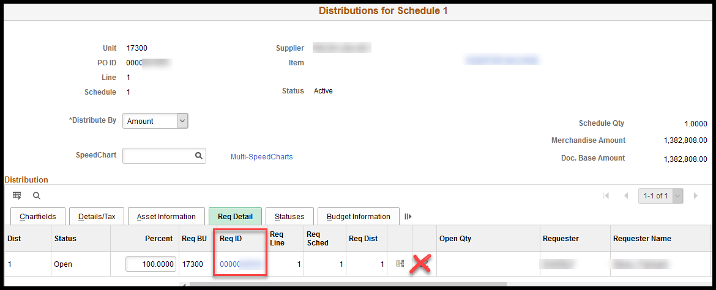
Note –Buyers SHOULD NOT select the Clear Requisition Info icon (eraser). Doing so breaks all connections between the PO and the requisition that initiated the PO. For example: Prior Authorizations are associated at the requisition level. If the Clear Requisition Info icon is selected, the connection to the requisition, and consequently the Prior Authorization, is lost.

Distributions – Budget Information Tab
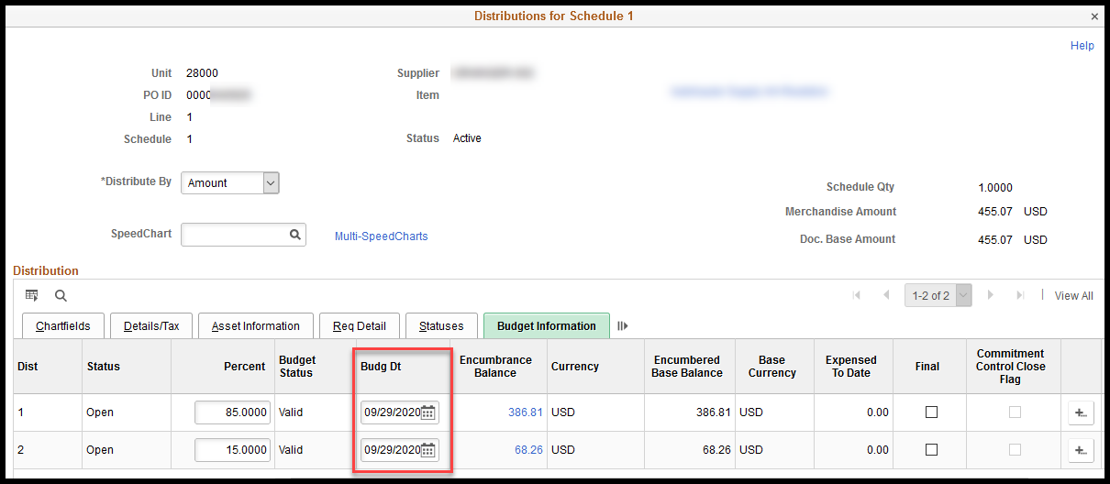
Fields | Description
Status | Status of Distribution Line
Percent | Percentage breakdown of encumbrance distribution
Budget Status | Budget status of Distribution Line
Encumbrance Balance | Amount of remaining original encumbrance available (not matched to a voucher) on each Distribution Line
Encumbrance Base Balance | Original encumbrance amount of each Distribution Line
Expensed To Date | Amount of original encumbrance matched on a voucher by Distribution Line
Before a purchase order (PO) can be dispatched to the Supplier, the PO must have a ‘Valid’ Budget Status. This means that there must be enough available budget to cover the amount shown on each of the PO Distribution lines.
Note - For most Agencies, SMART is looking for available budget at the fund and budget unit level. There are a few agencies that require a lower level of validation; for example, there would need to be available budget at the Fund / Budget Unit / Project level if the agency has set up their Project Budget to Track with Budget. Please see ‘Using Budget Inquiries – Training Guide’ for more information.

Comments
There are three (3) different places on the purchase order (PO) where comments can be entered:
- Header Comments
- Line Comments
- Ship To Comments

Header Comments
Header comments can be added using the Add Comments link in the header section of the purchase order (PO). The purpose of the header level comment is to provide information that applies to the entire purchase order. Comments at the header level can be 1) typed free form or 2) selected from saved comments from the Use Standard Comments link.

Example 1:
“Per the contract, shipping should not be included on the invoice.”
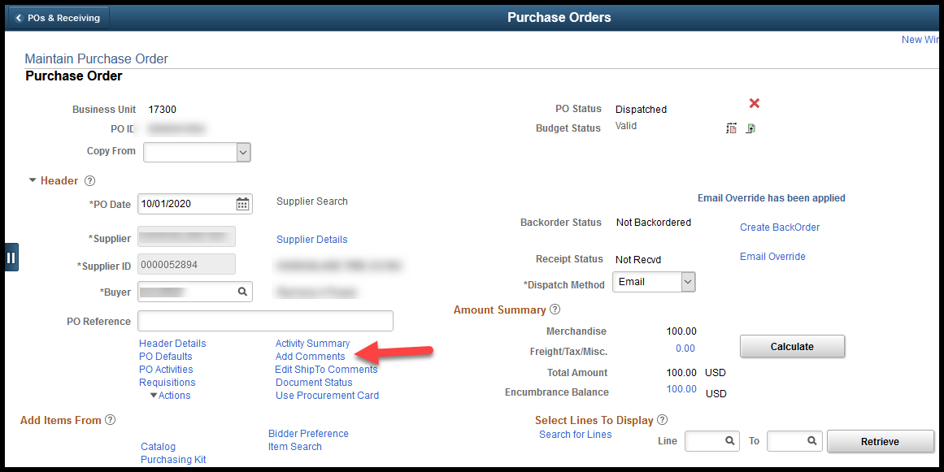
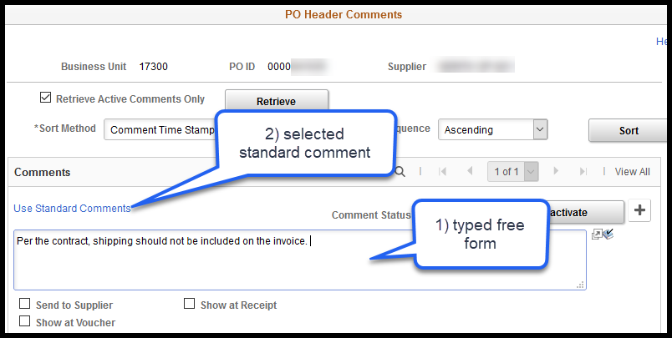

Line Comments
Line comments can be added using a Line Comments icon available in each line. The purpose of the line level comment is to provide information that applies only to the line item (good/service). Comments at the line level can be also be 1) typed free form or 2) selected from saved comments from the Use Standard Comments link, as seen above on PO Header Comments.

Example 2:
“We originally ordered one (1) widget but have increased the quantity to three (3).”
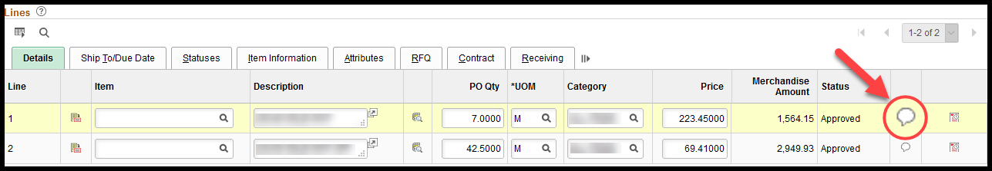

Ship To Comments
The ship to comments can be added using the Edit ShipTo Comments link in the header section of the purchase order (PO). The purpose of the ship to level comment is to provide the supplier with specific delivery instructions they may need to know about a specific Ship To location. Like the header and line, comments at the ship to level can be also be 1) typed free form or 2) selected from saved comments from the Use Standard Comments link, as seen above on PO Header Comments. In addition, the ship to can have comments directly associated to it. If comments were created on the Ship To Location and set they were set to Copy to Transactions, comments will default into the PO from the Ship To ID.

Example 3:
“All deliveries should be made between 8:00 AM and 4:00 PM Monday through Friday.”
The ship to comment (delivery instructions) default into the PO based upon the PO ship to location, if they exist on the ship to. Delivery instructions can be set up for each Ship To location, and if set up for it, will appear on every PO using that ship to location ID.
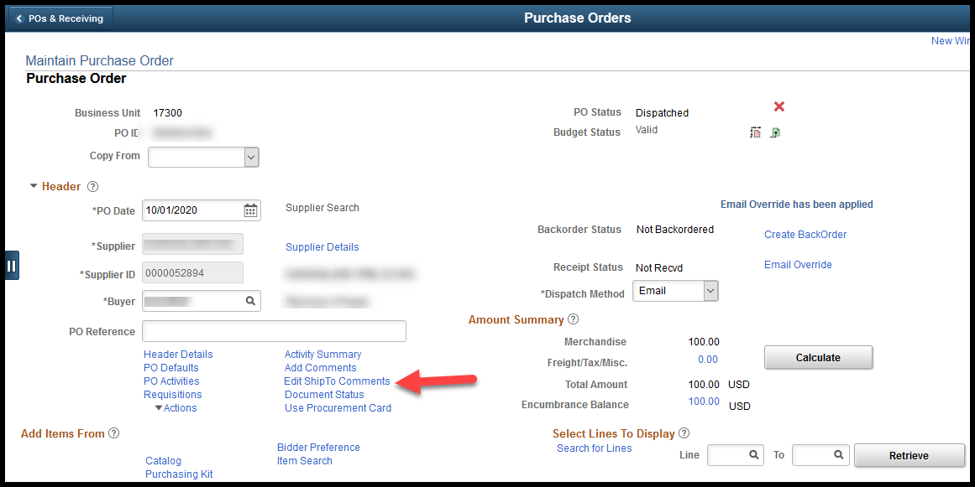
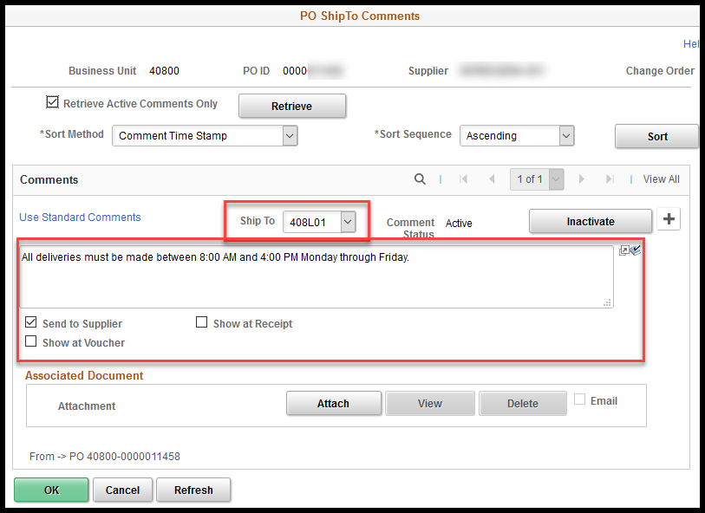
The Buyer can delete out the defaulted comment or can directly enter a ship to comment if there are specific delivery instructions for a single PO. To include the comment on the PO make sure that the Send to Supplier check box is checked.
Note – There is only one comment box per ship to location. A ManageEngine Service Desk request will need to be submitted if an agency wants to add or update a ship to comment to for a specific Ship To location.
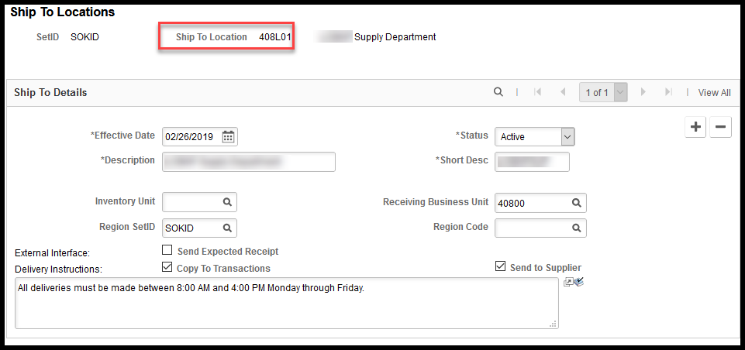

Send to Supplier
Select the Send to Supplier check box if the information should be included on the purchase order (PO) document that dispatches to the supplier.
The PO Header comment displays towards the bottom of the PO along with the Ship To comments, and the PO Line comment displays under the line description on the PO.
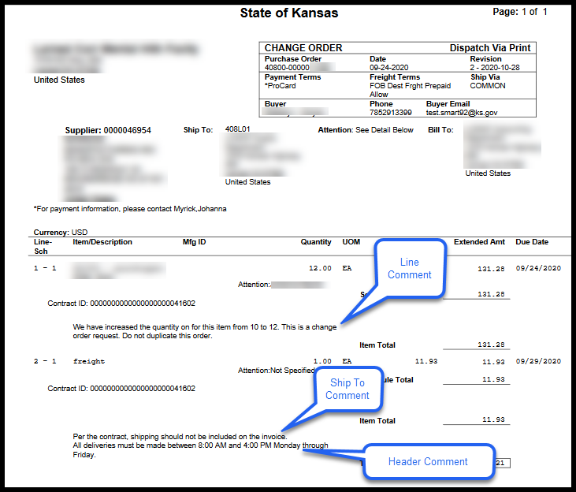

Show at Receipt
Select the Show at Receipt check box if the information should be provided to the user that will do the receiving. The comment will then viewable on the Receiving page under the PO Line comment icon on the Source Information tab.
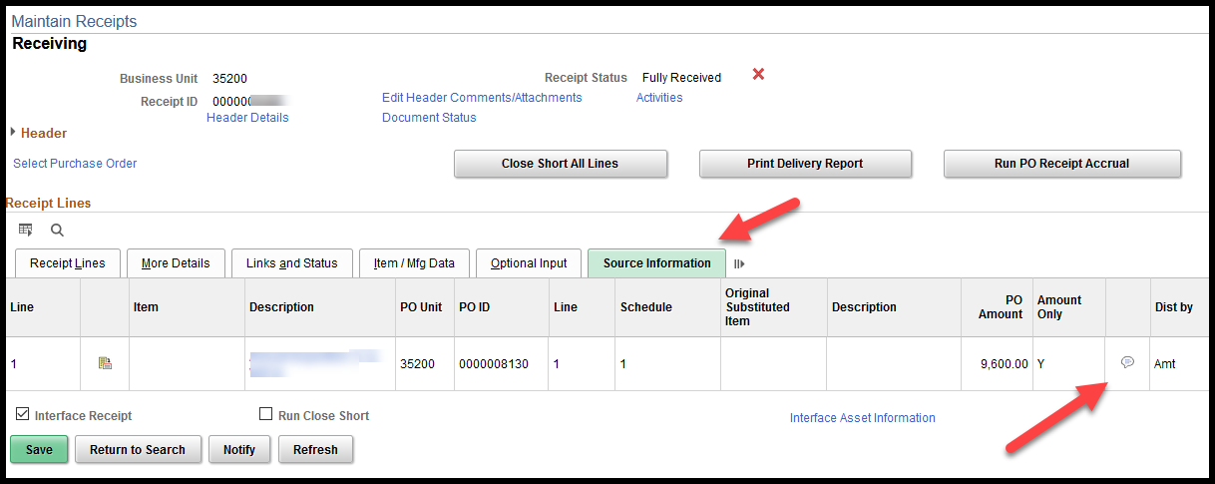

Show at Voucher
Select the Show at Voucher check box if the information should be provided to the Voucher Processor. The comments will then be available from the Voucher – Invoice Information (Tab) page by selecting the purchase order link in the Purchase Order section of the Invoice Lines and expanding the PO/Receipt Comments section.
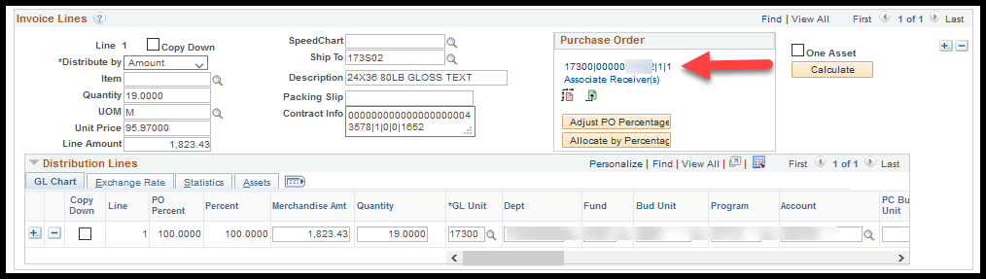

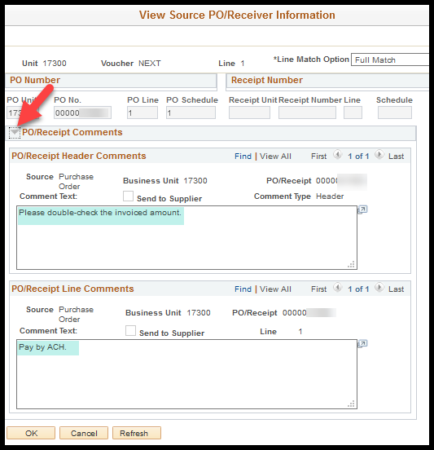

Attachments
The Purchasing module is NOT a document repository; consequently, Buyers should not attach documents such as invoices to purchase orders (POs). However, there are times when additional documentation is needed by the supplier or audit. If necessary, the buyer can attach documents at the header, line, or ship to levels by selecting the Attach button, browsing for the document, and selecting the Upload button.

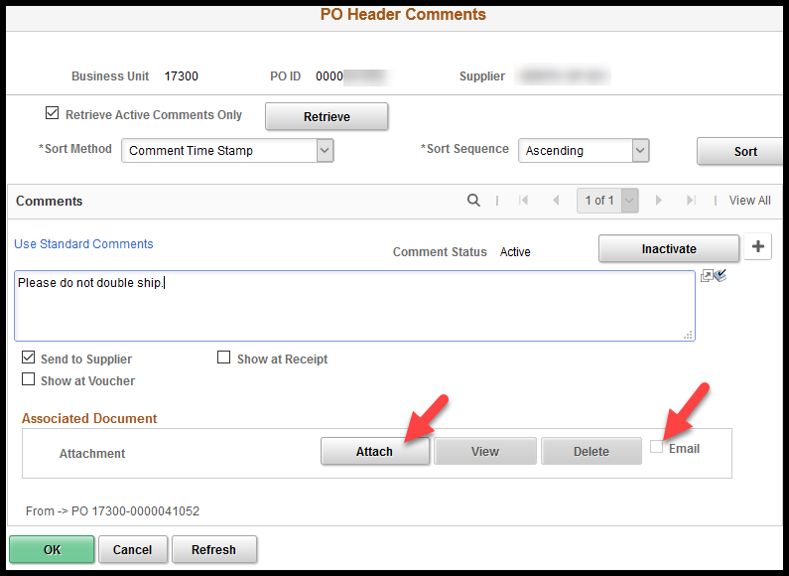

Both the PO and the attachment will be dispatched to the supplier if the Email checkbox is selected on the PO comments page and the PO Dispatch method is Email.

Managing Purchase Orders
Once the buyer has reviewed the information and made updates as necessary, the agency is ready to order the goods or services and establish a purchase order encumbrance.

Approving Purchase Orders
To Approve the purchase order (PO), the Buyer should select the Approve icon (green check mark in a checkbox icon) to the right of the PO Status label on the Maintain Purchase Order page.
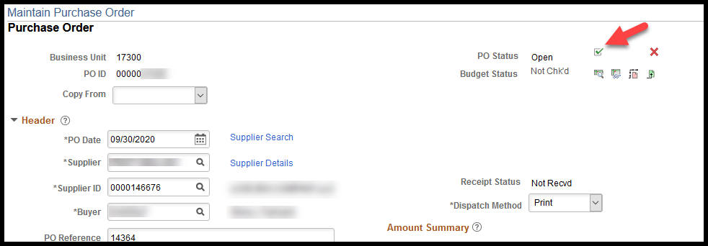
Once saved, the PO Status will update to Approved. The PO must be in an ‘Approved’ status before it can be ‘Budget Checked’ or ‘Dispatched’.

Budget Checking
On an hourly basis between 9 AM and 3 PM Monday through Friday, purchase orders (POs) with an Approved status are picked up for budget checking. The budget checking process validates that there is enough available budget to cover the amount of the PO. The validation happens at the distribution line level. This means that there must be enough available budget in the Fund / Budget Unit / Budget Period combination for each of the distribution lines on the PO.
Note – Nightly Batch Process: The PO Budget Checking batch process happens once each evening in addition to the hourly batch processes. The Nightly Batch Process is run once each evening Monday through Friday.

Review Budget Error Information
If there is not enough available budget the Buyer will see a Budget Status of Error and it will display as a link. The Buyer may need to contact the agencies Financial / Budget staff to resolve any Budget issues.
Select the Error link to see specifics about the budget failure.
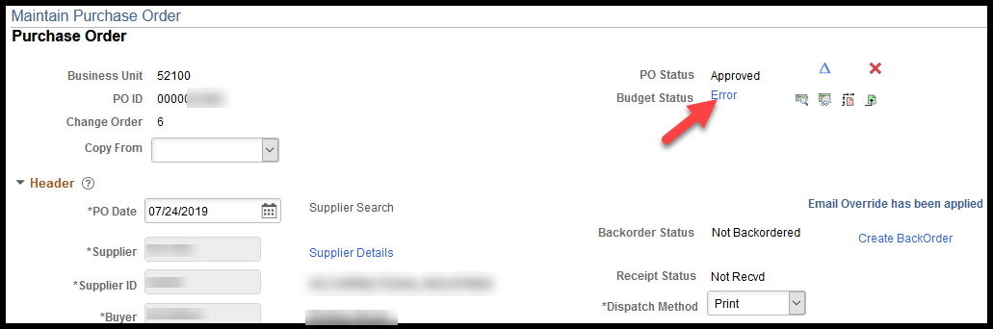
The budget failure details will appear in a new window. Selecting the Details icon will open the Purchase Order Line Drill Down page with the detail information.
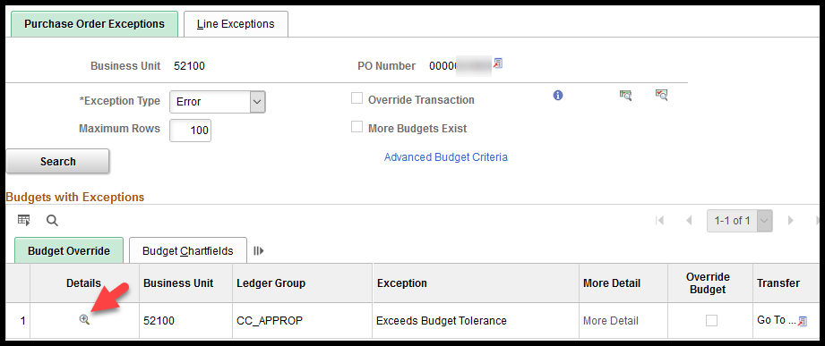
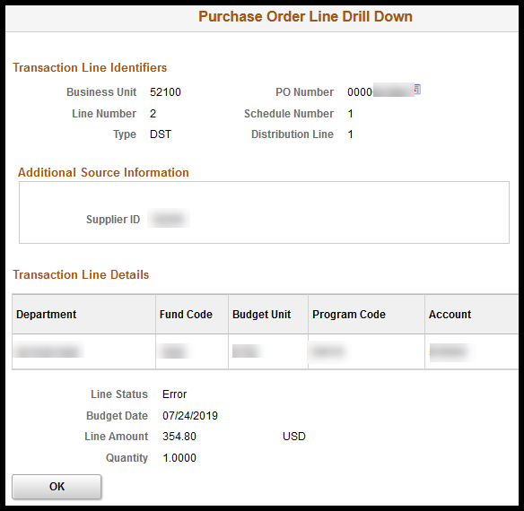

Instead of selecting Details icon, the Buyer can also see this information by navigating between tabs and selecting Line Exceptions and Line Chartfields.
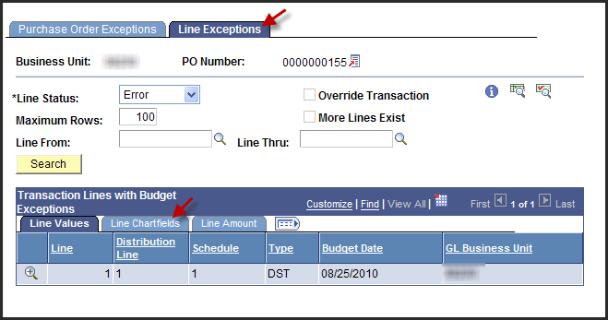
The Buyer can also search all POs for their Business Unit that have an Error status.
Fluid: POs & Receiving > Purchase Orders > Purchase Orders > PO Budget Check Exceptions
Classic: NavBar > Navigator > Commitment Control > Review Budget Check Exceptions > Purchasing and Cost Management > Purchase Order
Select the Business Unit, select the ‘Errors Exist’ ‘Process Status’ and select the ‘Search’ button:
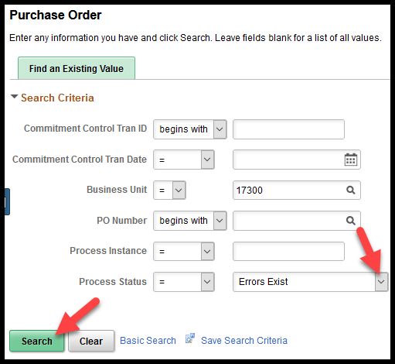
A list will appear if there are multiple POs with an Error status for the specified business unit.

Dispatching
On an hourly basis between 9 AM and 3 PM Monday through Friday and once each evening Monday through Friday, POs with an Approved status and a Valid budget status are picked up to be dispatched to the supplier.

Change Orders
If a Buyer needs to make changes to a purchase order (PO) that has already been dispatched a Change Order can be created by selecting the Change Order icon (blue triangle) to the right of the PO Status field.
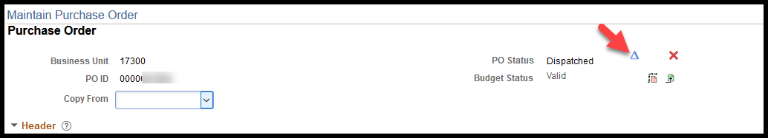
Once the Change Oder icon has been selected it will disappear from the right of the PO Status field.
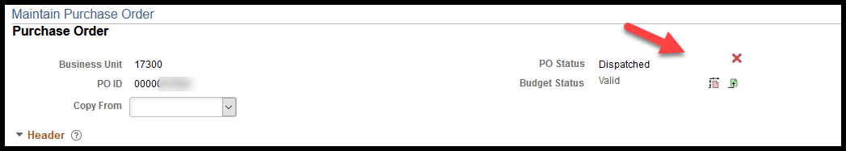
After the page is saved the header will updated to include an incrementing Change Order field under the PO ID field and the PO Status will be reset to Open and awaiting approval.
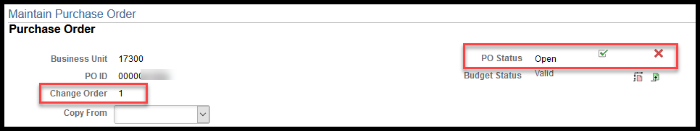

Change Orders will also be automatically kicked off if a change to the quantity or amount is saved.
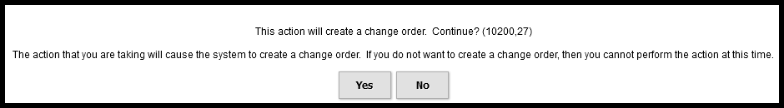
Note – When a Change Order PO is dispatched the resulting document will include the words ‘CHANGE ORDER’ are printed at the top, however suppliers will most likely not catch the changes being made and could then re-fill the complete order. Consequently, it is important that the Buyer communicates with the supplier, such as adding a comment, what changes have been made.

Appendix A: Key Navigations

Page | Purpose | Navigation
Sourcing Workbench | This page is used to identify and correct requisitions that were rejected during the PO Auto Sourcing process. | Fluid: POs & Receiving > Purchase Orders > Manage Purchase Orders > Sourcing Workbench  Classic: NavBar > Navigator > Purchasing > Purchase Orders > Stage/Source Requests > Sourcing Workbench
Change Order History | This is an on-line inquiry page that will show changes that were made to the PO. This page will only show those changes that need to be relayed to a supplier such as changing a quantity of one (1) to a quantity of two (2). This page will not show funding changes made. | Fluid: POs & Receiving > Purchase Orders > Review Purchase Orders > Chane Order History  Classic: NavBar > Navigator > Purchasing > Purchase Orders > Manage Change Orders > Review Change History OR Review Change Orders
Buyer’s Workbench | This page is primarily used to manually “Close” POs. Manually closing a PO will release any remaining encumbrance. This page may also be used to perform on-line inquiries. | Fluid: POs & Receiving > Purchase Orders > Manage Purchase Orders > Buyer’s Workbench  Classic: NavBar > Navigator > Purchasing > Purchase Orders > Buyer’s Workbench
Review PO Information | This is a view only PO page. Users with the Purchasing Viewer role will have access to this page to view the PO information. No actions can be taken from this navigation.  For more information please see, Purchase Order Inquiry Page. | Fluid: POs & Receiving > Purchase Orders > Review Purchase Orders > Review Purchase Orders  Classic: NavBar > Navigator > Purchasing > Purchase Orders > Review PO Information > Purchase Orders
PO Activity Summary | This is an inquiry page to provide a summary and drill downs to activities that have transacted against a PO. Summaries for the following transactions/Activities are provided: Receipt, Invoice, Matched, & RTV.  For more information please see, PO Activity Summary Page. | Fluid: POs & Receiving > Purchase Orders > Review Purchase Orders > Activity Summary  Classic: NavBar > Navigator > Purchasing > Purchase Orders > Review PO Information > Activity Summary
PO Accounting Entry Inquiry | This is an inquiry page that will provide the funding details for specified POs.  For more information please see, PO Accounting Entries. | Fluid: POs & Receiving > PO & Receiving Reports > Purchase Order Reports > PO Accounting Entry Inquriry  Classic: NavBar > Navigator> Purchasing > Purchase Orders > Review PO Information > PO Accounting Entries
PO Document Status | This inquiry page will provide a list of all the documents associated to the specified PO, e.g. requisition, contract, receipts, vouchers, etc. | Fluid: POs & Receiving > Purchase Order > Review Purchase Orders > PO Document Status  Classic: NavBar > Navigator > Purchasing > Purchase Orders > Review PO Information > Document Status
Req and PO Budgetary Activity | This report can be used to obtain encumbrance information. Depending on the search criteria entered; the user can produce a listing of POs that have a remaining encumbrance. | Fluid: POs & Receiving > PO & Receiving Reports > Purchase Order Reports > Req and PO Budgetary Activity  Classic: NavBar > Navigator > Purchasing > Purchase Orders > Reports > Req and PO Budgetary Activity
Add/Update Purchase Orders | Users with the Kansas Buyer role can use this page to review, update and approve Purchase Orders. The Kansas Buyer will only have update access to those POs for which they are assigned as the Buyer. | Fluid: POs & Receiving > Purchase Orders > Purchase Orders > Add/Update Purchase Orders  Classic: NavBar > Navigator > Purchasing > Purchase Orders > Add/Update POs

Appendix B: PO Review Checklist

- Supplier Details
- Use Procurement Card
- Dispatch Method
- Line – Item
- Line – Quantity
- Line – Category
- Line – Price / Amount
- Line – Amount Only
- Line – Contract
- Line – Receiving
- Schedule – Due Date
- Schedule – Ship To
- Distribution – Distribute By
- Distribution – ChartFields need to be as accurate as possible before the PO is ‘Approved’
- Distribution – Asset Information

