
State of Kansas
Manual PO Close Process
Statewide Management, Accounting and Reporting Tool

Date Created: | 03/30/2011
Version: | 2.0
Last Updated Date: | 11/24/2020
Purchase Orders meeting certain criteria are closed during the Monthly PO Close batch process on the weekend after the first business day of the month.
However, an agency may have a need to close a PO before it would qualify for the Monthly PO Close process. Closing POs will liquidate outstanding encumbrance balances. It will also reduce the number of results returned when searching for a PO(s) to update, improving search efficiency.
SMART Security Role | Buying Administrator
NOTE: Closed POs may be re-opened, provided they were not previously ‘Canceled’ and available budget exists. Log a Service Desk Request, using the title “Reopen PO” to request a PO be reopened.
Fluid Navigation: POs & Receiving > Purchase Orders > Manage Purchase Orders > Buyer’s Workbench
Classic Navigation: NavBar > Navigator > Purchasing > Purchase Orders > Buyer’s Workbench
If a Workbench ID does not already exist, a Workbench ID will need to be created by selecting the Add a New Value tab, enter a Workbench ID and select the Add button. | 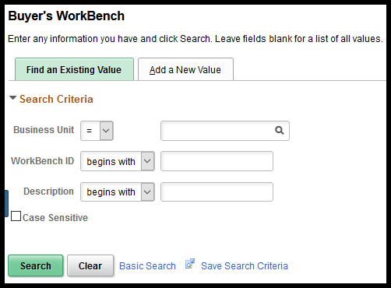
NOTE: Once the WorkBench ID has been created, this ID can be used for subsequent closure activity by clicking the Find an Existing Value tab, selecting the Search button and selecting the WorkBench ID that was created.
The user is taken to the Reconciliation Workbench - Filter Options page that provides several methods to search for POs, such as range of PO ID numbers, Supplier ID, or Buyer.  Searches may also be conducted based on PO status. For example, users may want to select POs that have been Fully Received and have an Open Encumbrance. | 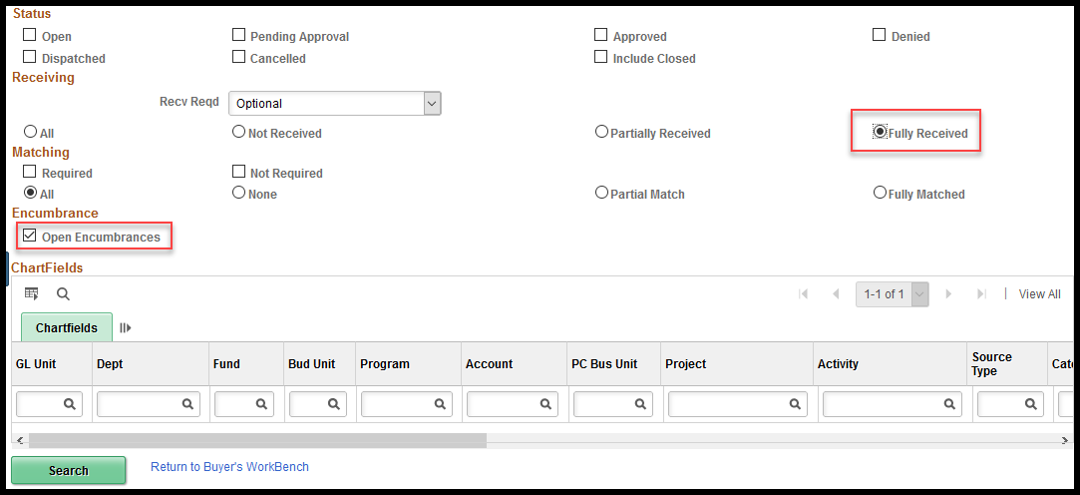
A specific PO or range of POs can also be inserted into the Search Criteria. | 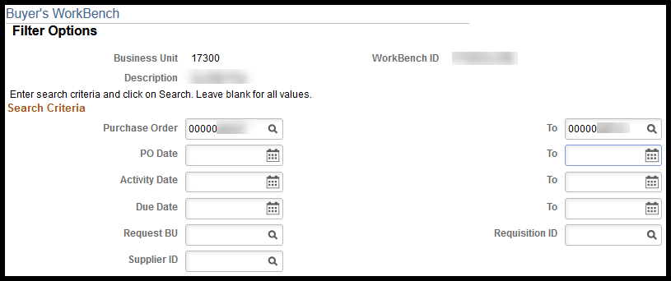
Manually Closing Purchase Order(s)
Search results are displayed on a new page. POs may be selected individually or with the Select All link. Once the desired POs are selected, enter a Description near top of page and click the Close button. | 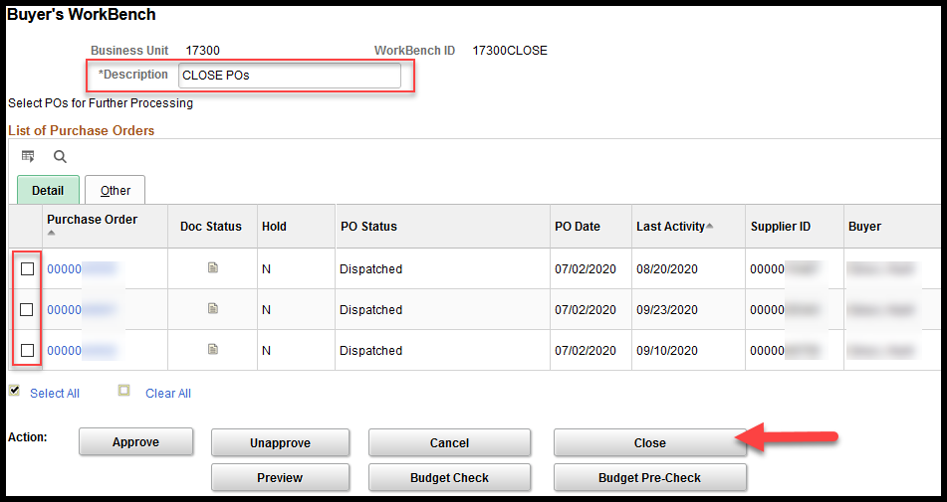
Any POs that meet the system criteria for closure will appear in the Qualified box (on right). Others not meeting system criteria, such as not being 90 days since last activity date, will appear under the Not Qualified box. | 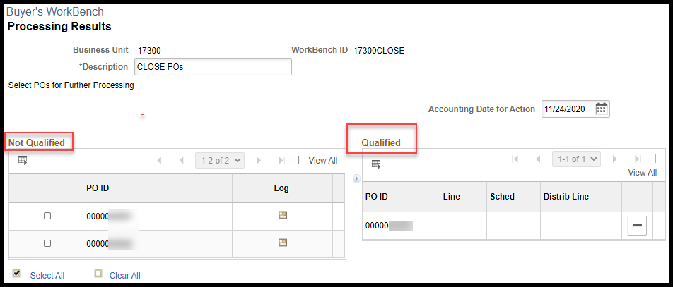
Not Qualified POs may be manually moved to the Qualified box by selecting the desired POs, then clicking the arrow icon between the boxes. | 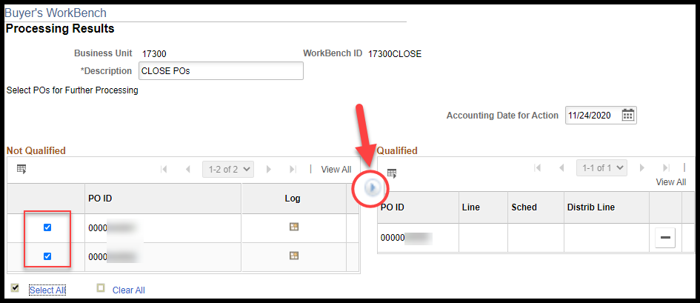
After clicking the arrow icon, POs will be located in the Qualified box. Click the Yes button to proceed with closing the POs. | 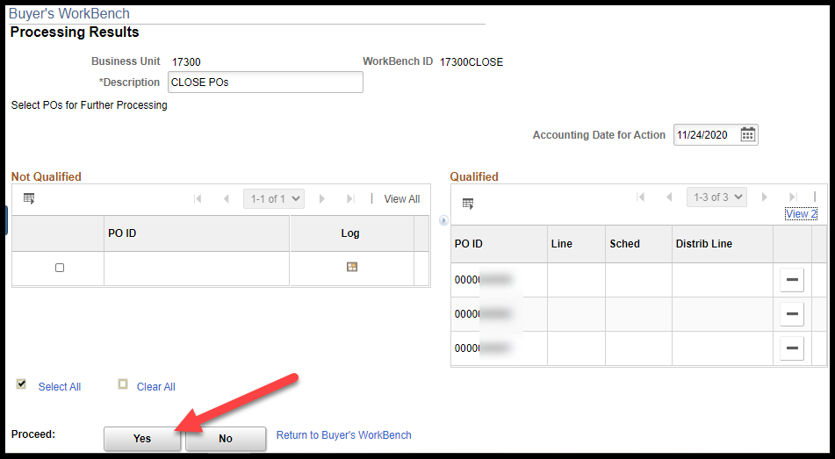
Select Yes on the pop-up message box. | 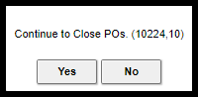
NOTE: Users should LEAVE the Accounting Date as the defaulted date.
The system may process for several seconds. When complete, the selection page will display with the updated status. | 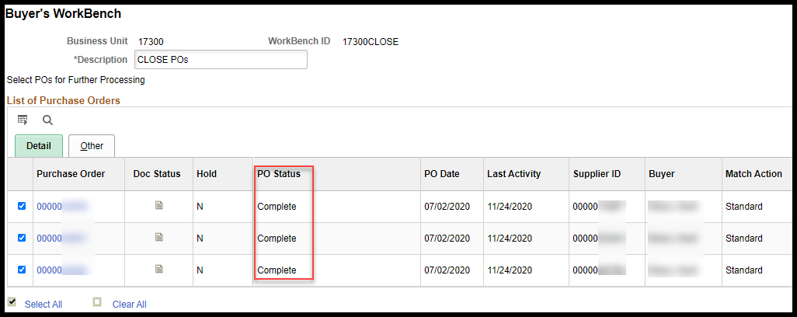
NOTE: The closed POs will now have a status of Complete. This process places the PO Budget Status in Not Checked status. Once the next Budget Check batch process runs, the encumbered funds will be released and the Budget Status will change to Valid.
NOTE: If the PO is connected to a Project and the Project chartfields or chartfield combinations have been Inactivated the PO will not pass the Budget Check process and will not release encumbered funds.
Manually Closing a Single PO Line
From the search results page, select the Lines icon in the far-right column for the desired PO. | 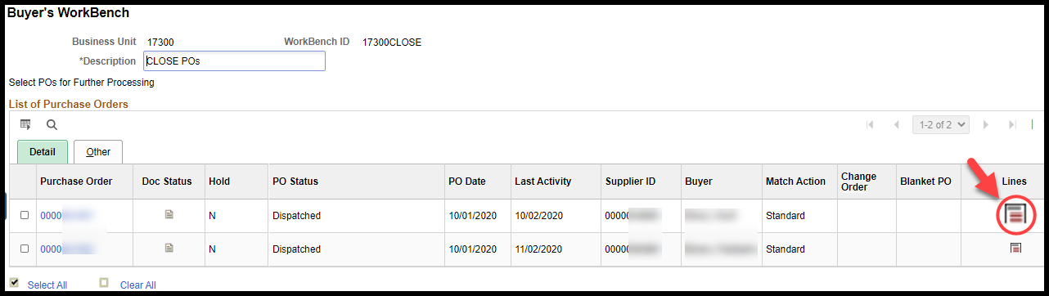
This opens the Purchase Order Lines page. Select the PO line(s) to be closed and then select the Return to Buyer’s Workbench link. | 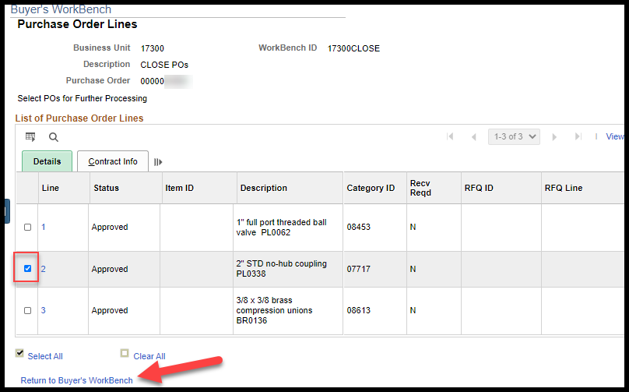
The check box in front of the PO with the selected line should be selected. Click the Close button. | 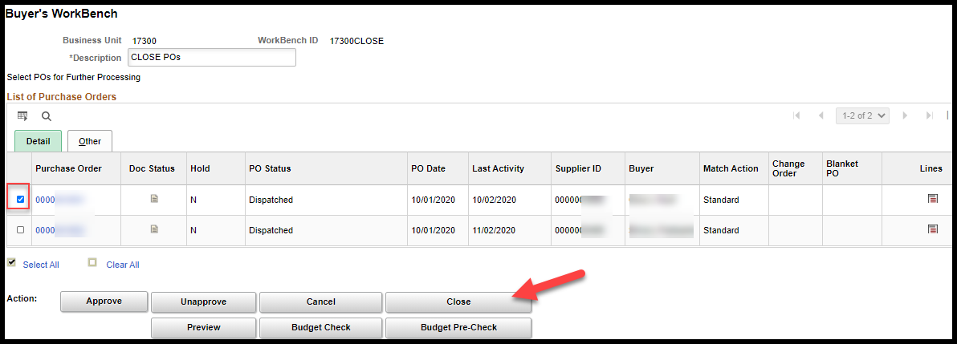
Select the check box in front of the PO ID and then select the arrow icon between the two tables. | 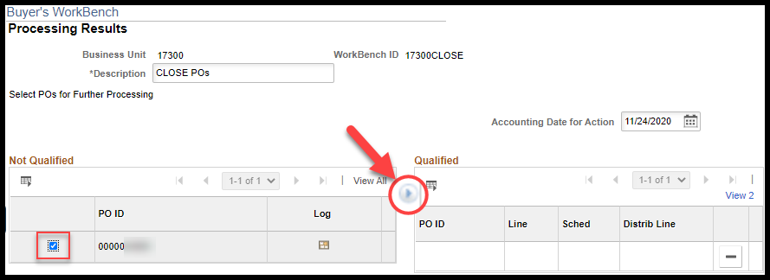
Select Yes to proceed with closing. | 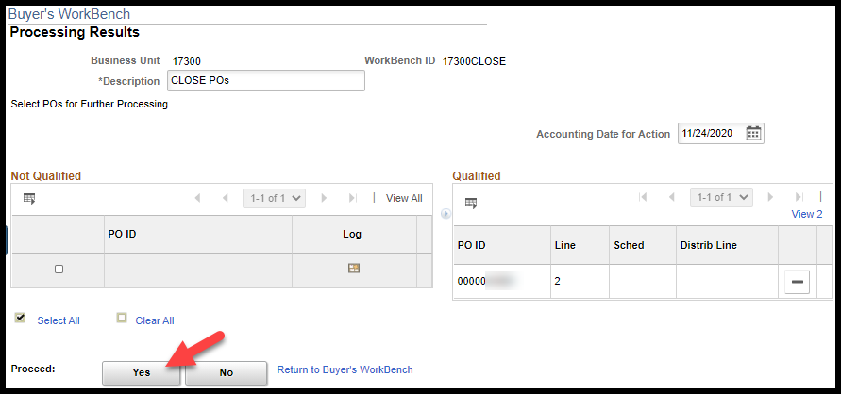
Select Yes on the pop-up message box.
The system may process for several seconds. When complete, the selection page will display the PO Status will remaining the same. Select the Lines icon to view the Line Status. | 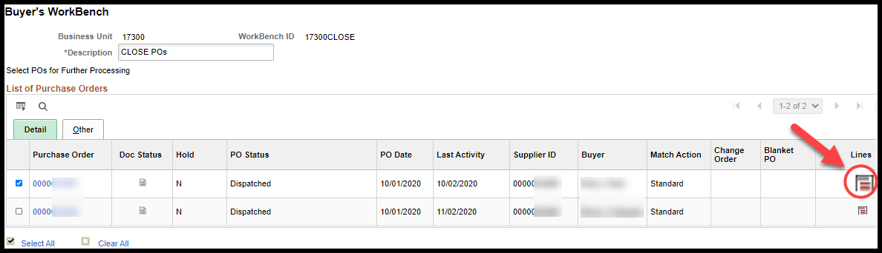
The status for line 2 of this PO now shows as Closed. | 

