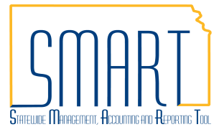
State of Kansas
Defualt Buyer ID BYRDFLT
Statewide Management, Accounting and Reporting Tool
Date Created: | 11/05/2015
Version: | 2.0
Last Updated Date: | 11/4/2020
Why is the Buyer ID on my PO showing as BYRDFLT? | The Buyer ID is a required field so that SMART can source a requisition to a Purchase Order. If the Requestor does not have a defined Buyer or the Buyer ID is left blank on the requisition SMART populates BYRDFLT as the Default Buyer ID.
If the BYRDFLT Buyer ID Appears on a PO
- If an agency discovers that a PO has been sourced from a requisition using the BYRDFLT Buyer ID, the agency can submit a ManageEngine Service Request specifying the correct Buyer ID to be used.
To Prevent the Default Buyer ID from Appearing on Future POs
Submit a SMART Security Access Form for an Agency Requisitioner and be sure to include the Default Buyer’s Name and their User ID.  This will ensure that the Buyer ID is populated when the Agency Requisitioner submits the requisition. | 