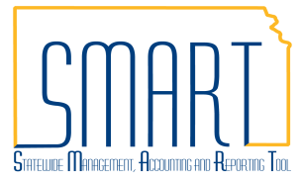
State of Kansas
Create Requisition
Request Options Summarization
Statewide Management, Accounting and Reporting Tool
This job aid provides an overview of the Request Options available for a requisition.

The Create Requisition page has several Request Options to choose from. Each are discussed below in more detail.
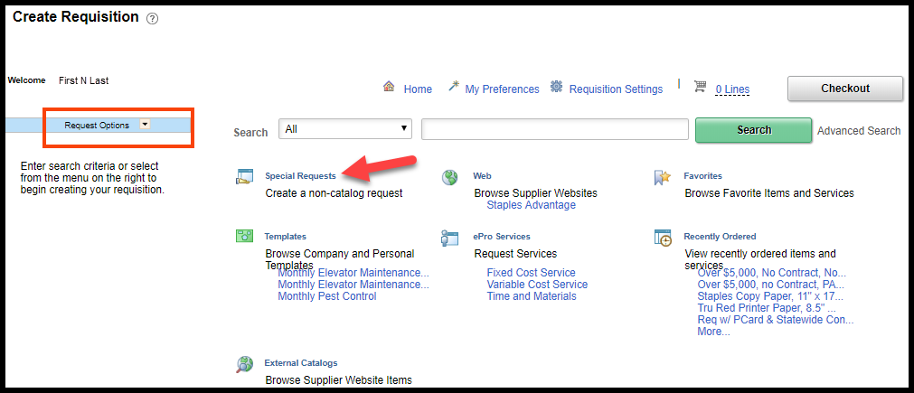
Create Requisition – Special Requests link

The Special Requests link is used by agencies to place an order for items and/or services.
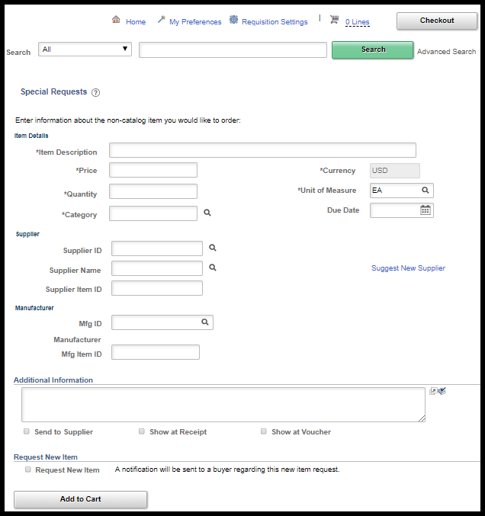
Create Requisition – Special Requests page
Fields | Description
Item Description | Use the Item Description field to enter a description of the item you are requesting. Field length is 254 characters (including spaces and punctuation).
Price | Use the Price field to enter the price of the item you are requesting (= price per unit of measure)
Quantity | Use the Quantity field to enter the quantity of the item(s) you are requisitioning.
Unit of Measure | Use the Unit of Measure field to enter the unit of measure (UOM) for the item(s) you are requesting. If you do not know the UOM, click the LookUp button to view and select from a list of available options.
Category | When creating a requisition in SMART, you MUST populate a Category code. Use the Category field to enter the Category code number for the item(s) you are requisitioning.  Note: Category codes are mapped to Account Chartfield codes in SMART. If you do not know the Category code, click the LookUp button to view and select from a list of available options. It is the agencies responsibility to ensure that the Account code that defaults in is appropriate for their purchase.
Due Date | Manually enter the desired due date or click on the Calendar Page icon to select a date from the Calendar.
Supplier ID | When creating a Special Request in SMART, you need to populate a Supplier ID unless the requisition is intended to go out for bid. If you do not know the Supplier ID number, click the LookUp button to view and select from a list of available options.  Note: Supplier ID’s are maintained by Central. If you cannot locate the Supplier ID, please work with your agencies Buyer to find the correct Supplier ID or get a Supplier ID established.
Supplier Item ID | Use the Supplier Item ID field to enter a Supplier’s reference or product number for the item. For example: The number/reference that the Supplier uses in their catalog.  This is an optional field in SMART.
Mfg ID | Use the Mfg ID field to enter the manufacturer’s ID number in SMART. If you do not know the Mfg ID number, click the LookUp button to view and select from a list of available options.  This is an optional field in SMART.
Mfg Item ID | Use the Mfg Item ID field to enter the manufacturer’s reference or product number for the item. For example SKU (Stock Keeping Unit) number.  This is an optional field in SMART.
Additional Information | Use the Additional Information field to enter any additional information about the item.  This field is a free text field and is optional in SMART.
Send to Supplier | Use the Send to Supplier checkbox to display the Additional Information text to the vendor on the purchase order.
Show at Receipt | Use the Show at Receipt checkbox to display the Additional Information text at the receipt in SMART
Show at Voucher | Use the Show at Voucher checkbox to show the Additional Information text at the voucher in SMART (Accounts Payable process)
Request New Item | The State of Kansas is not using this functionality. Please do NOT select the Request New Item checkbox.
Add to Cart button | Once you have completed entering all information into the Special Item request form, click the Add to Cart button to have SMART transfer the special item information to the Review and Submit page.

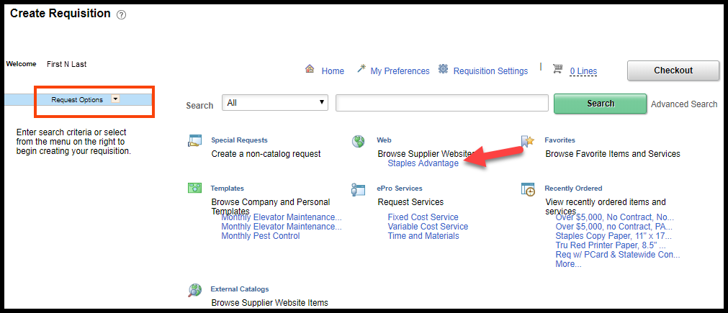
Create Requisition – Web link

The Web link is used to procure directly from a specific supplier. Each supplier listed on the Web link has a direct connection built to the State of Kansas, which allows agencies to click a link, and then access, view, add to cart, and checkout from the supplier’s catalog and inventory online.

At this time, the only Supplier listed on the Web link is Staples Advantage. The State of Kansas has a Statewide Contract with this supplier to purchase certain office supplies.

After ‘shopping’ and ‘checking out’ on the Staples website, you are returned to the ‘Review and Submit’ page of the requisition. The items you selected from Staples appear on this page, and from there you can review, edit, and finalize certain requisition information.

For additional information regarding placing orders with Staples using the Web link, please refer to the ‘Creating Requisitions Using Staples Advantage’ training document located on the SMART website at:

https://www.smartweb.ks.gov/training/purchasing#Requisitions

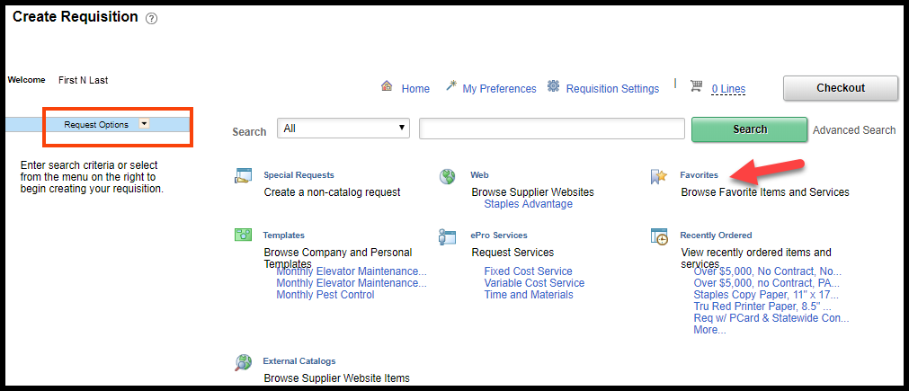
Create Requisition – Favorites link

The Favorites link is a great efficiency tool provided in SMART for Requisitioners to use. The Favorites link provides a quick way to insert individual requisition lines for items or services in to a requisition.

A Favorite item may be created in SMART to save items or services which are purchased frequently AND whose price does NOT change on a regular basis.

Note: Favorites are stored by Requester in SMART.

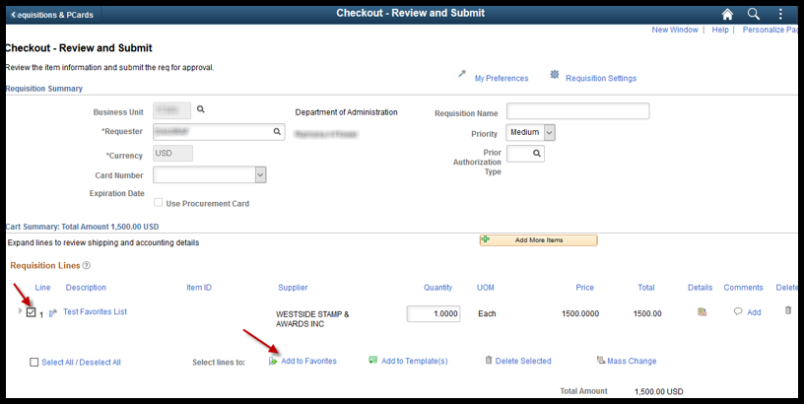
Adding to Favorites
Items and/or Services that are selected may be saved to a Requester’s Favorites. This item selection is performed on the ‘Review and Submit’ page of the requisition: at the requisition line level, using the item selection checkboxes located to the left of each requisition line.

After selecting the desired items and/or services, the select the Add to Favorites icon. The selected line items/services are then saved to the Requester’s Favorites list, and become available for future use (by ANY agency Requisitioner that is entering a requisition for that Requester).

Note: Do NOT add items or services that experience regular price changes or fluctuations. For example, Staples office supplies prices change quarterly.

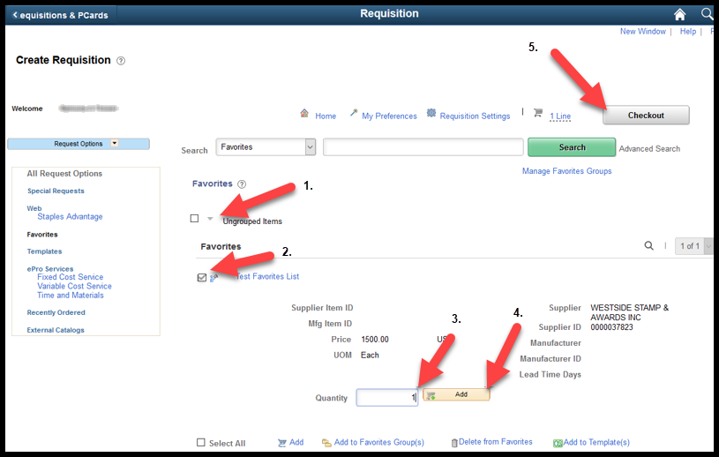

Applying Favorites

Favorites are a fantastic efficiency tool to use in SMART and can help expedite the entry of future requisitions in SMART.

- Click the Expand icon (right facing triangle icon), located to the left of each Favorite in the list to view details. Clicking the Expand button opens the information for each Favorite, and changes the right facing arrow icon to a downward facing arrow icon.

- Select the item using the item selection checkbox located to the left of the Favorite line.

- Manually change the Quantity to the quantity desired. (Alternatively, you can edit the quantity on the ‘Review and Submit’ page of the requisition later).

- Click one of the Add button located on the Favorites page. (Clicking the Add button adds the items/services to the requisition lines).

- Select Checkout button to be taken to the ‘Review and Submit’ page to view the added items/services at the requisition line level.

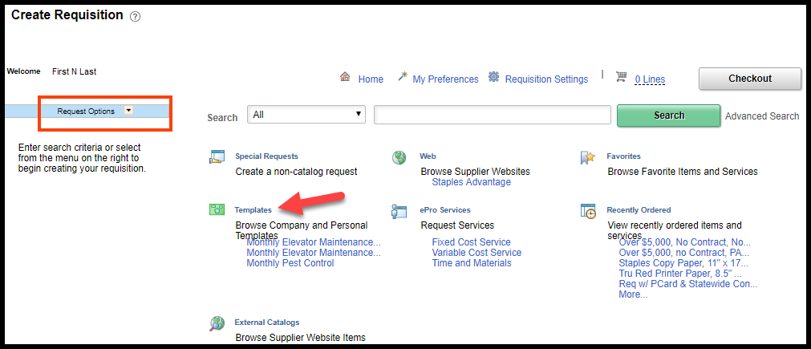

Create Requisition – Templates link

The Templates link is a great efficiency tool provided in SMART for Requisitioners to use. The Template link provides a quick way to insert multiple requisition lines for items or services in to a requisition.

Templates may be created in SMART to save items or services which are purchased frequently AND whose price does NOT change on a regular basis.

Note: Templates are stored by Requester in SMART.

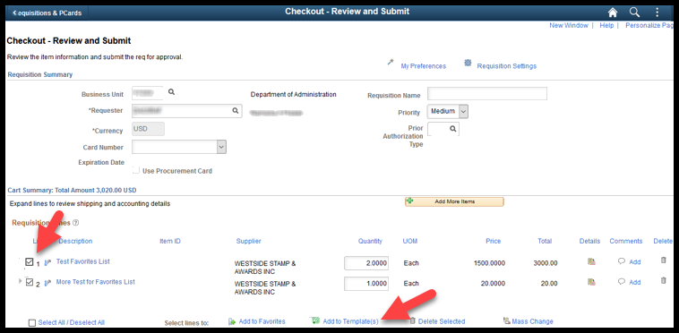

Adding to Templates

Items and/or Services that are selected may be saved together as a group known as a Template. This item selection is performed on the ‘Review and Submit’ page of the requisition: at the requisition line level, using the item selection checkboxes located to the left of each requisition line.

After selecting the desired items and/or services, the Add to Template(s) icon is clicked. The selected line items/services are then saved to the Requester’s Templates list and become available for future use (by ANY agency Requisitioner that is entering a requisition for that Requester).

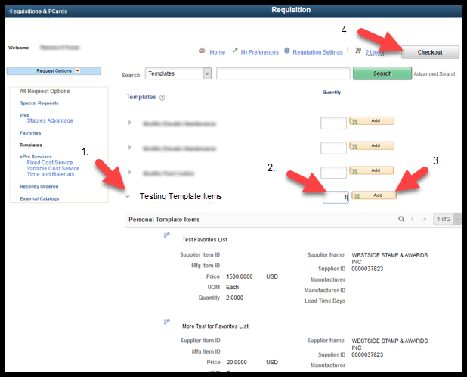

Applying Templates

Templates are a fantastic efficiency tool to use in SMART and can help expedite the entry of future requisitions in SMART.

- Click the Expand icon (right facing triangle icon), located to the left of each Template in the list. Clicking the Expand button opens the information for each Template and changes the right facing arrow icon to a downward facing arrow icon.

- Manually change the Quantity if desired. (Alternatively, you can edit the quantity on the ‘Review and Submit’ page of the requisition later).
  - Note: It is important to know and understand that when a template is first created and saved, SMART saves the Quantity of the items/services within the Template. If your template was set up with a Quantity of more than ‘1’, then SMART will multiply the Quantity by the value you enter in to the ‘Quantity’ field on the Template page!

- Click one of the Add button located on the Templates page. (Clicking the Add button adds the items/services to the requisition lines).

- Select Checkout button to be taken to the ‘Review and Submit’ page to view the added items/services at the requisition line level.

Create Requisition – ePro Services link

There are several Special Request options available under the ePro Services link.

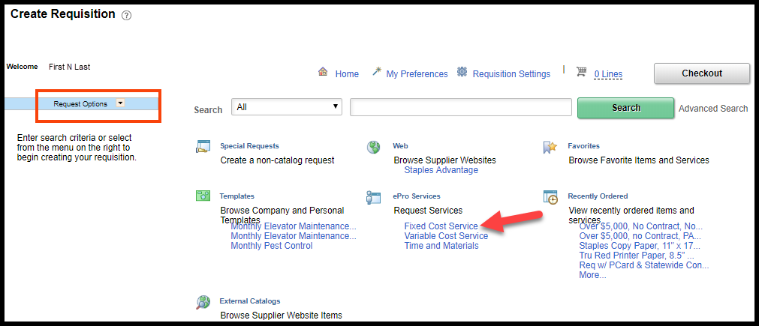

Create Requisition – ePro Services – Fixed Cost Service link

The Fixed Cost Service option can be used when purchasing a service for which the pricing will not change.

For example, pest control services. Typically, pest control services have a fixed monthly cost per site, such as $100.00 per site / per month.
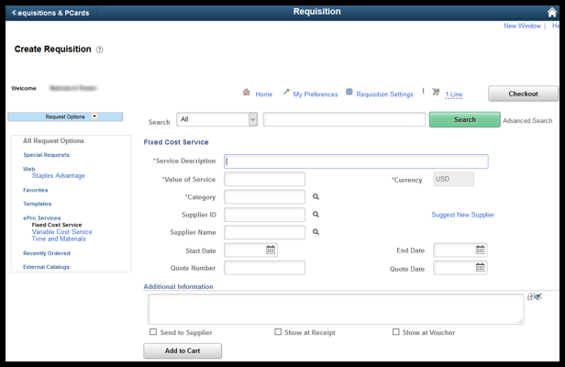
Fields | Description
Service Description | Use the Service Description field to enter a description of th item you are requesting. Field length is 254 characters (including spaces and punctuation).
Value of Service | Use the Value of Service field to enter the cost of this service. This amount is saved on the requisition line with the quantity 1 and the unit of measure Each.
Category | When creating a requisition in SMART, you MUST populate a Category code. Use the Category field to enter the Category code number for the item(s) you are requisitioning.  Note: Category codes are mapped to Account Chartfield codes in SMART. If you do not know the Category code, click the LookUp button to view and select from a list of available options. It is the agencies responsibility to ensure that the Account code that defaults in is appropriate for their purchase.
Supplier ID | When creating a Fixed Cost Service in SMART, you need to populate a Supplier ID. If you do not know the Supplier ID number, click the LookUp button to view and select from a list of available options.  Note: Supplier ID’s are maintained by Central. If you cannot locate the Supplier ID, please work with your agencies Buyer to find the correct Supplier ID or get a Supplier ID established.
Start Date | Use this field to enter the start date of service.
End Date | Use this field to enter the ending date of service.
Quote Number | Use this field to enter the Quote Number received from the vendor providing the service. This is an optional field in SMART.
Quote Date | Use this field to enter the date that the Quote was received from the vendor. This is an optional field in SMART.
Additional Information | Use this field to enter any additional comments for the special request

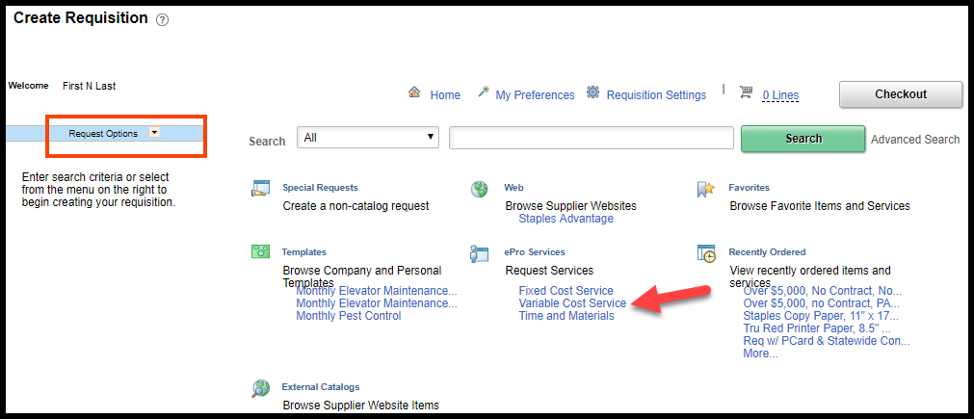

Create Requisition – ePro Services – Variable Cost Service link

The Variable Cost Service option can be used when purchasing a service for which the fee is based upon time worked.
For example, temporary staffing. Typically, temporary staffing has a fixed hourly rate, and the number of hours to be worked varies.

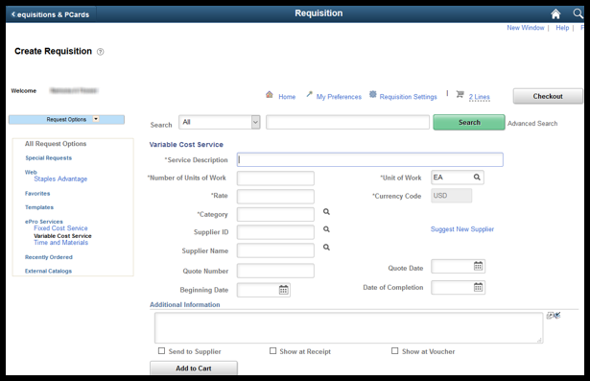

Fields | Description
Service Description | Use this field to specify details about the service that you are requesting.
# of Units of Work | Use this field to enter the time that is needed to complete the service, based on the unit of work. For example, 2 hours or 6 days.
Unit of Work | Use this field to enter the number of measured time-based units of work needed for the service.
Rate | Use this field to specify the unit price for this service, based on the unit of work.
Category | When creating a requisition in SMART, you MUST populate a Category code. Use the Category field to enter the Category code number for the item(s) you are requisitioning.  Note: Category codes are mapped to Account Chartfield codes in SMART. If you do not know the Category code, click the LookUp button to view and select from a list of available options. It is the agencies responsibility to ensure that the Account code that defaults in is appropriate for their purchase.
Supplier ID | When creating a Variable Cost Service in SMART, you need to populate a Supplier ID. If you do not know the Supplier ID number, click the LookUp button to view and select from a list of available options.  Note: Supplier ID’s are maintained by Central. If you cannot locate the Supplier ID, please work with your agencies Buyer to find the correct Supplier ID or get a Supplier ID established.
Quote Number | Use this field to enter the quote number given to you by the Vendor.
Beginning Date | Use this field to enter the beginning date of service.
Date of Completion | Use this field to enter the ending date of service.
Additional Information | Use this field to enter any additional comments for the special request.

