
State of Kansas
ManageEngine for Requesters
Statewide Management, Accounting and Reporting Tool

Date Created: |  | 04-10-17
Version: |  | V 1.2
This document covers three areas:
- How to submit a Service Desk ticket.
- How to find an existing ticket.
- Forgotten passwords.
- Reopening a CLOSED ticket

1.1 | First, using the appropriate email address and password, log in to the Help Desk at:  https://sokdahelpdesk.ks.gov/ | 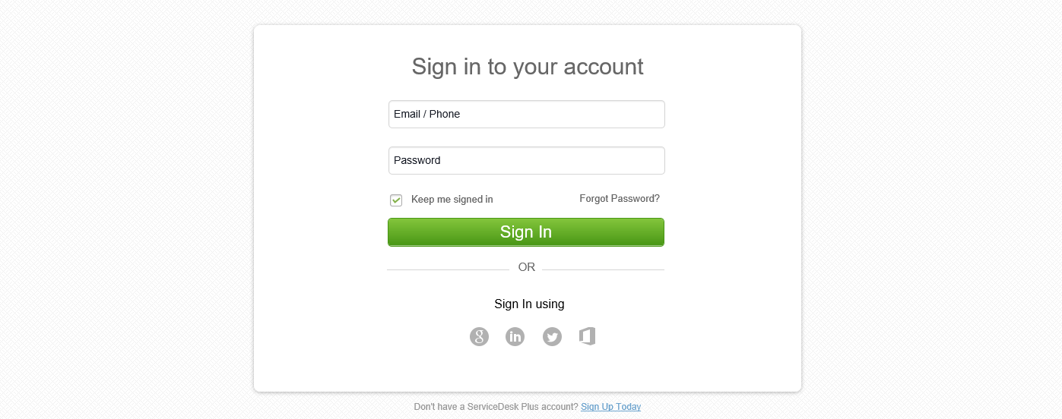
1.2 | At the Home screen, select Create an Incident.  OR  Open the New Request drop-down menu. If a template has been created for the request type, select it from the list; otherwise, select Default Request.  A template can also be selected after choosing ‘New Incident’. | 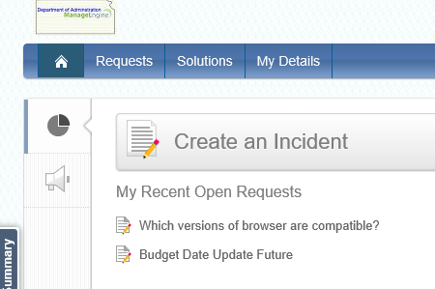  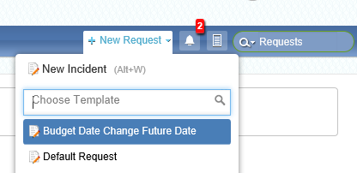  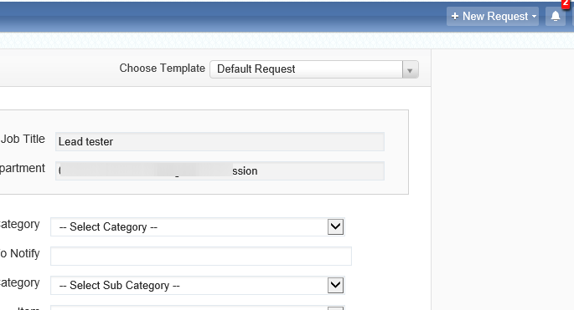
1.3 | A template will have many of its fields already filled with information appropriate to the request, though some fields may still need to be manually completed.  Aside from the Requester’s Details, a Default Request will be entirely blank. | 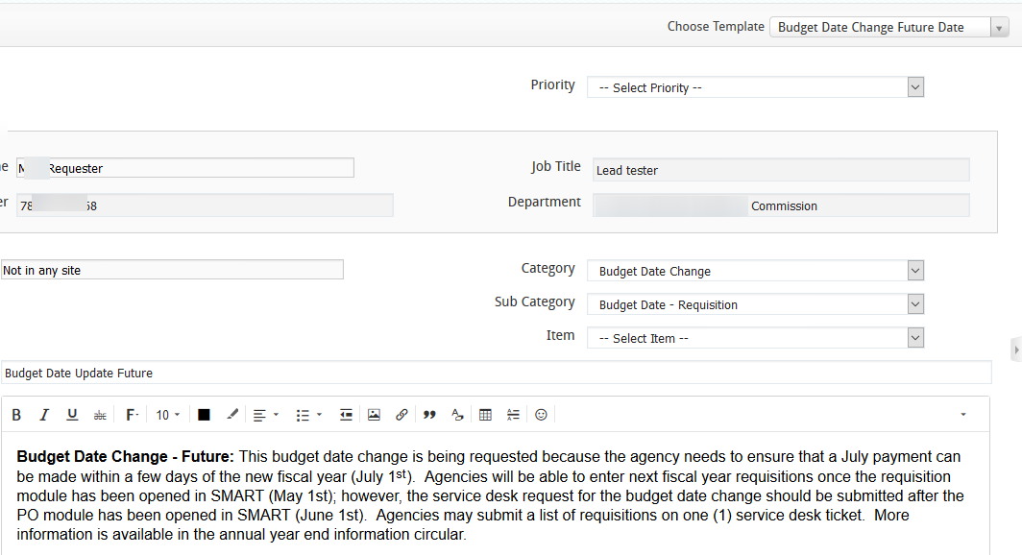
1.4 | From the drop-down Category menu, select the category that most accurately fits the request.  Once a category has been selected, repeat the process with the Subcategory menu. | 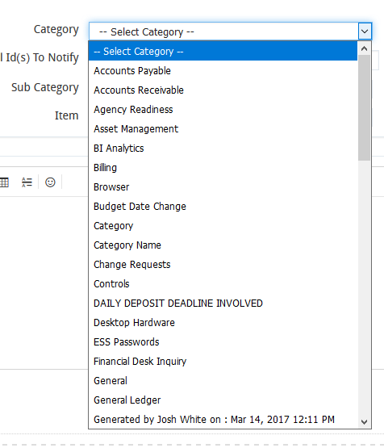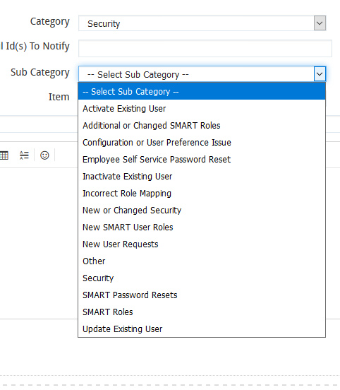
1.5 | In the Subject line, create a subject that provides a succinct and accurate summary of the request.  If this is an extremely high priority or emergency request, please indicate so in the subject. | 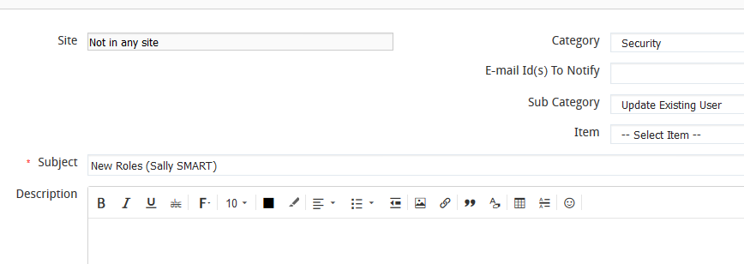
1.6 | If a template was used, it may be necessary to scroll up through the pre-filled Description field, as additional information relevant to your request may be required.  Otherwise, the nature of the request should be described within in as much detail as is necessary to avoid miscommunication. | 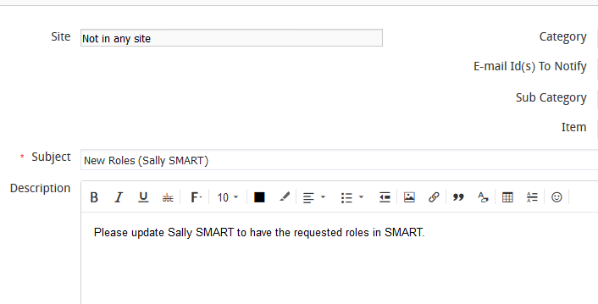
1.7 | If any forms or other supporting documents are required, they may be attached to the request via the Attach File feature. | 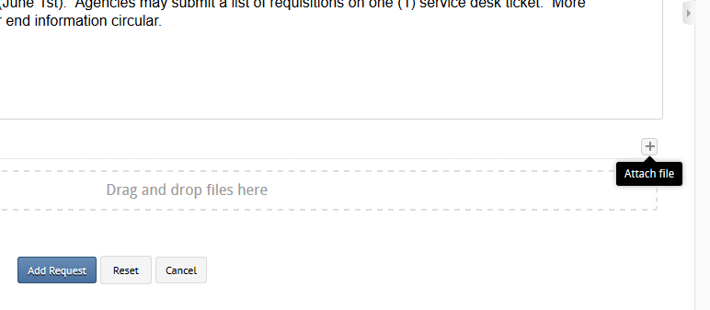
1.75 | Files will need to be attached to the request one at a time by selecting the desired file through Attach File, then selecting Open. | - 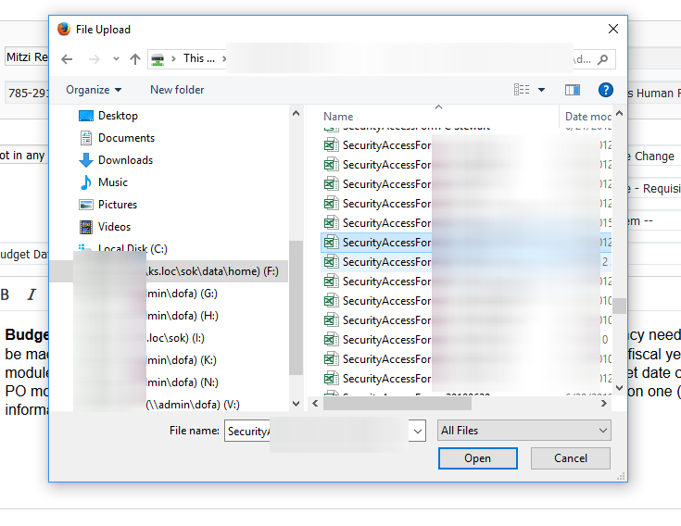
 | Alternatively, files can be attached by dragging and dropping their icons into the designated area. | 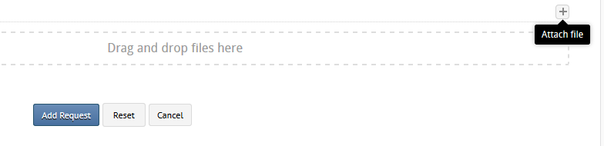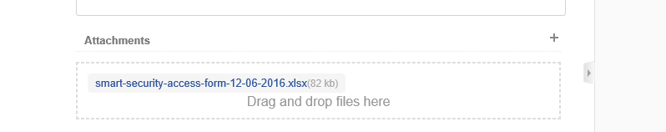
1.8 | As the requester, the individual submitting the ticket will automatically be provided with e-mail updates regarding the progress of the request.  Other parties can be included in these communications by entering the desired address in the “E-mail Id(s) To Notify” field. | 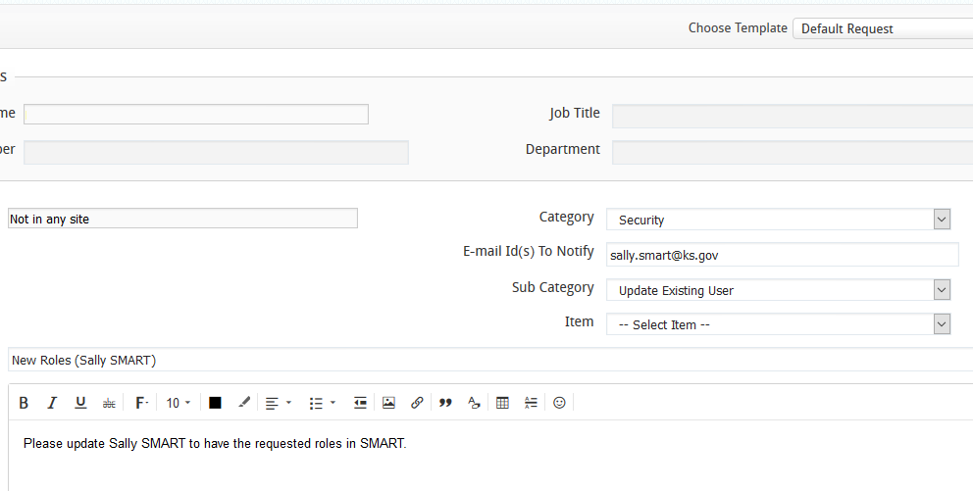
1.9 | Once all necessary files have been attached, submit the request by selecting Add Request.  As the requester, the individual submitting the ticket will automatically be provided with e-mail updates regarding the progress of the request.  The EMAILS will come from sokdahelpdesk.ks.gov/.  PLEASED REPLY TO THE EMAILS WITH AN EMAIL!!! You will receive emails from sokdahelpdeskl.ks.gov. This is ManageEngine and is the manner in which the tool is trying to communicate to you. When you reply via email, your reply will be added to the Conversations section in your ticket in ManageEngine.  Please do not reply within the ManageEngine ticket/tool. | 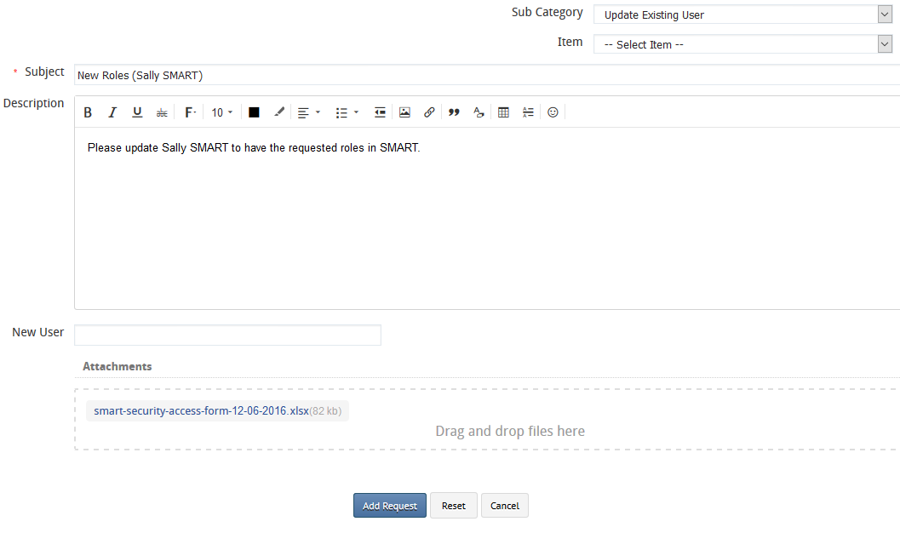  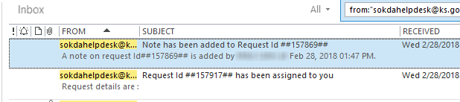  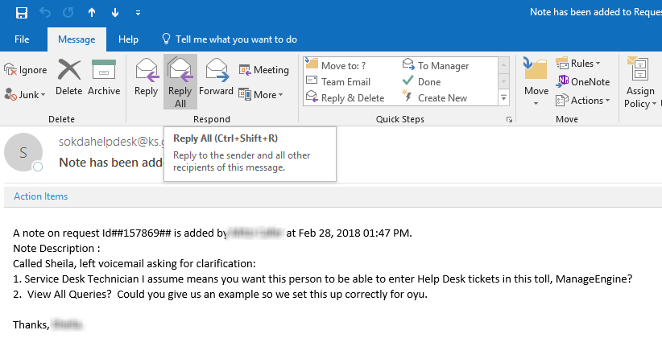
How do I find an existing ticket?
2.1 | There are two methods available for searches and can be accessed on the Requests tab.
2.2 | The first is done by clicking on the dropdown arrow next to the magnifying glass. Type in a keyword for the search, in this example, the search is for tickets containing the word ‘function’. | 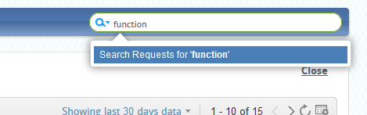
2.3 | The result is ticket 141553 | 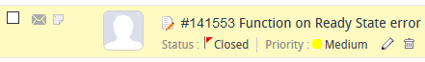
2.4 | The second ‘Search’ function is initiated by clicking on the magnifying glass icon. | 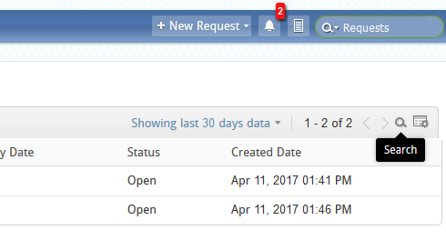
2.5 | The searchable fields will be presented by displaying an empty box. | 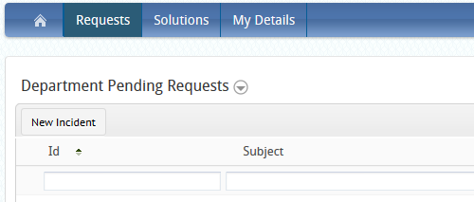  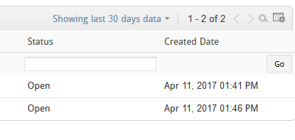
2.6 | Once the known information has been entered, selecting “Go” will present the matching Requests. | 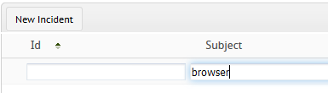  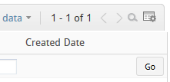
2.7 | This search ‘browser’ topic requests and yielded request ID 20. | 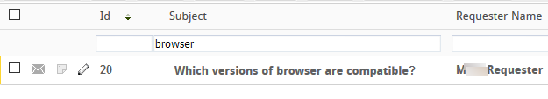
2.8 | Requests can also be filtered into several discrete views based on the status of the Request, for easier browsing.  Click on the drop down box and the options will be presented. | 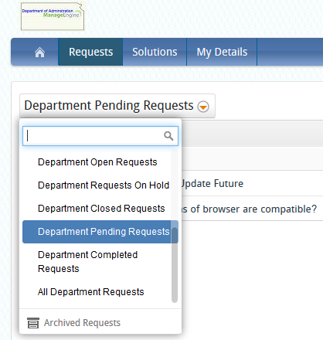
What if I forget my password?
3.1 | An opportunity to set a new password can be requested by selecting the “Forgot Password?” option on the initial login page. | 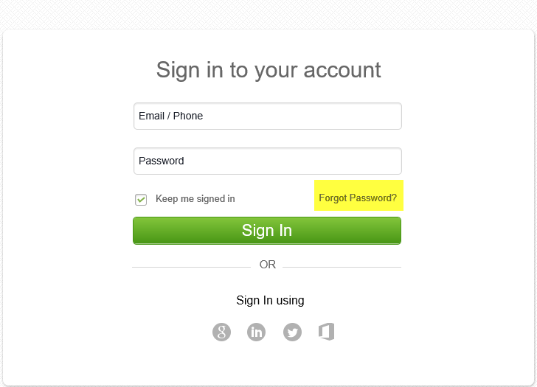
3.2 | You will be prompted to enter your Email and verify a word that is presented. In the example to the right, the word is ‘valaxed’.  Click ‘Request’ | 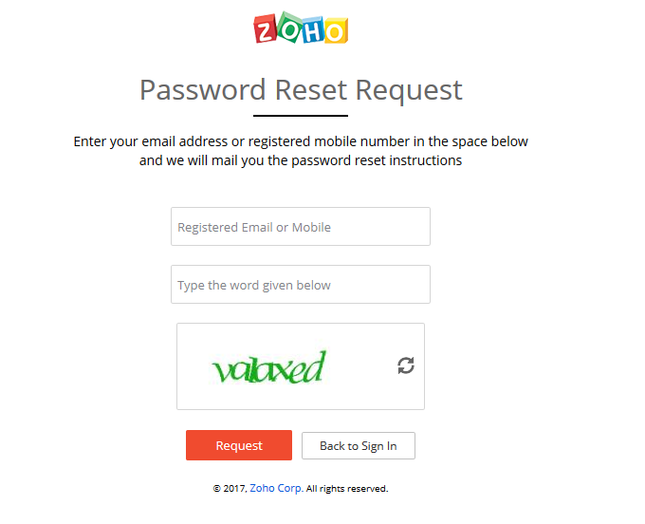
3.3 | A password is sent to your email address. | 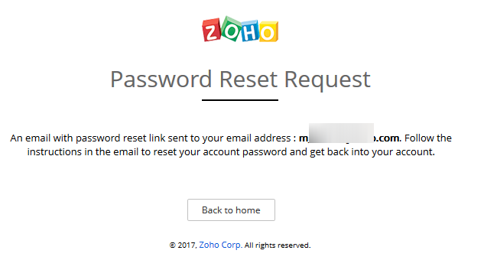
3.4 | Passwords can also be changed from within ManageEngine.  From the drop-down menu in the upper right hand corner, select “My Account”. | 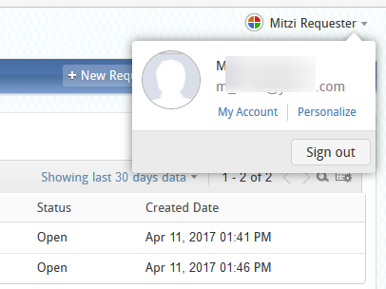
3.5 | The next page presents a variety of personalization options.  To change a password, select Security. | 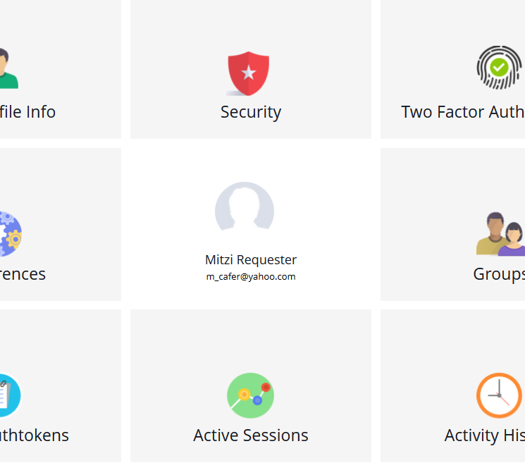
3.6 | After filling the Current and New Password fields, select Save to change the password. | 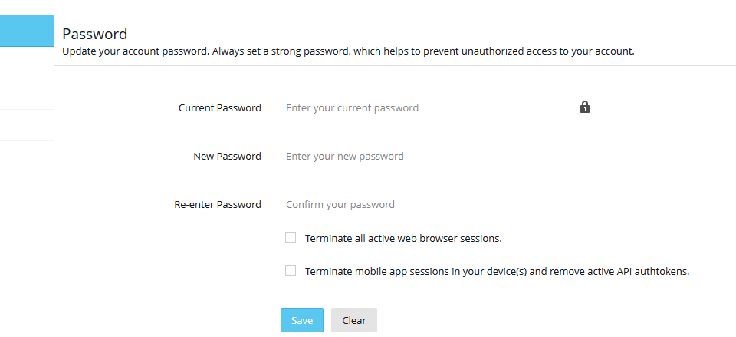
3.7 | For security purposes, you will receive a password change notification Email | 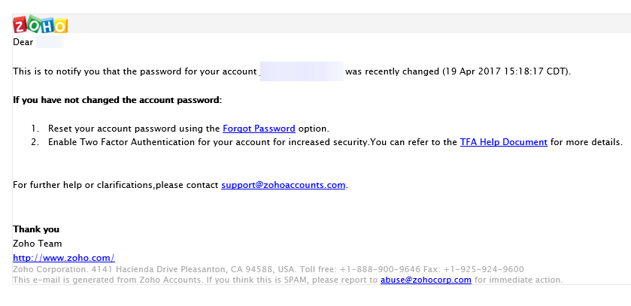
What if I disagree with the resolution and need further discussion with the Technician?
4.1 | When a ticket is completed by the Technician, the Resolution is entered on the Resolution tab. | 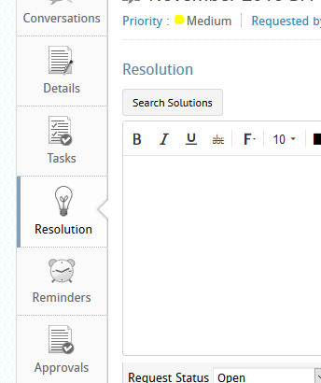
4.2 | The Requester will receive an email from sokdahelpdesk (State of Kansas) containing the Resolution entered. | 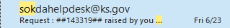
4.3 | By REPLYING to the EMAIL, you will cause the request to be REOPENED.  Replying to the ticket within ManageEngine itself will not reopen the ticket.  DO NOT PERFORM THE REPLY IN THE REQUEST!! | 

