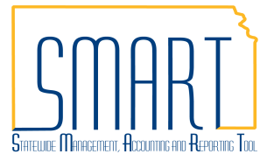
State of Kansas
Update Interfund Personal Detail Pop-up Window
Statewide Management, Accounting and Reporting Tool

Date Created |  | 03/21/2018
Version |  | 2
Last Update |  | 05/24/2019
Security |  | - Role Security: Only those individuals with the following roles will have access to view the interfund vouchers and deposits:  - Agency AR Interfund Processor (KAR_Agy_Interfund_Processor)  - Agency AP Interfund Processor (KAP_Interfund_Processor)  - BU Security: Business Unit Security is applied. Agencies will only have access to the vouchers, deposits, and interfunds associated to their agency business unit.
Purpose |  | Provide instructions to update the name, email address, and telephone number on the Interfund Details Personal Detail pop-up window associated to the Accounts Receivable and Accounts Payable Interfund Processors and Approvers.
Navigation |  | Use any of the following navigations to access the Interfund Details Page:  - Accounts Receivable Homepage > Interfund Details  - NavBar: Navigator > Accounts Receivable > Interfund Details  - Accounts Payable Homepage > Interfund Details  - NavBar: Navigator > Accounts Payable > Interfund Details
1. | Access the Interfund Details Page  Enter the Interfund Id on the Interfund Details page. Click Search.  View the Interfund Details Page  Select the ‘Entered By’ or ‘Approved By’ user ID links in either the Accounts Receivable Interfund Details section or the Accounts Payable Interfund Details section.  Personal Detail for the user displays in a pop-up window  Contact information displayed includes:  - First Name  - Last Name  - Email address  - Telephone number | 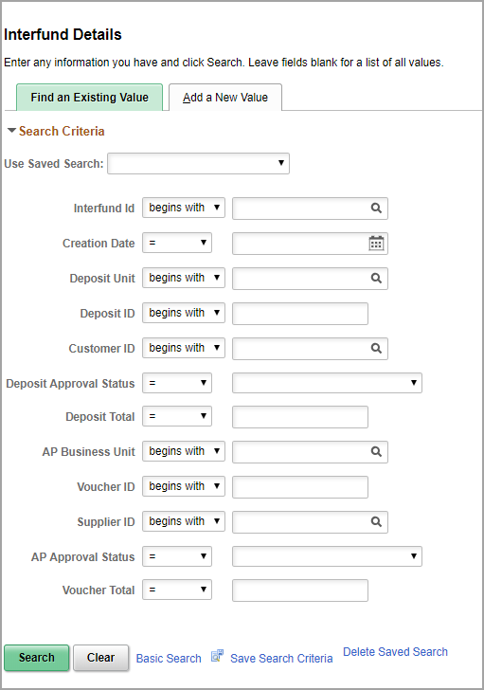  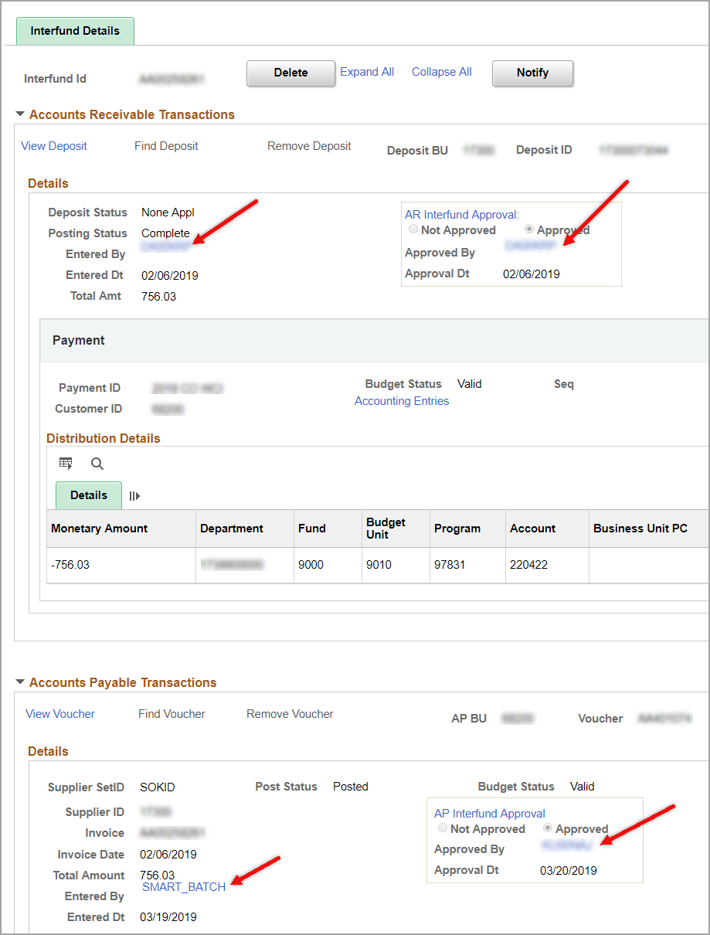  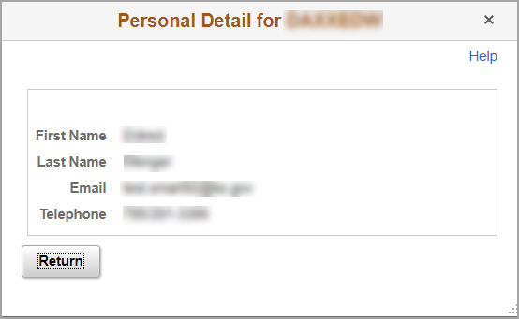
Navigation |  | SMART Homepage > My System Profile > General Profile Information
2. | Update the Email Address  The email address that displays on the Interfund Personal Detail pop-up Window comes from SMART ‘My System Profile’. Click the tile to view details and/or make updates.  The ‘Business’ Email Type is the one associated to the Interfund Personal Detail pop-up window.  This business email address does NOT have to be marked as the primary email account. It can be one of several email accounts on this page, or can be the only email account listed.  This information can be updated by the user by adding or deleting email addresses using the ‘+’ and ‘-’ signs to the right of the email address.  After all updates are completed click ‘Save’. | 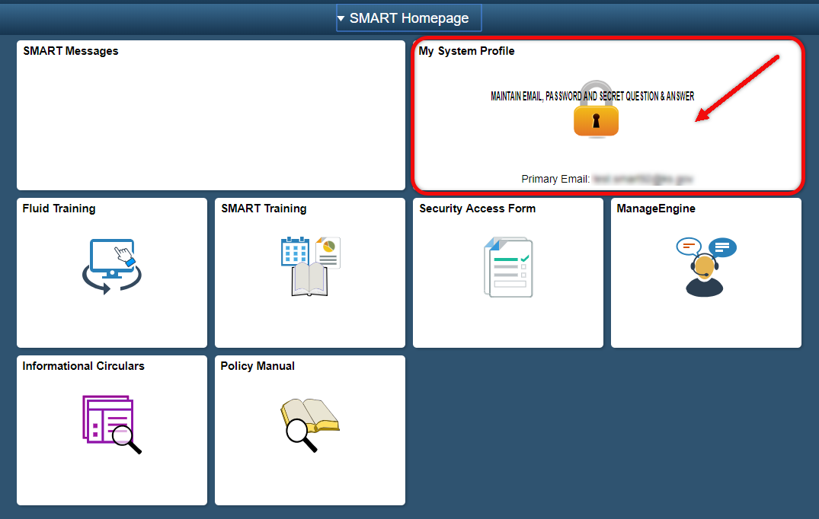  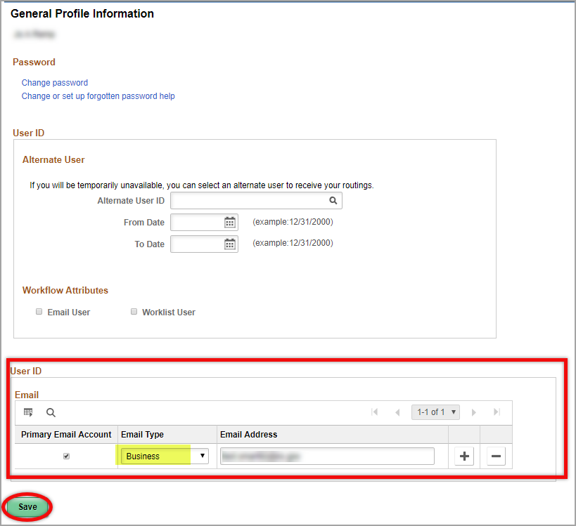

Navigation |  | Access to SHARP will be available to HR staff:  - SHARP Homepage > Workforce Administration Homepage > Maintain Employee Record > Modify a Person  - NavBar: Navigator > SHARP Main Menu > Workforce Administration > Personal Information > Modify a Person > Contact Information Tab
3. | Update the First and/or Last Name  The first name and last name displayed on the Interfund Personal Detail pop-up window comes from SHARP (Statewide Human Resource and Payroll System). If these fields are not correct or do not display, you must contact your agency HR staff and ask that a change be made to your SHARP record.  If your agency HR staff does not have access to update the name in SHARP, the agency HR staff can send an email requesting the update to SHARP@ks.gov. Department of Administration HR staff will update SHARP.  Once the SHARP update has been made, the updated first and last names will display in SMART. | 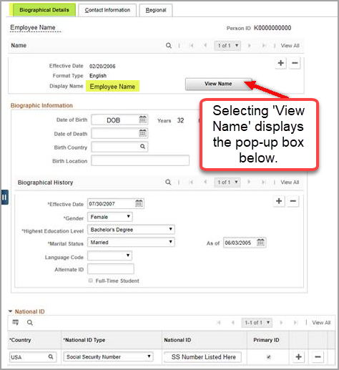  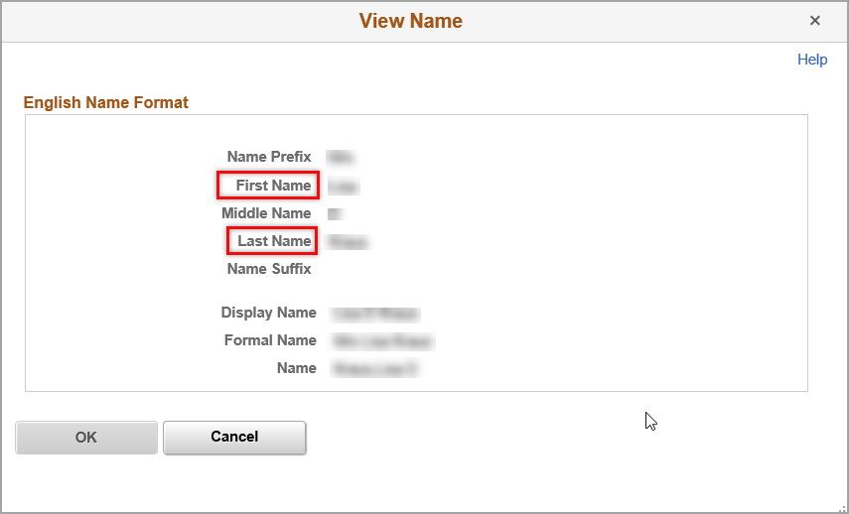

4. | Update the Telephone Number  The telephone number displayed on the Interfund Personal Detail pop-up window comes from SHARP (Statewide Human Resource and Payroll System).  Only the ‘Business’ Phone Type is associated with the Interfund Personal Detail pop-up window.  If there is no ‘Business’ Telephone Number, or if the existing ‘Business’ Telephone Number is incorrect, you must contact your agency HR staff and ask that a change be made to your SHARP record.  If your agency HR staff does not have access to make this Telephone Number update in SHARP, the agency HR staff can send an email requesting the update to SHARP@ks.gov. Department of Administration HR staff will update the SHARP record.  Once the SHARP update has been made, the telephone information will display in SMART. | 