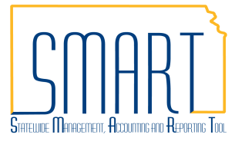
State of Kansas
Matching for Interfund Vouchers
Statewide Management, Accounting and Reporting Tool

Date Created |  | 3/20/2018
Version |  | 1.1
Last Update |  | 05/17/2019
Security |  | - Role Security: Only those individuals with the following roles will have access to view and run Matching on an interfund voucher:  - Agency AP Maintainer (KAP_Agy_AP_Maintainer)  - Agency AP Interfund Processor (KAP_Interfund_Processor)  - BU Security: Business Unit Security is applied. Agencies will only have access to the vouchers and interfunds associated to their agency business unit.
Purpose |  | The matching process for interfund vouchers only runs automatically during the nightly batch processes after both sides of the interfund have been approved. This job aid provides instructions for using the Match Workbench to run matching for interfund vouchers. This will allow users to make sure the interfund vouchers are matched properly and contain no match exceptions before the interfund is approved and sent through the nightly batch.
Navigation |  | Use any of the following navigations to access the Interfund Details Page:  - Accounts Receivable Homepage > Interfund Details  - NavBar: Navigator > Accounts Receivable > Interfund Details  - Accounts Payable Homepage > Interfund Details  - NavBar: Navigator > Accounts Payable > Interfund Details
1. | Check the Match Status of an Interfund Voucher  Before approving the voucher side of an interfund, the approver should ensure that the voucher has an appropriate match status by viewing the voucher attached to the interfund.  - Click the ‘Update Voucher’ hyperlink.  - View the Summary tab of the voucher. If the Match Status is ‘Ready’ OR ‘Exceptions’ do not approve the interfund.  - Click the ‘Cancel’ button after viewing to exit back to the Interfund.  The voucher’s Match Status should be either ‘No Match’ or ‘Matched’ in order to proceed with approving the interfund.  Proceed to:  Step 2 - ‘Ready’ status  Step 3 - ‘Exceptions’ status | 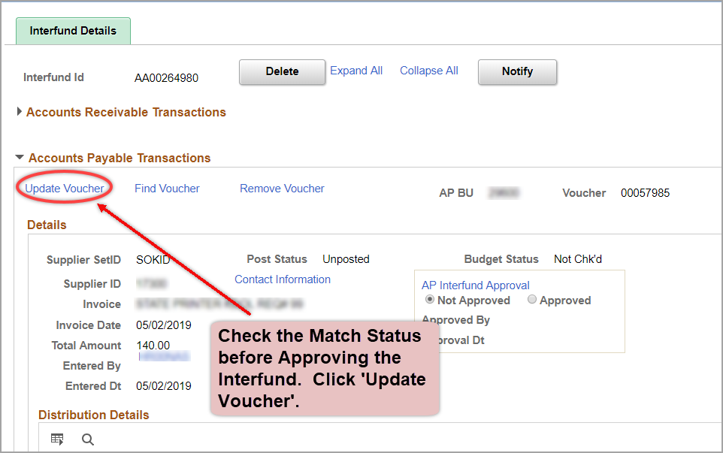  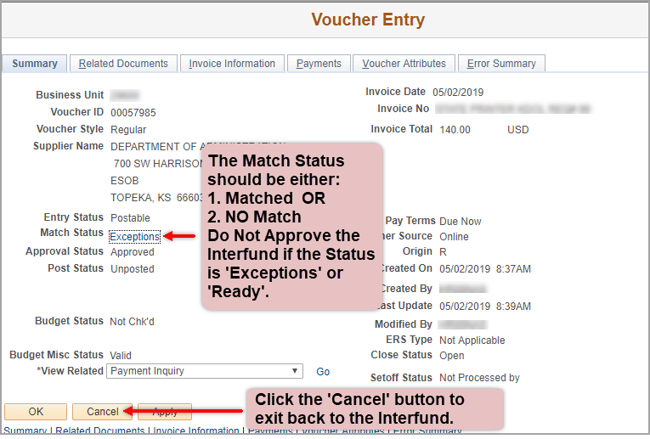
Navigation |  | - Accounts Payable Homepage > Vouchers > Match Workbench  - NavBar: Navigator > Accounts Payable > Review Accounts Payable Info > Vouchers > Match Workbench
2. | Match Status is ‘Ready’: Use the Match Workbench to Run Matching.  Specify search criteria:  Business Unit – Enter your agency’s business unit.  Match Status – Select ‘To Be Matched’ from the drop-down menu.  Voucher ID – Select ‘equal to’ from the drop-down menu. Enter the Voucher ID in the open field.  Click the ‘Search’ button.  - To Match the voucher:  - Check the box next to the voucher.  - Select ‘Matching’ in the Action drop-down menu.  - Click the ‘Run’ button.  - A message will display indicating that ‘Matching has been launched with Process Instance Number 9999999’. Select OK.  - Click the ‘Process Monitor’ link toward the top of the page.  - On the Process List tab, click Refresh periodically until the Run Status and Distribution Status are ‘Success’ and ‘Posted’ on the row corresponding to the Process Instance Number from the pop-up message.  - Navigate back to the Interfund to check the Match Status on the voucher and approve if appropriate. | 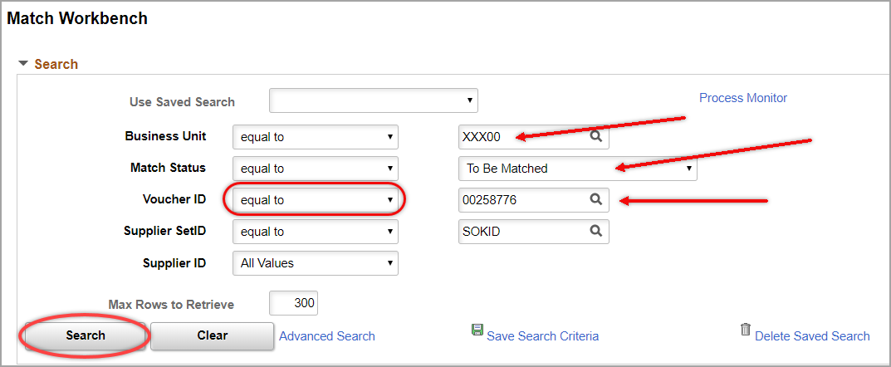  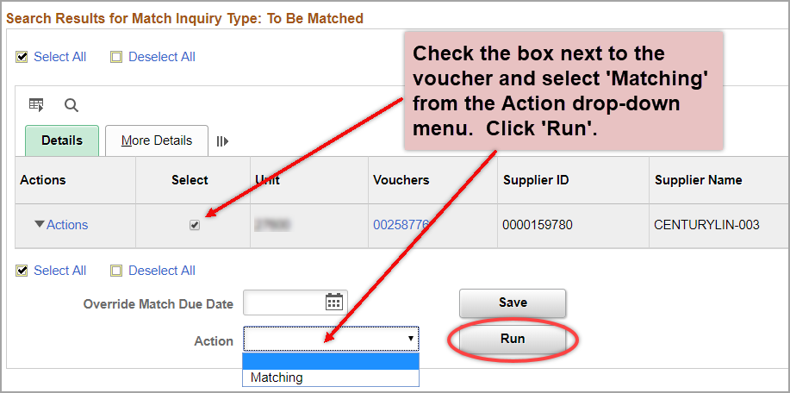  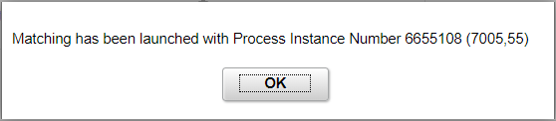  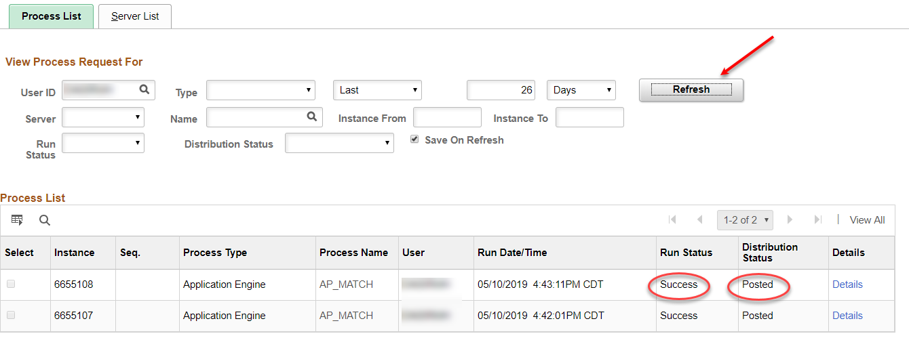
3. | Match Status is ‘Exceptions’: Resolve the exceptions using the Match Exceptions on Vouchers job aid listed on the Accounts Payable Training page. After resolving the exceptions, go through the matching process in Step 2 before approving the interfund.

