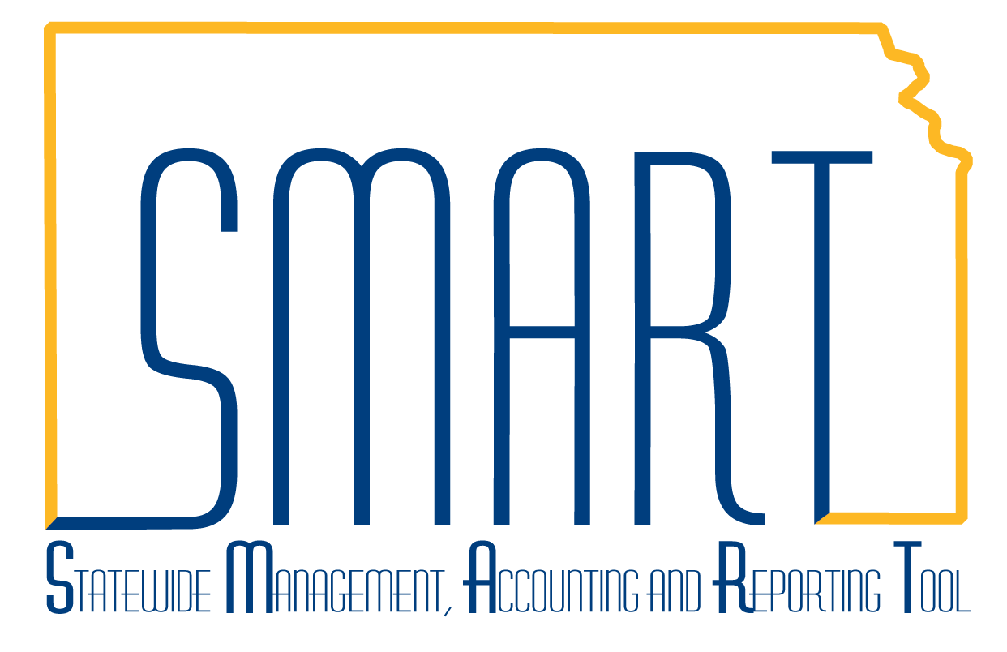State of Kansas
SMART Homepage Guide
Statewide Management, Accounting and Reporting Tool

Date Created: | 3/4/2019
Version: | 1.2
Last Updated Date: | 7/18/2019
Background: | The SMART Homepage is the default landing page for all SMART users upon login. It provides convenient links to many external websites that contain resources for SMART users.
Module Homepage access: | The SMART homepage contains a drop-down menu at the top center of the page, which provides access to the other Module-specific homepages:  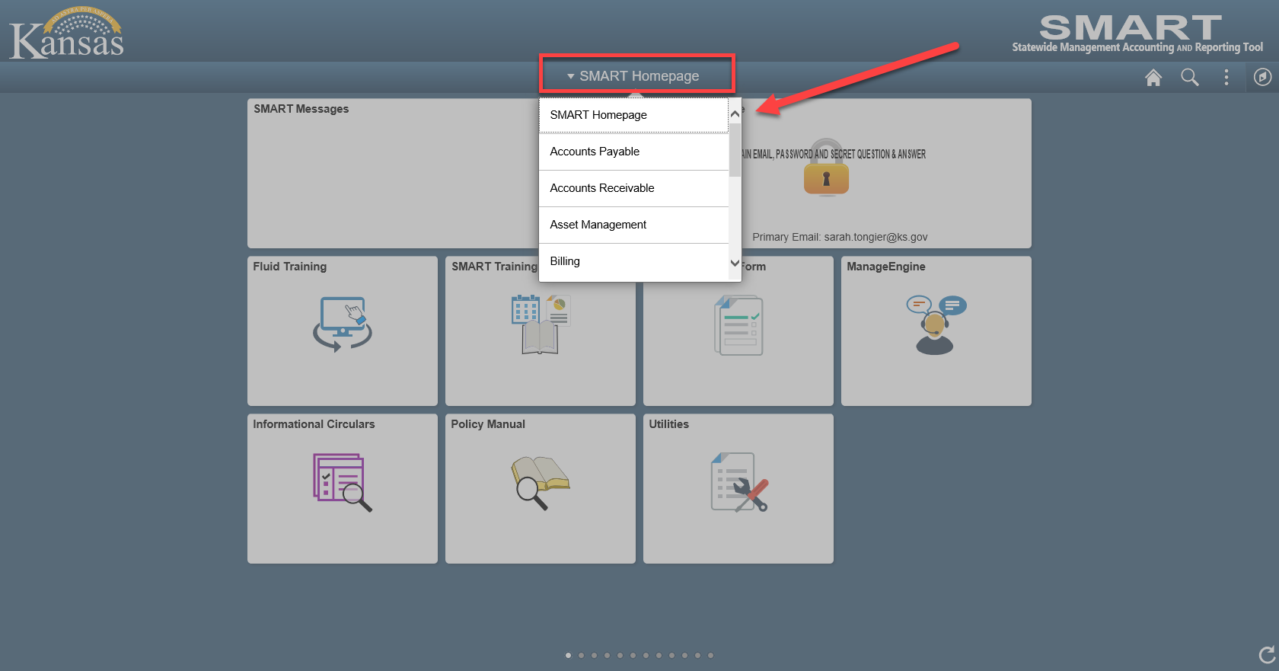
SMART Homepage: | The SMART homepage contains the following tiles:  - SMART Messages  - My System Profile  - Fluid Training  - SMART Training  - Security Access Forms  - ManageEngine  - Informational Circulars  - Policy Manual  - Utilities  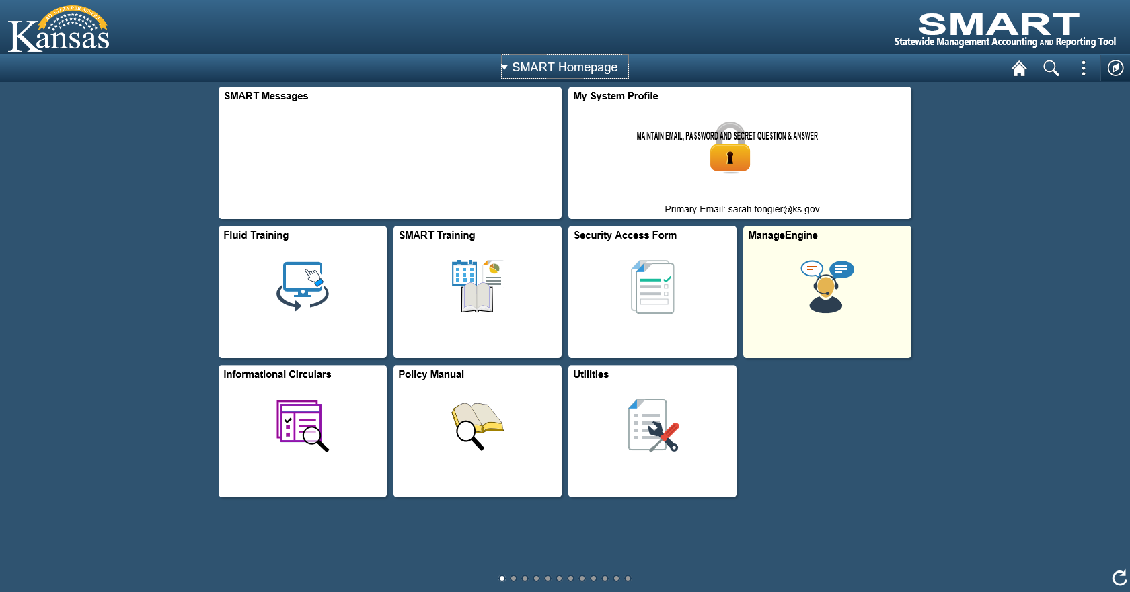
SMART Messages | The ‘SMART Messages’ tile will contain any important messages that need communicated to the entire SMART user community. Unless there is a message that users need to see, this tile will remain blank.
My System Profile | The ‘My System Profile’ tile is a quick link to the user’s individual profile information. This is where email addresses can be updated, passwords can be changed and the Secret Question & Answer used to reset passwords can be maintained.  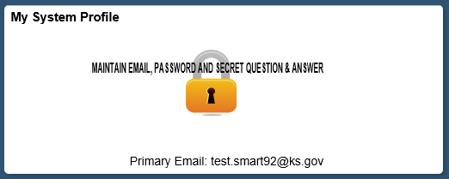  If users have not established a question & answer for resetting their SMART password using the ‘Forgot Password?’ function, then they will only see 1 tile:  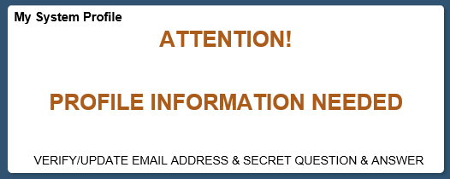  No other tiles will be available until a Secret Question and Answer have been provided.  Click the tile, then click the ‘Maintain Secret Question & Answer used for “Forgot Password”’ link:  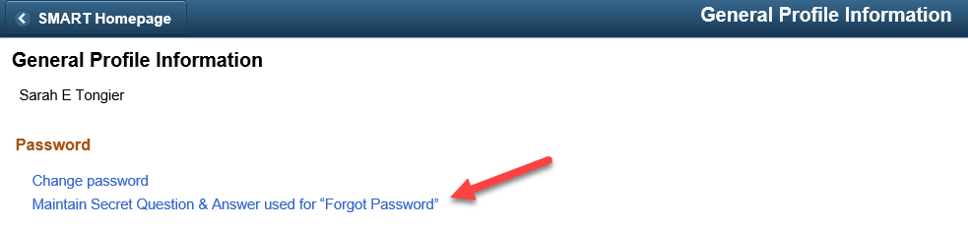  Select a pre-set Question and then provide the answer in the Response field before clicking ‘OK’.  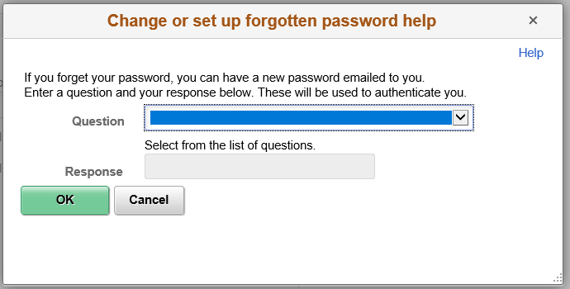

Fluid Training | This tile opens a new window to the Fluid Training page on SMARTWeb.  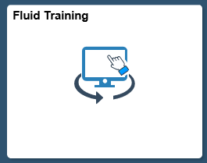
SMART Training | This tile open a new window to the New User Training page on SMARTWeb.  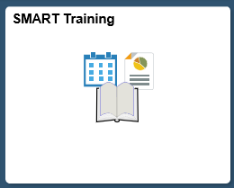
Security Access Form | This tile open a new window to the Security Access Forms page on SMARTWeb.  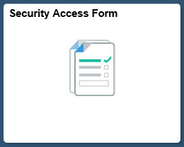

ManageEngine | This tile opens a new window to the ManageEngine Service Desk signon page.  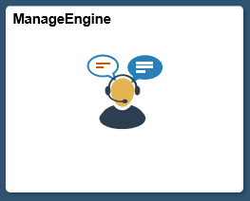
Informational Circulars | This tile opens a new window to the Informational Circulars page of the Department of Administration website.  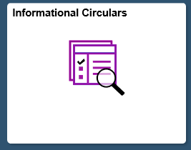
Policy Manual | This tile opens a new window to the Policy Manual page of the Department of Administration website.  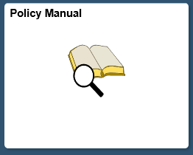

Utilities | This tile allows users to access the Process Monitor, Queries, Report Manager, Worklist, nVision Report Request and BI Analytics.  