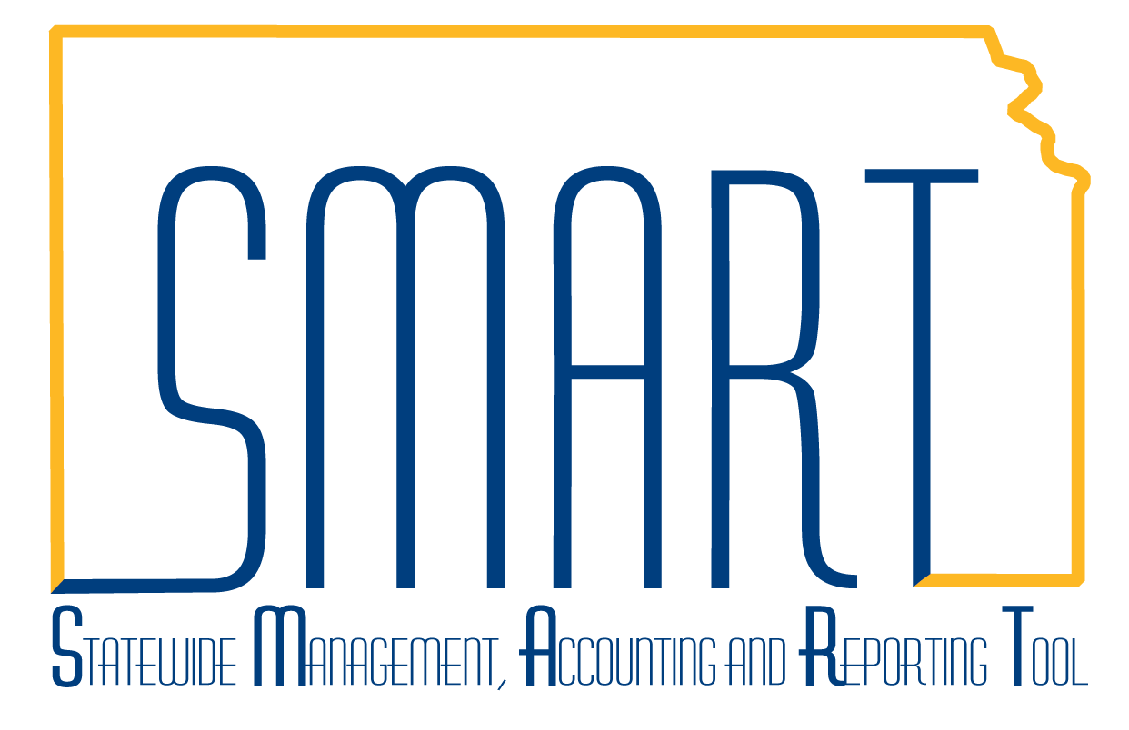
State of Kansas
Project and Grants Homepage Guide
Statewide Management, Accounting and Reporting Tool

Date Created: | 2/19/2019
Version: | 1.0
Last Updated Date: | 2/19/2019
Process: | The Projects and Grants homepage contains the module navigations for Project Costing, Grants, and Customer Contracts and are logical groupings of the most used pages from each module area.
Projects and Grants Homepage  Dependent on the browser being used, the pages may display tiles three across or four across. Cell phones or tablets may only display single or two across.  The collections of pages attached to tiles are ordered to accomplish a particular task, as in creating a Grant or creating a Customer Contract. Miscellaneous tasks are listed further down in a navigation collection or in a separate folder. In those instances where tasks may be completed infrequently, the folder order may be reversed. | 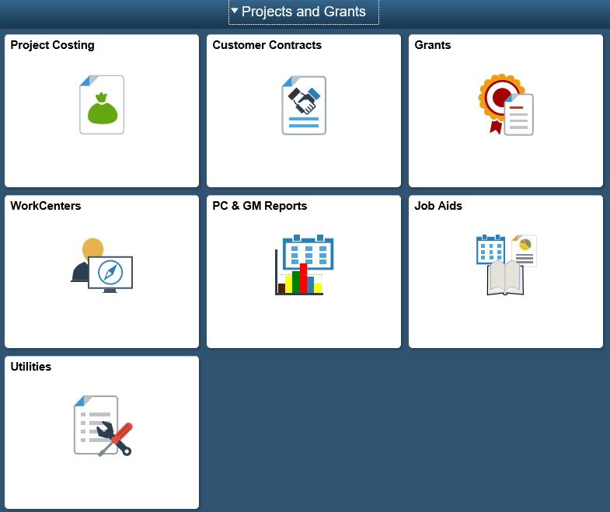
Project Costing  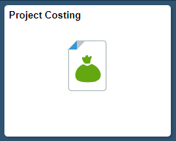  The Project Costing tile, when selected, displays the navigation collection of pages, but opens on the Project Setup folder and opens on the first page listed: General Information.  The folders may be opened or collapsed using the down or up arrows.  Note: The blue box with the || icon may be selected to collaspe the navigation collection on the left. | 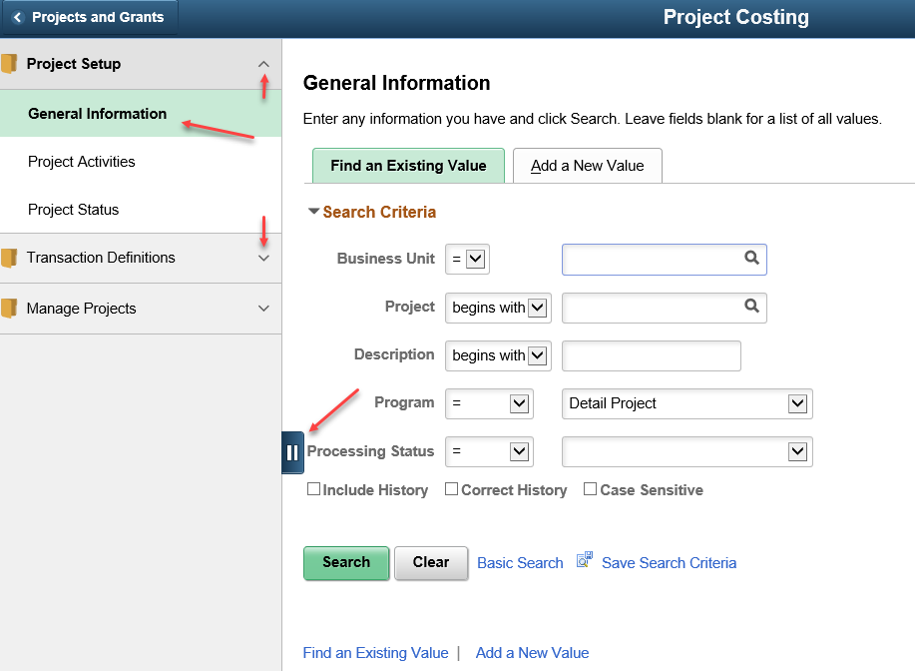
The Project Costing navigation collection contains the following pages, depending on the user’s security access. | 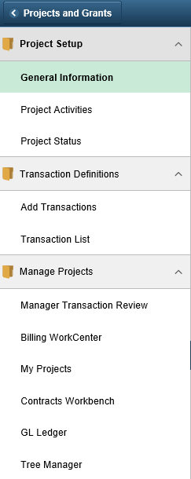
Each folder may contain one or more pages that may or may not be specific to the module area.  For example, the GL Ledger link highlighted is from the General Ledger module, but is very useful for those managing projects and grants. | 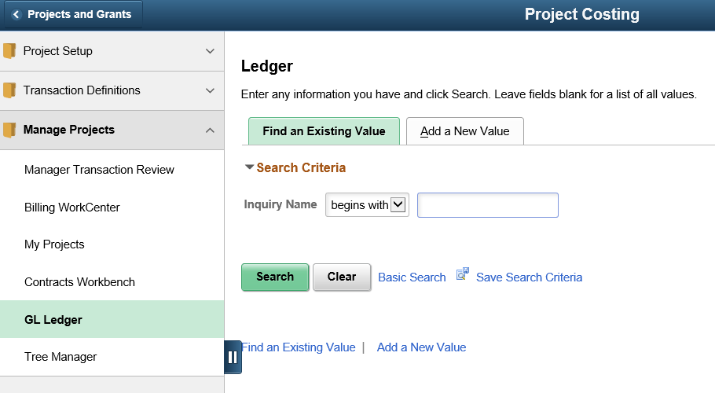
To navigate back to the homepage, select either the the < icon on the left or the home icon on the right. | 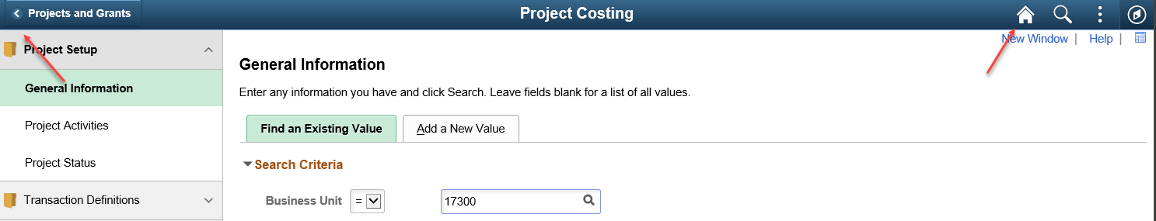
Customer Contracts  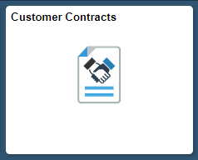  After selecting the Customer Contracts tile, the page opens with the “My Contracts” page displayed. | 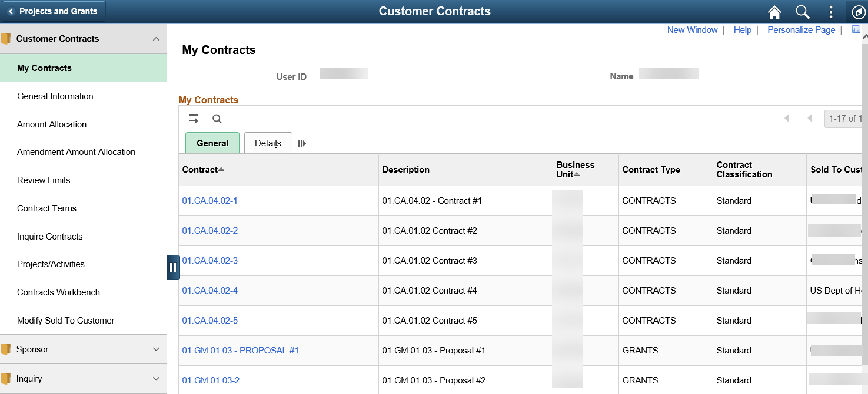
The next selection is the General Information page, which will open in a new window. | 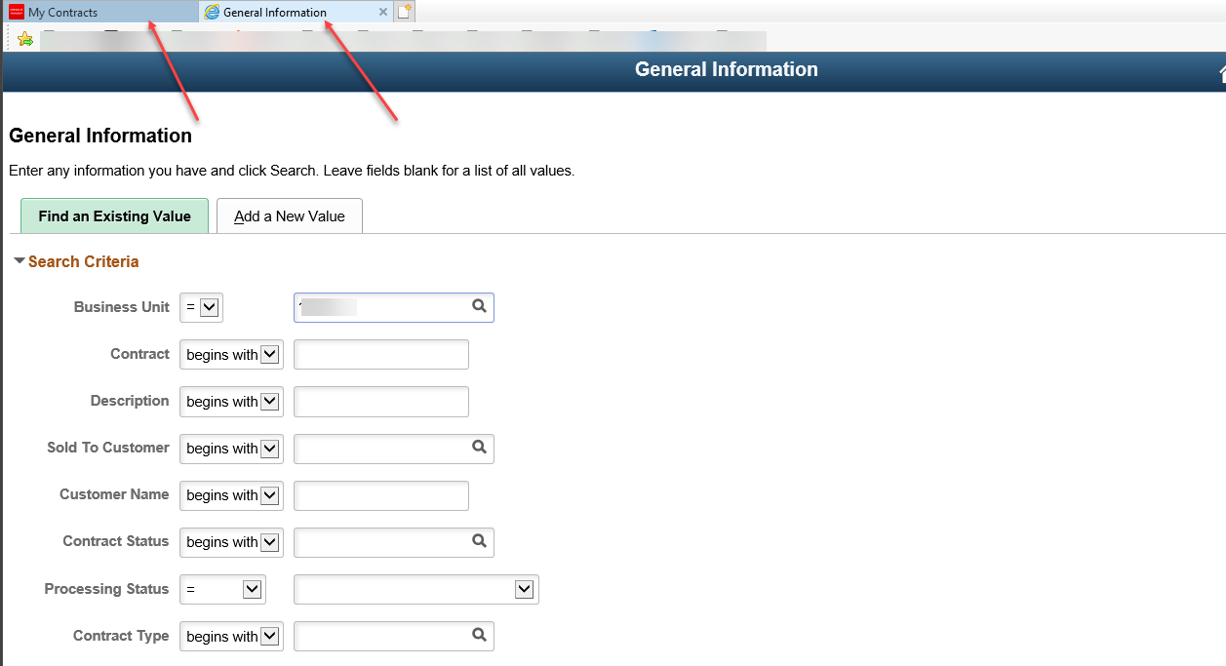
The Customer Contracts navigation collections contains the following pages: | 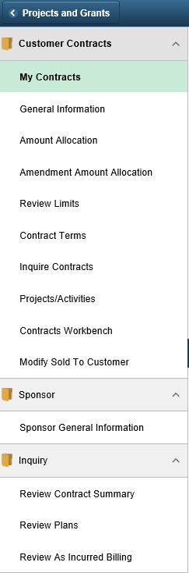
Grants  The Grants tile and navigation collection are grouped according to task, such as Creating a Grant. | 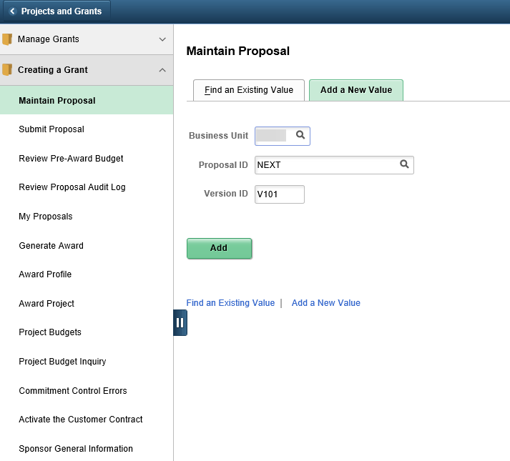
The Manage Grants folder contains pages used in managing a Grant. | 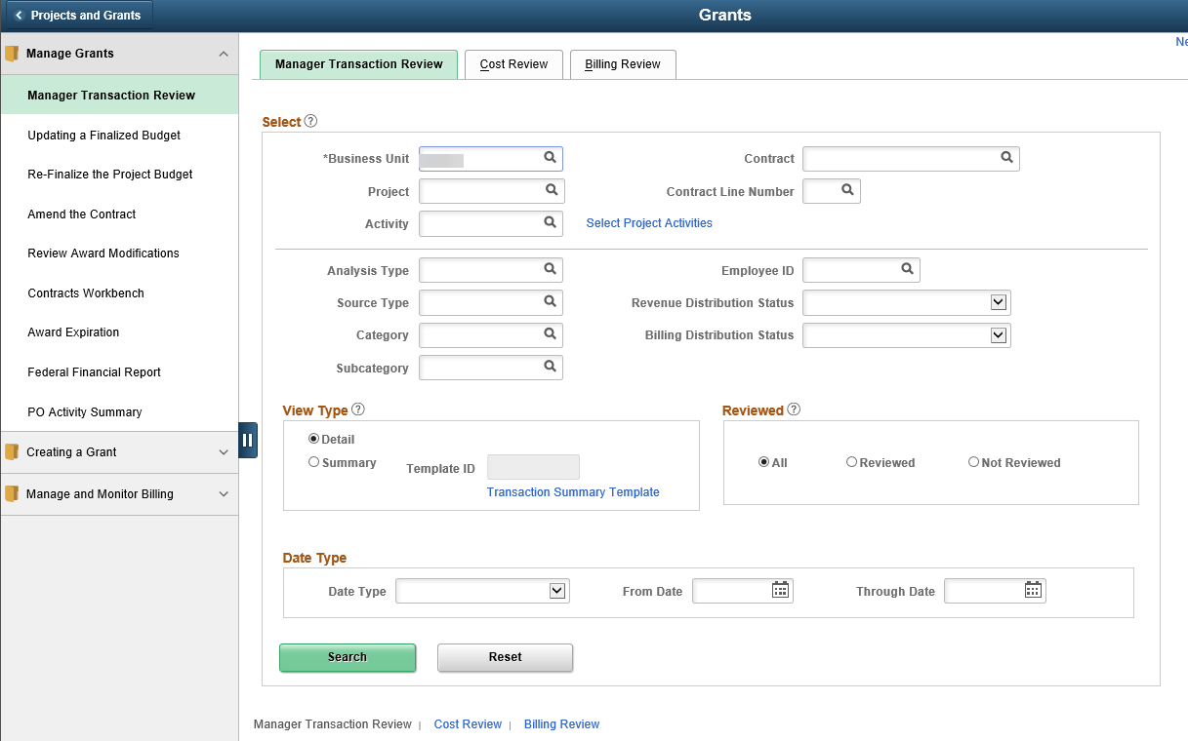
The Manage and Monitor Billing folder contains pages for monitoring what is on the Billing Worksheet, what has already been billed, and what AR Pending items have been processed, plus other information specific to Billing. | 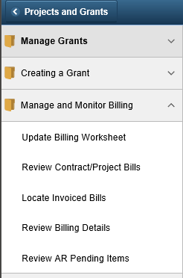`
WorkCenters  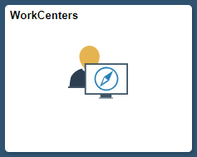 | 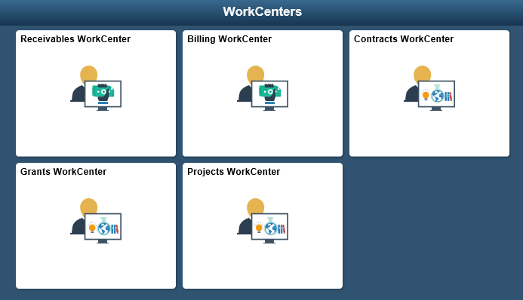
Selecting the WorkCenters tile takes the user to another homepage that contains all the WorkCenters related to grants management. The WorkCenters were released with the 2015 upgrade to PeopleSoft version 9.2 and contain links similar to how the navigations collections are set up. | 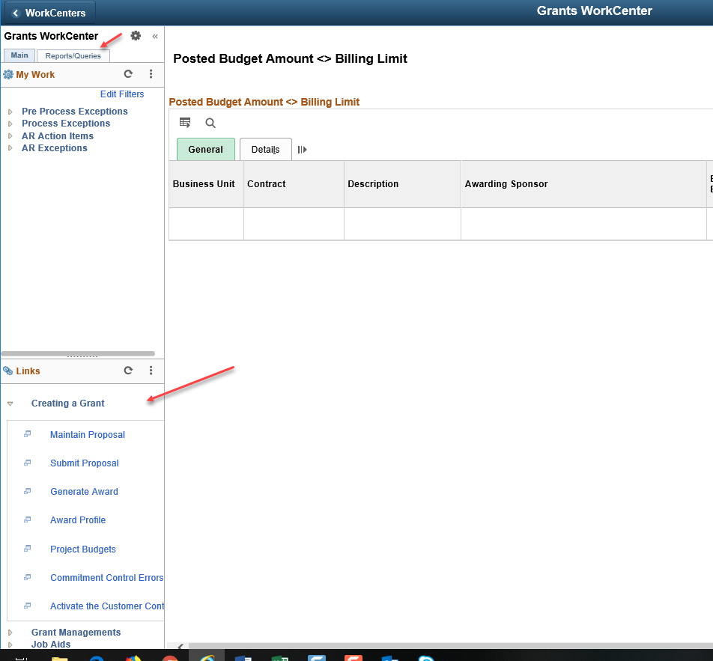
WorkCenters also provide quick links to Queries, Reports, the Process Monitor and Report Manager. | 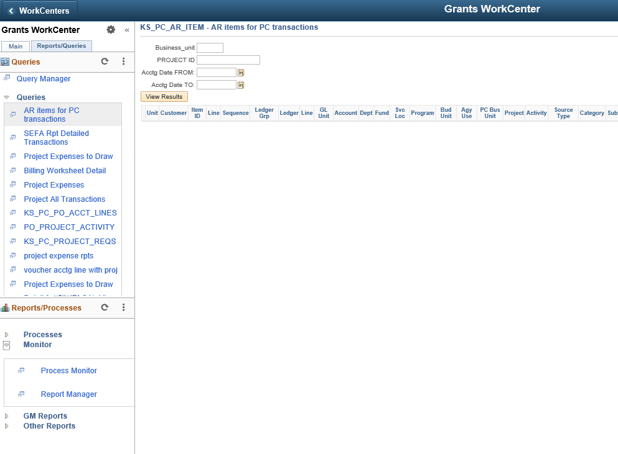
PC & GM Reports  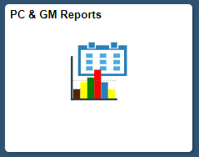  The PC & GM Reports tile contains pages useful in running reports and queries, not only from the PC and GM modules, but from the PO and GL modules as well. | 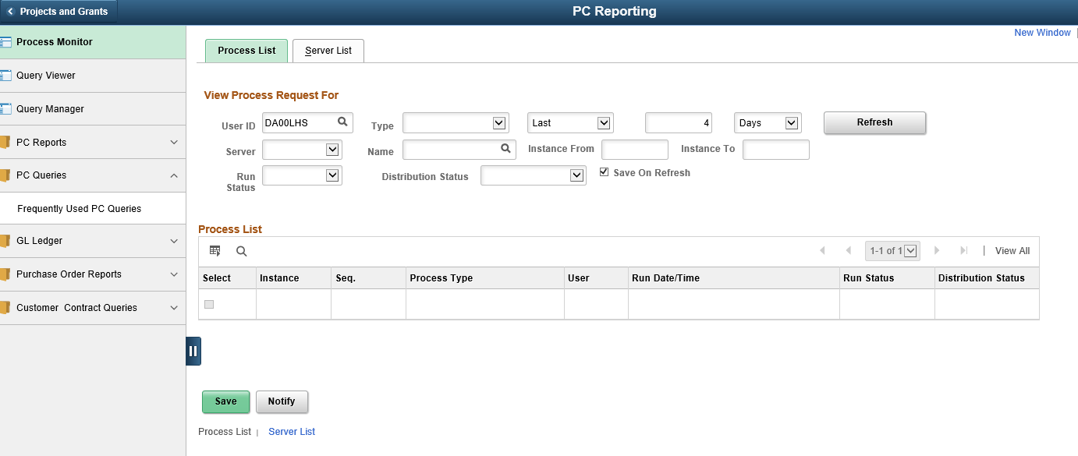
Job Aids  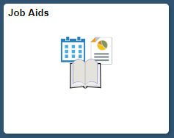  The Job Aids tile contains links to all job aids on SMARTWeb. When a job aid is selected, a new window opens directly to the SMARTWeb page specific to the topic needed. | 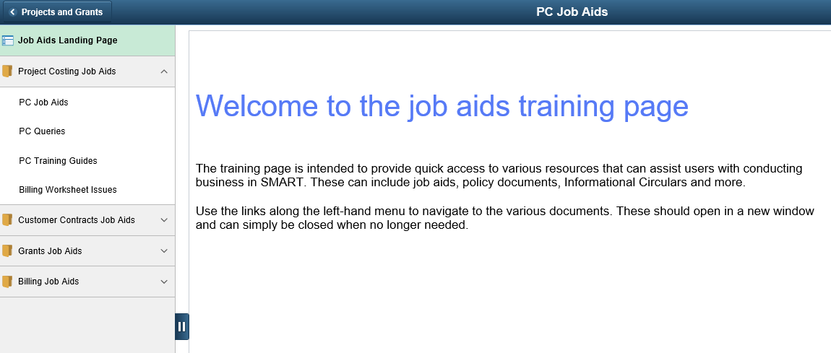  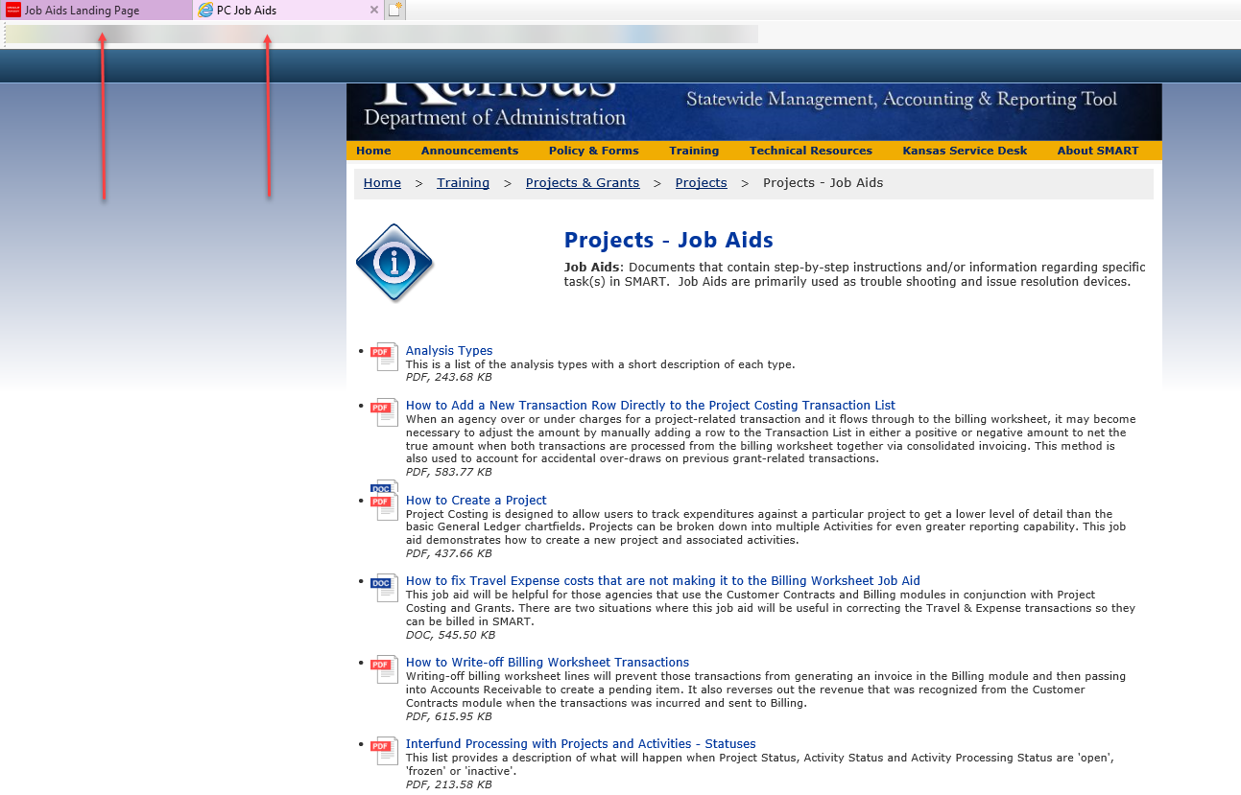
Utilities  The Utilities tile provides easy navigation to Query Viewer, Schedule Query, Process Monitor and other system tools. | 