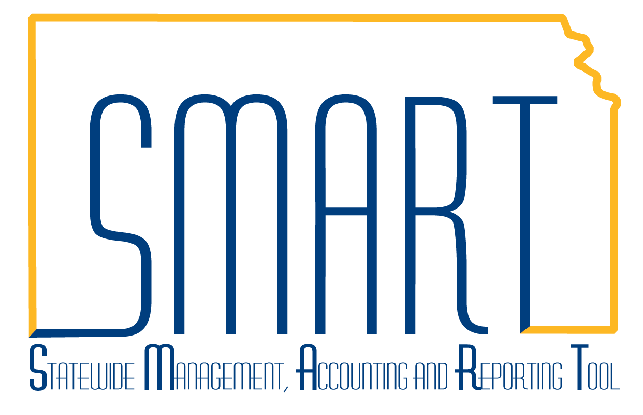
State of Kansas
Billing Homepage Guide
Statewide Management, Accounting and Reporting Tool

Date Created: | 2/19/2019
Version: | 1.0
Last Updated Date: | 2/19/2019
Process: | The Billing Homepage tiles are structured to group pages primarily by activity. The ‘Process Billing Worksheets’ tile is used by the agencies using Project Costing, Customer Contracts and Billing, or those using the Grants module, which incorporates functionality from all the previously listed modules. The ‘Online Billing’ tile is used by agencies who wish to invoice their customers to record the receivable in the General Ledger. The other tiles provide analytics at-a-glance, the WorkCenters, job aids, and utilities.
Billing Homepage:  The tiles specific to the Billing Homepages are shown at the right.  Note: Depending on what device or browser is being used, the tiles may display differently. A user may need to scroll to the left, right, up, or down to access the tile desired. | 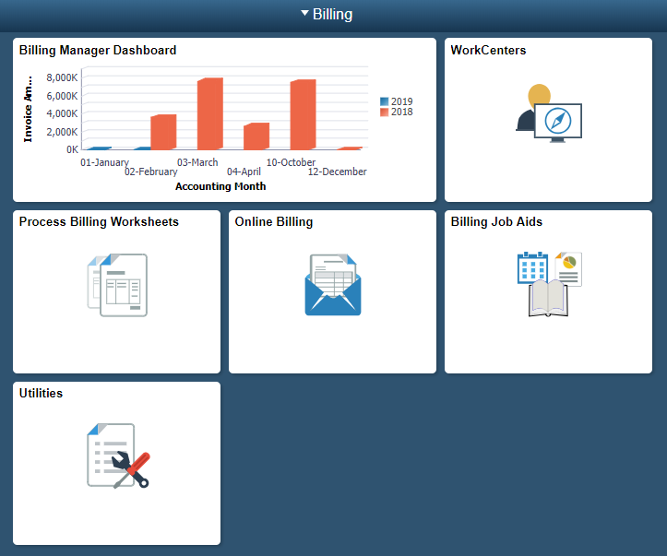
Billing Manager Dashboard  The Billing Manager Dashboard provides a graphical display. Select the graph to set up its properties. Click the blue rectangle with the || icon. Enter the following information:  Business Unit  Date Option  Number of Months  Ending Date  Click Search.  Select the gear on the right to save the entries. | 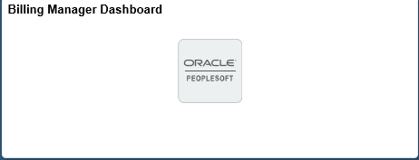  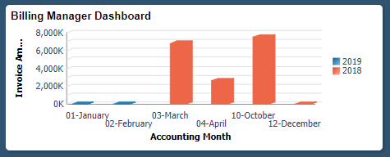  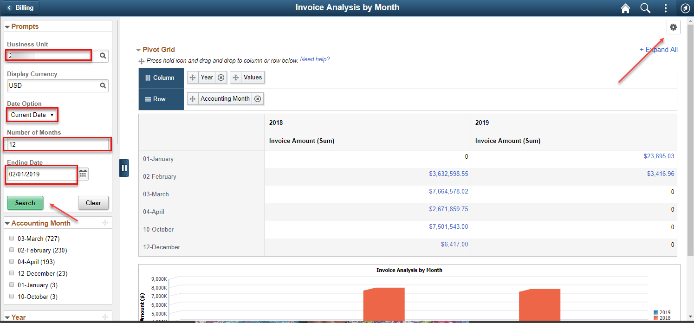
Click the blue rectangle with the || icon to collapse the side window. The graph will display along with the supporting data.  Click any of the amounts to open another window and drill into the detail.  Click the < Billing button on the upper left to return to the homepage tiles. The Billing Manager Dashboard will now show the graph created. | 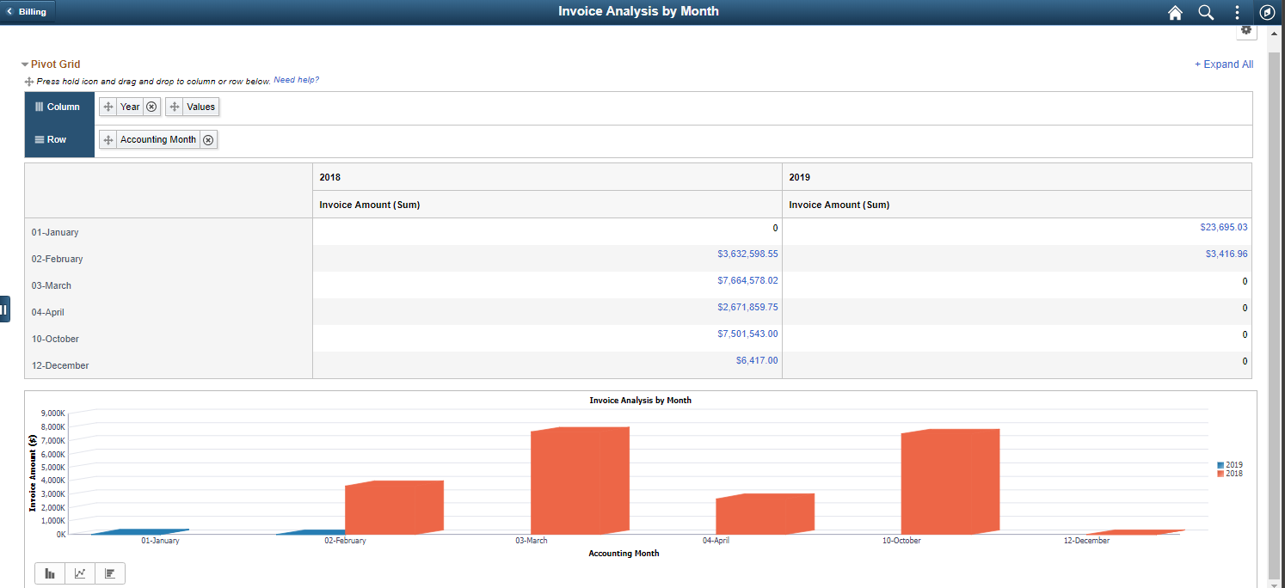  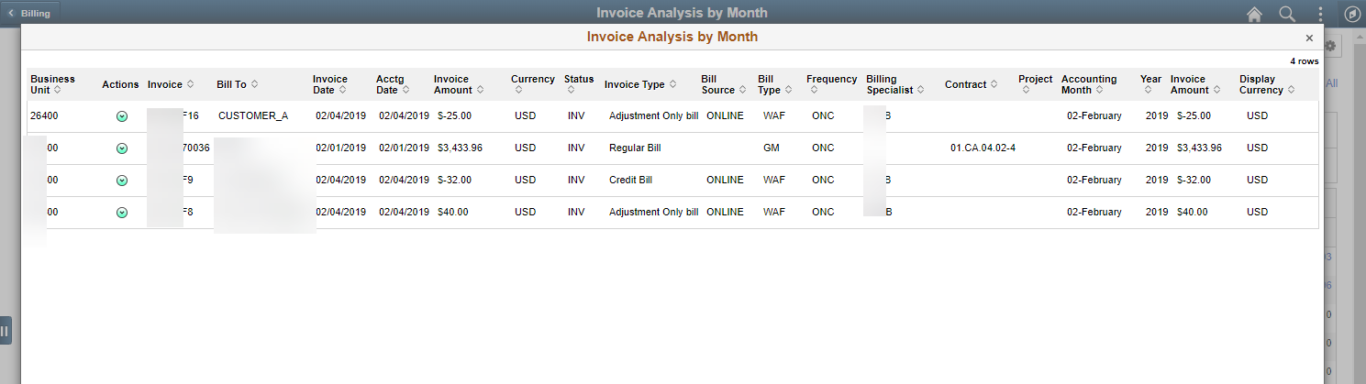  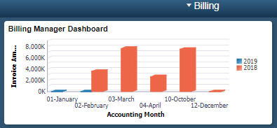
WorkCenters  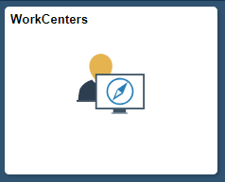  Clicking on the WorkCenters tile will display the tiles for all WorkCenters that may be useful to those currently using the Billing module. | 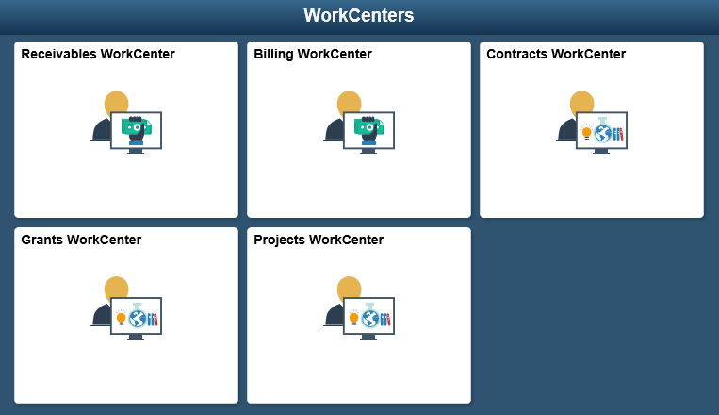
Billing WorkCenter  The Billing WorkCenter is the FLUID version. The primary difference is that all groups are now in the left window without the tabs. The same sections still exist (My Work, Links, Queries, and Reports/Processes). The sections can be expanded, or collapsed, as needed. The Queries section provides many of the queries specific to Billing. | 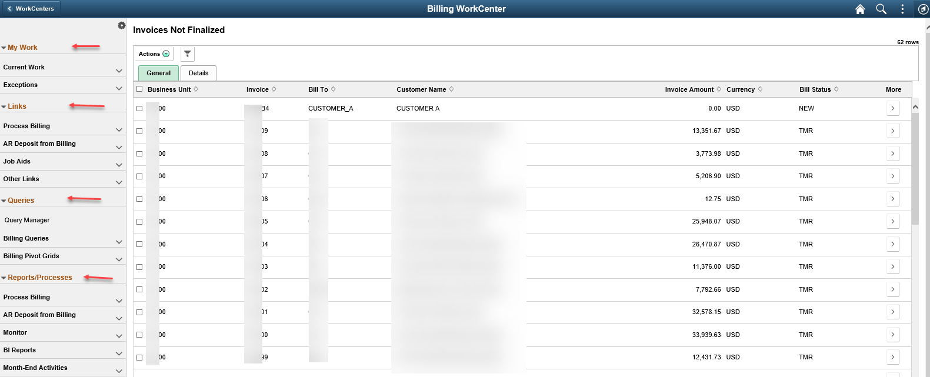
Use the < (followed by the name of the previous page) in the upper left corner to go back to the Billing homepage. | 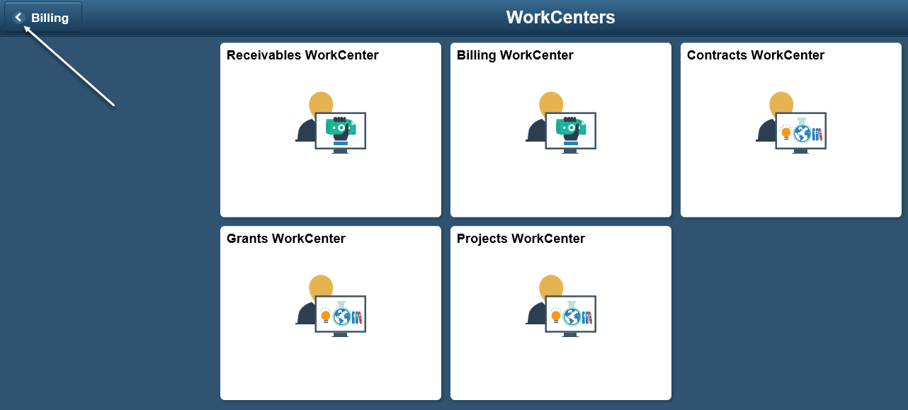
Process Billing Worksheets  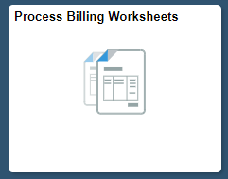  Select the Process Billing Worksheets tile to access pages pertaining to the entire worksheet approval and invoice generation process. | 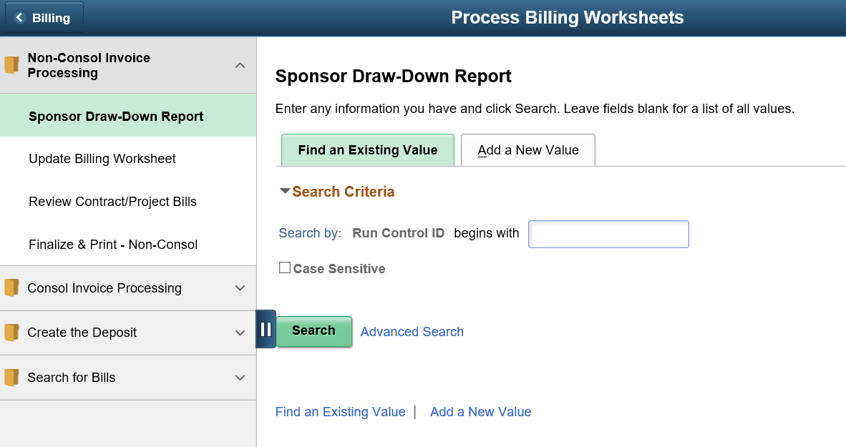
By using the up and down arrows to the right of the folder allows the user to expand or collapse the folders. The dark blue rectangle with the || icon allows the user to expand or collapse the left window. | 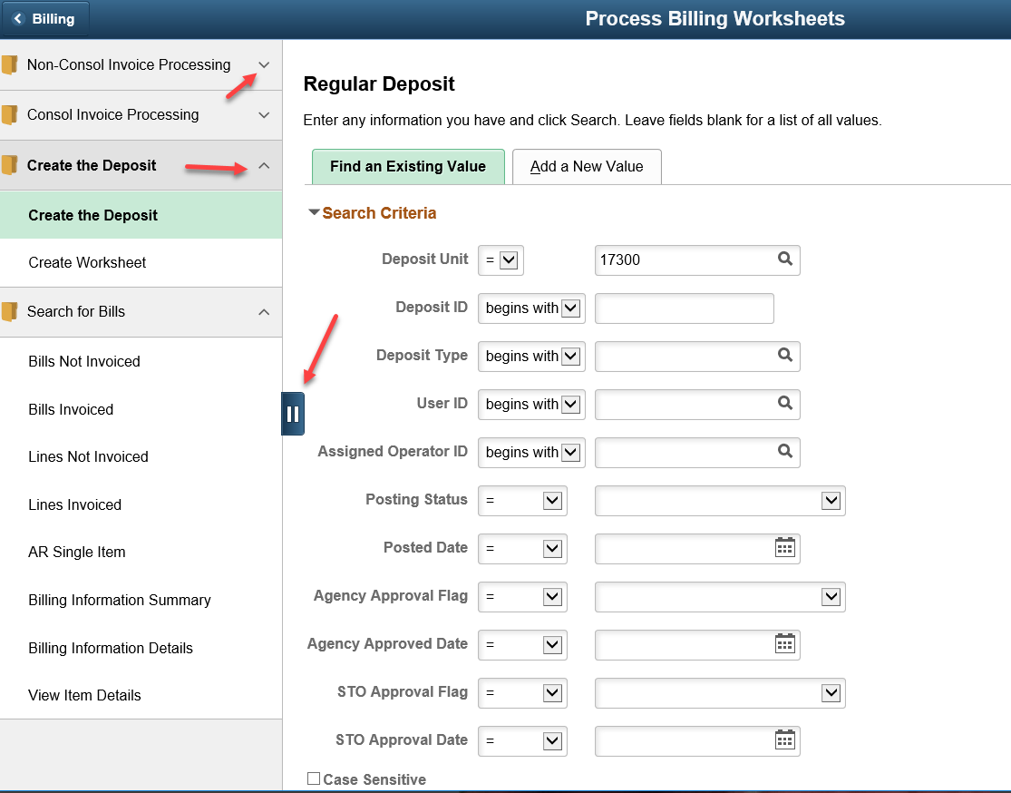
Online Billing  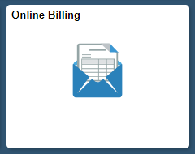  Select the Online Billing tile from the Billing homepage to access the pages to process online invoices in SMART. | 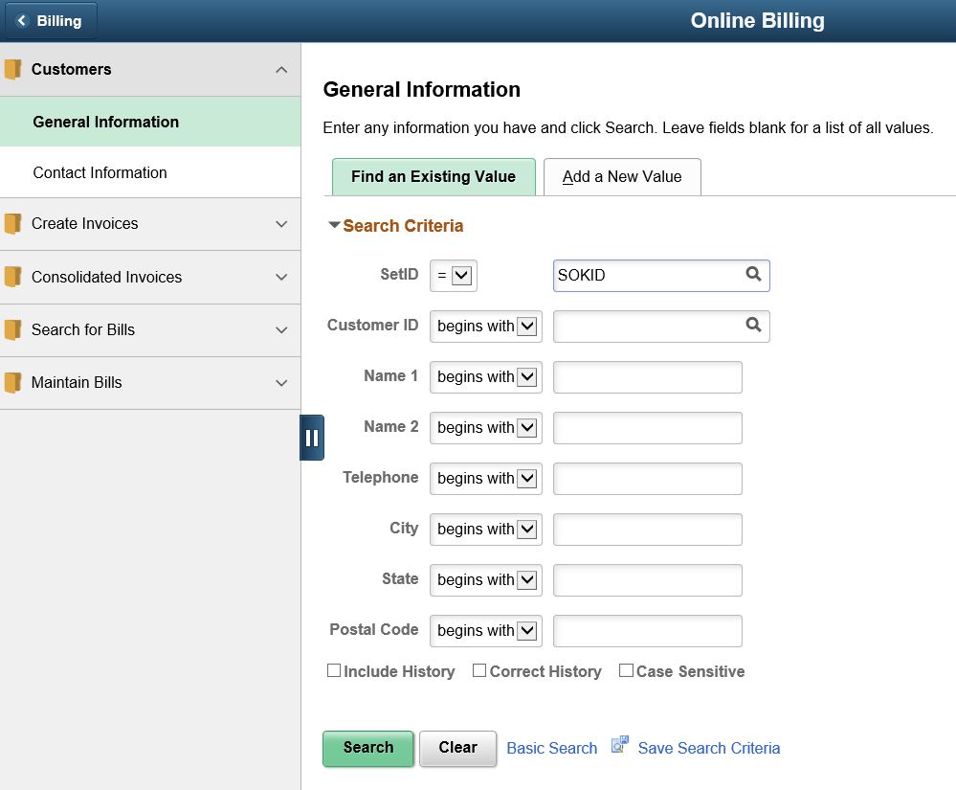
There are useful page links for monitoring the billing processes. | 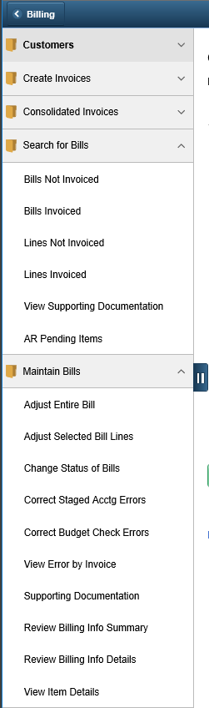
Billing Job Aids  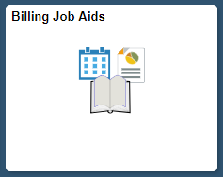  Select the Billing Job Aids tile to access the Billing Training Guides and Job Aid on SMARTWeb. | 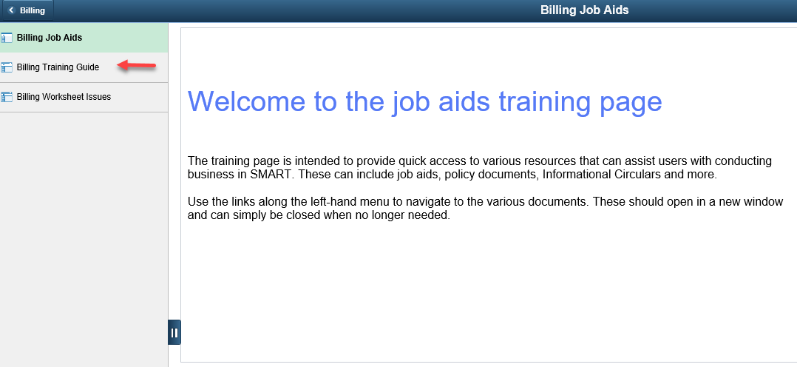
Selecting a link will open SMARTWeb in new window and take the user directly to the Billing Training Guides and Job Aid. | 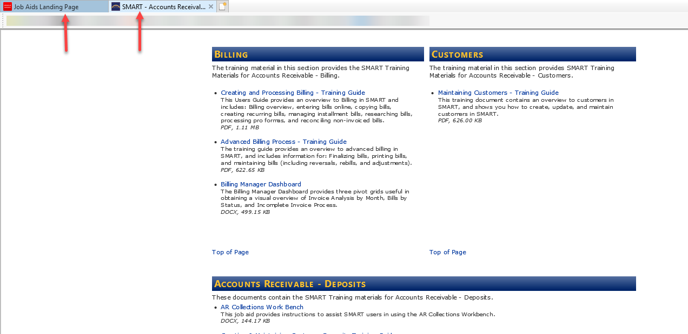
Utilities  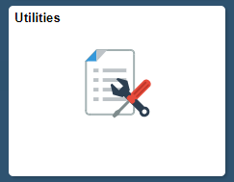  This tile allows users to acccess the Process Monitor, Queries, Report Manager, nVision and BI Analytics. | 