**State of Kansas**

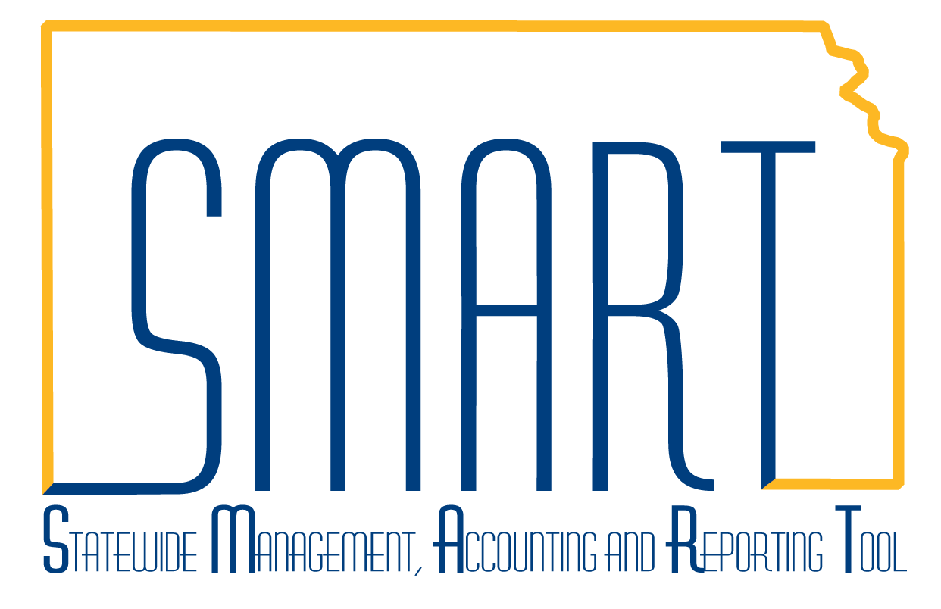

**High-Level Changes from 9.0 to 9.2 in Asset Management:**

**Supplemental Data**

***Statewide Management, Accounting and Reporting Tool***

|  |  |
| --- | --- |
| **Date Created:** | 10/28/2015 |
| **Version:** | 1.0 |
| **Last Updated Date:** |  |
| **Purpose:** | *This document highlights one of the changes between 9.0 and 9.2 in the Asset Management module.* |
| **Security:** | * Role Security: The following roles are applicable:   Agency Asset Processor  KS Assets Viewer  BU Security: Business Unit Security is applied. Agencies will only have access to the assets in their Business Unit. |

Procedure

The Supplemental Data page in Basic Add allows agencies to track custom attributes of an asset.

The **Asset Condition** and **Special Disposal Restrictions** fields have been moved to the Supplemental Data page in 9.2. In 9.0, these fields were located on the General Information tab of Basic Add.

Supplemental Data fields can be agency-specific. If your agency requested additional fields on the Supplemental Data tab as part of an agency task, those fields will be available. If an agency has additional attributes that need to be tracked, please log a Service Desk ticket with that information.

| **Step** | **Action** |
| --- | --- |
|  | Click the **Main Menu** button. |
|  | Click the **Asset Management** menu. |
|  | Click the **Asset Transactions** menu. |
|  | Click the **Owned Assets** menu. |

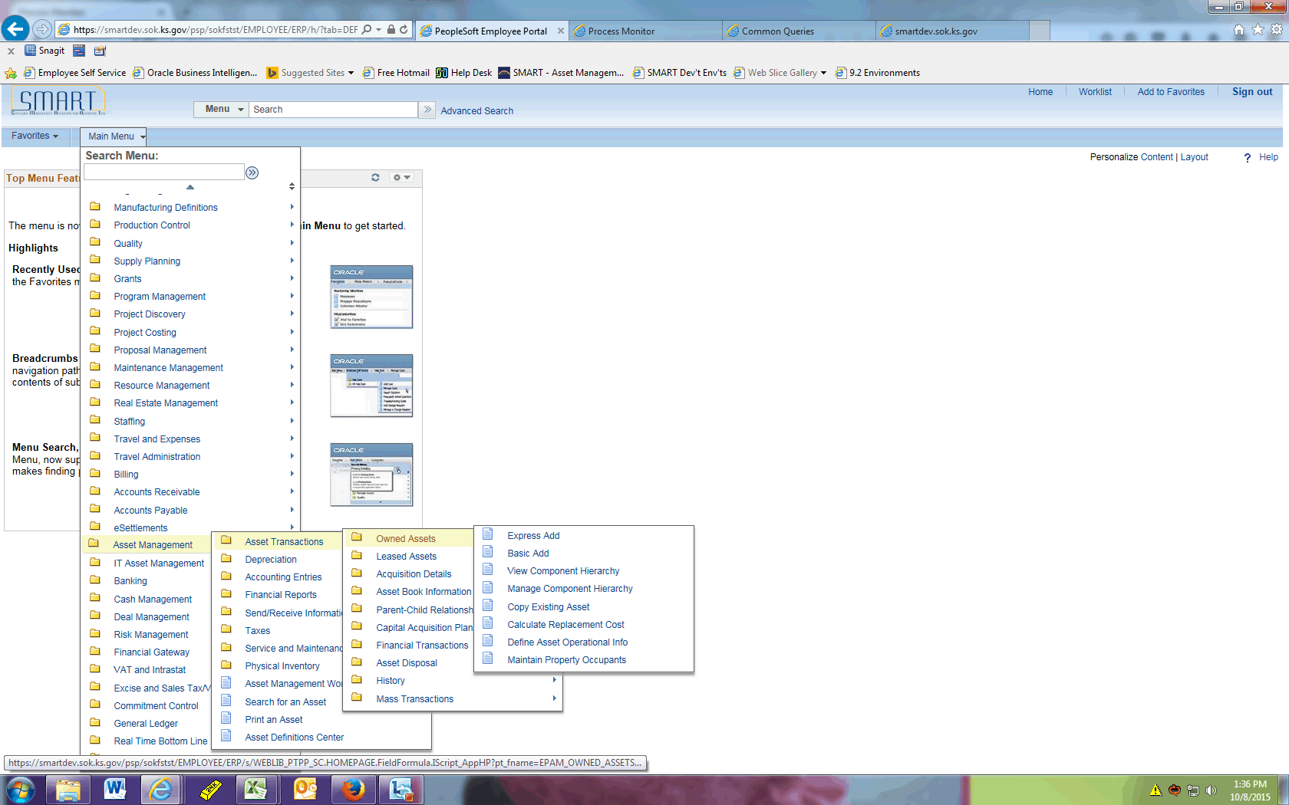

| **Step** | **Action** |
| --- | --- |
|  | Click the **Basic Add** menu. |
|  | Click the **Search** button. |
|  | Select the asset you wish to open. |

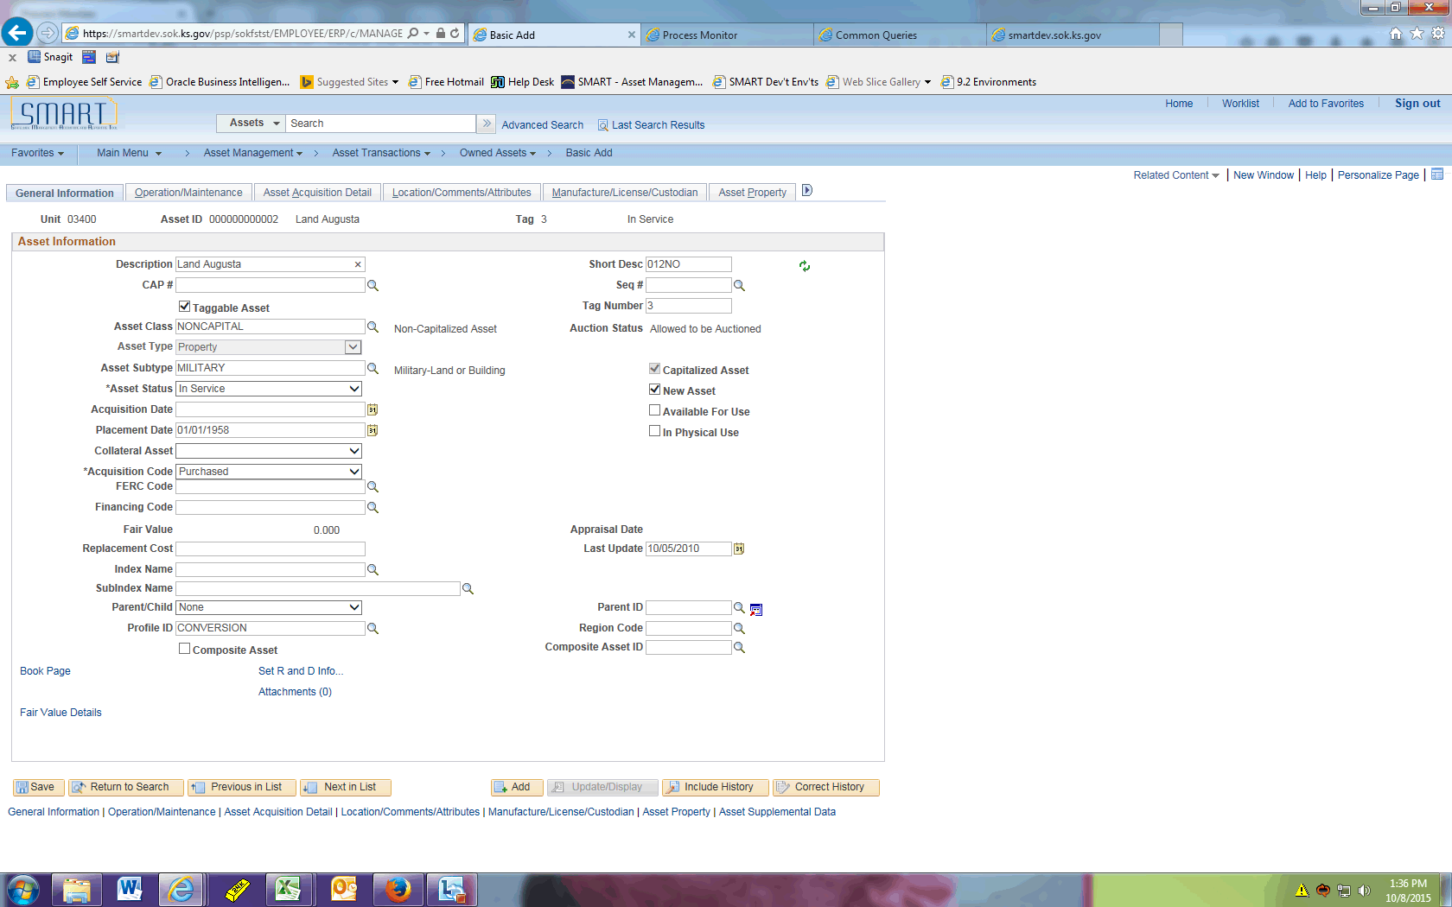

| **Step** | **Action** |
| --- | --- |
|  | Click the **Show following tabs** button. |
|  | Click the **Asset Supplemental Data** tab. |

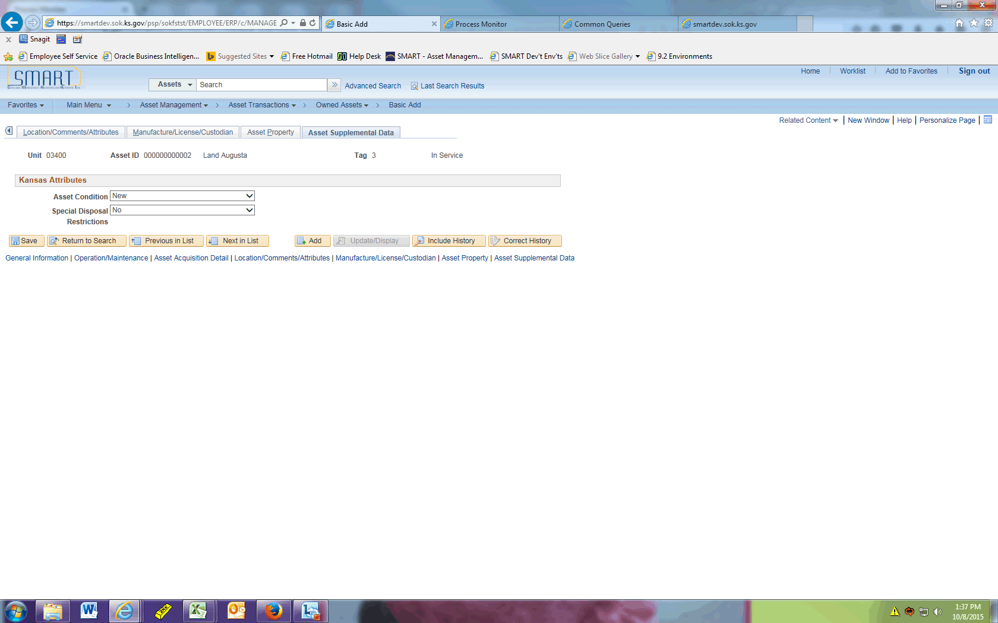

| **Step** | **Action** |
| --- | --- |
|  | Click the **Asset Condition** list. Select a value from the dropdown. |

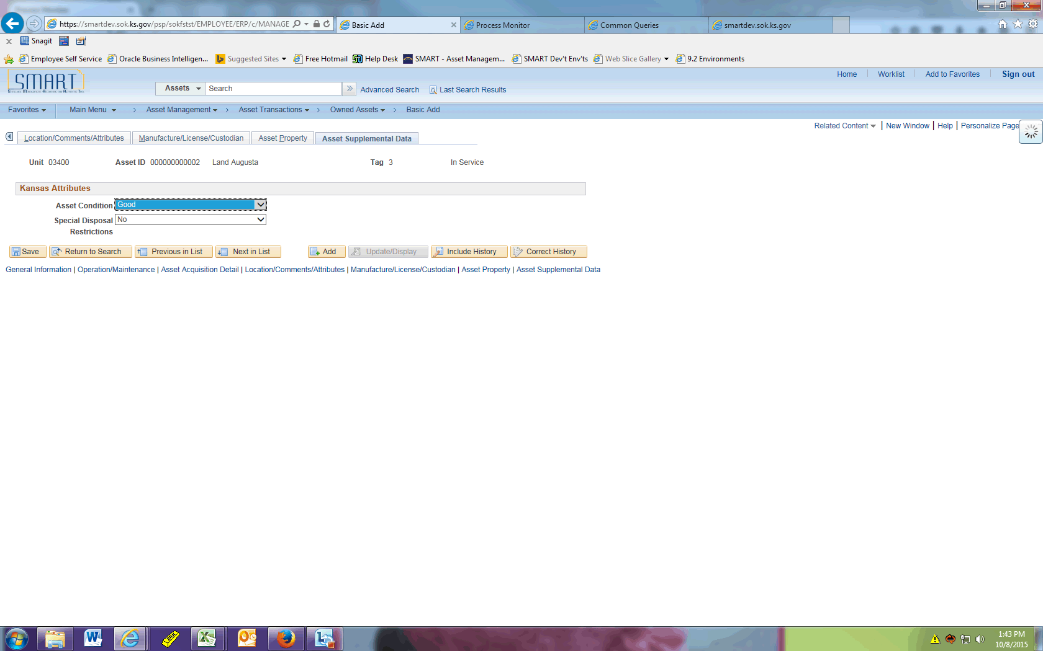

| **Step** | **Action** |
| --- | --- |
|  | Click the **Special Disposal Restrictions** list. Select a value from the dropdown. |
|  | Click the **Save** button. |
|  | This concludes the 'AM - Supplemental Data' topic. Thank you for taking this course.  **End of Procedure.** |