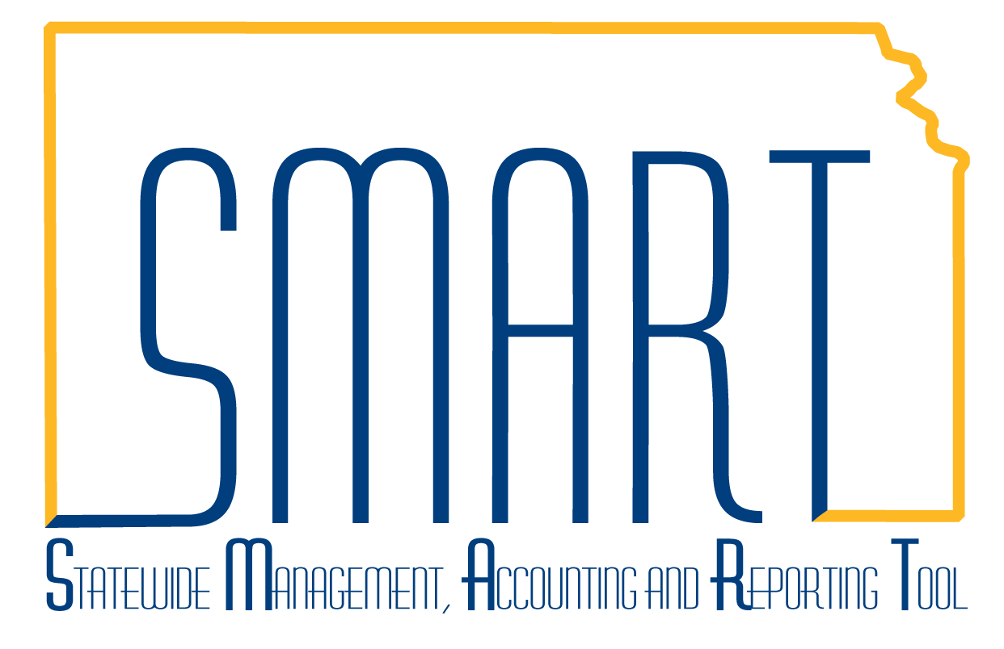**State of Kansas**



**Erroneous Asset Removal**

***Statewide Management, Accounting and Reporting Tool***

Created: 06/18/2010

Updated: 09/30/2013

Version #4

This job aid outlines the steps needed to remove an asset from SMART. Please note this is not the normal retirement process. This job aid should be used if the asset was entered erroneously. For example, you might need to remove an asset because you accidentally entered one and saved. Another example would be if you incorrectly labeled the asset as a property asset (Asset Type = Property) and shouldn’t have. In that case, you would need to remove that asset using the steps defined below and manually enter the corrected one using Express Add.

**Steps to Remove an Erroneously Entered Asset**

1. Determine the “Begin Depreciation Date” for the asset.
   1. Navigate to *Asset Management > Depreciation > Review Depreciation Info > Asset Depreciation > Depreciation* tab and expand Depreciation Attributes section. Document the Begin Date.
      1. The most common error in this step is to use the In Service Date instead of the Begin Date. Be sure to use the Begin Date as this field correctly reverses the accounting. Using the In Service date does not.
      2. If the Begin Date is a future date (ie the asset has not started depreciating yet), you will use today’s date as the Transaction Date in step 2b.

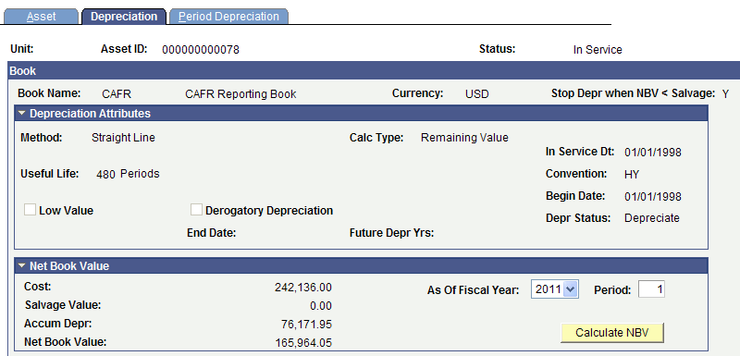

1. The Agency Adjustment/Transfer/Retirement Processor must adjust the cost of the asset down to $0.00.
   1. Navigate to *Asset Management > Asset Transactions > Financial Transactions > Cost Adjust/Transfer Asset.*
   2. Enter the Begin Date (as documented in Step 1) in the Transaction Date field. Today’s date will default in the Accounting Date field.
      1. See Step 1.a.ii if you receive the following error: “You cannot enter an accounting date less than the transaction date.” Change the Transaction Date to today’s date if you were using a future date.
   3. Select an Action of Adjustment and click GO!

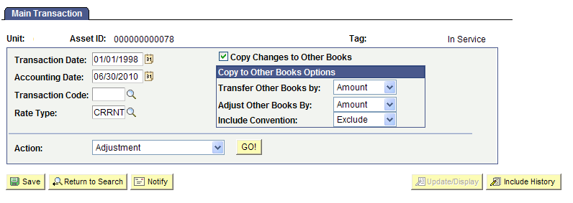

* 1. Enter a zero in the Cost field for the first book.

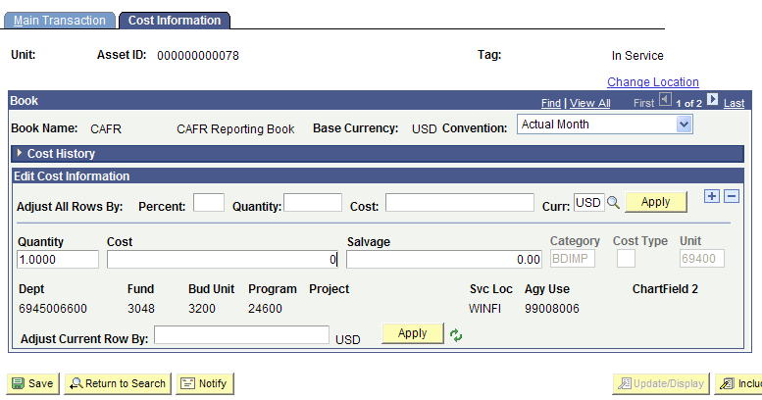

* 1. Click Save. Click OK to any warning messages.

1. The Agency Adjustment/Transfer/Retirement Processor must retire the asset.
   1. Navigate to *Asset Management > Asset Transactions > Asset Disposal > Retire/Reinstate Asset*.
   2. Click Go in the first book section.

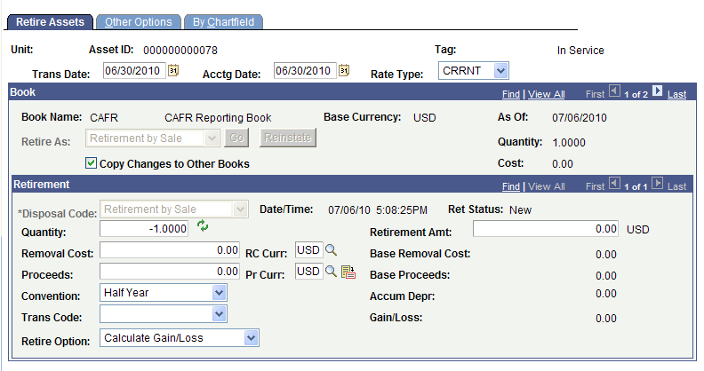

* 1. Click the Other Options tab. In the Description field for the first book, enter “Erroneous Asset Entered.”

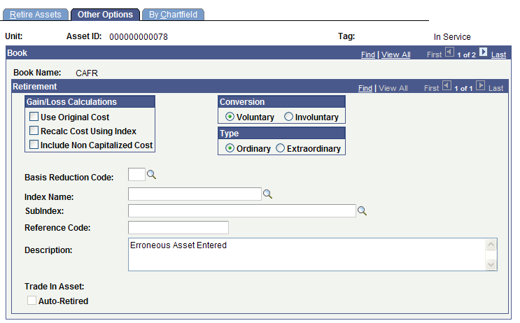

* 1. Click Save. On the Retire Assets tab, the Ret Status should be New for all books.

1. If the asset had the CAFR book, log a Help Desk ticket so that the Central Asset Processor can validate all accounting entries generated for the CAFR book have been backed out. Include the following in your ticket:
   1. Category: Asset Management
   2. Sub-Category: Other
   3. Subject: Erroneous Asset Removal-validate entries
   4. Description box:
      1. Business Unit
      2. Asset ID

**Central Asset Processor Steps**

**Run Depreciation processes adhoc**

1. Determine if there are open transactions for the asset (navigate to Asset Management>Accounting Entries>Review Financial Entries and look for the note that reads ‘This asset has pending creation of some accounting entries’). If there are open transactions, run the Depr Calc process (Asset Management>Depreciation>Processing>Calculate) and the Create Acctg Entries process (Asset Management>Accounting Entries>Create Accounting Entries) ad hoc. See **Core AM Batch Jobs** job aid for detailed instructions on how to run these processes.
2. Run the Depr Close process ad hoc for the asset(s) at Asset Management>Accounting Entries>Close Depreciation.
   1. Note: The batch process should not be affected by this ad hoc run. UC4 will skip the error message about how Depr Close has already been run for this Business Unit and complete the job.
   2. Select Rerun if Depr Close has already been run; select Reverse if entries have been posted to the GL and need to be reversed.

**Validate CAFR entries are backed out**

1. Navigate to *Asset Management > Accounting Entries > Review Financial Entries*.
2. Validate that all entries for the CAFR book have been backed out.
   1. Note that because of the half year convention, the Begin Date for depreciation will be either on January 1st or July 1st depending on when the asset was added. So if you run Depreciation Close and no entries generate, check to see if the Begin Date on the Review Depreciation Information page shows a future date. If the begin date is a future date, no entries are created.
   2. For an asset with a future depreciation begin date, the entries should include ADD and ADJ entries.

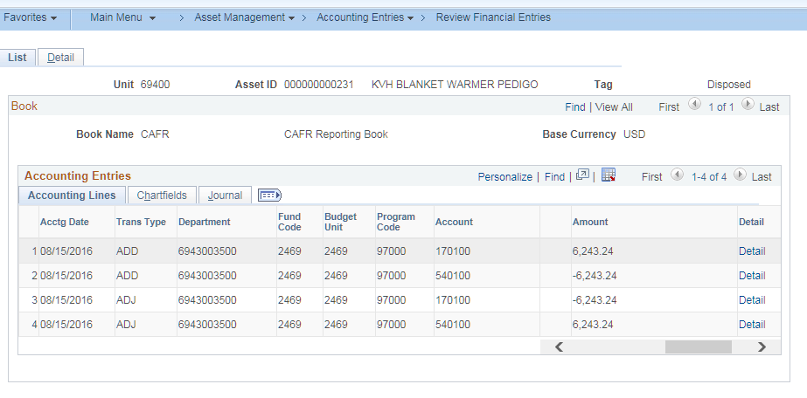

* 1. For an asset that has depreciated, the DPR and PDP entries should completely reverse the fixed asset account ADD type entries: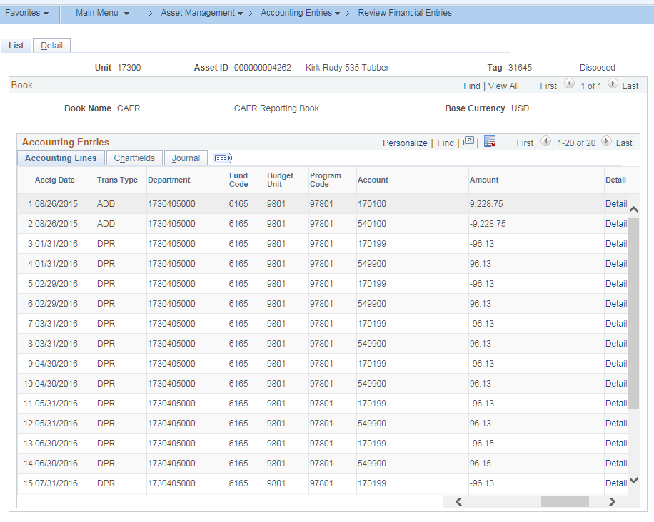 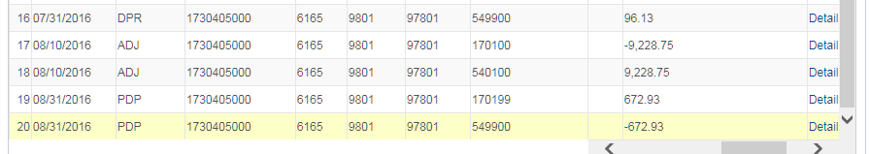
  2. If CAFR entries are not properly backed out, reinstate the CAFR book and adjust the cost back up using the dates the agency used. Run depreciation and accounting entries. Then adjust the cost down using the correct dates and retire. Run depreciation, accounting entries, and depreciation close. Review the entries again.