AM Tool 4 - Asset Receipts
04/15/2019
V.1.1
This document provides instruction on how to process a receipt that contains asset data. This document does not outline all steps to entering a Receipt; only those asset-specific steps are highlighted.

Foundation Information
Integration cannot begin on the Receipt. The Receipt will only have asset data if the associated Purchase Order had asset information.

The Receipt provides an Asset Management Information page to record physical data, including Tag Number, Serial ID, Location, Custodian, and manufacturing information. The Receipt passes the information to Asset Management so the asset can be added with its Physical Information.

Note: Because physical data is sent to AM after the Receipt is processed, the asset data on the Receipt must be correct. That means the Serialize/Use One Asset ID buttons have been selected if applicable and the Profile ID is correct. For this reason, some agencies have chosen to start the integration on the Voucher level. It is easier to correct errors in the AM Loader Tables when the integration begins on the Voucher. The decision on where to start the integration should be made by the agency based on the Purchasing Staff Members’ ability to select Profile IDs. A Voucher Processor might be more comfortable with this task because he/ she is familiar with selecting Account Codes.
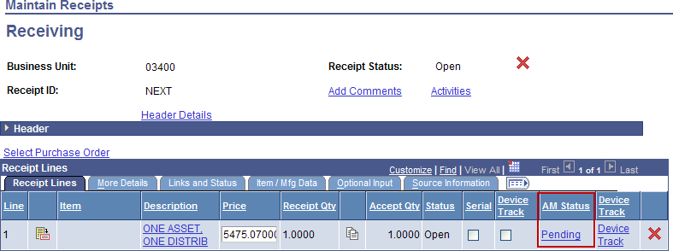
Homepage Navigation: POs & Receiving>Receiving>Add/Update Receiving or
NavBar: Purchasing>Receipts>Add/Update Receipts
Access asset data on the Maintain Receipts - Receiving page using the AM Status link.

The receipt information must be correct for the asset information to flow into the AM Loader Tables correctly. The example below is the most basic: One asset with one funding source. Other more complex examples are covered in Scenarios 1.1, 1.2, and 1.3.
One Asset with One Distribution Line
Click the Pending hyperlink.
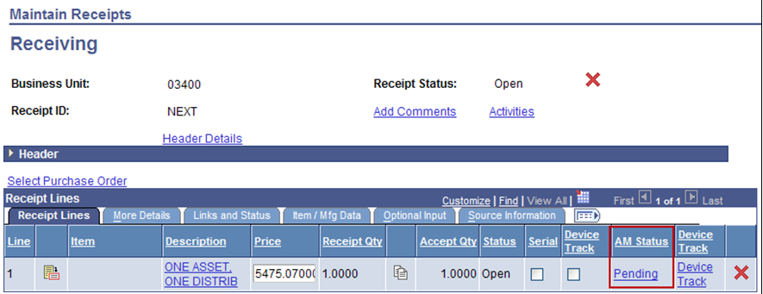
Populate any known Physical fields on the Asset Management Information for Line 1 page.
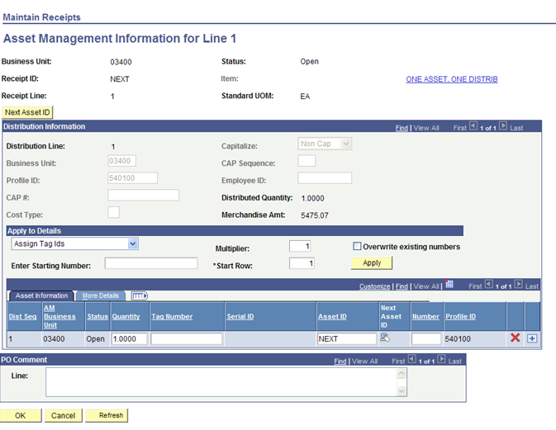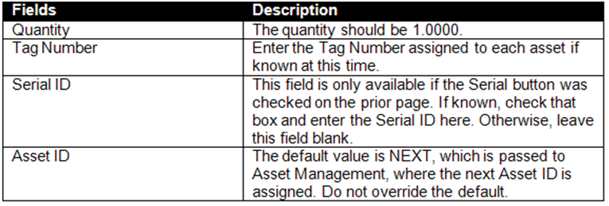

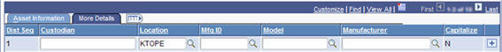

Select the More Details tab to populate additional Asset Physical Information.

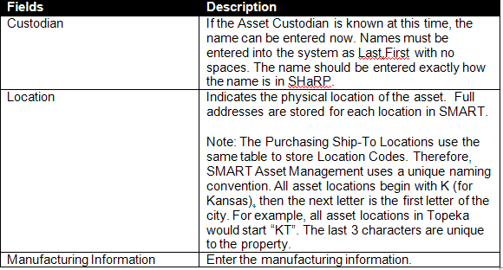
Click OK and Save. When the receipt is saved, a batch job will automatically run. The AM Status should change to Moved when you navigate back into the Receipt. An Asset ID will be assigned automatically in the Asset Management module. That asset will have a status of ‘Received’ until cost is integrated from the voucher.

