AM Tool 2 - Asset Requisitions
04/12/2019
V.1.1

This document provides instruction on how to process a requisition that contains asset data. This document does not outline all steps to entering a requisition; only those asset-specific steps are highlighted. Additional instruction on entering requisitions can be found in the Purchasing training documents.

Foundation Information

- It is important to understand 3 basic asset concepts before processing an asset requisition. All of these are defined in the Asset Management - The Basics Training Guide located on the SMART website under the Training page, Asset Management section.

  - You should know the definition of Asset.
  - You must have an understanding of Profile IDs.
  - You must know the capitalization thresholds utilized by the State of Kansas.

- There are two fields that trigger the integration: the AM Business Unit (your business unit) and the Profile ID. It is critical that the correct Profile ID is selected on these documents to prevent processing problems in the AM module.

- Asset Integration can begin on the Requisition, Purchase Order, or Voucher. The agency should be consistent in the method they choose.

Note: Adjustments to existing asset costs (as in the case of Construction in Progress (CIP) assets) must come from the voucher only. The system assumes that Requisitions and PO's are for new assets.

Note: Because physical data is sent to AM after the Receipt is processed, the asset data on the Receipt must be correct. For this reason, some agencies have chosen to start the integration on the Voucher level. It is easier to correct errors in the AM Loader Tables when the integration begins on the Voucher. The decision on where to start the integration should be made by the agency based on the Purchasing Staff Members‟ ability to select Profile IDs. A Voucher Processor might be more comfortable with this task because he/she is familiar with selecting Account Codes.

Entering Asset data on a Requisition
Follow the directions to create a requisition on the ‘Entering Requisitions Training Guide’ in the Purchasing section of SMART Web Training. Asset data is entered on the Review and Submit page on the Asset Information tab in the Accounting Lines Section.

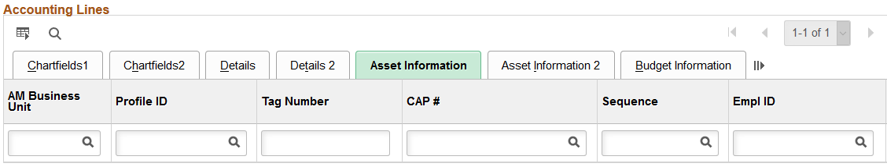
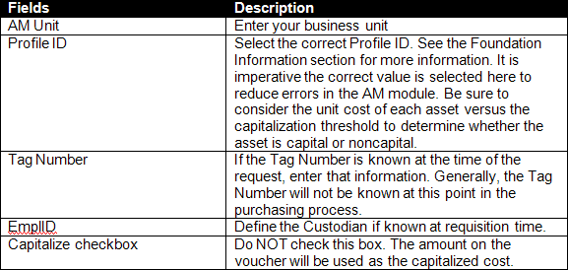
All requisition lines with asset data must have the Asset Information populated. Only those marked with the AM Unit and Profile ID will integrate forward into AM.

The AM Business Unit and Profile ID fields selected on the Requisition will copy forward into the Purchase Order.

Considerations When Setting Up the Requisition/Purchase Order

The way in which the Req/PO is set up can impact processing on the Receipt or the Voucher.

O Multiple Assets on Same Req/PO (one funding source): If a quantity of 3.000 is used on the Req/PO Line and the purchase is for 3 separate and distinct Assets, the Distribution Lines on the Asset Information page on the Receipt will need to be Serialized to separate the Quantity of 3.000 into 3 separate Assets. See AM Scenario 1.1 for Receipt processing tips.

Be sure you enter the correct Quantity, especially if this PO will be copied into multiple Vouchers. If a quantity of 1.000 is used, all costs from all Vouchers tied to this PO will go to the same Asset ID in AM. If you’re purchasing 10 vehicles (which should be 10 separate assets), use a quantity of 10.000.

O One Split-Funded Asset: If a quantity of 1.000 is used on the Req/PO Line and the purchase is distributed on more than one Distribution Line, the Distribution Lines on the Asset Information page on the Receipt will need to be combined so that one split-funded asset is created. See AM Scenario 1.2 for Receipt processing tips.

O Multiple Split-Funded Assets on Same PO: If multiple split-funded assets are on the same Req/PO, it is highly recommended that each asset have its own Req/PO line. Then split-funding is entered in the Accounting Lines section for the Req or the Distributions for Schedule page for the PO. See AM Scenario 1.3 for Receipt processing tips.

The reasons for setting up the Req/PO with one asset per Req/PO line are:
- Each PO line is pulled into individual receipt lines, which makes accepting partial receipts easier to process.
- It is simple to combine the distribution lines on the receipt by clicking the Use One Asset ID button for each Receipt line (ie asset). Otherwise, you have to combine the Distribution Lines by clicking the Use One Asset ID button, then you have to manually split out the distribution lines and associate them to the correct assets by changing the Asset ID value (ie NEXT2, NEXT3, etc) for every chartfield set. This is a tedious task which can result in data entry errors.
- It allows the same method of entry to be used when there are different distributions for different assets.
- Each PO line will create a Voucher Invoice line, so it is simple to tell how many assets are being purchased and the cost breakdown of each one on the Voucher.

