AM Tool 1 – Cost History Page
03/29/2019
V.1.1
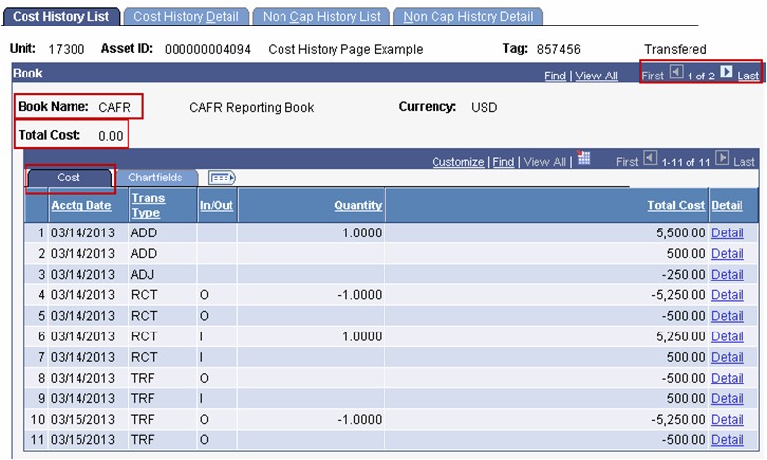
The Cost History page is one of the most valuable pages in the Asset Management module. It contains every transaction for each asset, as well as the book(s) associated to each asset. The Cost History page also includes the total cost for the asset.
Foundation Information

The Cost History page is used to view up to date cost and financial transactions for an asset. This page is updated automatically as soon as a transaction (Addition, Adjustment, Retirement, etc) is processed and saved. The ‘Asset Acquisition Detail tab’ in ‘Basic Add’ should not be relied upon to view cost updates. This page does not reflect updates to cost and ChartField information. It simply shows the cost and ChartFields used to originally add the asset.

SMART Users with the KAM_KS_ASSETS_VIEWER role can access this page.
Homepage Navigation: Asset Management Homepage>Asset Transactions>Asset History>Review Cost History.
NavBar: Navigator>Asset Management>Asset Transactions>History>Review Cost

Cost History List page:

This page immediately displays which Book(s) the asset has as well as the Total Cost.

The Cost tab (in the Book section) displays all the transaction types and the amounts that make up the Total Cost.

Below are the Transaction Types (Trans Types) on the Cost History List page:

ADD—Addition
This Transaction Type is used for the original transaction which adds the asset to SMART. An ADD transaction will also display if additional cost rows were added to the asset with different funding sources than the original cost row.

ADJ—Adjustment
This Transaction Type is used when the cost and/or quantity has been updated on an existing cost row.

RCT—Recategorization
This Transaction Type is used when the asset’s category has been changed.

  - The RCT-O line stands for Recategorization Out. This line shows the asset was transferred out of the old category.

  - The RCT-I line stands for Recategorization In. This line shows the asset was transferred into the new category.

REI—Reinstatement
This Transaction Type is used when the asset has been reinstated after it was previously retired.

RET—Retirement
This Transaction Type is used when the asset has been retired.

TRF—Transfer
There are two types of transfers. IntraUnit Transfers change ChartFields for the asset. InterUnit Transfers occur when an asset is transferred to another agency (Business Unit).

  - The TRF-O line stands for Transfer Out. For IntraUnit Transfers, the TRF-O line shows the old ChartFields from which the asset was transferred. For InterUnit Transfers, this line shows the asset was transferred out of this Business Unit.

  - The TRF-I line stands for Transfer In. For IntraUnit Transfers, the TRF-I line shows the new ChartFields to which the asset was transferred. For InterUnit Transfers, this line shows the asset was transferred into your Business Unit from another Business Unit.

Note: The difference between the two transfer types is how many TRF transactions there are.

- If there is a TRF-O and a TRF-I line with the same Accounting Date, it’s an IntraUnit Transfer.

- If there is NOT a corresponding TRF-I for a TRF-O (or vice versa) with the same Accounting Date, it’s an InterUnit Transfer.

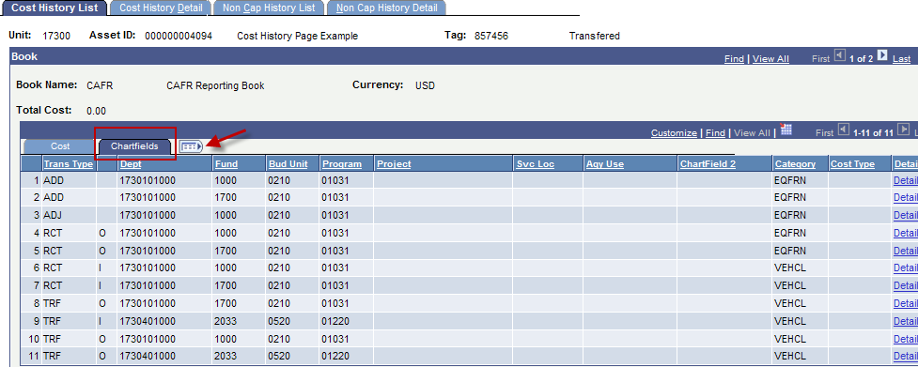Chartfields Tab

Additional Chartfield and Category details are available on the “Chartfields” tab (in the Book section). This tab displays what Chartfields were used to add the asset, which Chartfields the asset has been transferred out of and into, and the current Category for the asset.

Knowing how to interpret the data on this page will help determine what transactions have occurred.

Note: By clicking the Show all Columns button, all columns from both the
Cost tab and the Chartfields tab are visible.

From the example shown in the screenshot above:

Line 1: The asset was originally added.

Line 2: A second ADD transaction occurs with a different fund.

Line 3: The cost from Line 1 was adjusted.

Lines 4-5: Both cost rows were recategorized out of the EQFRN category.

Lines 6-7: Both cost rows were recategorized in to the VEHCL category.

Line 8: The cost row from line 2 is transferred out to another funding stream.

Line 9: This shows the new funding as a result of the IntraUnit Transfer. Notice how every chartfield has changed.

Lines 10-11: The original cost row from line 1 and the updated cost row from line 9 are both transferred into a new Business Unit.

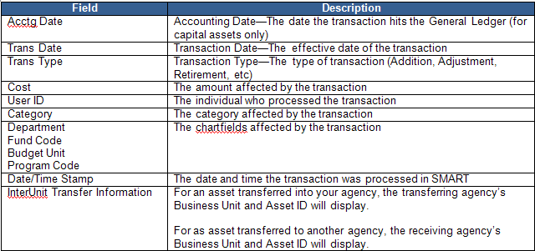
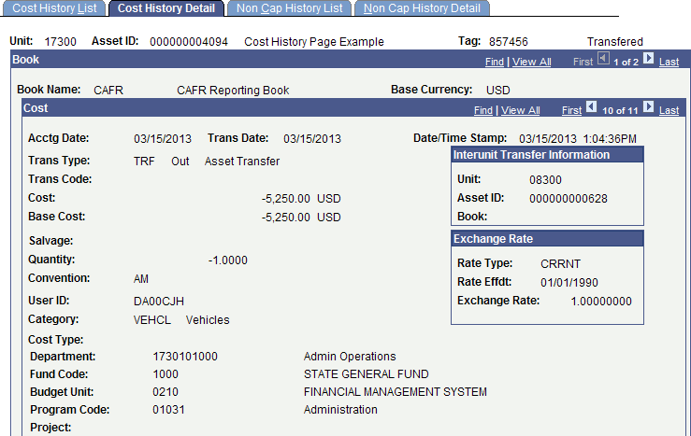
Non Cap History List and Non Cap History Detail Pages

The State of Kansas does not utilize these pages.
Cost History Detail page:

This page shows a detailed list of all the transactions and pertinent information about each one.

Note: You can also navigate to this page by clicking the Detail link for the transaction you wish to view. The Detail link is on the far right side of the Cost History List page.

The information in the following table is available on this page. Each transaction has its own section populated with this information. You can navigate through each transaction by clicking either the ‘next record’ button or the ‘previous record’ button (both of which are located on the far right side of the Cost section title bar).

