Version 1.2 04/25/2019

Scenario - One Asset with Multiple Distribution Lines on Receipt
AM Scenario 1.2: One Asset with Multiple Distribution Lines on Receipt

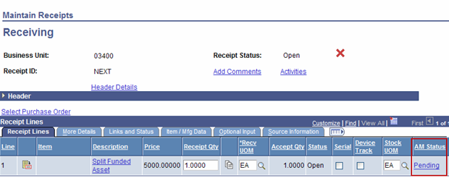

Accessed from Pending Hyperlink

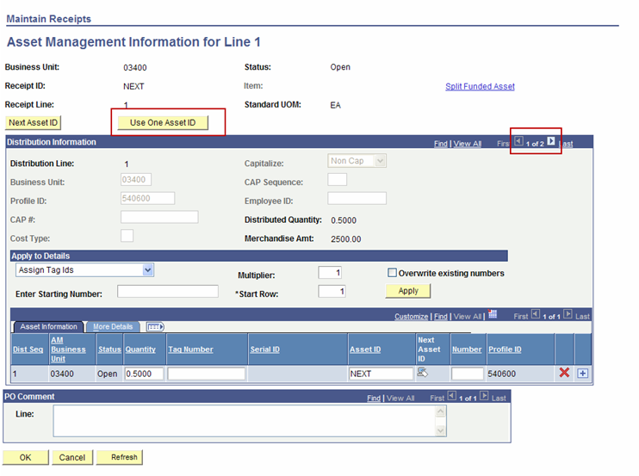

The example above has two split Distribution Lines indicated by the multiple rows available on the page (1 of 2). These Purchase Order Distribution Lines can be combined into one asset by using the button. This will combine the two Distribution Lines into One Load Line in the AM Interface Tables.

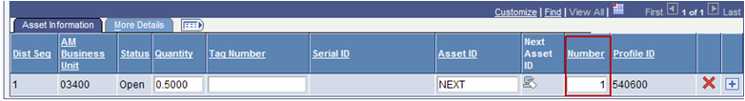Distribution Line #1
Distribution Line #2 (accessed by clicking the Show Next Row button in the Distribution Information section (in red box on page 1)
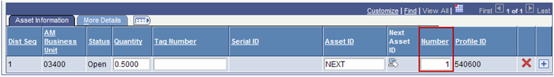
By using the Use One Asset ID feature, both Distribution Lines for this Purchase Order Line have the Number field set to ‘1’. This will ensure the Distribution Lines will be combined into one Load Line in the Interface Tables yet retain the split ChartField information in Asset Management.
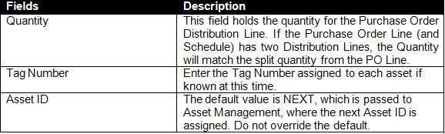
The More Details Tab holds additional Asset Physical Information.
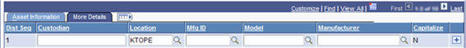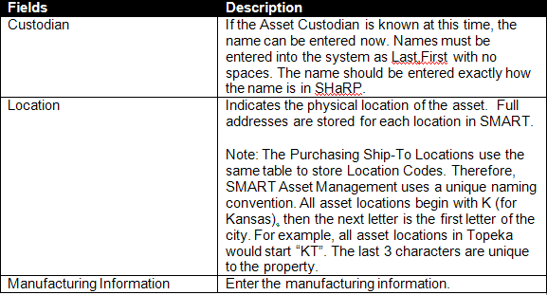

Click OK and Save. When the receipt is saved, a batch job will automatically run. The AM Status should change to Moved when you navigate back into the Receipt. An Asset ID will be assigned automatically in the Asset Management module. That asset will have a status of ‘Received’ until cost is integrated from the voucher.

