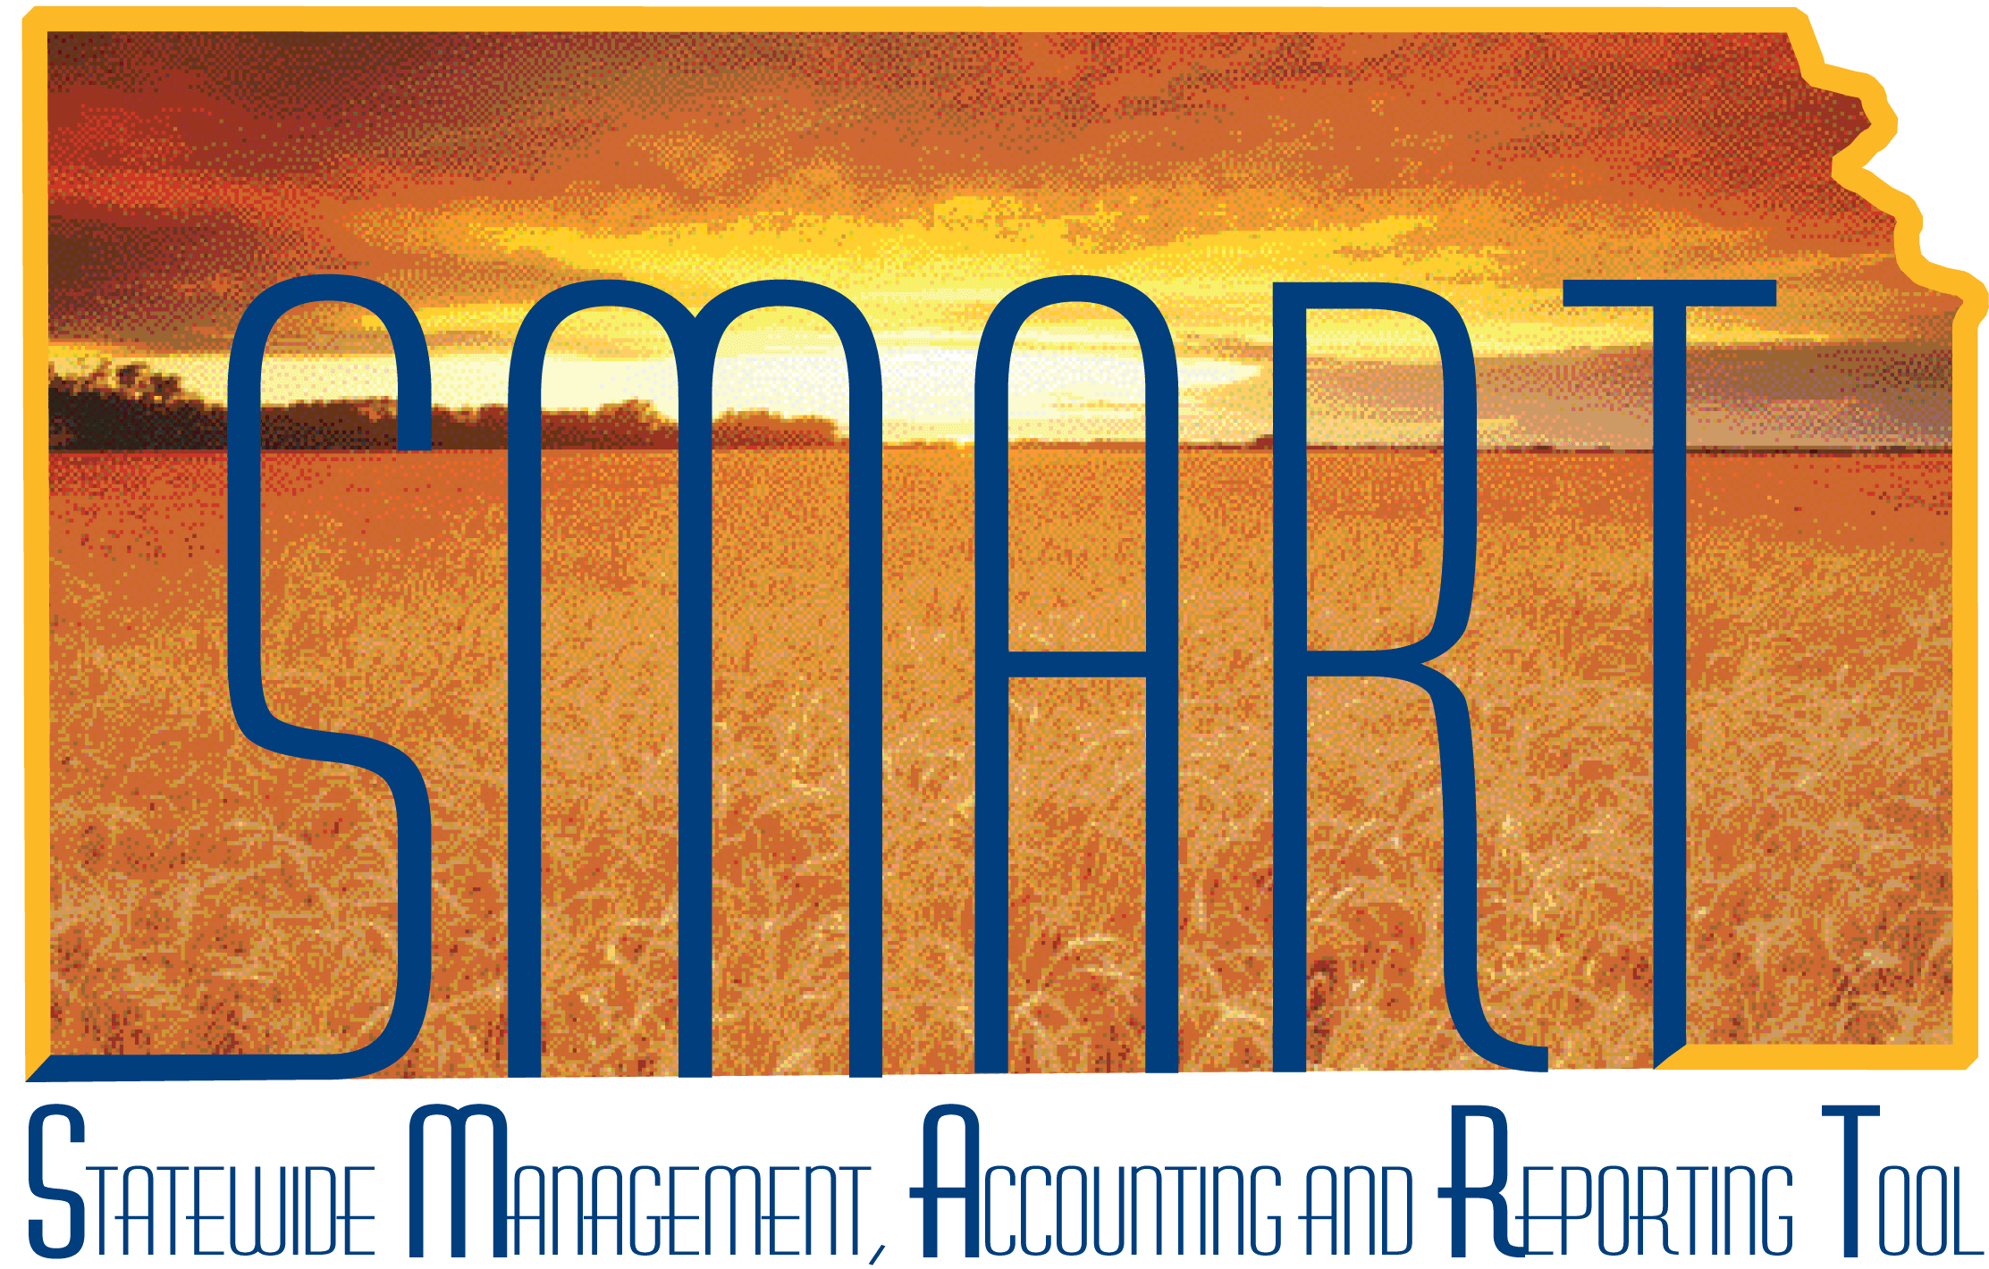

Training Guide – Asset Management
Adjustments and Additions to
Cost and/or Quantity

State of Kansas

Applicable Role(s):

Agency Adjustment/Transfer/Retirement Processor
Table of Contents
Overview 3
Steps to Perform Adjustment-How to Adjust an Existing Cost Row 3
Steps to Perform Addition-How to Add an Additional Cost Row 7
Adjustments/Additions on Parent-Child Assets 11

Adjustments and Additions to Cost and/or Quantity

Overview
- There are two Transaction Types that will change an asset’s cost and/or quantity. Instructions for both types are included in this Training Guide.
  - An Adjustment allows the user to update the asset’s cost and/or quantity. It adjusts an existing cost row.
  - An Addition allows the user to update the asset’s cost or quantity. It adds a new cost row to the asset. If you need to add a line of funding, Addition is the correct Transaction Type.
- When you update a capital asset’s cost, SMART creates the appropriate accounting and depreciation entries through a batch process, which is automatically run as part of month-end.
  - The accounting entries are sent to the General Ledger and update the value and depreciation information for the asset.
  - These entries ensure that the agency correctly represents the value of its assets.

Steps to Perform Adjustment—How to Adjust an Existing Cost Row

- Navigate to the Cost Adjust/Transfer Asset page.
Navigation
Asset Management Homepage>Asset Transactions>Cost Adjust/Transfer Asset

or

NavBar: Navigator>Asset Management>Asset Transactions>Financial Transactions>Cost Adjust/Transfer Asset

- Populate the applicable fields on the Main Transaction page.

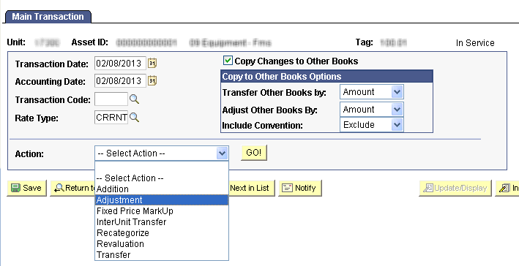
Main Transaction Page – Adjustment
Fields | Description
Transaction Date | The current date will default. If necessary, override this date to the actual date of the transaction.  Note: This date cannot be greater than the Accounting Date.
Accounting Date | The current date will default. The Accounting Date field is dependent on when the General Ledger is open. Therefore, this date should not be changed.
Copy Changes to Other Books | This checkbox defaults as checked. The State of Kansas has chosen to keep all books in sync. Therefore, any changes you make are automatically copied to all books for this asset.  You should not uncheck this box unless you are solely needing to adjust one book and not another. That situation should be rare.
Copy to Other Books Options | Do not change the defaults in this section.
Action | Use the Action drop-down list to choose Adjustment.
Main Transaction – Fields
- Click GO! The Cost Information page will display.

- Update the asset’s Quantity and/or Cost in the fields in the boxes below.
  - If more than one cost row should be updated, make all the applicable changes.
  - Remember, you only need to do this in one Book since the Copy Changes to Other Books option defaults as selected.
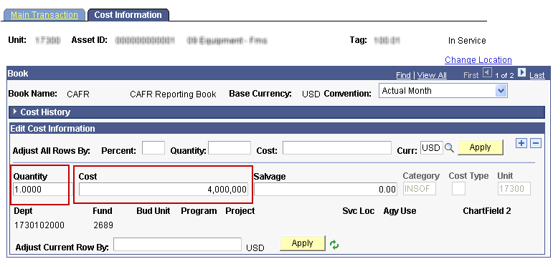
Cost Information Page – Adjustment

Fields | Description
Quantity | Enter the quantity if a change is necessary.  Example: If the current quantity says 3.0000 and it should be 1.0000, simply enter 1.0000 in the Quantity field. The system will calculate the adjustment down of 2.0000.
Cost | Enter the updated cost. You can adjust an asset’s cost for individual cost rows by entering the new cost into the Cost field for each cost row that you want to change.  Example: If the current cost is 15,000 and it should be 20,000, simply enter 20,000 in the Cost field. The system will calculate the adjustment up of 5,000.
Cost Information Fields – Adjustment
- Click Save.
- Review the Cost History page to validate the transaction.
Navigation
Asset Management Homepage>Asset Transactions>Asset History>Review Cost History

or

NavBar: Navigator>Asset Management>Asset Transactions>History> Review Cost

  - You should see an ADJ transaction.
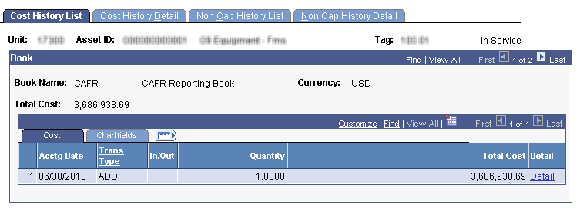
This is a screenshot from before the adjustment was made. Notice the Total Cost field.
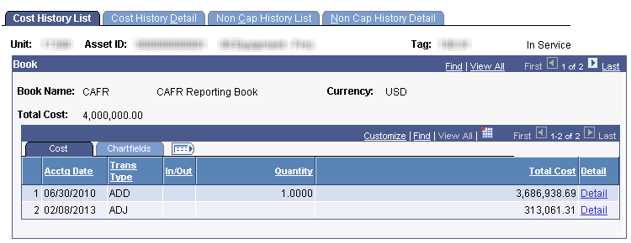
This is a screenshot from after the adjustment. Notice how the Total Cost has been updated and the system calculated the adjustment amount automatically. The STATE book would be identical.

Note: If the quantity had been adjusted, that value would appear in the Quantity column.

Steps to Perform Addition—How to Add an Additional Cost Row

- Navigate to the Cost Adjust/Transfer Asset page.
Navigation
Asset Management Homepage>Asset Transactions>Cost Adjust/Transfer Asset

or

NavBar: Navigator>Asset Management>Asset Transactions>Financial Transactions>Cost Adjust/Transfer Asset

- Populate the applicable fields on the Main Transaction page.

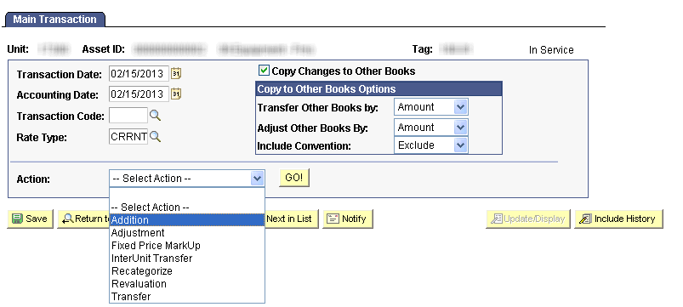
Main Transaction Page – Addition
Fields | Description
Transaction Date | The current date will default. If necessary, override this date to the actual date of the transaction.  Note: This date cannot be greater than the Accounting Date.
Accounting Date | The current date will default. The Accounting Date field is dependent on when the General Ledger is open. Therefore, this date should not be changed.
Copy Changes to Other Books | This checkbox defaults as checked. The State of Kansas has chosen to keep all books in sync. Therefore, any changes you make are automatically copied to all books for this asset.  You should not uncheck this box unless you are solely needing to adjust one book and not another. That situation should be rare.
Copy to Other Books Options | Do not change the defaults in this section.
Action | Use the Action drop-down list to choose Addition.
Main Transaction – Fields
- Click GO! The Cost Information page will display.
- Click the + button to add an additional cost row.
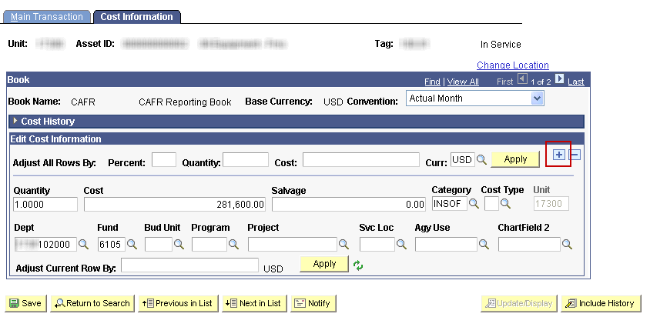
- Enter the additional cost, Category, and funding.
  - Remember, you only need to do this in one Book since the Copy Changes to Other Books option defaults as selected.
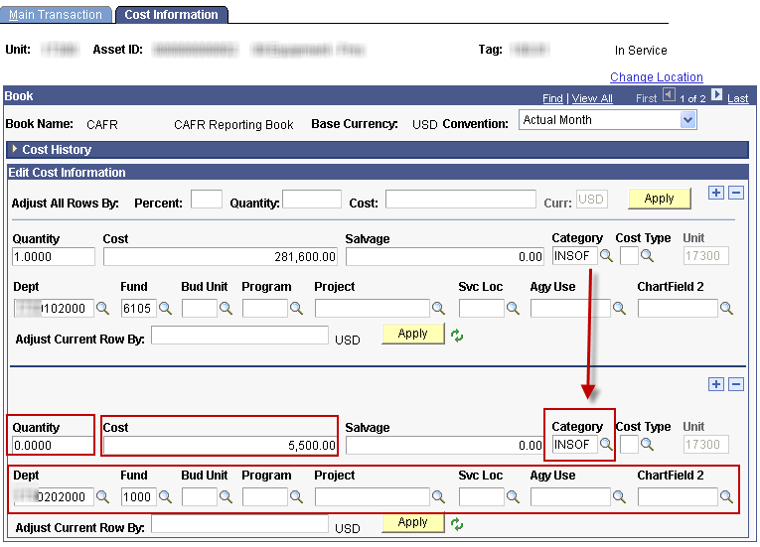
Cost Information Page – Addition
Fields | Description
Quantity | Enter the quantity.  Note: This may be 0.000 if the entire quantity has already been booked under the original cost row.
Cost | Enter the additional cost.
Category | Enter the Category. It should be the same value as the prior cost row.  Note: Missing this field is a common mistake. Be sure to populate it as it has an effect on accounting.
Dept  Fund  Bud Unit  Program  Project  Svc Loc  Agy Use  Chartfield2 | Populate all applicable chartfields. At a minimum, you must enter the Fund Code.  Note: This chartfield stream should be different than the one(s) already on the asset. That’s why an Addition is necessary—to add an additional cost row. If the chartfield stream is the same as an existing cost row, the action should be Adjustment.
Cost Information Fields – Addition
- Click Save.
- Review the Cost History page to validate the transaction.

Navigation
Asset Management Homepage>Asset Transactions>Asset History>Review Cost History

or

NavBar: Navigator>Asset Management>Asset Transactions>History> Review Cost

- You should see an ADD transaction.
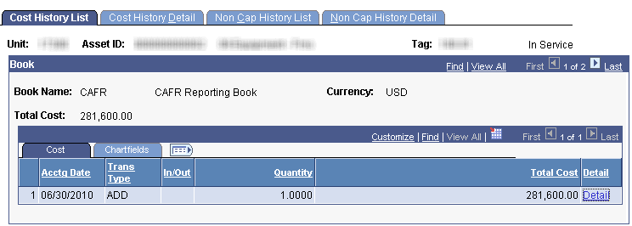
This is a screenshot from before the addition was made. Notice the Total Cost field.
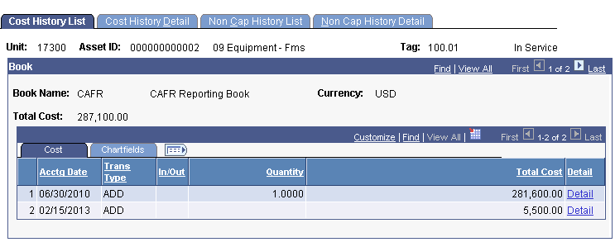
This is a screenshot from after the addition. Notice how the Total Cost has been updated and the system added a second ADD row. The STATE book would be identical.

Note: If the quantity had been altered, that value would appear in the Quantity column.
- You can also view the chartfields on the Chartfields tab.
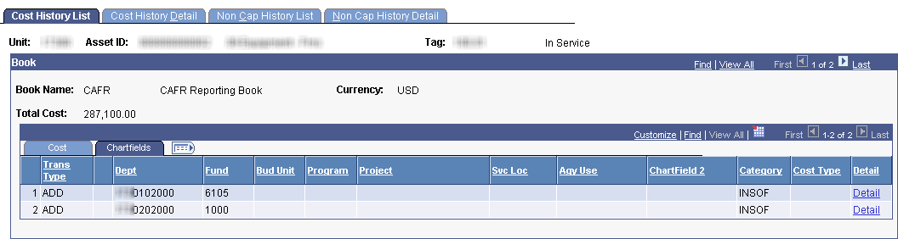

Adjustments/Additions on Parent-Child Assets

- When you perfom an adjustment/addition on a parent asset:
  - SMART does not automatically filter the adjustment down to child assets. If necessary, perform a separate transaction for the child asset(s) to reflect the adjustment.
  - SMART displays a reminder message stating that child assets exist for the parent to which you are making the adjustment.

