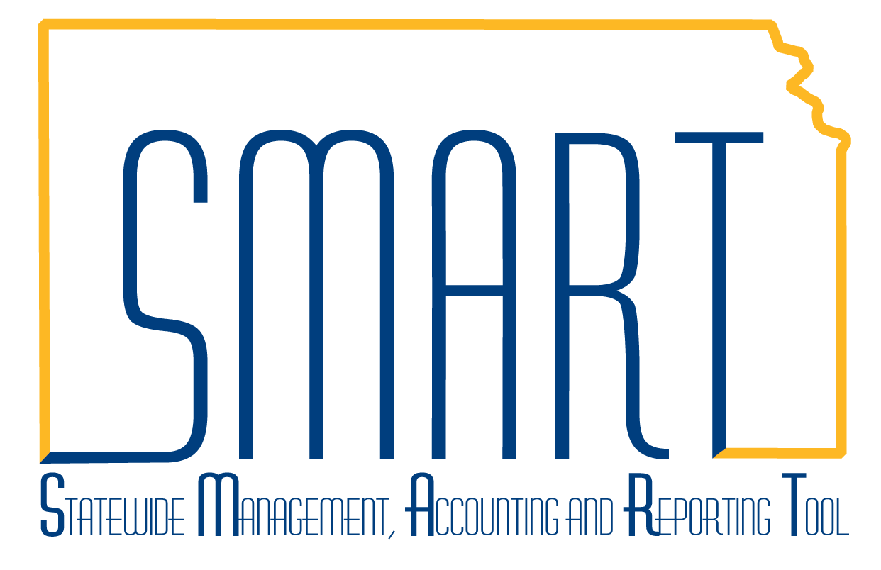State of Kansas
Asset Management: Adding an Asset Using Express Add
Statewide Management, Accounting and Reporting Tool

Date Created: | 11/2/2015
Version: | 3.0
Last Updated Date: | 03/27/19
Purpose: | To demonstrate how to add an asset via Express Add
Security: | Role Security: The following roles are applicable:  Agency Asset Processor  BU Security: Business Unit Security is applied. Agencies will only have access to the assets in their Business Unit.
Add Asset

Use Express Add to add assets directly into Asset Management. Express Add primarily contains financial information for the asset. For this reason, you must know the cost and funding information for the asset being entered before utilizing Express Add.

Step | Action
Navigation: Asset Management Homepage>Asset Transactions>Express Add
Or
NavBar: Navigator>Asset Management>Asset Transactions>Owned Assets>Express Add

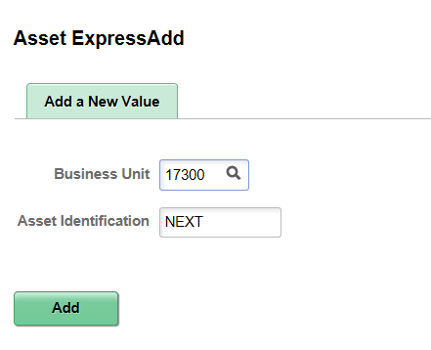

Step | Action
 | Click the Add button then enter data on Asset Information page.

Step | Action
It is critical to select the correct Profile ID as numerous data defaults from the Profile. See ‘Asset Management: The Basics’ training document for more detail on the Profile ID field. Based on the asset profile, SMART defaults financial and depreciation information for the asset. For a complete list of Profile IDs, see the “Profile ID Selection” job aid.

Click the Look up Profile ID (Alt+5) button.
 | Click the 540300 link.
Enter a detailed description for the asset.

Enter the desired information into the Description field. Enter "Express Add Example".
The Location field indicates the physical location of the asset. Full addresses are stored for each location in SMART.

Click the Look up Location (Alt+5) button.
The Purchasing Ship-To Locations use the same table to store Location Codes. Therefore, SMART Asset Management uses a unique naming convention. All asset locations begin with K (for Kansas), then the next letter is the first letter of the city. For example, all asset locations in Topeka would start “KT”. The last 3 characters are unique to the property.

Enter the desired information into the Location Code field. Enter "KT".
 | Click the Search button.
 | Click the KT987 link.
 | Enter the desired information into the Tag Number field. Enter "57955".
The Transaction Date field indicates the date the asset was put in service. The Accounting Date field indicates the date that SMART posts the transaction to the General Ledger. The Accounting Date defaults to today's date and should not be changed.

Note: If you need to enter an asset with an In-Service Date prior to today’s date, change the Transaction Date field to that In-Service Date. This is important because the Transaction Date drives the Depreciation start date. If this is an asset purchased 5 years ago and the Transaction Date is left as today’s date, that asset will begin depreciating when in reality it may already be fully depreciated.

Enter the desired information into the Trans Date field. Enter "mm/dd/yyyy".

The Trans Code field is used for assets that were either donated to or seized by the State of Kansas. Most assets will not have a Transaction Code.

Note: According to PPM 13,001, an agency must determine the Fair Market Value at the time of donation/seizure as the cost for that asset.
 | Enter the desired information into the Cost field. Enter "7846.52".
 | Click the Look up Dept (Alt+5) button.
 | Click the 1730101000 link.
Fund Code is a required field for all capital assets. If no Fund Code is selected, a combination edit error will display when you try to save the asset.

Click the Look up Fund (Alt+5) button.
 | Click the 1000 link.
 | Click the Look up Bud Unit (Alt+5) button.
 | Click the 0200 link.
 | Click the Look up Program (Alt+5) button.
 | Click the 01031 link.
 | If an additional line of funding was used to purchase this asset, you should click the '+' button to add the next funding row. In this example, there is only one funding stream.
Use the Default Profile button to copy the asset cost information to any other books associated to this profile and to populate the Category field. Default Profile is clicked after all asset cost rows have been added. This will default all the cost information from the first book into the second book, if applicable.

Click the Default Profile button.
 | After the Default Profile button is selected, the cost data is automatically populated into any additional Books.
SMART defaults the Asset Type based on the Asset Profile. Asset Types can be used for reporting purposes.

Asset Subtypes are pre-defined and associated to an Asset Type. Choose the subtype that best fits the asset. Asset Subtypes are used to refine reporting results.

Click the Look up Asset Subtype (Alt+5) button.
 | Click the OFFICE EQUIP link.
 | Enter the desired information into the Serial ID field. Enter "987654321".
Other fields in the Asset Additional Information section include:

Asset Class: SMART defaults the asset class based on the asset profile. The two valid values are “CAPITAL” and “NONCAPITAL”.

Acquisition Date: Indicates the date the asset was obtained. Defaults from the Transaction Date.

Acquisition Code: Defines how the asset was acquired. Typically this value will be “Purchased.”
If the asset was donated/seized, change the Acquisition Code to "Donated" or “Seized".

Parent/Child: If the asset is a parent asset or a child asset, select the appropriate option. If it is a child asset, specify the associated parent asset ID.

 | Click the Save button.
 | Upon save, SMART assigns the Asset ID at the top of the page.

