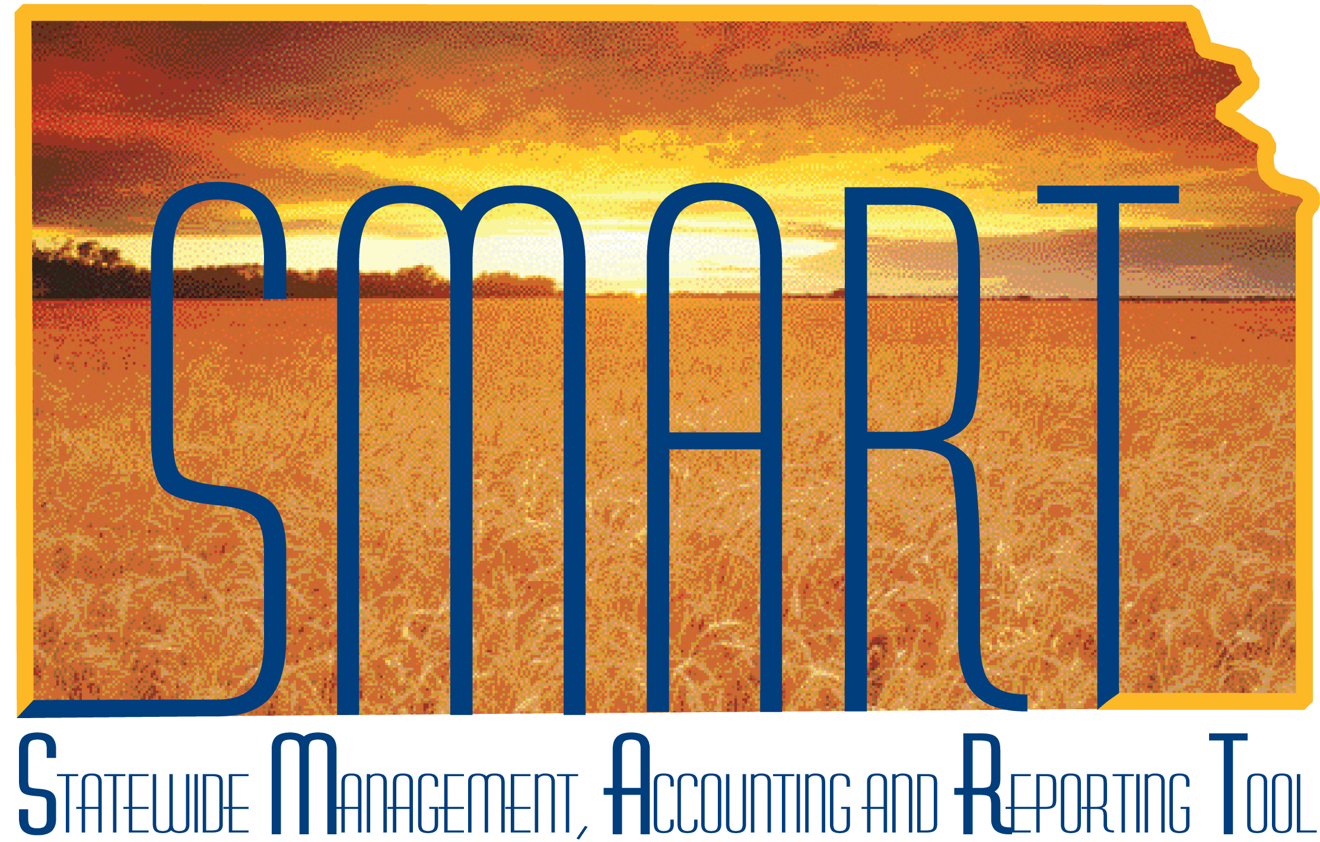

Training Guide – Accounts Receivable
Creating and Maintaining Deposits for Non-AR Payments

State of Kansas

Applicable Role(s): Deposit Processor - Agency, AR Agency Administrator - Central and Agency

Table of Contents

Deposits for Non-AR Payments 3
Key Terms 3
Defining Deposits 4
Deposit Process and Roles 4
Entering Payments 5
Deposit Types and Payment Methods 5
Entering Miscellaneous Deposits 5
Entering Direct Journal Payments 9
Entering Deposit Adjustments 12
Reviewing Payments 12
Deposit Approval Process 12
Viewing All Deposits 12
Viewing Cash Received by a Business Unit 13

Deposits for Non-AR Payments

Non-AR (or Miscellaneous) Deposits are payments that do not correspond to Customer Pending Items.

Deposit Key Terms
SpeedCharts – The pre-defined ChartField combinations that can contain a single accounting distribution or multiple accounting distributions. SpeedCharts are identified and invoked with a SpeedChart code during data entry to increase efficiency by reducing the number of keystrokes for frequently used accounting distributions.
Payments – Monies owed to and received by the State of Kansas
Regular Deposit – The standard method for recording the receipt of payment for goods or services sold. This is the only type of deposit used by the State of Kansas.
Electronic Payment – Payments from credit card, eCheck, and EFT. This interface is controlled and maintained by the State Treasurer’s Office (STO). Electronic revenue comes in the form of credit card or eCheck payments. Once the deposit is posted, the agency can do a deposit adjustment to assign the correct ChartField string.
Direct Journal Payments – These receipts are not associated with customers and cannot be applied to pending items. Cash is journalled directly to the General Ledger. SMART refers to these payments as directly journalled payments and treats them as miscellaneous cash receipts.
Deposit Adjustment – A deposit that is used to move money from one funding string to another and to correct previously posted deposits. For example, agencies can use deposit adjustments to move money originally deposited into a clearing fund to their agency specific fund.
Deposit Batch – A group of payments that need to be processed or have been processed
Pending Items – Only used in SMART Billing, Accounts Receivable and payments related to Customer Accounts Receivables (AR cash)

Defining Deposits
  - There are four basic steps to complete a deposit:
    - Enter control totals, enter payment information, create and complete accounting entries, approve deposit
- Journaling cash directly to the General Ledger will be used when you are processing non-AR cash
- A deposit consists of payments that are grouped together for processing. Cash and checks can be entered in the same deposit but EFT must be entered alone.

Deposit Process and Roles
The following diagram represents the End-to-End Deposits process flow.
Deposits End-to-End Process Diagram
SMART has two roles for handling non-AR deposits:
Role | Description
Deposit Processor - Agency | This role is responsible for entering deposits and viewing payment and deposit information
AR Agency Administrator - Central and Agency | This role is responsible for approving agency deposits

Entering Payments

Deposit Types and Payment Methods

Types (entered on Regular Deposit – Totals page):
M Miscellaneous
A Deposit Adjustment
E Electronic Payment
C Customer Receipts (only used if tracking Customer Accounts Receivable)
I or R or P Interfund - can only be assigned by SMART Interfund processing

Payment Methods (entered on Regular Deposit - Payments page):
Check Can be used with Deposit Types M or A or C
Cash Can be used with Deposit Types M or A or C
Electronic Fund Transfer Must be used with Deposit Type E

Entering Miscellaneous Deposits

- A miscellaneous deposit consists of four steps:
- Enter control totals and deposit characteristics on the Totals page.
- Enter payment information on the Payments page.
- Create and complete accounting entries in Direct Journal Payments.
- Approve deposit on the Totals page.

 | Homepage Navigation
Regular Deposit - Totals | Accounts Receivable Homepage > Payments > Online Deposit Search/Entry > Regular Deposit

 | NavBar Navigation
Regular Deposit - Totals | Accounts Receivable > Payments > Online Payments > Regular Deposit

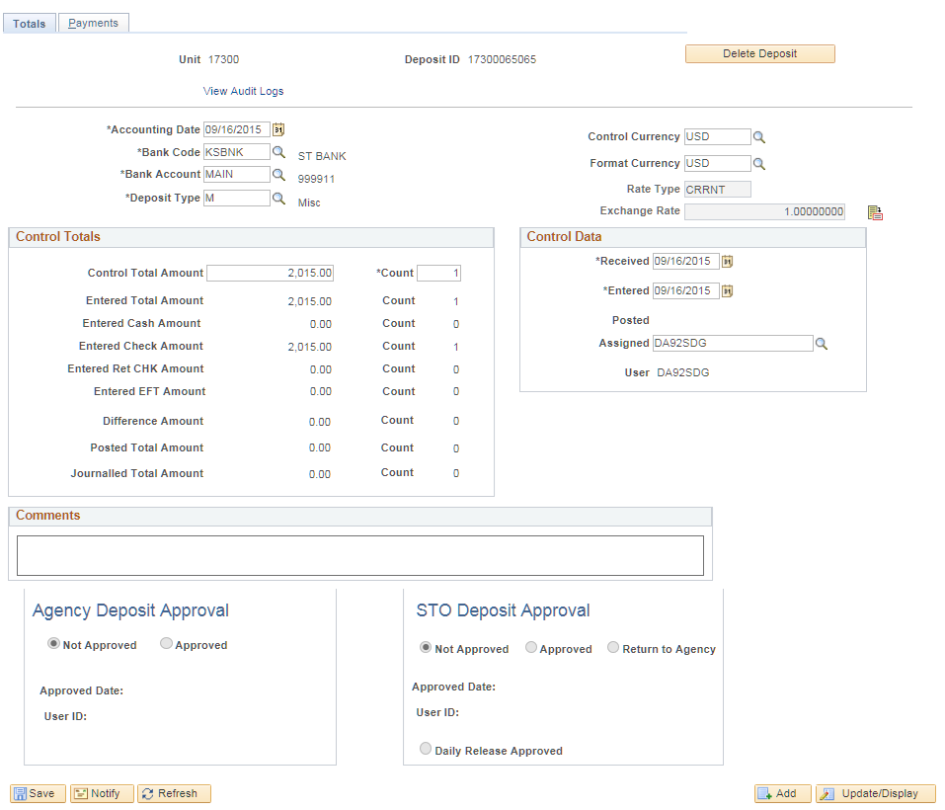

Totals Page

Field | Description
Accounting Date | This field defaults to the current date. SMART validates the accounting date to make sure it falls within the open period for the business unit and transaction type as defined on the Open Period page for the business unit.
Deposit Type | Deposit type is used to designate the type of deposit being entered. Deposit Types for the State of Kansas are as follows: A - Adjustments, C - Customer receipts, E - EFT receipts, M - Miscellaneous receipts. There are also Interfund related Deposit Types, I - Initiating Interfunds and R- Reciprocating Interfunds.
Control Total Amount/Count | Enter the totals for the amount and count of all the payments that will be included in this deposit.
Entered Total Amount/Count | These fields display the amount and count of the payments that you have entered and need to equal the Control Totals.
Entered Cash Amount and Count | The total amount of cash and the number of cash payment lines that were entered in the deposit
Entered Check Amount and Count | The total amount of all checks and the number of checks entered in the deposit
Entered EFT Amount and Count | The total amount of EFT and the number of EFT payment lines entered in the deposit
Entered Returned Check Amount and Count | The total amount of all returned checks and the number of returned checks entered in the deposit
Difference Amount/Count | These fields display any difference between the payments entered and the control totals. If the control and entered totals and count are not equal, the deposit will indicate Not Balanced. You cannot create accounting entries until the deposit indicates Balanced. The deposit will not be able to be approved until accounting entries are created.
Posted Total Amount/Count | This field displays the amount and count of payments that are successfully posted for AR Pending Item payments.
Journalled Total Amount/Count | This field displays the amount and count of payments that are successfully journalled (Direct Journal payments)
Received Date and Entered Date | These fields default to the current date but can be overridden. The received date is generally the date you received the payment and the entered date is generally the date the payment was entered in SMART. Because of normal processing delays, the received date may be different from the entered date.
User | Displays the user ID of the individual assigned to the deposit. If you received an electronic deposit, the Payment Loader process assigns the user ID of the individual who created the run control ID for the process. If another user modifies the deposit in the Regular Deposit component, SMART automatically changes the user ID to that person's user ID.
Comments | This free-form field can be used for various purposes. It is required by the State Treasurer, that the deposit preparer’s name and phone number are in this field.
Totals Page Elements

 | Homepage Navigation
Regular Deposit - Payments | Accounts Receivable Homepage > Payments > Online Deposit Search/Entry > Regular Deposit

 | NavBar Navigation
Regular Deposit - Payments | Accounts Receivable > Payments > Online Payments > Regular Deposit

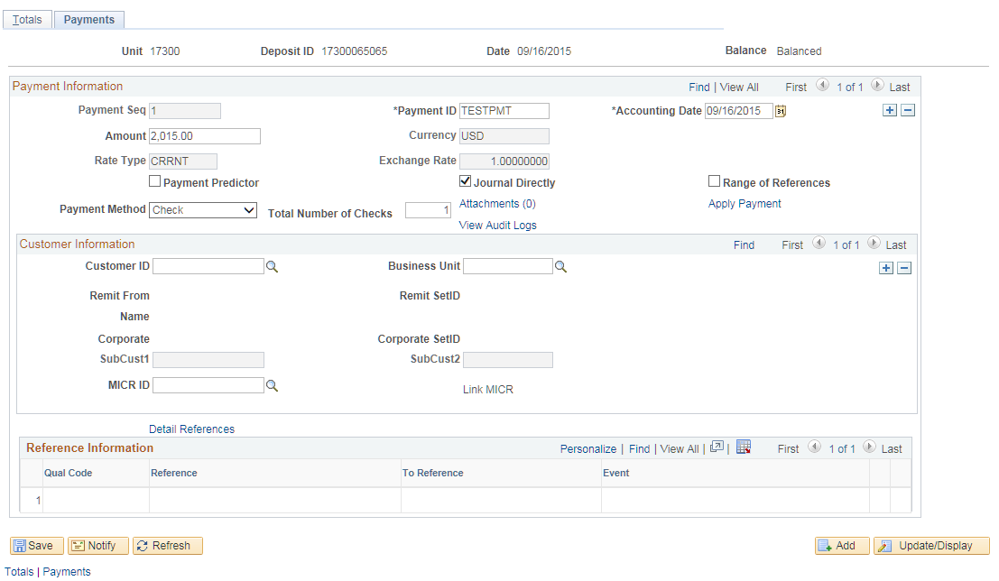

Payments Page
Field | Description
Balance | Displays the balance status of the deposit. When the entered total amount and count are equal to the control total amount and count on the Totals page, the status changes from Not Balanced to Balanced. The deposit must be in a balanced status before you can create accounting entries.
Payment Seq (sequence) | Assigned by SMART when you enter a Payment ID. SMART assigns sequential numbers to the payments so you can track the order in which payments are entered.
Payment ID | This is a free form field of a maximum of 15 characters for the agency to enter reference information.
Accounting Date | This field defaults from the accounting date on the Totals page
Amount | Payment amount is entered for each Payment ID.
Payment Predictor | Only used for Customer payments.
Attachments | Use this link to attach deposit documentation. To add an attachment, click on the ‘Attachments’ hyperlink. Click the ‘Add Attachments’ button. Click Browse and find the attachment that should be added to this deposit by clicking once on the file. Click ‘Open’. Click the ‘Upload’ button. Enter a description for the file attachment and click the Internal checkbox. Click ‘OK’. The Attachments hyperlink has a number next to it indicating the number of attachments to this deposit. Click ‘Save’.
Apply Payment | PeopleSoft 9.2 provides a link to create accounting entries for deposits directly from the Payments page, without having to navigate back to the menu.
Journal Directly | Select this check box if the payment is for miscellaneous cash rather than for Customer Pending Items. Payments to be directly journalled cannot be processed in payment worksheets and do not go through the AR Update process.
Payment Method | Select Check, Cash, Returned Check, or EFT. Cash, check, and returned check can be entered in any combination. EFT must be entered alone.
Total Number of Checks | This field becomes available when payment method of Check or Returned Check is selected. Checks can be entered individually on separate payment lines or as a total on one payment line. This field is for agency reference. Enter the total number of checks included in the total for the payment line.
Customer ID | Only used for Customer payments
MICR ID | This is a free form field of a maximum of 26 characters for agencies to enter additional reference information. It has no functionality in SMART.
Qual Code (qualifier code) | Only used for Customer payments if tracking Accounts Receivable
Reference (reference value) | Only used for Customer payments if tracking Accounts Receivable
Detail References Link | The State of Kansas is not utilizing this link
Payments Page Elements

Entering Direct Journal Payments
- Direct Journal Payment – Payments that do not correspond to Customer Pending Items are called miscellaneous cash or non-AR cash. In SMART, they are referred to as directly journalled payments because you create accounting entries for them without applying them to any Pending Item.
- Direct Journal Payments can be made to reduce previous expenditures vs. increasing revenue. This is accomplished by selecting expenditure ChartField values when creating accounting entries.
- The Direct Journal Payments – Create Accounting Entries page is used to create accounting entries for payments that are to be journalled directly. SpeedCharts can be used on this page to create Distribution lines. SpeedCharts are not required but can increase efficiency and reduce keystrokes by populating Distribution lines based on percentage from SpeedChart set up.

When processing a Direct Journal payment, remember to:

- Select the Journal Directly checkbox on the deposit’s Payments page.
- Create accounting entries for the payment on the Direct Journal Entry – Accounting Entries page and mark the entries Complete.
- Deposit Approval Process (Agency, State Treasurer and Daily Release).
- Budget Check and Journal Generator processes are run to complete and send the entries to General Ledger.
Apply Payment Link: PeopleSoft 9.2 provides a link on the Payments tab to create accounting entries directly from the Payments page, without having to navigate back to the menu.

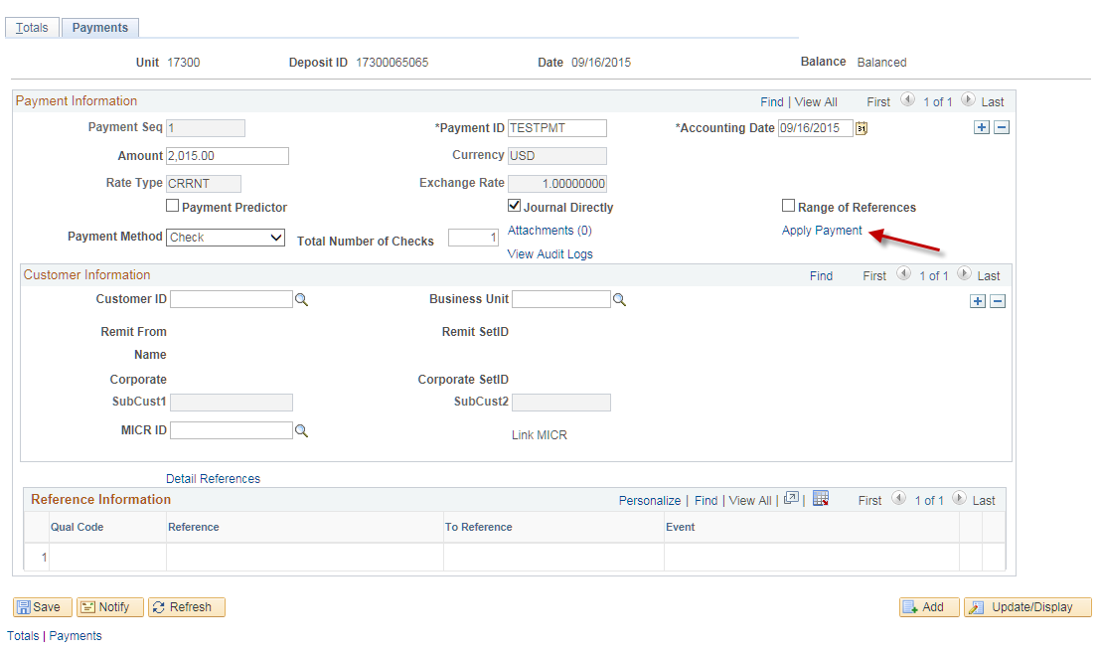

 | Navigation
Accounting Entries | Accounts Receivable > Payments > Direct Journal Payments > Create Accounting Entries > Accounting Entries  or  Use the ‘Apply Payment’ link on the Regular Deposit – Payments tab.
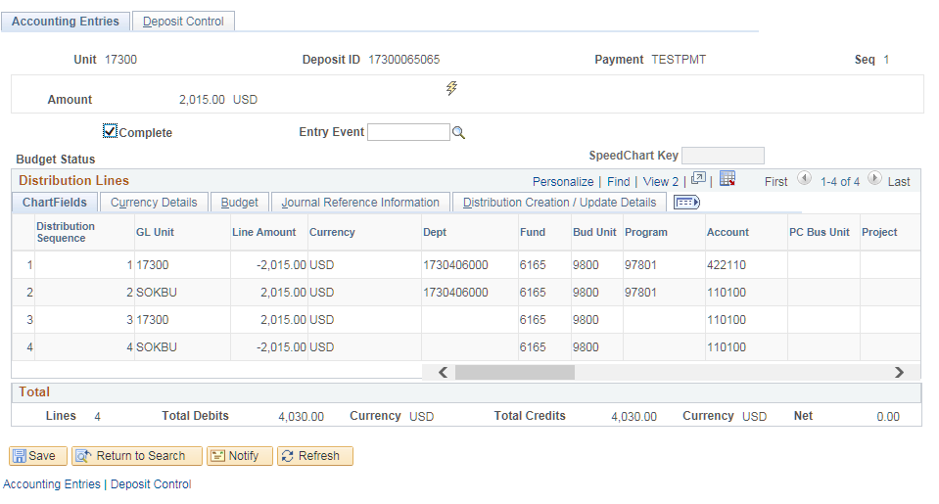
Accounting Entries Page
Accounting Entries Page: Enter Accounting distribution data beginning on line one or use a SpeedChart Key. Remember to enter the Line Amount in the opposite sign of the total amount on the Totals page. Once complete, use the lightning bolt icon to create the remainder of the accounting lines. After reviewing the lines, place a checkmark in the ‘Complete’ box and save.
Field | Description
Complete | Check this box once accounting entries are displayed correctly on this page. By doing this, the accounting entries will display on the Regular Deposit – Accounting Entries page and this payment will be marked as complete. If not marked, the deposit will not be able to be approved.  To modify or delete the accounting entries after the Complete box has been checked, the AR Administrator must uncheck the box, make any necessary changes, and then the recheck the box to mark the accounting entries as complete.
Budget Status | This field becomes populated with a status of Valid after the budget check process has run successfully. A status of Valid allows the payment to be processed by Journal Generator.
SpeedChart Key | This is an optional field. Populate this field with a SpeedChart key and SMART will create accounting entries based off the SpeedChart set-up.
 | Click the Create button to create the all accounting lines for a direct journal payment
 | Click the Delete button to delete accounting lines (if the Complete box is checked, the button will not be available.
Directly Journalled Payments Page Elements
Note: Direct journal payments are processed when Journal Generator is run during the nightly processing. The majority of agencies will be using direct journals to enter in their revenue because they will not be tracking receivables in SMART.

Entering Deposit Adjustments
Deposit Adjustments are used to move money from one funding string to another and to correct previously posted deposits.

See Job Aid – Deposit Adjustments

Credit Card Adjustments
As often as daily, the State Treasurer’s Office will process EFT Deposits in SMART on behalf of Agencies for their Credit Card and E-Check revenue. The State Treasurer’s Office deposits these monies into Credit Card Clearing Funds that have been designated for each Agency.

There is no automatic notification that a Credit Card Deposit has been processed. It is the Agency’s responsibility to search for and adjust these transactions daily:
Step 1: Search for your Credit Card Deposit
Step 2: Open your Credit Card Deposit and view the Control and Payments tabs to determine the information that needs to be adjusted.
Step 3: Create a Deposit Adjustment

See Job Aid – Credit Card Transactions

Reviewing Payments

Deposit Approval Process

There are two levels to the Deposit Approval Process. Both approval boxes are located on the Totals page of the Regular Deposit. Once both levels of Approvals have been completed, the State Treasurer performs a Daily Release, which allows budget check to process and journals to generate in the General Ledger, making monies available to spend against.

  - Agency Approval
    - Once a deposit has been entered and accounting entries have been created and marked Complete, the deposit is ready for Agency Approval
    - The Agency Administrator role has the responsibility of approving deposits of all types

  - State Treasurer Approval
    - Once the deposit has been approved by the Agency, it is ready for the second level of approval: State Treasurer Approval
    - The State Treasurer approves Deposit Types of C – Customer Receipts, E – EFT Receipts, M – Miscellaneous Receipts, and N – Insufficient Funds.
    - Accounts & Reports approves the Deposit Type of A – Adjustment.

Viewing All Deposits
- SMART enables you to view the deposit status for a single deposit either to find problems associated with a specific deposit or to locate errors in posting.
- Use the All Deposits page to view details about a specific deposit ID (including control totals and status) or scan all deposits, one at a time.
 | Nav Bar Navigation
All Deposits | Accounts Receivable > Payments > Review Payments > All Deposits > All Deposit
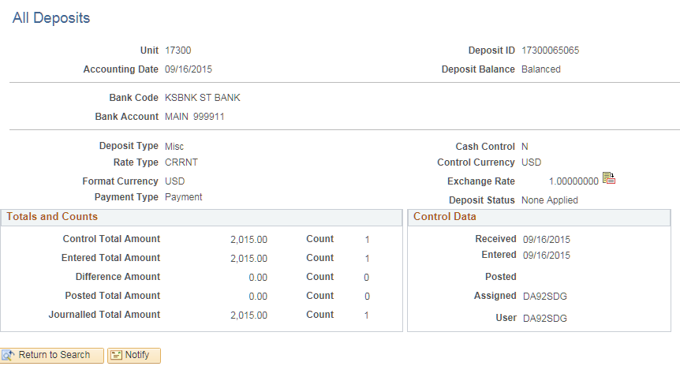

All Deposits Page

Viewing Cash Received by a Business Unit
- You review the deposits for a single business unit for one or more days or for a specified period. If you have security access to more than one business unit, view the inquiry for one business unit at a time.
Use the Cash Received by Unit page to view cash received by one business unit.
 | Nav Bar Navigation
Cash Received by Unit | Accounts Receivable > Payments > Review Payments > By Unit > Cash Received by Unit

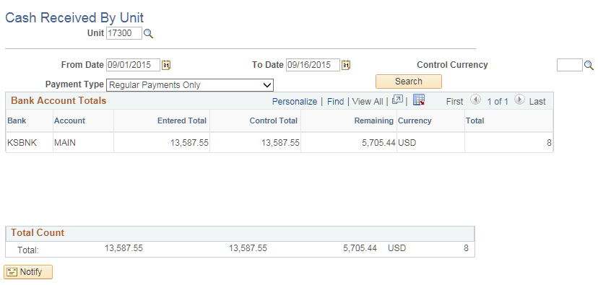

Cash Received By Unit Page

