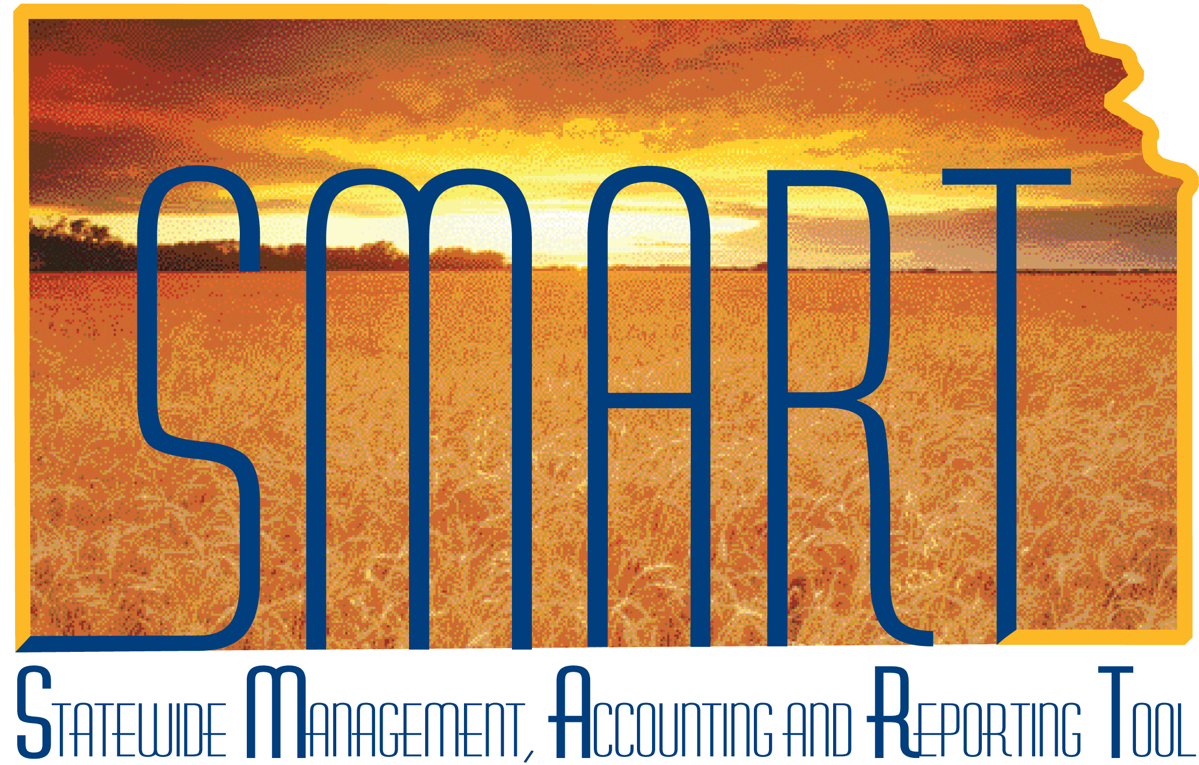

Training Guide – Accounts Receivable
Maintaining Customers

State of Kansas

Applicable Role(s): Customer Creator, AR Agency Administrator and AR Configurator

Table of Contents
Introduction to Customers 3
3
End-to-End Process of Accounts Receivable and Billing in SMART 4
Customer Maintenance Roles 4
Creating Customers 5
5
Entering a Customer 5
Copying a Customer 21
21
Updating and Maintaining Customers 23
23
Updating Customer Types and General Customer Information 23
Correspondence Customer Options 23
Attachments 24
Notes 24

Introduction to Customers

A customer can be designated with one or many different roles within the SMART Accounts Receivable and Billing process. Customer roles determine the functional use of the customer ID. Customer information is associated with specific customer roles. You can use the customer General Information component to maintain information that applies to multiple customer roles and to select those roles. You can use the pages with role designations to enter processing attributes and additional information that are unique to the customer's function.
The customer’s function may be to receive bills or submit payments. Each customer may also be part of a larger customer group. Customers should be assigned to their appropriate role or roles in order to create reports and analyze payment history, either by role or as a customer group.

Key Terms:

- Customers – Entity that receives or consumes products (goods or services) and has the ability to choose between different products and suppliers
- Customer Role – Defines the functional use of the customer by an agency or the State of Kansas
- Primary Roles
  - Bill To – The customer that receives the invoice
  - Remit From – The customer that pays the invoice
- Additional Customer Roles
  - Correspondence Customer – Correspondence customers are, by default, associated with a ‘Bill To’ customer. The information that you establish for the correspondence customer defines processing options, ‘send to’ information and ‘remit to’ address information for customer correspondence, such as statements, finance charge invoices, and dunning letters.
Note: If you select a customer as a correspondence customer and then decide to deselect the checkbox, you must first delete the correspondence options that you set for the customer.
  - Grants Management Sponsor – This role indicates that this customer is an external sponsor who provides grant funding to State of Kansas agencies. When you select that the customer is a Grants sponsor, this enables the customer information that you enter on these pages to be included in other Grants pages and processing.

End-to-End Process of Accounts Receivable and Billing in SMART

Figure 1. End-to-End Accounts Receivable and Billing Process

Customer Maintenance Roles
Role | Description
Customer Creator | This role is responsible for creating and updating customers and customer information.
AR Agency Administrator | This role is responsible for approving agency deposits in addition to creating and updating customers and customer information.
AR Configurator | This role is responsible for setting up and maintaining values that are used for some AR fields including Speed Charts and Reason Codes.
Billing Administrator | This role is responsible for setting bills to "ready" status and running the process to finalize invoices, as needed. Maintenance of agency-configured values is included with this role. This role also shares access to the customer maintenance tables with the AR Agency Administrator and may create new customers in the SMART system.
Central AR Configurator | This role is responsible for setting up and maintaining values that are used for some AR fields, such as payment terms an aging categories. They also have the ability to correct history for effective-dated rows.
Central BI Configurator | This role is responsible for maintaining centrally controlled BI configuration values such as Remit To Addresses and Billing Sources.
Table 1. Customer Maintenance Roles

Creating Customers

Entering a Customer
- In order to conduct business with customers, information needs to be tracked, including general and processing information and roles and correspondence options.
Note: The SOK does not utilize Ship To or Sold To customer roles.

When you establish a customer, the first page that you complete is the General Info page. This page is used to enter and maintain overall customer information and roles.

Accounts Receivable Navigation
General Information – General Info | Accounts Receivable Homepage > Customers and Accounts > Customer Information > General Information > Add a New Value
Billing Navigation
General Information – General Info | Billing Homepage > Online Billing > Customers > General Information > Add a New Value
NavBar
General Information – General Info | Navigator > Customers > Customer Information > General Information > Add a New Value

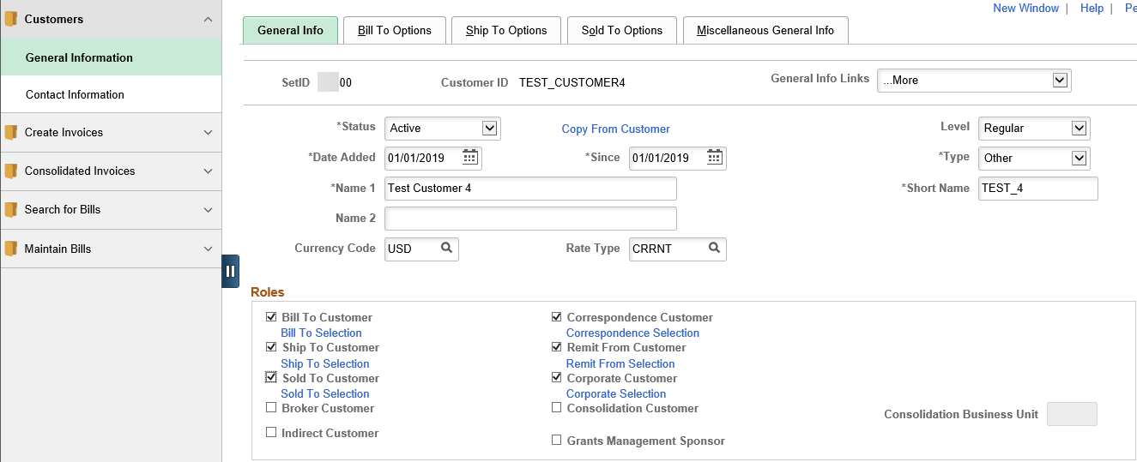Figure 2. General Info Page, part 1

Fields | Description
Customer Status | Select from the available options:  Active – There are no restrictions on how the customer can be used in the system. This defaults in SMART.  Inactive – You cannot post pending items to inactive customer accounts in SMART Accounts Receivable. Additionally, prompt lists exclude inactive customers. Their account information, however, appears on the customer pages and remains part of historical information.  Note: This field can also be found in other customer areas, such as addresses when users add a new effective dated row. It is best practice to select “Inactive” for incorrect or updated customer information.
Date Added and Since | Enter the date when you established this customer in the system. You can also specify that the customer has been a customer since a certain date, which may or may not be the date added. The current date appears by default for both fields.
Type | Use this field to enter the customer type. The SOK has four customer types: FEDGOV (Federal Government), LOCGOV (Local Government), STATE (InterFund-State Agency), and OTHER (Other). Customer Type defaults to OTHER, but can be changed.
Name 1 | Enter the customer's primary name. Enter the customer’s standard name in the Name 1 field on this page. You can enter an alternate name in the Name 2 field on this page if the customer has a different doing business as (DBA) name. A third name field, Name 3, appears on the Miscellaneous General Information page, in addition to the Name 1 and Name 2 fields.
Short Name | Enter a name to appear on pages when there is not room for the full name. The system populates this field with the first ten characters of the Name 1 field.
Currency Code | The SOK has one value for this field, USD. This must be selected when creating a customer. This field does not default.
Rate Type | The SOK has one value for this field, CRRNT. This must be selected when creating a customer. This field does not default.
Bill To Customer | Select if the customer receives invoices. When you select this check box, the system designates the customer as a correspondence and a remit from customer, and makes those check boxes available. Only bill to customers can be correspondence or remit from customers. To change the correspondence or remit from assignments for this customer, clear the corresponding check boxes. Two additional fields appear for entry of the Set ID and the Customer ID of the new correspondence or remit from customer. SMART Billing and Accounts Receivable use these roles.
Correspondence Customer | Correspondence customers are, by default, associated with a bill to customer. The information that you establish for the correspondence customer defines processing options, send to information, and remit to address information for customer correspondence, such as statements, finance charge invoices, and Dunning letters.
Remit From Customer | A remit from customer is the paying entity. All customers are their own Remit From Customers by default, unless you assign the customers to Remit From Groups in the General Information component.
Table 2. General Info Page Elements, part 1
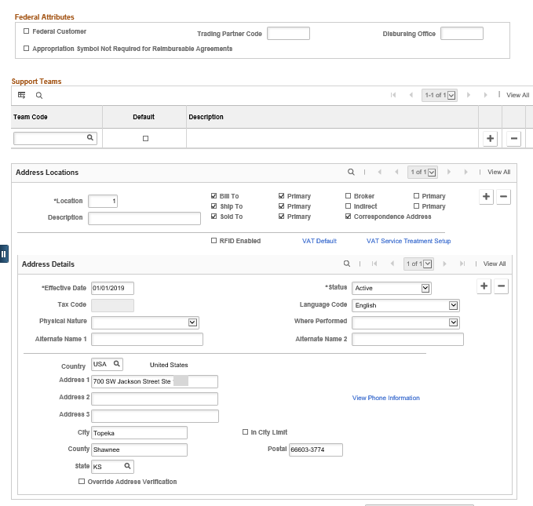
Figure 3. General Info Page, part 2
Fields | Description
Team Code | There is only one value defined for SOK, KANSAS.
Default | Use this field to specify the support team to be referenced on sales orders and quotes. This is a required field even though the SOK only has one Team Code.
Location | This field defaults to 1 the first time it is used. If a customer has more than one address, SMART auto-numbers the additional addresses.
Descriptions | This field is used to describe the address location.
Bill To | Use this field to indicate that this is a Bill To customer address.
Primary | Use this field to indicate that this address is the primary mailing address for billing information. If there is more than one customer address, you must indicate which address is the primary address.
Correspondence Address | Use this field to indicate that this address is the address where all correspondence is to be sent.
Effective Date | This field defaults to the current system date.
Address Information | All address information including Address 1, City, State, and Postal must be entered.
Table 3. General Info Page Field Elements, part 2
Use the Bill to Options page to enter default values for associated processes in Billing. Also, select and identify the collection personnel for this customer.

Accounts Receivable Navigation
General Information – Bill To Options | Accounts Receivable Homepage > Customers and Accounts > Customer Information > General Information > Bill to Options tab
Billing Navigation
General Information – Bill To Options | Billing Homepage > Online Billing > Customers > General Information > Bill to Options tab
NavBar
General Information – Bill To Options | Navigator > Customers > Customer Information > General Information > Bill to Options tab

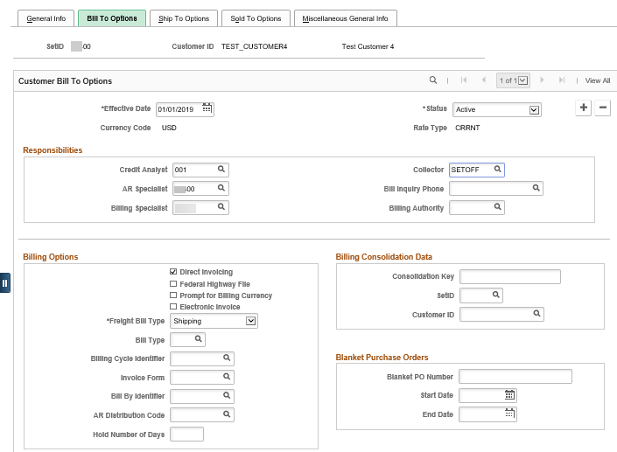
Figure 4. Bill To Options Page, part 1

Fields | Description
Credit Analyst, Collector, and Billing Specialist | Use these fields to select predefined personnel codes for those who work with this customer. SMART Billing and Accounts Receivable use these Fields.  Credit Analyst: This is a required field for all bill to customers. The SOK uses one Credit Analyst, 001.  Collector: This is a required field for all bill to customers. There are only two available values for Collector, SETOFF and 3RDPARTY.  Billing Specialist: This field is agency specific.
AR Specialist (accounts Receivable specialist) | Use this field to select the code for the person who SMART Accounts Receivable assigns as the initial owner for the customer's deductions and disputed items. If you do not enter a value, the system uses the Accounts Receivable specialist whom you assign to the Accounts Receivable business unit. If you assign an Accounts Receivable specialist to an entry reason on the Automatic Entry Type - Selection page, the system uses that specialist.
Table 4. Bill To Options Page Elements, part 1
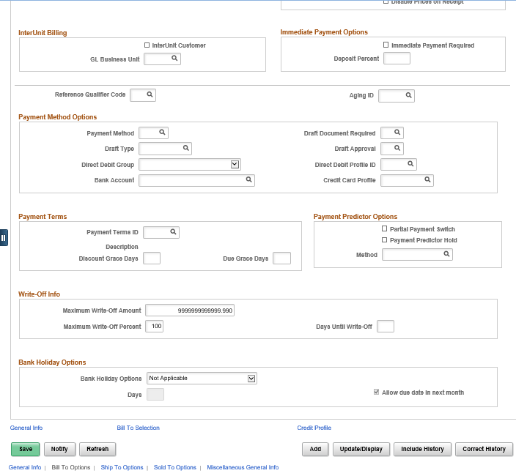
Figure 5. Bill To Options Page, part 2
Fields | Description
Maximum Write-Off Amount | This is a default value that cannot be changed. The SOK default is 99999999999999999999999.999.
Maximum Write-Off Percent | This is a default value that cannot be changed. The SOK default is 100.
Days Until Write-Off | This is a default value that cannot be changed. The SOK default is 0. This means that if you create or update a customer item, you can write-off the same business day.
Table 5. Bill To Options Page Elements, part 2
Use the Correspondence Options page to select contact and address information that is used in statement and letter headers and decide where you want your customer to send payments. You can determine when to exclude items from correspondence and when not to send the letter or statement.

Accounts Receivable Navigation
Correspondence Options | Accounts Receivable Homepage > Customers and Accounts > Customer Information > General Information > Select
Billing Navigation
Correspondence Options | Billing Homepage > Online Billing > Customers > General Information > Select 0040 – Correspondence Options in the General Info Links drop-down
NavBar
Correspondence Options | Navigator > Customers > Customer Information > General Information > Select 0040 – Correspondence Options in the General Info Links drop-down
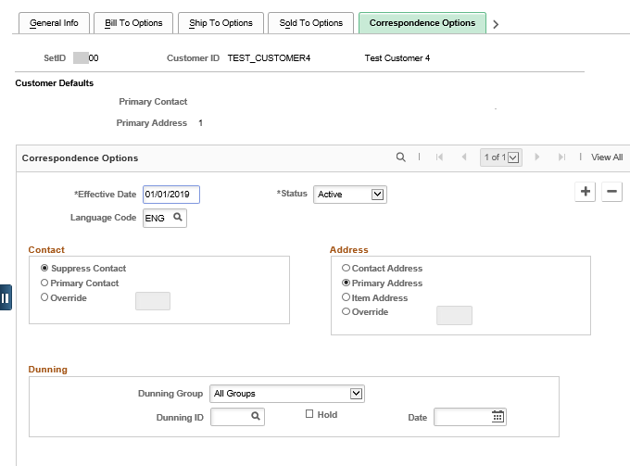
Figure 6. Correspondence Options Page, part 1
Fields | Description
Suppress Contact | Use this field to prevent letters from being addressed to the primary contact.
Primary Contact | Use this field to have correspondence addressed to the primary contact.
Override | Use this field to correspond with someone other than the primary contact. Then select the sequence number of the other contact person from the available values.
Remit to Type | Use this field to select the default remit to bank account information for the customer on a bill. The SOK value for this field is Default Remit To.  Note: If your agency is NOT using Billing, then this field is not used.
Bank | The SOK has incorporated REMIT for all state agencies to use for Bank information.  Note: If your agency is NOT using Billing, then this field is not used.
Account | Use this field to select the default remit to bank account information for customer billing.  Note: If your agency is NOT using Billing, then this field is not used.
Dunning ID | The SOK has incorporated KSDUN for all state agencies to be used for Dunning ID’s within their specific business unit. The Agency AR Configurator is the only role that can create a new Dunning ID. If there is another id in this field, end users do have the ability to choose that option.
Statement ID | The SOK has incorporated STATE for all state agencies to be used for Statement ID’s within their specific business unit. This field cannot be overwritten.
Dunning Hold and Statement Hold | Select any of these check boxes to prevent the system from creating Dunning letters or customer statements for this customer. These check boxes are useful when, for example, a customer does not wish to receive statements, or you wish to exclude a customer from Dunning.
Table 6. Correspondence Options Page Elements, part 1

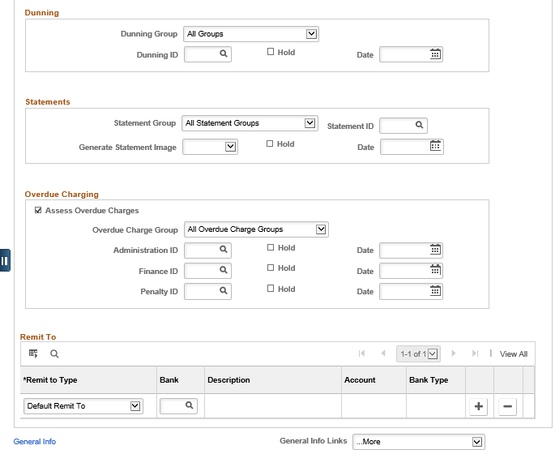
Figure 7. Correspondence Options Page, part 2
The remit-from customer is the paying entity. A remit-to customer relationship is set up to mirror customers that have an accounts payable location that pays the bills for multiple companies. If your agency has decided to use this option, it could help you apply payments. For example, if you did not have any invoice numbers available to you in the payment worksheet (which is covered in AR351), you could view all open items for a Remit-from group.

Accounts Receivable Navigation
General Information – Remit-From Selection | Accounts Receivable Homepage> Customers and Accounts > Customer Information > General Information > Click the Remit-From Selection link on the General Info Page
Billing Navigation
General Information – Remit-From Selection | Billing Homepage > Online Billing > Customers > General Information > Click the Remit-From Selection link on the General Info Page
NavBar
General Information – Remit-From Selection | Navigator > Customers > Customer Information > General Information > Click the Remit-From Selection link on the General Info Page

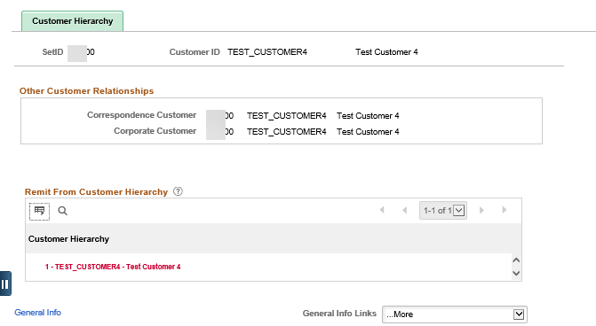
Figure 8. Remit From Selection Page
The Miscellaneous General Information page stores additional information, such as the date the customer was last modified and by whom.

Accounts Receivable Navigation
General Information – Miscellaneous General Info | Accounts Receivable Homepage> Customers and Accounts > Customer Information > General Information > Miscellaneous General Info tab
Billing Navigation
General Information – Miscellaneous General Info | Billing Homepage > Online Billing > Customers > General Information > Miscellaneous General Info tab
NavBar
General Information – Miscellaneous General Info | Navigator > Customers > Customer Information > General Information > Miscellaneous General Info tab

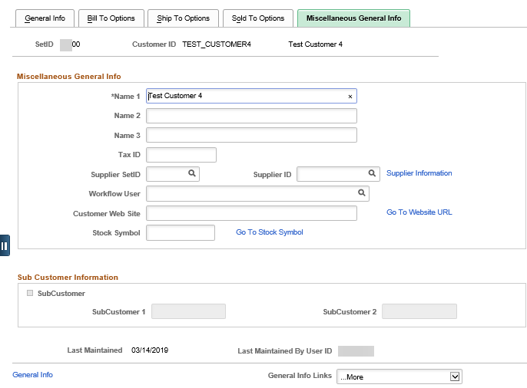Figure 9.

Figure 8. Miscellaneous General Info Page

Contact Information

For additional reference, you can enter contact information for a customer into the Contacts component. This component also allows for setting up Customers for email delivery of finalized invoices.

Note: Adding Contact Information here will also make the contact available as an Interfund Contact.
Accounts Receivable Navigation
Maintain Contacts | Accounts Receivable Homepage > Customers and Accounts > Contact Information > Add a New Value
Billing Navigation
Maintain Contacts | Billing Homepage > Online Billing > Customers > Contact Information > Add a New Value
NavBar
Maintain Contacts | Navigator > Customers > Contact Information > Add a New Value

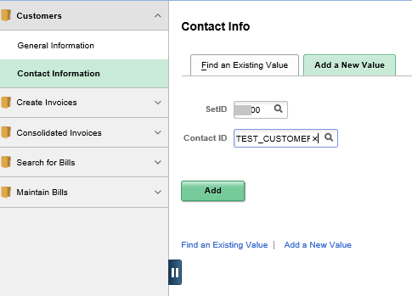
Figure 9. Contact Information, Add a New Value page

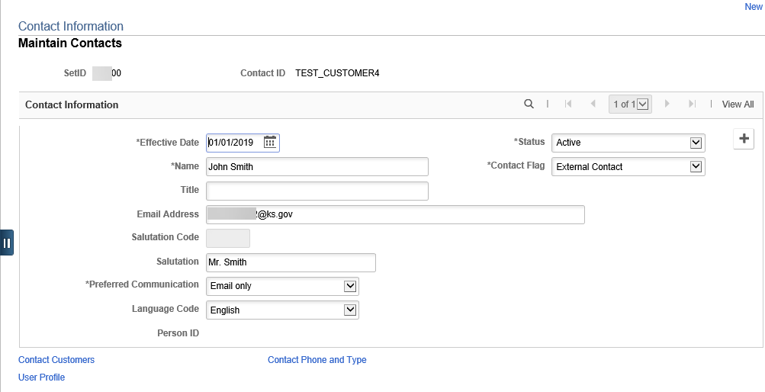
Figure 10. Contact Information Page

Fields | Description
Contact Flag | Use this field to select whether the contact is External or Internal.
Email Address | Use this field to enter a valid email address for the contact. If the Contact is linked to the Customer on the Contact Customers page below, then the Documentation page, invoices can be emailed automatically during the Finalization and Print process in Billing.
Salutation Code | Use this field to select appropriate title from the list.
Salutation | Use this field to enter up to 30 characters for a salutation.
Preferred Communication | Use this field to select the type of communication the customer contact prefers. If you choose Email only, an e-mail address must be entered on this page. If Fax or Call is selected, click the Contact Phone and Type link to enter the required information.

Table 7. Contact Information, Maintain Contacts page

To associate this contact with a customer, click the Contact Customers at the bottom of the Contact Page.

Accounts Receivable Navigation
Contact Customer | Accounts Receivable Homepage > Customers and Accounts > Contact Information > Contact Customers link
Billing Navigation
Contact Customer | Billing Homepage > Online Billing > Customers > Contact Information > Contact Customers link
NavBar
Contact Customer | Navigator > Customers > Contact Information > Contact Customers link

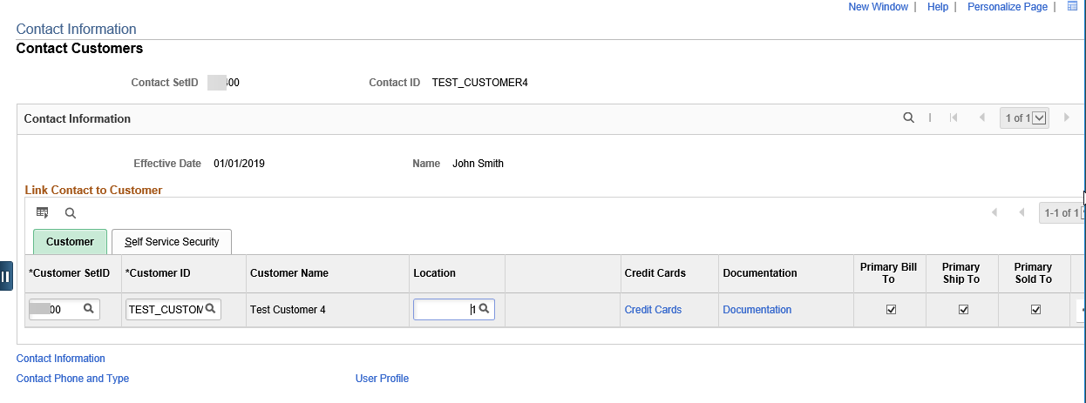
Figure 11. Contact Customers Page

For Billing, to utilize functionality to automatically email a finalized invoices, click the Documentation link. Using the lookup for Document Code, select INVC. For invoice processing, select Email Invoice as Attachment for the Preferred Communication.

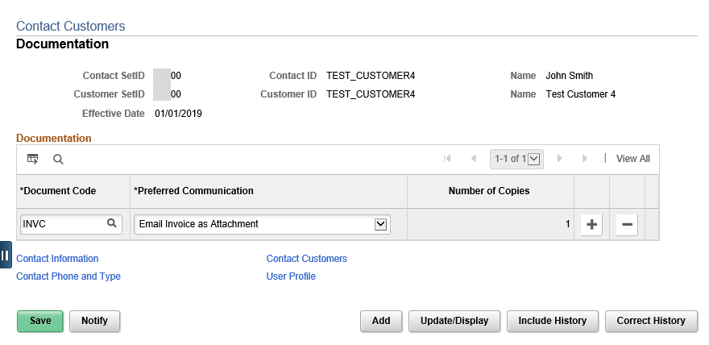
Figure 12. Documentation page

Copying a Customer

The customer pages contain a shortcut to establish a customer, called the Customer Copy function. You can use it any time you want to use attributes from one customer to establish a new customer.

If you decide to use the copy function, you can copy all or selected attributes from another customer. The link is only available when adding a new Customer. Clicking the Copy Customer link opens up a new page where you can select check boxes for the different customer roles and attributes that you want to assign to your new customer.

Note: The Copy Customer function does not copy all attributes. You must enter the Default, Dunning and Statement ID. It is also best practice to verify that all information was copied correctly.

Accounts Receivable Navigation
Copy Customer | Accounts Receivable Homepage > Customers and Accounts > Customer Information > General Information > Add a New Value tab > General Information page > Click the Copy From Customer link
Billing Navigation
Copy Customer | Billing Homepage > Online Billing > Customers > General Information > Add a New Value tab > General Information page > Click the Copy From Customer link
NavBar
Copy Customer | Navigator > Customers > Customer Information > General Information > Add a New Value tab > General Information page > Click the Copy From Customer link.

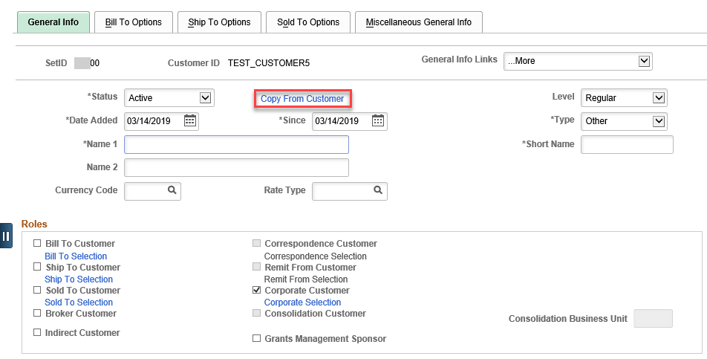
Figure 13. General Information page, Copy From Customer Link
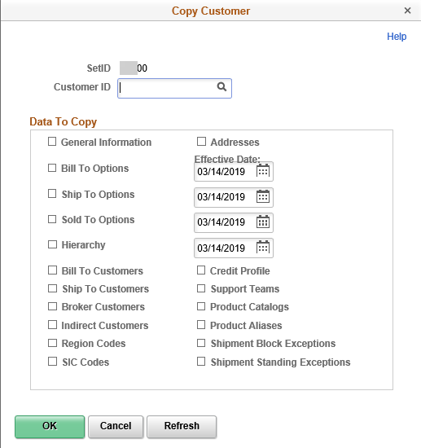
Figure 14. General Info Page, Copy from Customer Link

Updating and Maintaining Customers

Updating Customer Types and General Customer Information
When customers have been established, they do not need to be re-entered if changes occur. As your customers change addresses, hire new personnel, and alter relationships within their corporate structure, you must update your information accordingly. However, users need to maintain that information to ensure that the collectors have the most current information when they are making collection calls or that payment information for a customer is accurate and current, as it can affect the processing or receipt of the customer’s payment. SMART uses the most recent history for customer processes.
Errors might have been made when a new customer’s data was entered into SMART, thus requiring corrections to be made. Users insert effective dated rows for changes to customer information such as office moves and changes in names or phone numbers so that an audit trail is created.
The following is the Business Process Flow for Updating a Customer.
Figure 15. Updating a Customer Business Process Flow

Correspondence Customer Options
On the Customer Correspondence Options page, you can:
- Select contact and address information that is used in statement and letter headers.
- Decide where you want your customer to send payments
- Override the business unit defaults for dunning letters, invoices, and statements for a particular customer
- Determine when to exclude items from correspondence and when not to send the letter or statement

Attachments
Use the Attachments page to attach files such as Word documents or Excel spreadsheets to customer records.
Accounts Receivable Navigation
Attachments | Accounts Receivable Homepage > Customers and Accounts > Customer Information > General Information > Click on General Info Links List > Attachments
Billing Navigation
Attachments | Billing Homepage > Online Billing > Customers > General Information > Click on General Info Links List > Attachments
NavBar
Attachments | Navigator > Customers > Customer Information > General Information > Click on General Info Links List > Attachments
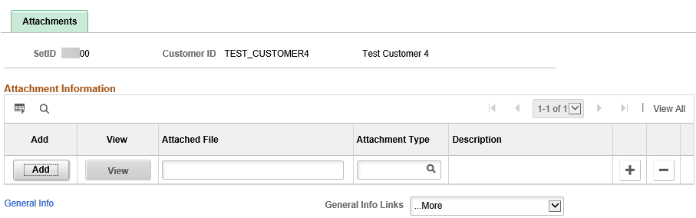
Figure 16. Attachments Page

Notes
Customer Notes are printed on documents such as invoices. You use the Notes Page to select standard notes that can be reused for multiple customers or for custom notes with unique messages. For example, you might have a standard note announcing a seasonal promotion or a note thanking a customer for a particularly large order.
Accounts Receivable Navigation
Notes | Accounts Receivable Homepage > Customers and Accounts > Customer Information > General Information > Click on General Info Links List > Notes
Billing Navigation
Notes | Billing Homepage > Online Billing > Customers > General Information > Click on General Info Links List > Notes
NavBar
Notes | Navigator > Customers > Customer Information > General Information > Click on General Info Links List > Notes

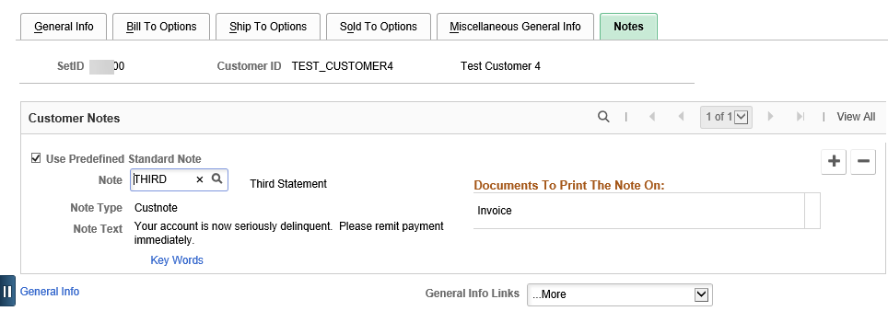
Figure 17. Notes Page
Fields | Description
Delete row | Use this icon to remove old or invalid customer notes.
Table 8. Notes Page Field Description

