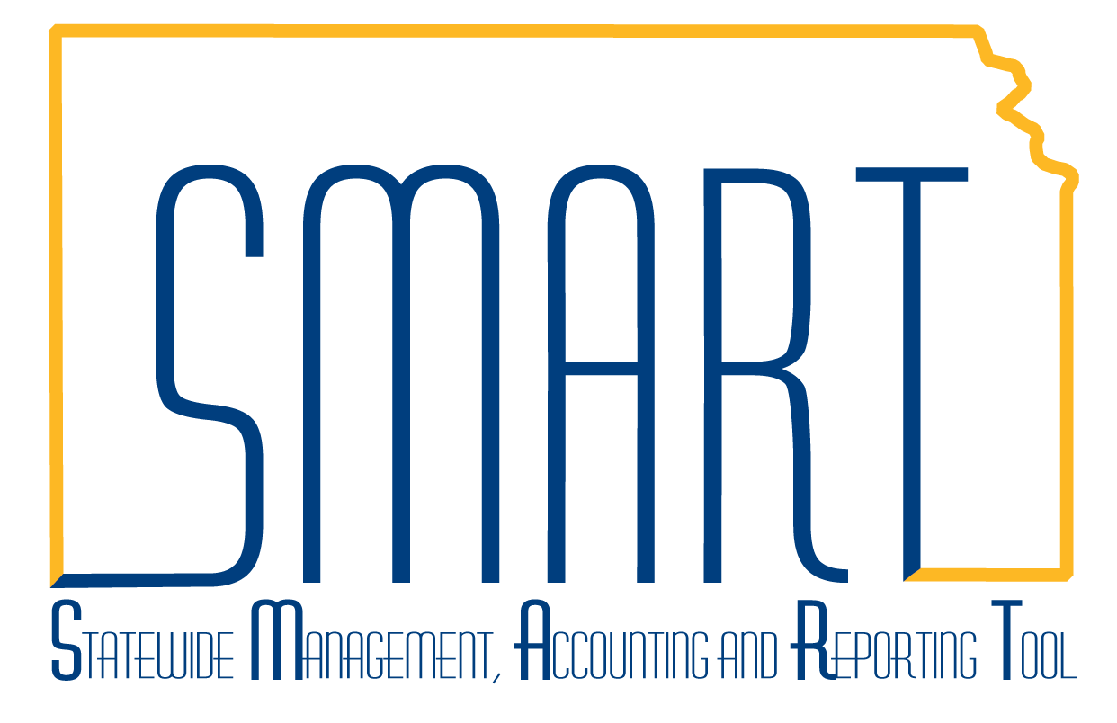
State of Kansas
Billing Manager Dashboard

Statewide Management, Accounting and Reporting Tool

Date Created: | 11/11/2015
Version: | 1.0
Last Updated Date: | 3/4/2019
The Billing Manager Dashboard provides three pivot grids useful in obtaining a visual overview of Invoice Analysis by Month, Bills by Status, and Incomplete Invoice Process.

Note: On the Incomplete Invoice Process pivot grid, the Bill Source field did not populate in the data tables prior to the Upgrade. As data accumulates, this grid should populate.
Navigation: Billing Homepage > Utilities > Review Billing Information > Billing Manager Dashboard or Navigator > Billing > Billing Manager Dashboard  Select the gear icon and select Prompts. | 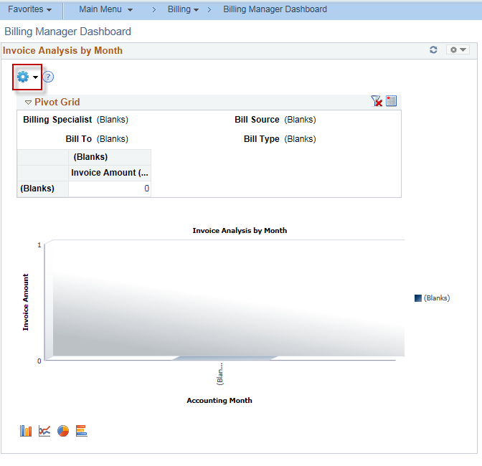
Enter the criteria for the prompt. Click OK. | 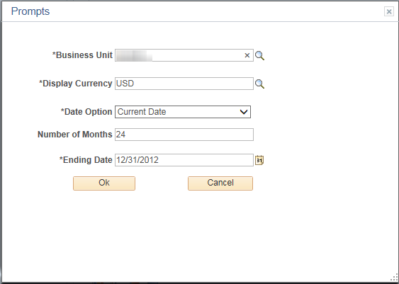
After the grid updates, use the filters to further limit results. | 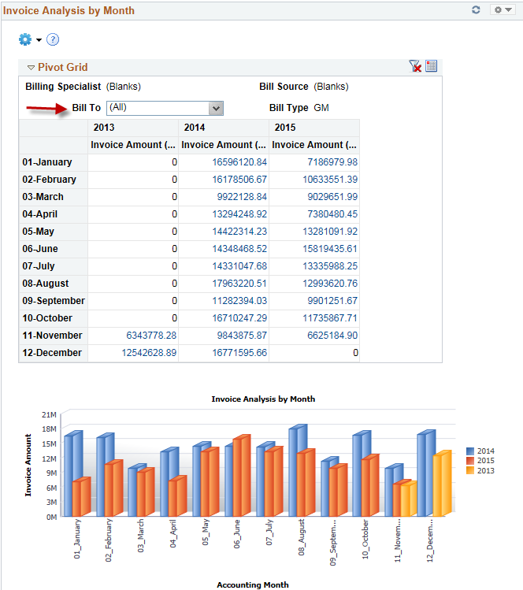
The grids provide many hyperlinks or Action links to drill down into the data. | 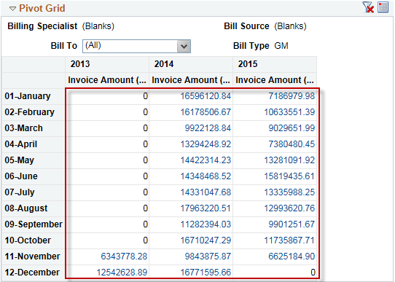  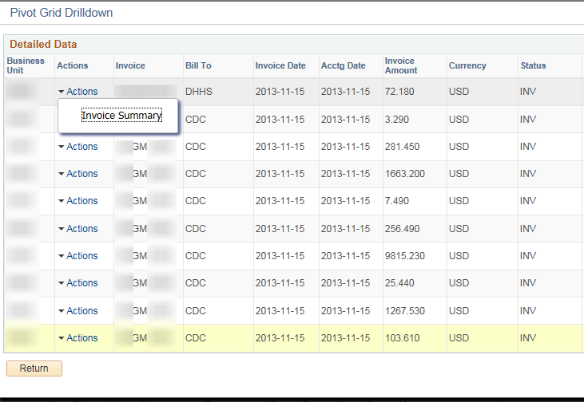
Results are limited to 100. Click Return or X to close the Pivot Grid Drilldown. | 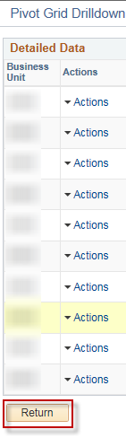  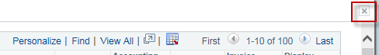
Clicking on the Bar Chart, then clicking the Detailed View also activates the Privot Grid Drilldown with the detail for the month selected. | 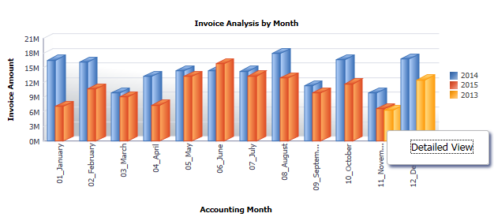
The icons in the screenshot allow for the personalization of the chart. | 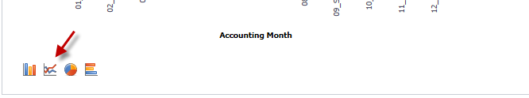  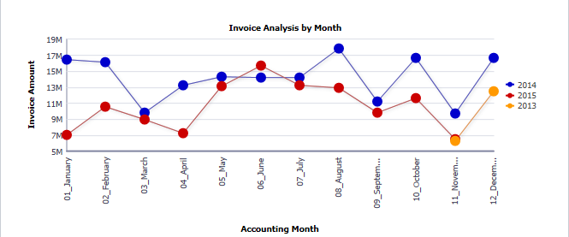
The grids provide the ability to download the data. | 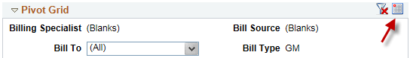  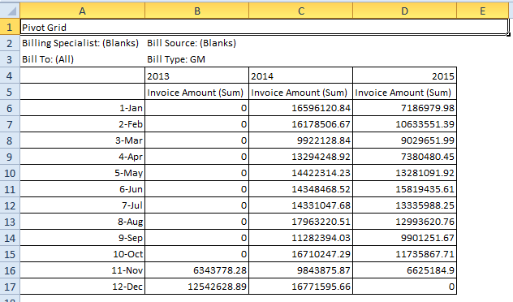
Bills by Status and Incomplete Invoice Process pivot grids follow the same setup as above by using the gears to set up prompts and filters for display.

