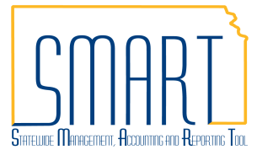
State of Kansas
Setoff/Offset: Impact on Vouchers & Suppliers
Statewide Management, Accounting and Reporting Tool

Date Created | 01/26/2018
Version | 2.1
Last Update | 05/08/2019
Security | - Role Security: Only those individuals with the following role will have access to view a voucher:  - Agency AP Processor (KAP_Agy_AP_Processor)  - BU Security: Business Unit Security is applied. Agencies will only have access to the vouchers associated to their agency business unit.
Purpose of Job Aid | - Most vouchers created in the Accounts Payable Module in SMART are subject to Setoff/Offset analysis for debt matching. This job aid describes the process and how vouchers, payments, and suppliers are affected.
Overview of the Two Debt Collection Programs
 | Setoff (KDRS) | Offset (KTOP)
Example of Notice (click links): | Notice of Intent to Setoff | Notice of Offset
Suppliers and Individuals Owe: | State and/or Kansas Municipalities | Federal Government
Timeline for Setoff/Offset: | 2 Days | Immediate
Agency Receives Email from: | kssetoff@treasurer.state.ks.us | ktop@treasurer.state.ks.us
Time of Day Email is Received: | 12:00 PM | 3:30 PM
Credit Memo Message:  (Found on the Payments Tab) | SETOFF PER KSA 75-6201 ET SEQ QUESTIONS CALL 785-296-4628 | OFFSET PER KSA 75-6201 ET SEQ QUESTIONS CALL 785-296-4500
Customer Call Center: | 785-296-4628 | 785-296-4500
Contact for Agency: | Doug Craig 785-296-2474  Dusti Slocum 785-296-4514
Business Email Address: | kssetoff@ks.gov | ktop@ks.gov
Website Address: | http://www.admin.ks.gov/offices/chief-financial-officer/setoff-program | http://www.admin.ks.gov/offices/chief-financial-officer/ktop

1. Understanding the Setoff Status on a Voucher  See the table for a list of each Setoff Status and its definition.  The Setoff Status for a voucher can be viewed on almost every tab of the voucher in SMART.  A voucher becomes eligible to start moving through the Setoff/Offset analysis process once it has been successfully matched, budget checked, and approved. | Setoff Status Chart  Setoff Status Definition  Not Processed by Collections Default status for all new vouchers entered online in SMART  Exempt from Collections Exempt from setoff/offset based on Account  Not Eligible for Collection Manually identified as not eligible for setoff/offset  Rdy to Snd for Collctns Analys Eligible to be sent for debt match analysis This does not mean it will be setoff/offset  In Collection Eligiblty Analys Sent to Setoff/KTOP for debt match analysis This does not mean it will be setoff/offset  No Credit memo created No debt match was found – full payment released for paycycle  Collections Complete Debt match was found – partial or $0 payment released for paycycle

2. Setoff Status Timeline for Vouchers

Time | Setoff Status(es) | Explanation
Creation of Voucher | Not Processed by Collections | When a voucher is first entered online in SMART, it begins in a “Not Processed by Collections” Setoff Status.
10 AM daily | Exempt from Collections  Not Eligible for Collection  In Collection Eligiblty Analys | All eligible vouchers, aside from a small list of exceptions, are sent to Setoff and KTOP for analysis to determine if there is a debt match. At this point, the voucher Setoff Status will change to one of the three listed to the left.
2 PM daily | No Credit memo created  Collections Complete | Any voucher that was sent through Setoff analysis and does not have a debt match is released for paycycle and will show a Setoff Status of “No Credit memo created.” Vouchers that have a debt match will continue to have the status of “In Collection Eligiblty Analys” until the debt setoff/offset occurs. When that process is complete, the voucher will then have a status of “Collections Complete.”
2:30 PM daily | Rdy to Snd for Collctns Analys | All eligible vouchers, that have not already run through Setoff, are placed on Hold Payment and the Setoff Status is changed to "Rdy to Snd for Collctns Analys". This is to prevent the vouchers from being picked up during paycycle before they go through Setoff analysis. These vouchers will get picked in the next 10 AM Setoff batch.

3. Exempt Account Codes & Not Eligible for Collections  See the list of account codes to the right that are exempt from Setoff. When these account codes are used on a voucher, that voucher will not go through the Setoff analysis process. The Setoff status will be set to “Exempt from Collections”.  Other vouchers that do not go through the Setoff analysis process include Single Payment vouchers, Interfund vouchers, and vouchers that are created with a payment method of ‘Wire’ or ‘Manual’. These vouchers will end up with one of the two following Setoff statuses:  “Not Processed by Collections”  “Not Eligible for Collection” | Account Description  220420 PAYROLL DEDUCTIONS SHARP  220421 PAYROLL DEDUCTIONS REGENTS EE  220422 PAYROLL DEDUCTIONS REGENTS ER  220430 PAYROLL GARNISHMENTS SHARP  220431 PAYROLL GARNISHMENTS REGENTS  220440 PAYROLL TAXES SHARP  220441 PAYROLL TAXES REGENTS EMPLOYEE  220442 PAYROLL TAXES REGENTS EMPLOYER  220451 DEDUCTIONS REMIT BY REGENTS EE  220452 DEDUCTIONS REMIT BY REGENTS ER  526800 REHAB CLIENT MAINT AND TUITION  526970 MILITARY ACTIVATION PAYMENT  543100 LAND AND INTEREST IN LAND  543112 RELOC ASSIST ROW NO SETOFF  543190 LAND & INTERESTS NON CAP  552070 UNCLAIMED PROP CHILD SUPPORT  552400 WORKERS COMPENSATION CLAIMS  553010 EMPLOYMENT SECURITY BENEFITS  554400 EMPLOYER PAID DEATHS  555100 DIRECT STATE WELFARE ASSIST  555200 DIRECT FEDERAL WELFARE ASSIST  555300 FOOD STAMPS  555850 HOUSING ASSISTANCE  556600 STUDENT SCHOLAR FELLOW GRANT

4. Other Impacts on Vouchers & Payments  Setoff Hold Payment  Hold Payment is checked when a voucher is in one of two different Setoff Statuses:  “Rdy to Snd for Collctns Analys” “In Collections Eligiblty Analys”  When a voucher is in either of these Setoff Statuses, it is locked down and updates to it cannot be made. Once analysis is complete, the voucher gets released from Hold Payment and the Setoff Status is updated accordingly.  Payment of a Setoff Voucher  A voucher that has a Setoff status of “Collections Complete” will be matched up with its associated Setoff Credit Memo and the payment will be the net amount of the regular voucher and credit memo. There are a couple ways to find the associated Setoff Credit Memo for the voucher.  A. Use the Regular Entry Page in SMART to Find an Associated Credit Memo  Place the original voucher ID in the ‘Related Voucher’ search field. Click Search.  The Search Results section will show any vouchers that are ‘Related’ to the orginal voucher. This can include journal vouchers, reversal vouchers, and adjustment vouchers. This is also an easy way to find the associated Setoff Credit Memo for a voucher with a “Collections Complete” Setoff Status.  View the Setoff Credit Memo to gather details about the payment. Navigate to the Payments tab to view the “Message” field to determine if it was a Setoff or Offset.  This tab shows the amount of the Setoff/Offset. This is the amount the supplier will not receive from your payment.  To look up payment information, note the Reference ID at the bottom of the tab and navigate to the Payment page in SMART.  *See the job aid for Reviewing Historical Payment Data for Accounts Payable Vouchers on the Accounts Payable page of SMARTWeb.  B. Use a SMART Query to Find Setoff Vouchers and Associated Credit Memos  The query results provide the information for all vouchers that have a Setoff Status of “Collections Complete” and the associated Credit Memo. The amount of the original voucher, amount of the credit memo, and Net Amount Paid to the Supplier are all shown in the query results. | 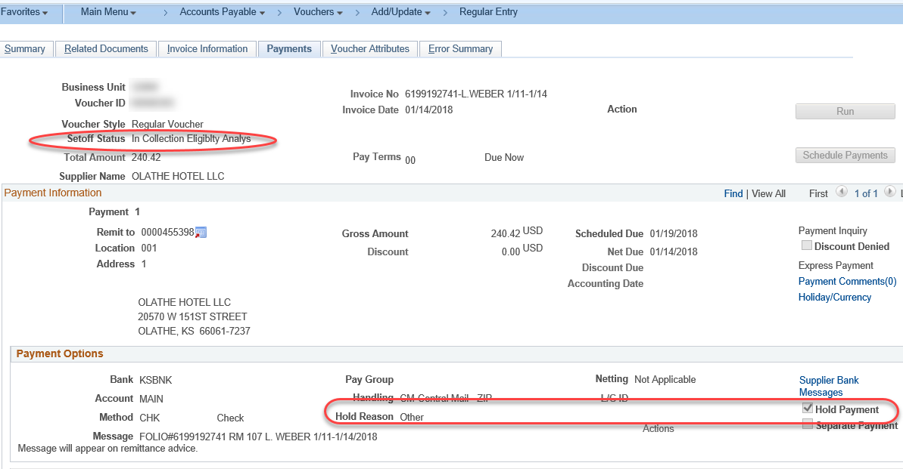  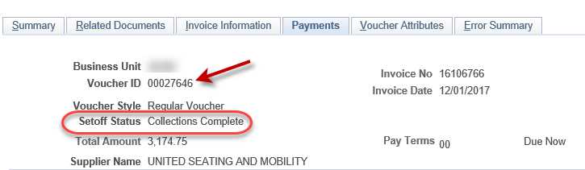  Navigation:  - Accounts Payable Homepage > Vouchers > Add/Update > Regular Entry  - NavBar:Navigator>Accounts Payable>Vouchers>Add/Update> Regular Entry  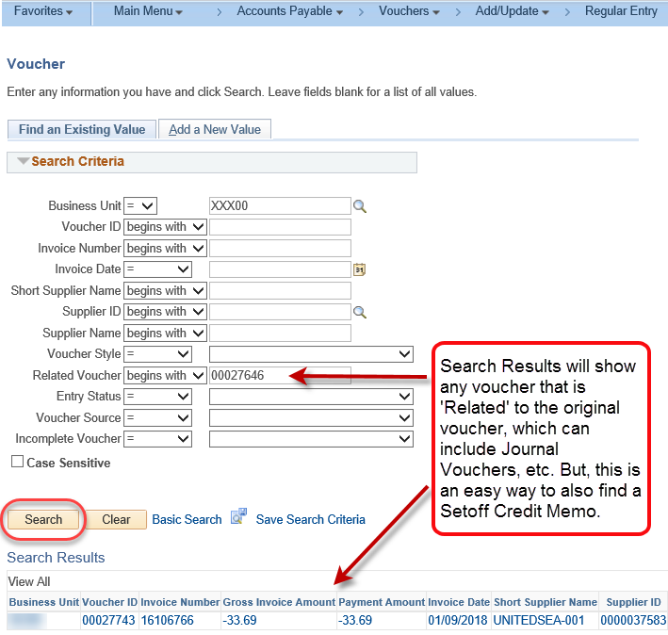  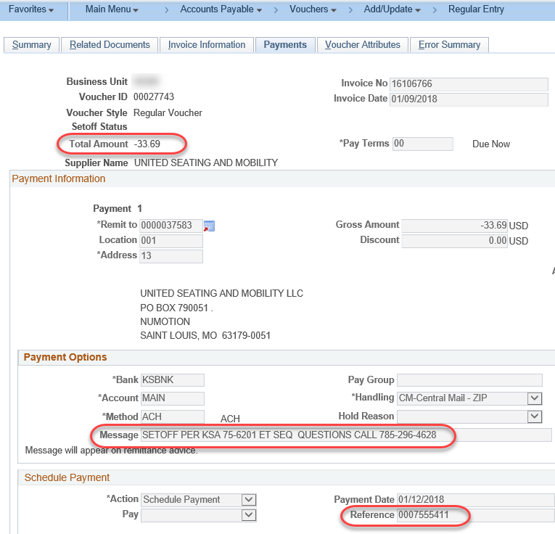  Navigation:  - Accounts Payable Homepage > Utilities > Query Viewer  - NavBar: Navigator >Reporting Tools > Query > Query Viewer  Look for the following query: KS_AP_VOUCHERS_WITH_SETOFF  *Do not run this query for a period longer than 30 days as it could tax the system.  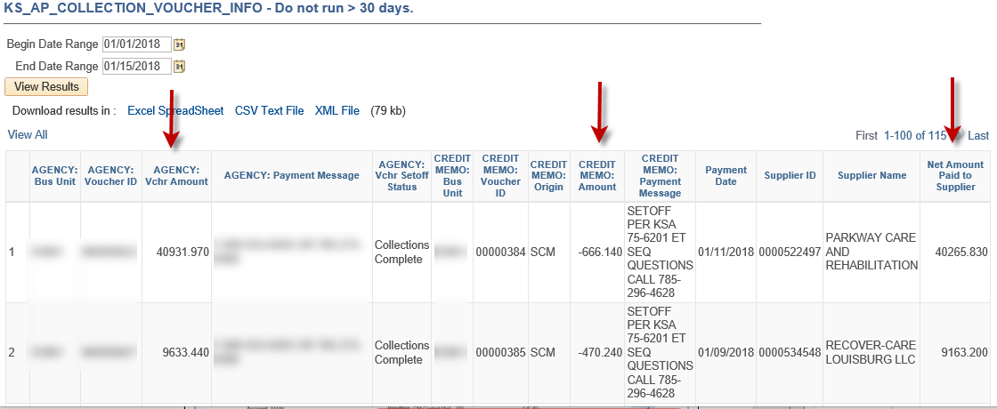
5. Impact on Suppliers  There are a few ways in which a Setoff/Offset payment will impact a Supplier: | - Suppliers will receive a reduced payment due to the amount that is held out for the Setoff/Offset.  - The payment may take a little longer to get to the Supplier because of the period of time it takes for debt analysis.  - Suppliers will receive a Notice of Intent to Setoff/Offset from KDRS/KTOP in the mail. This notice gives details about the debt owed and the payment(s) that are being Setoff/Offset.

