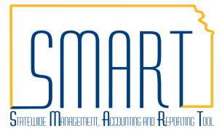
State of Kansas
Imprest Fund and Petty Cash Fund:
Record Expenditures by Creating a Voucher
Statewide Management, Accounting and Reporting Tool

Date Created: | 11/19/2012
Version: | V.1.2.
Last Updated Date: | 04/21/2017
Security: | - Role Security: Only those individuals with the following role will have access to create a voucher to record expenditures for Imprest Funds and Petty Cash Funds:  - Agency AP Processor Limited (KAP_AGY_AP_PROCSSR_LMTD)  - BU Security: Business Unit Security is applied. Agencies will only have access to the vouchers associated to their agency business unit.
Reason for Job Aid: | Payments from an Imprest Fund or Petty Cash Fund shall be entered in SMART to record the expenditures to the suppliers. Recording the expenditures is step 1 in a 2 step process. Creating a replenishment voucher is step 2 – see job aid Imprest Fund and Petty Cash Fund: Replenish Fund by Creating a Voucher.  Payments from an Imprest Fund and Petty Cash Fund shall be entered in SMART by the 15th day of the following month.  A User ID associated to an origin code authorized specifically for imprest and petty cash processing shall be used to log into SMART. The User ID is attached to the Agency AP Processor Limited (KAP_AGY_AP_PROCSSR_LMTD) role.  Refer to Policy & Forms > Security Access Forms on the SMART Web website for additional information. Create a ManageEngine Service Desk incident if additional security access is needed.

Navigation |  | Main Menu > Accounts Payable > Vouchers > Add/Update > Regular Entry
1.1 | Create a Voucher  Note: Ensure you are logged in under the Agency AP Processor Limited user ID.  Use the ‘Add a New Value’ tab:  Required Fields:  Business Unit: Your Business Unit number will default.  Note: If you use multiple Business Units, change the Business Unit value as necessary.  Voucher ID: Either accept the default value of ‘NEXT’ or follow your Agency’s business process for assigning Voucher ID numbers.  Voucher Style drop-down list: Select the ‘Regular Voucher’ option as shown in the screenshot to the right – this is the default. | 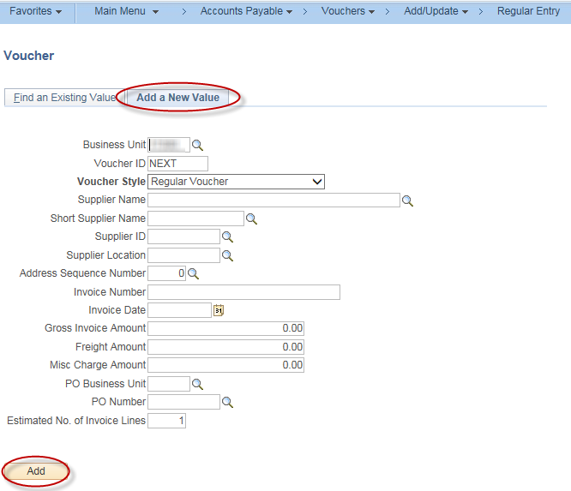
1.2 | Populate Remaining Fields:  Complete the remaining fields on the Add a New Value tab:  Supplier ID, Invoice Number, Invoice Date, and Gross Invoice Amount.  After filling in the fields, click the ‘Add’ button. | Invoice Number: Agencies shall use the check number as the invoice number when recording the expenditure from an Imprest Fund and shall use the disbursement form number as the invoice number when recording the expenditure from a Petty Cash Fund.  Invoice Date: Agencies shall use the date of the disbursement from the imprest fund or petty cash fund.

1.3 | Invoice Information:  Enter data in the Voucher Header, Invoice Lines and Distribution Lines.  Distribution Lines: Refer to PM 10,752 – Petty Cash Fund Policy and PM 10,802 – Imprest Fund Policy for details regarding the fund(s) to be used. | 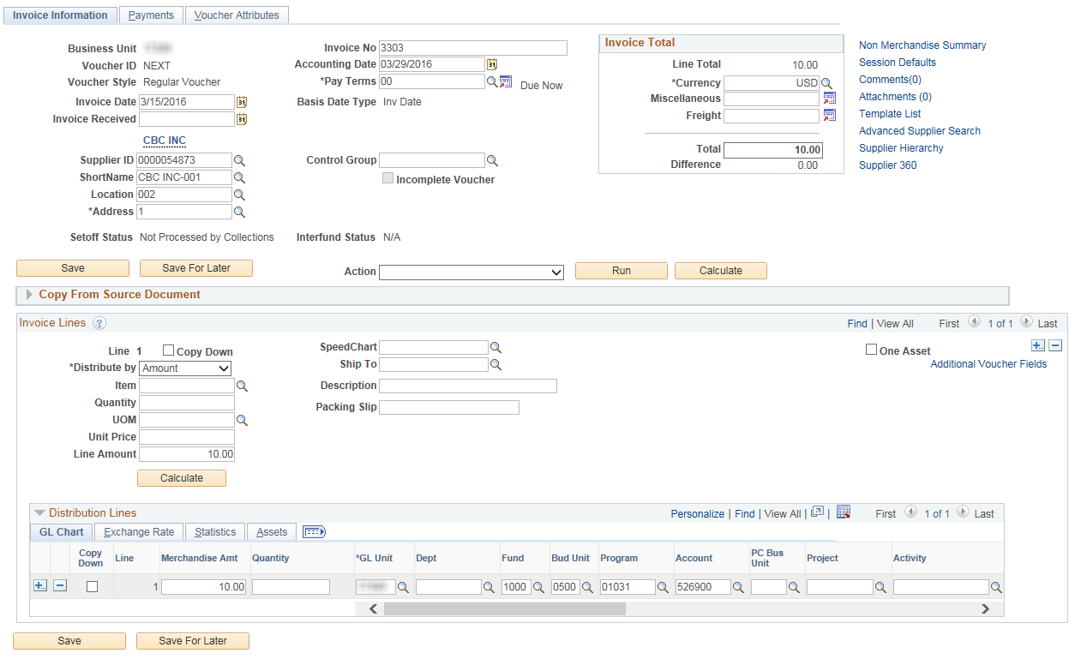
1.4 | Payments:  Verify values in the Voucher Header and Payment Information.  Payment Options:  Bank (required): Select valid imprest or petty cash bank – this is different than the KSBANK used for regular vouchers.  Account (required): Select valid imprest or petty cash account.  *The Bank and Account may also be found by using the following query in Reporting Tools > Query > Query Viewer  KS_AP_IMPR_PETTY_BANK_ACCT_KEY  Method: CHK (Check).  Message (optional): Message or note may be entered.  Payment Comments (optional – link is on right of screen): Message or note may be entered.  Select ‘Save’. Voucher ID is assigned upon saving. | 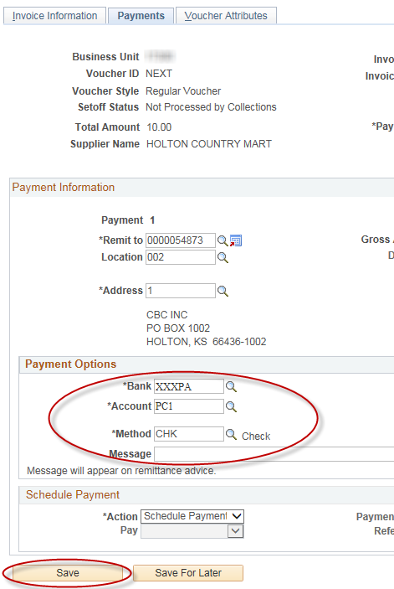
Navigation |  | Main Menu > Accounts Payable > Vouchers > Add/Update > Regular Entry
2.1 | Update Voucher to reflect manual payment processing  IMPORTANT:  After the voucher has been successfully budget checked and matched (if applicable), updates MUST be made to the voucher to reflect manual payment processing to prevent a check from being issued. Updates must be made before pay cycle is run on the day the voucher is created.  Budget Check will run in batch process on an hourly basis. Budget Status will become Valid once budget check is successful.  Imprest and petty cash vouchers are preapproved based on Origin. The  workflow approval process is not required. | 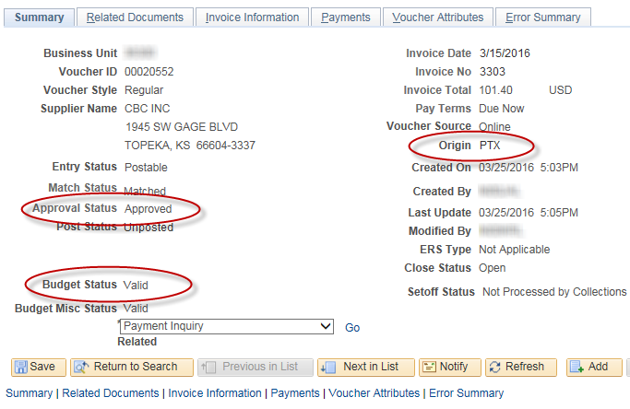
2.2 | Navigate to the Payments tab of the voucher.  Update voucher to reflect manual payment processing to prevent a check from being issued.  Payment Options:  Bank: Verify a valid imprest or petty cash bank populates this field.  Account: Verify a valid imprest or petty cash account populates this field.  Method: Select MAN (Manual). | 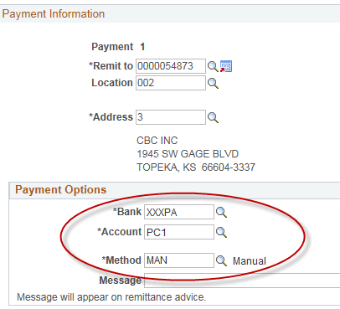

2.3 | Schedule Payment:  Action: Select Record a Payment.  Pay: Full option will default with the Action selection.  Payment Date: Current date will default with the Action selection.  Reference: Agency assigned value for check number. Agencies shall use the imprest fund check number or the disbursement form number for petty cash.  Select ‘Save’. | 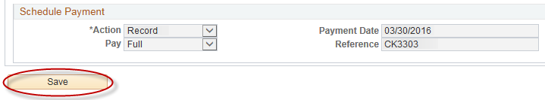
2.4 | Voucher will go through Payment Post process to create the accounting entries in GL. Payment Post will run each night as a part of the nightly batch process.

