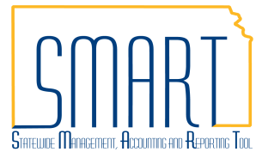
State of Kansas
Delete or Close a Voucher
Statewide Management, Accounting and Reporting Tool

Date Created | 04/21/2017
Version | 2.1
Last Update | 04/19/2019
Security | - Role Security: Only those individuals with the following roles will have access to delete or close a voucher:  - Agency AP Supervisor (KAP_Agy_AP_Supervisor)  - Agency AP Maintainer (KAP_Agy_AP_Maintainer) (Delete ONLY)  - BU Security: Business Unit Security is applied. Agencies will only have access to the vouchers associated to their agency business unit.
Vouchers Eligible to be Deleted Checklist  (see page 2 to delete a voucher) | - The voucher must have never been Posted (i.e. there are no accounting entries associated with the voucher). You may look up the status of the accounting entries for a voucher by following the navigation:  Accounts Payable Homepage > Vouchers > Accounting Entries  or  NavBar: Navigator > Accounts Payable > Review Accounts Payable Info > Vouchers > Accounting Entries  - The voucher must not be matched. If needed, unmatch the voucher on the Match Workbench.  - The finalize PO check box must not be checked on any distribution line in the voucher. If needed, uncheck the finalize PO box on the distribution line(s).  - The voucher must not be paid.
Vouchers Eligible to be Marked for Closure Checklist  (see page 3 to close a voucher) | - The voucher must be Posted. View the Post Status on the Summary tab of the voucher.  - The voucher must not be selected for payment. View the Payment Status on the Related Documents tab of the voucher.  - The voucher must not be paid.

Navigation |  | Accounts Payable Homepage > Vouchers > Add/Update > Delete Voucher  or  NavBar:Navigator > Accounts Payable > Vouchers > Add/Update > Delete Voucher
1. | Delete a Voucher  a. Navigate to the voucher you intend to delete.  Confirm the voucher is eligible to be deleted by going through the checklist on page 1. | 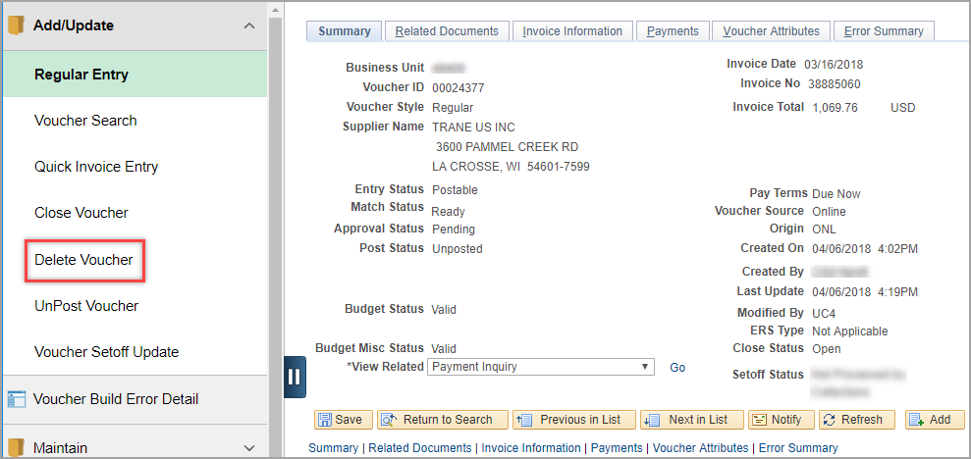
 | b. You can also look up your voucher in the Voucher Delete search using the various search options.  If the voucher you intend to delete does not show up in the search results, it is likely not eligible to be deleted. Review the checklist above. | 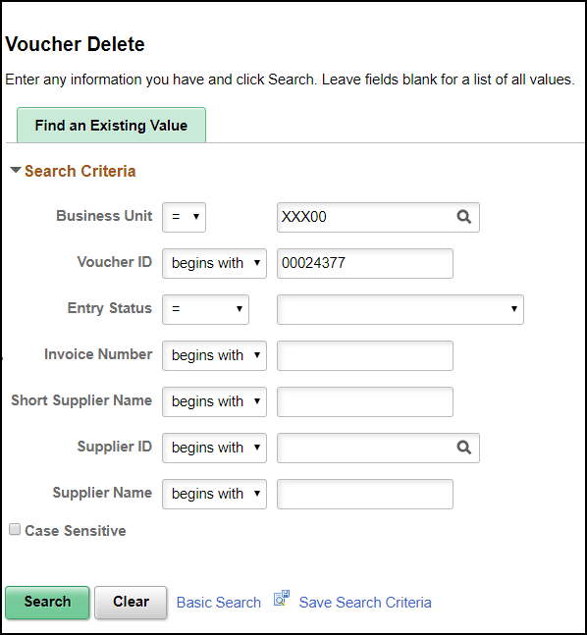
 | c. Select the voucher you intend to delete and click the ‘Delete’ button.  d. A popup message will appear to confirm the voucher will be deleted. Click the ‘OK’ button to delete the voucher.  e. Another popup message will appear to confirm the voucher has been deleted as well as any budget transactions. Click the ‘OK’ button.  A deleted voucher will no longer appear when you search for it in Accounts Payable. | 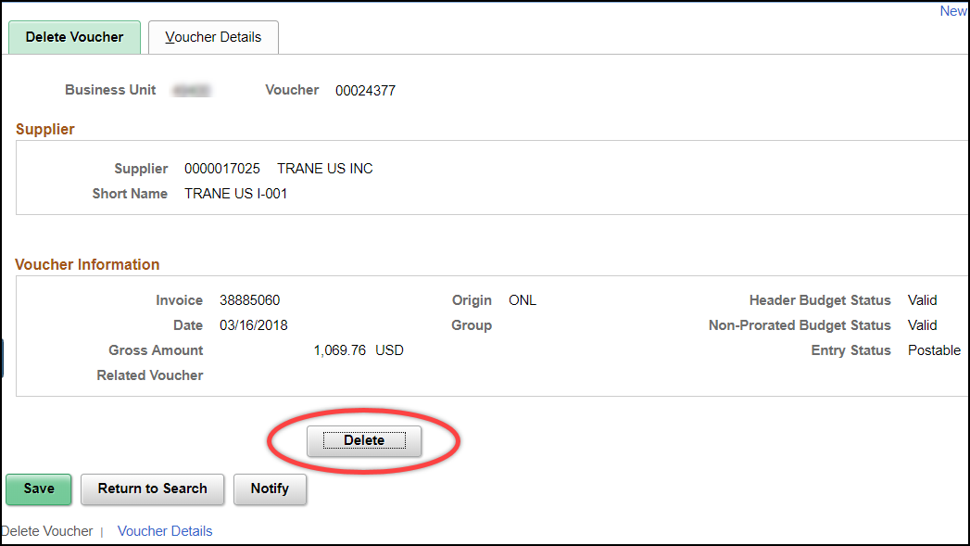  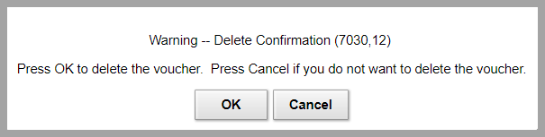  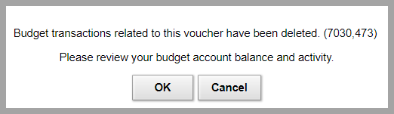
Navigation |  | Accounts Payable Homepage > Vouchers > Add/Update > Close Voucher  or  NavBar: Navigator > Accounts Payable > Vouchers > Add/Update > Close Voucher
2. | Close a Voucher  a. Navigate to the voucher you intend to close.  Confirm the voucher is eligible to be marked for closure by going through the checklist on page 1.  b. You may also look up your voucher in the Voucher Close search using the various search options.  If the voucher you intend to mark for closure does not show up in the search results, it is likely not eligible to be closed. Review the checklist above.  c. Once you have selected the voucher you intend to close, check the box to ‘Mark Voucher for Closure’.  If the voucher is associated with a PO, a pop up box will appear asking if you would like to restore the encumbrance associated with the voucher you are closing.  d. Restoring the encumbrance will undo the matching that occurred on the voucher. This will make the amount that had been matched on the voucher available for future use from the PO.  e. If there is more than one line associated with a PO on the voucher, all POs associated with the voucher will appear. Check the box next to each PO you intend to restore the encumbrance for then click ‘OK’. | 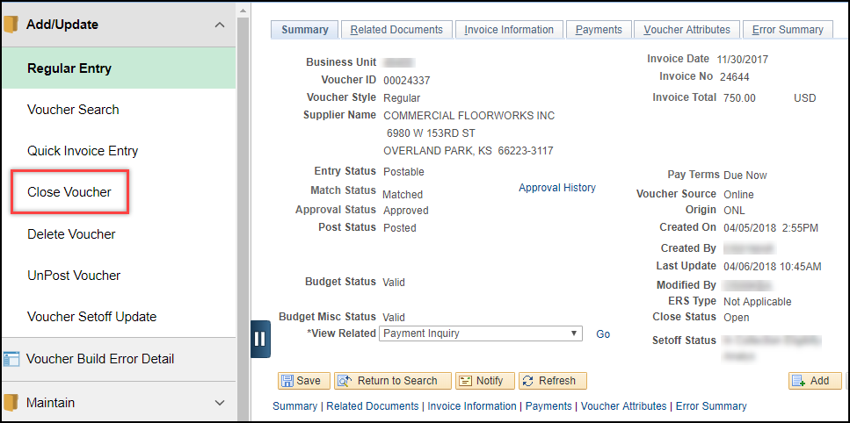  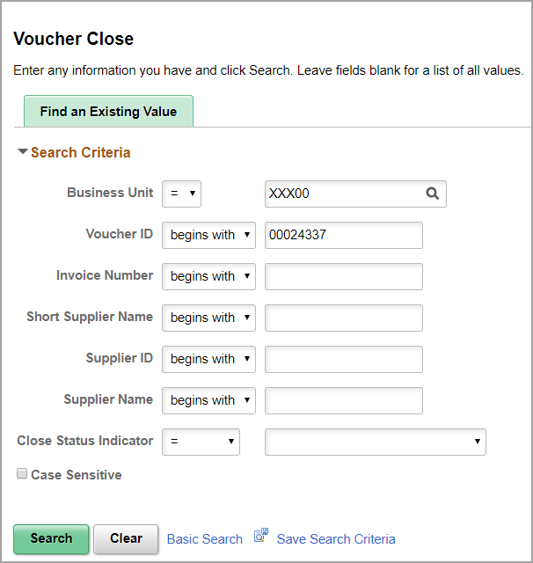  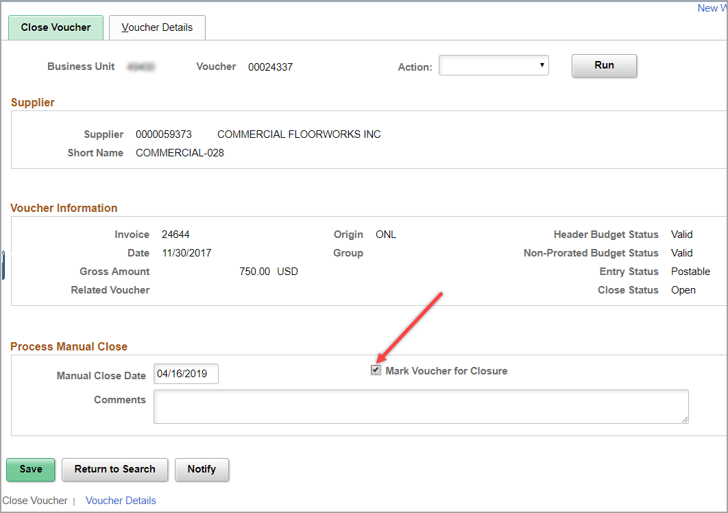  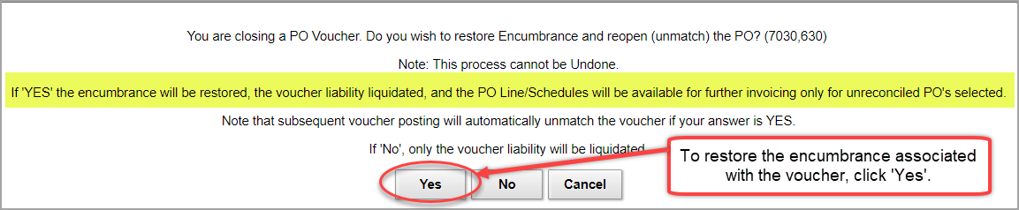  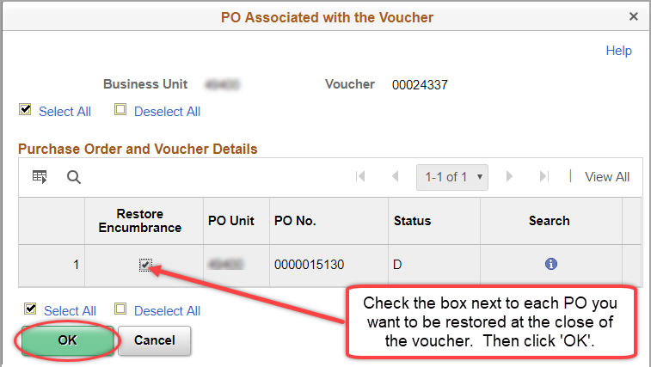

 | f. Enter a note in the Comments field if desired. This will show up in a hyperlink on the Summary tab of the voucher once the voucher is closed.  Click ‘Save’.  You can choose to run ‘Voucher Post’ from the drop-down menu if you would like the Closed status to show on the voucher immediately. Otherwise, the Close Status will be updated in the nightly batch cycle. | 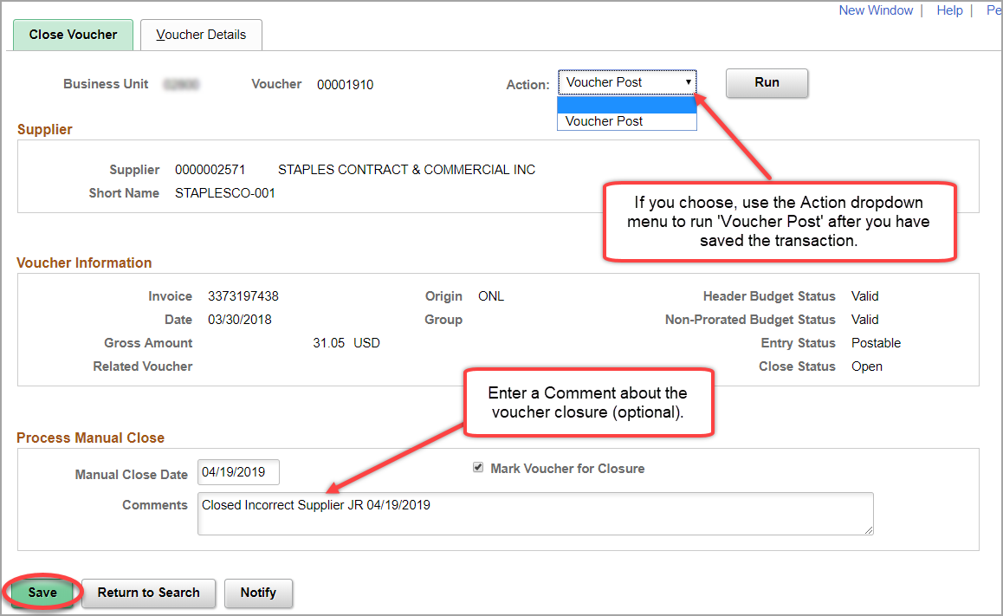
Navigation |  | Accounts Payable Homepage > Vouchers > Add/Update > Regular Entry  or  NavBar: Navigator>Accounts Payable>Vouchers>Add/Update>Regular Entry
 | g. To confirm the voucher has a Close Status of ‘Closed’, go to the Summary tab of the voucher. You may have to check this status the next business day.  Select the ‘Comments’ link to view the comments entered when the voucher was closed.  A closed voucher will still show up in SMART, but the Close Status will be ‘Closed’. The voucher cannot pay or be processed further at this point.  A voucher will also have a Close Status of ‘Closed’ when a payment is cancelled via a DA-7 request form. | 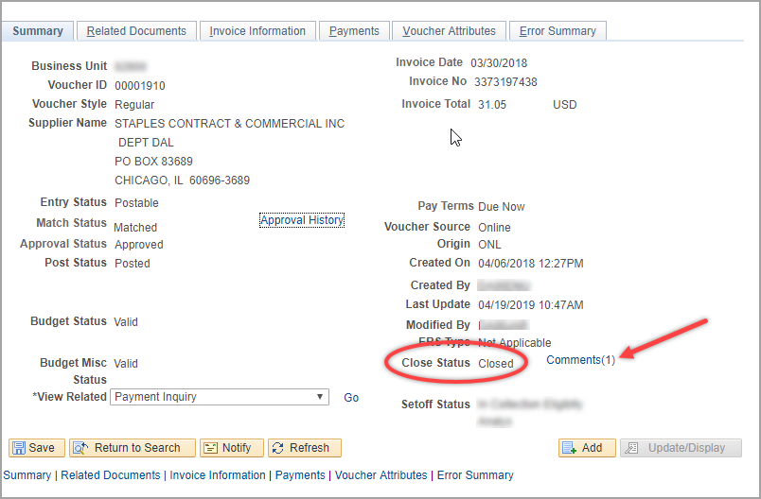  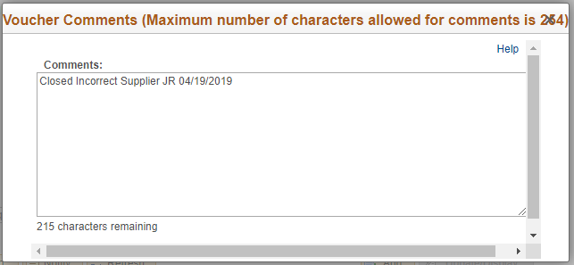
Navigation |  | Accounts Payable Homepage > Utilities > Query Viewer  or  NavBar: Navigator > Reporting Tools > Query > Query Viewer
3. | Look up Deleted or Closed Vouchers Using a Query  Use the queries listed below to find vouchers that have been deleted or closed within the specified date range.  KS_AP_DELETED_VCHRS KS_AP_CLOSED_VCHRS | 