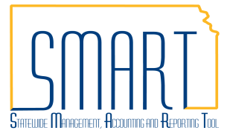
State of Kansas
AP Voucher Approval – Establish and Maintain
Set A, Set B, and Fiscal Office Approvers
Statewide Management, Accounting and Reporting Tool

Date Created | 02/26/2020
Version | 1.0
Job Aid Replaces | Enter and Maintain Voucher Origin Approvals 11-19-12
Security | - Role Security: Only those individuals with the following roles will have access to enter and update Set A and Set B approvers:  - Agency AP Workflow Maintainer (KAP_Agy_AP_WF_Maintainer)  - BU Security: Business Unit Security is applied. Agencies will only have access to vouchers and interfunds associated to their agency Business Unit.
Purpose
Voucher origin codes are used in AP workflow to route vouchers for pooled approval. The origin code is assigned to a user as part of the SMART Security set up. Each User ID is assigned one origin code. When a user enters a voucher, the origin code defaults into the voucher.

Any origin codes that must go through workflow approval (online, INF02 Inbound Voucher Interface, or INF50 Excel Spreadsheet Upload) should have Set A and Set B approvers established.

There are two steps to establishing Set A and Set B approvers in SMART.
Step 1: Agency requests authority for users to approve vouchers at the Set A and Set B levels using the SMART Security Access Form.
Step 2: Agency establishes and/or maintains the Set A and Set B voucher approval assignments, based on the voucher origin code, in SMART. Instructions for this process start on page 2 of this job aid.

Fiscal office approvers are the users that provide the final agency approval on each voucher. Authority to approve vouchers at the Fiscal Office approval level is requested and maintained using the SMART Security Access Form.

Vouchers entered to record Petty Cash and Imprest Fund expenditures are preapproved, so no Set A, Set B, or Fiscal Office approvers are required for those origin codes.
Navigation | Any of the following paths will take the user to the Query Page  - Accounts Payable Homepage > Utilities > Query Viewer  - NavBar: Navigator > Reporting Tools > Query > Query Viewer
Queries to Manage Voucher Workflow
Use the KS_AP_ORIGIN_CODES query to determine which origin codes are assigned to the Business Unit. Any origin code with ‘Default from Higher Level’ in the Voucher Approval Flag column of the query results requires workflow for approval, and therefore, Set A and Set B approvers.

Use the queries listed below to determine which agency users are currently established as a Set A/Set B or Fiscal Office Approvers.

KS_SET_A_B: This query result lists the Set A and Set B approvers for the agency by Origin Code. The Primary Permission List (Prim Perm List) is also listed which will assist in determining the Business Unit(s) for which the user is authorized.

KS_APPROVER_AP_V1: This query result lists all users with the KAP_AGY_AP_FO_APPR role for the agency, along with the Route Control Profile (Field Prof) to confirm the Business Unit(s) for which the user is authorized.

Navigation | Any of the following paths will take the user to the Set A and Set B Approvers page  - Accounts Payable Homepage > Vouchers > Agency Table Maintenance > Set A and Set B Approvers  - NavBar: Navigator > Kansas > KS AP > Voucher Origin Approvals
- Establish Set A/Set B Voucher Approvers  - Select ‘Add a New Value’ tab.  - Enter a valid Business Unit, Origin, and Step combination.  - Select ‘Add’.  NOTE: The origin code must already exist in SMART. If a new origin code is required, please log a ManageEngine Ticket. A new origin code is needed only if the agency has a new workflow approval path that cannot be accommodated with existing origin codes. Most agencies use origin codes beginning with letter ‘O’ to route vouchers for workflow purposes. ‘ONL’ is the most widely used origin code for this purpose.  - Adjust the Effective Date if necessary. The field defaults to the current date.  - Enter the User ID that is authorized to approve vouchers for the specified origin code and step.  - If additional User IDs are authorized for the origin code / step, use the ‘+’ sign to add additional User ID rows.  When all users are entered, click ‘Save’.  Repeat Step 1 to establish Set B approvers. | 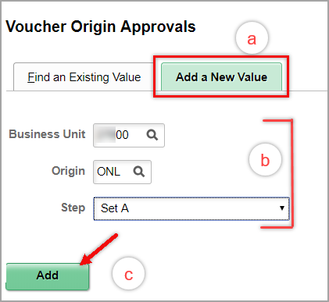  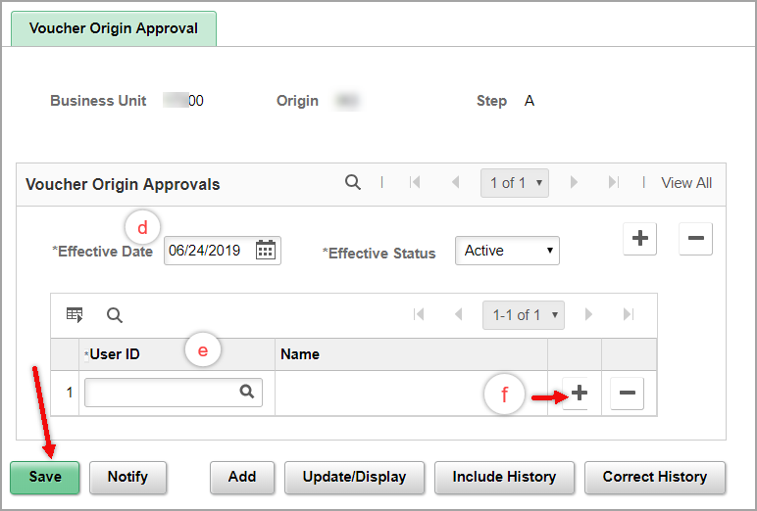
- Update Set A/Set B Voucher Approvers  - Select the ‘Find an Existing Value’ tab.  - Enter a valid Business Unit, Origin, and Step combination.  - Click ‘Search’.  - Click on the ‘+’ to add a new set of approvers with a new effective date.  - The new table (set of approvers) is now ‘1 of 2’.  - The effective date defaults to the current date and can be changed if the updates should be future-dated or back-dated. This date correlates to the Accounting Date on the voucher to be approved.  - User IDs can be added using ‘+’ or deleted using ‘-‘.  Click SAVE when changes are complete.  NOTE: The instructions in Step 2d above, direct users to add a new effective dated table. If a historical record of the approval updates is not required by your agency, select ‘Correct History’ on the initial search page OR when the search result is displayed. Changes to the most recent active set of approvers can be made by adding and deleting User IDs (using the ‘+’ and ‘-‘ buttons in the User ID section) then clicking the Save button. | 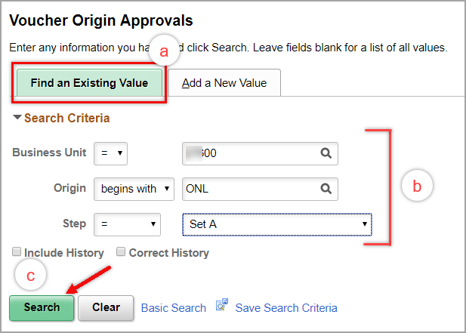  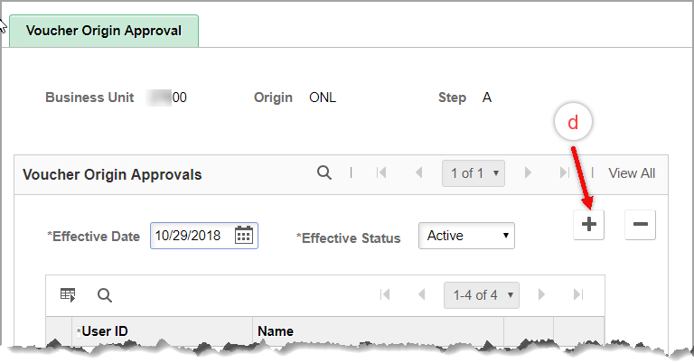  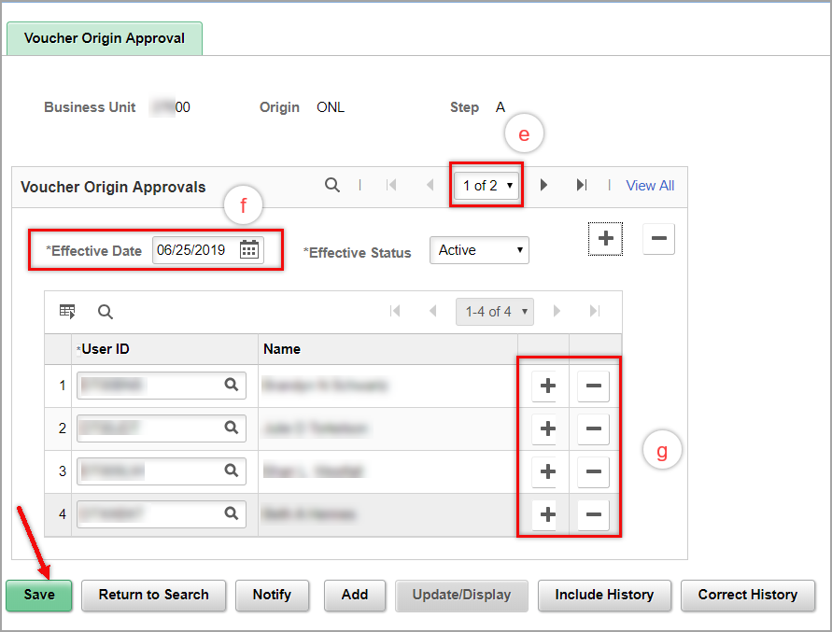  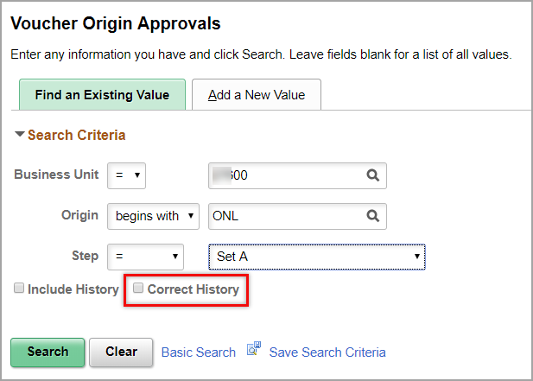  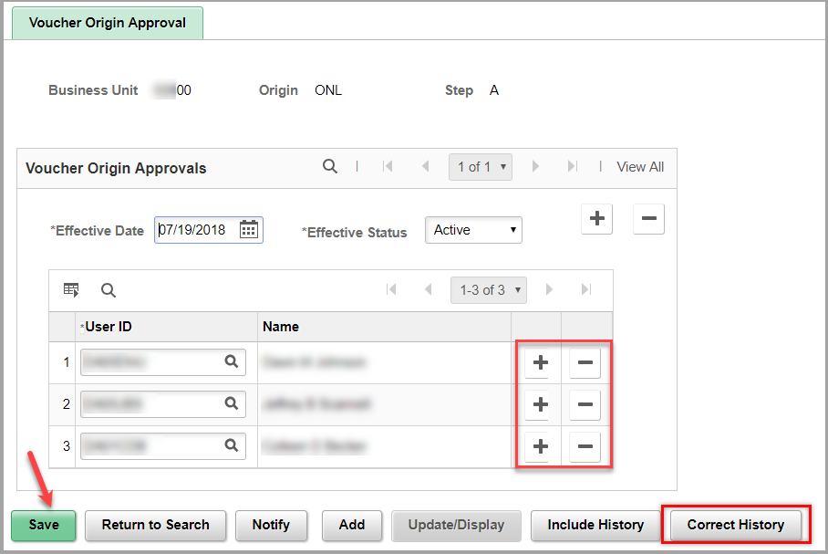

Navigation | Any of the following paths will take the user to the Voucher Pages  - Accounts Payable Homepage > Vouchers > Add/Update > Regular Entry  NavBar: Navigator>Accounts Payable>Vouchers>Add/Update>Regular Entry
Confirming Workflow Updates  To see the revised workflow path based on any Set A or Set B modifications, workflow will need to be retriggered on any vouchers already submitted to workflow. To retrigger workflow on a voucher see the AP Voucher Approval job aid (Step 11).  Select the ‘Preview Approval’ hyperlink (for new vouchers not yet submitted to workflow) or the ‘Approval History’ hyperlink (for vouchers where workflow has been retriggered) on the summary tab of the voucher to view the revised approval details for the voucher. | 