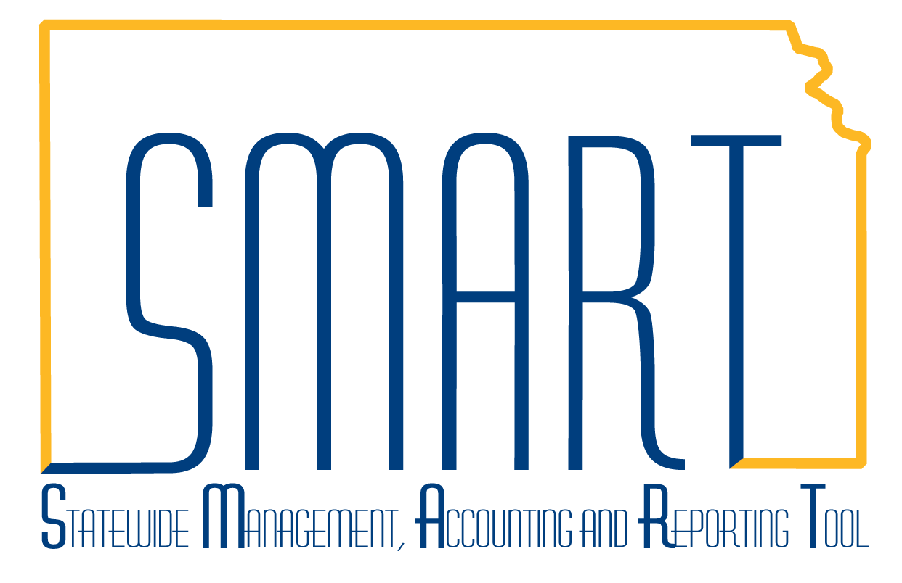
State of Kansas
Check for Existing Supplier Record
Statewide Management, Accounting and Reporting Tool
Date Created: | July 18, 2014
Version: | V.2.0
Last Updated: | January 2021
General Information | Always review SMART before adding a new supplier.  Reviewing first prevents a duplicate record from inadvertently being entered. Duplicate records can lead to delays in payment processing.
Contents | 1. Navigation  2. Review Supplier  3. Results
- Navigation | Log in to SMART. From SMART Homepage, navigate to Accounts Payable homepage > Suppliers tile  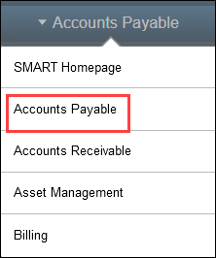
- Review Suppliers | There are several ways to search for an exisitng supplier in SMART.  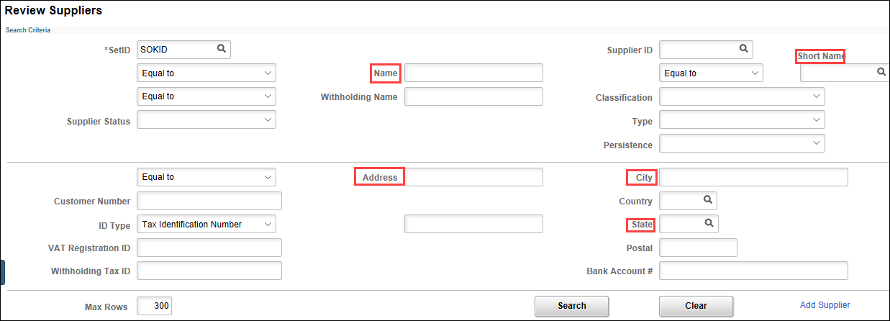  The most successful and preferred way to search for an existing supplier in SMART is to use the Supplier’s Withholding Tax ID number.  - Social Security number  - Federal Employer Identification Number (FEIN)  - Employer Identification Number (EIN)  (FEIN/EIN are the same thing)  Click on Review Suppliers and navigate to the Withholding Tax ID box.  Enter the tax ID indicated on the W9 provided by the supplier (no spaces, no punctuation)  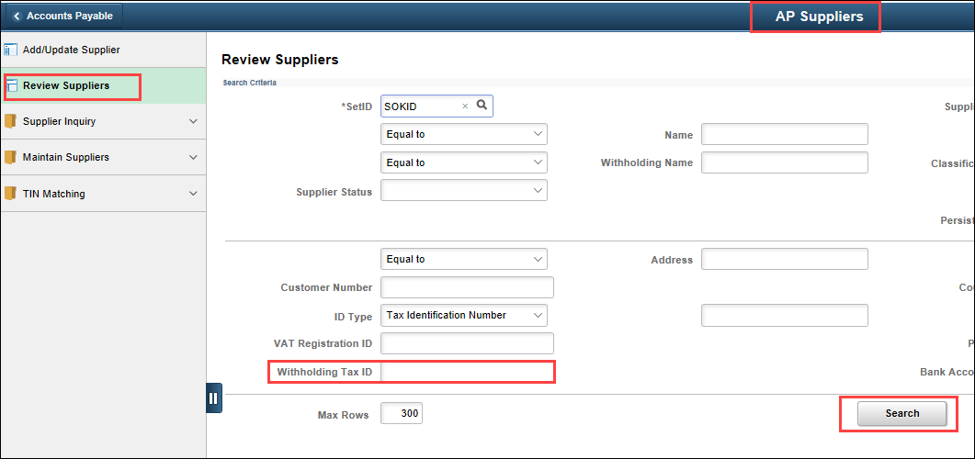  Click Search.
3. Results | There will be one of two results:  - The tax ID number entered is not listed in SMART. If no rows were found in your search, proceed with entering a new supplier in SMART. Refer to the Create a New Supplier job aid found here https://smartweb.ks.gov/training/accounts-payable and follow the instructions.  - A list of the SMART supplier records associated with the tax ID number entered displays.  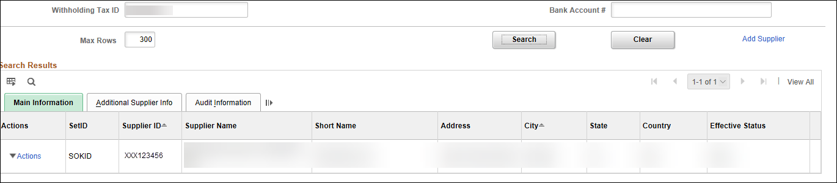
To view the supplier’s record, click on Actions. From the dropdown menu click Maintain Supplier.

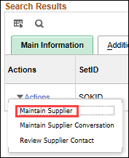
This will take you directly to the SMART supplier record.

